NAME ____________________________________ INDEX NO. _______________
SCHOOL ____________________________________ SIGNATURE _______________ DATE _______________

232/2
PHYSICS
PAPER 2
(THEORY)
JULY/AUGUST, 2015
TIME: 2 HRS

232/2
PHYSICS
PAPER 2
(THEORY)
TIME: 2 HRS

INSTRUCTIONS TO CANDIDATES
- Write your name, school and index number in the spaces provided above.
- Sign and write the date of the examination in the spaces provided above.
- This paper consists of two sections, Section A and B.
- Answer ALL the questions in both sections in the spaces provided in this paper.
- ALL working must be clearly shown.
- KNEC mathematical tables and non-programmable silent electronic calculators may be used.
Note:
Take acceleration due to gravity, g = 10m/s², C = 3.0×10⁸ms⁻¹, M_{e} = 9.11×10⁻³¹kg, e = 1.6×10⁻¹⁹C

FOR EXAMINER’S USE ONLY
Section | Question | Maximum score | Candidate’s score
A | 1-13 | 25
B | 14 | 10
 | 15 | 13
 | 16 | 11
 | 17 | 10
 | 18 | 11
 | TOTAL | 80

This paper consists of 12 printed pages
Candidates should check to ensure that all pages are printed as indicated and no questions are missing
SECTION A (25 MARKS)
Answer ALL the questions in this section in the spaces provided.
- Differentiate between nuclear fission and nuclear fusion as used in the study of physics. (2 marks)
____________________________________________________________________________________________________________________________________________________________________________________________________________________________________________________________________________________________________________________________________________
- The diagram below shows an electrical appliance connected to the mains.
Name the colour for the leads A, B and C and state the purpose of the fuse. (3 marks)
______________________________________________________________________________________________________________________________________________________________________
_________________________________________________________________________________________________________________________________________________________________________________________________________________________________________________________
- The figure below shows a circuit diagram for a photocell.
State the variation in the UV-light that will cause a decrease in the reading of the millimeter. (1 mark)
______________________________________________________________________________________________________________________________________________________________________

- Diagram (a) below shows the position of the bright spot on the screen of a C.R.O when there is no signal on both Y and X- plate. Indicate on the diagram (b) when the Y-plate is connected to a.c signal and for (c) the X- plate is connected to a d.c signal i.e. the display on the screen. (3 marks)

- Using the band theory, differentiate between conductor and a semi-conductor . (1 mark)
______________________________________________________________________________________________________________________________________________________________________
______________________________________________________________________________________________________________________________________________________________________
- The following is a decay series of Uranium 238.
U Th Pa
$α-Particle$
$β-Particle$
Determine the value of x and y. (2 marks)
x ________________________________________________
y ________________________________________________
- A girl stands 2m in front of a plane mirror, the mirror is then moved 0.6m away from the girl. Determine the distance from the first position of the image to the second position of the image. (2 marks)

- What is the ‘direction of the magnetic field’ at a point in the field? (1 mark)
______________________________________________________________________________________________________________________________________________________________________
- State with a reason which type of reflector would be preferred for:
- Underground parking area (1 mark)
___________________________________________________________________________________
- Solar concentrators (1 mark)
___________________________________________________________________________________
- Polarization and local action are the common defects in a simple cell. How are these defects minimized in the cell? (2 marks)
_________________________________________________________________________________________________________________________________________________________________________________________________________________________________________________________
- A man standing at the middle of two parallel walls fires a gun. He hears an echo after 1.5 seconds. Determine the distance of separation of the walls. (Velocity of sound is 340m/s) (2 marks)

- A highly negatively charged rod is brought slowly towards the cap of a positively charged leaf electroscope. It is observed that the leaf initially collapses and then diverges.
Explain the observations. (2 marks)
______________________________________________________________________________________________________________________________________________________________________
___________________________________________________________________________________
______________________________________________________________________________________________________________________________________________________________________
- The figure below shows ray B₁ incident through a glass block to air interface.
O
B₂ is the emergent ray of B₁. Determine the refractive index of the glass block. (2 marks)

SECTION B (55 MARKS)
Answer ALL the questions
- a) What is meant by the term ‘photoelectric effect?’ (1 mark)
______________________________________________________________________________________________________________________________________________________________________
___________________________________________________________________________________
b) State any two factors that affect photoelectric effect. (1 mark)
___________________________________________________________________________________
___________________________________________________________________________________
c) The graph below shows stopping potential plotted against frequency, f.
Stopping potential Vs (volts)
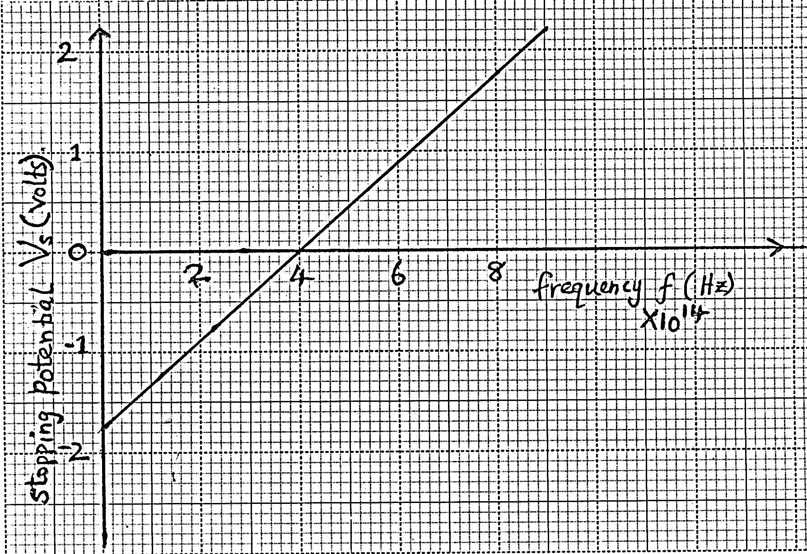
Frequency f (Hz)
×10¹⁴
From the graph determine:
i) Planks constant. (3 marks)

ii) Work function (2 marks)

- A metal surface has a work function of 4.85eV. Calculate the maximum kinetic energy in joules
of the electrons emitted when the metal is irradiated with uv light of frequency 1.75$×$10¹⁵Hz. (3 marks)

- a) i) Explain why Carbon −14 $\left({}_{6}^{14}C\right)$ is radioactive while Carbon – 12 $\left({}_{6}^{12}C\right)$ is not. (1 mark)
_________________________________________________________________________________________________________________________________________________________________________________________________________________________________________________________
ii) A radioactive isotope showed a count rate of 82 counts per second initially. After a time
of 210 seconds, the count rate dropped to 19 counts per second. The average background
count remained constant at 10 counts per second. What is the half-life of the material?
(2 marks)

b) The figure below shows features of a diffusion cloud chamber used for detecting radiations from a radioactive source.
Explain how the chamber works when a radioactive particle is introduced at the source. (2 marks)
______________________________________________________________________________________________________________________________________________________________________
______________________________________________________________________________________________________________________________________________________________________
c) i) What is the purpose of solid carbon (IV) oxide. (1 mark)
___________________________________________________________________________________
_________________________________________________________________________________________________________________________________________________________________________________________________________________________________________________________
ii) State one advantage of the cloud chamber over a G.M tube as a detector of radioactive radiations. (1 mark)
______________________________________________________________________________________________________________________________________________________________________
d) i) Using a diagram, explain how doping produces a p-type semi-conductor. (3 marks)

ii) What is biasing? (1 mark)
___________________________________________________________________________________
iii) The diagram below shows a circuit with a p-n junction and a very low power bulb.
State with reason the observations made on the bulb when the switch is closed. (2 marks)
_________________________________________________________________________________________________________________________________________________________________________________________________________________________________________________________

- Some plane water waves were produced in a ripple tank. They pass from a region of deep water into a region of shallow water. The figure shows what the waves look like from above.
Boundary
Shallow water
Deep water
Waves move this way

- State what happens at the boundary to:
- The frequency of the waves. (1 mark)
___________________________________________________________________________________
- The speed of the waves. (1 mark)
___________________________________________________________________________________
- The wavelength of the waves. (1 mark)
___________________________________________________________________________________
- The waves have a speed of 0.12ms⁻¹ in the deep water wave crests are 0.08m apart in deep water. Calculate the frequency of the source producing the waves. (2 marks)

- Arrange the following electromagnetic waves in order of their increasing wavelength.
X-rays, gamma rays, ultra violet, visible light, infrared and microwaves. (2 marks)
______________________________________________________________________________________________________________________________________________________________________
- Study the circuit below:
1.5 Ω
3 Ω
4.5 Ω
6 V

- Determine the combined resistance of the circuit. (2 marks)

- Determine the current flowing in the circuit. (2 marks)

- a) The figure below shows a section a flexible wire carrying current perpendicularly out of the paper.
A
B

The wire moves in the direction shown as current passes through it.
- Label the polarities of the magnets A and B. (1 mark)
- Explain the behaviour of the flexible wire. (2 marks)
______________________________________________________________________________________________________________________________________________________________________
______________________________________________________________________________________________________________________________________________________________________
b) The figure below shows an induction coil used to step-up voltage.
i) State the difference between the induction coil and a step-up transformer. (1 mark)
_________________________________________________________________________________________________________________________________________________________________________________________________________________________________________________________
ii) Explain how voltage is stepped up by the induction coil. (3 marks)
______________________________________________________________________________________________________________________________________________________________________
_________________________________________________________________________________________________________________________________________________________________________________________________________________________________________________________
- The voltage is stepped up from 12V to 15kV. Determine the ratio of the secondary to primary coils in the induction coil. (1 mark)

- The function of the capacitor is to eliminate sparking at the contacts. State why sparking occurs at the contacts. (1 mark)
______________________________________________________________________________________________________________________________________________________________________
- State how the capacitor eliminates sparking. (1 mark)
______________________________________________________________________________________________________________________________________________________________________
- a) X-rays are used for detecting cracks inside metal beams.
- State the type of the x-rays used. (1 mark)
___________________________________________________________________________________
- Give a reason for your answer in (i) above. (1 mark)
___________________________________________________________________________________
- Figure 4 shows the features of an x-rays tube.
- Name the parts labelled A and B. (1 mark)
______________________________________________________________________________________________________________________________________________________________________
- Explain how a change in potential across PQ changes the intensity of the x-rays produced in the tube. (2 marks)
______________________________________________________________________________________________________________________________________________________________________
____________________________________________________________________________________________________________________________________________________________________________________________________________________________________________________________________________________________________________________________________________
- During the operation of the tube, the target becomes very hot. Explain how this heat is caused. (2 marks)
_________________________________________________________________________________________________________________________________________________________________________________________________________________________________________________________
- What property of lead makes it suitable for use as shielding material? (1 mark)
______________________________________________________________________________________________________________________________________________________________________
- In a certain x-ray tube, the electrons are accelerated by a pd of 12000V. Assuming all the energy goes to produce x-rays, determine the frequency of the x-rays produced.
(Planks constant h = 6.62$×{10}^{-34}$ J and charge of an electron, e = 1.6$×{10}^{-19}$ C) (3 marks)

