NAME ____________________________________ INDEX NO. _______________
SCHOOL ____________________________________ SIGNATURE _______________ DATE _______________

232/2
PHYSICS
PAPER 2
(THEORY)
JULY / AUGUST 2015
TIME: 2 HRS

232/2
PHYSICS
PAPER 2
(THEORY)
TIME: 2 HRS

INSTRUCTIONS TO CANDIDATES
- Write your name, school and your index number in the spaces provided.
- Sign and write the date of examination in the spaces provided above.
- This paper consists of two sections, Section A and B. Answer ALL the questions in both sections in the spaces provided in this paper.
- ALL working must be clearly shown.
- KNEC mathematical tables and non-programmable silent electronic calculators may be used.

Note: Take gravitational field strength, g = 10N/Kg

FOR EXAMINER’S USE:
SECTION | QUESTION | MAXIMUM SCORE | STUDENTS SCORE
A | 1-14 | 25
B | 15 | 14
 | 16 | 09
 | 17 | 10
 | 18 | 10
 | 19 | 11
 | TOTAL | 80

This paper consists of 10 printed pages
Candidates should check to ensure that all pages are printed as indicated and no questions are missing

SECTION A (25 MARKS)
Answer ALL the questions in this section in the spaces provided.
- Figure 1 below shows an object O placed in front of a plane mirror. A ray of light is drawn coming object O and striking the mirror at P. After striking the mirror, the ray of light is reflected.
- Which of the four dots represent correct position of the image of O? Label this dot Q (1 mark)
- By drawing a line on the diagram above to represent the reflected rat at P, mark the angle of reflection and label it r. (1 mark)
- A charged conductor is slowly brought near the cap of a positively charged electroscope. The leaf first collapses and then diverges. State the charge on the conductor. (1 mark)
___________________________________________________________________________________
- Give a reason why it is necessary to leave the caps of the cells open when charging an accumulator. (1 mark)
______________________________________________________________________________________________________________________________________________________________________
- Figure 2 below shows a simple experiment using a permanent magnet and two metal bars A and B put close to the iron filings.
State with a reason which bar is made from a soft magnetic material. (2 marks)
______________________________________________________________________________________________________________________________________________________________________
- Figure 3 below shows two parallel current carrying conductors P and Q placed close to one another. Current flows in the opposite directions.

Sketch on the figure the magnetic field pattern formed by the two conductors. (1 mark)
- Figure 4 below shows two identical lamps L₁ and L₂ connected to a battery.
S
- Using an arrow, indicate on the diagram above the direction of the convectional current. (1 mark)
- State the effect if any, of closing switch S on L₁. (1 mark)
___________________________________________________________________________________
- Figure 5 below shows a ray of light incident on water-kerosene interphase.
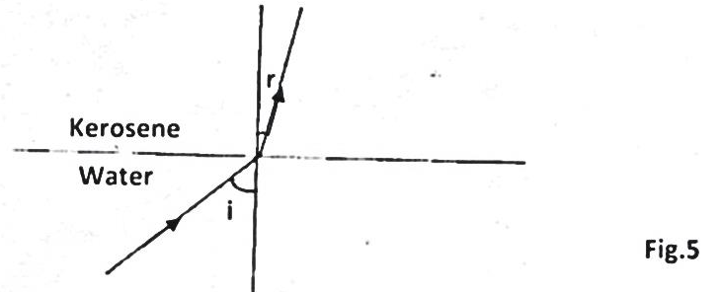
State which one of the two liquids has a higher absolute refractive index. (1 mark)
___________________________________________________________________________________
- The table in figure 6 below shows part of the electromagnetic spectrum in order of decreasing wavelength.
A | B | Infrared radiation | Visible light | C | D

- How are waves C produced? (1 mark)
______________________________________________________________________________________________________________________________________________________________________
- State one use of the wave D. (1 mark)
___________________________________________________________________________________
- Figure 7 below shows two solenoids, X and Y close to each other.
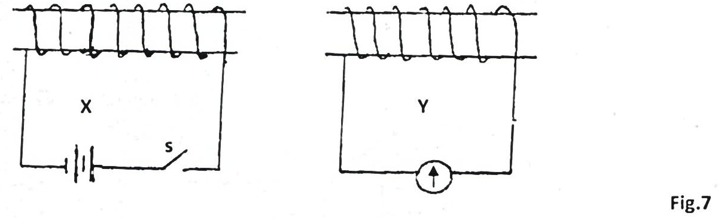
- Name the process by which current is caused in Y by closing the switch S. (1 mark)
___________________________________________________________________________________
- Show on the diagram above the direction of current in Y as switch S closes. Use an arrow. (1 mark)
- A house has a lighting circuit operated from a 240V mains supply. Four bulbs rated 40W 240V and six bulbs rated 100W 240V are switched on for 5 hours a day. Determine the monthly bill for the consumer given that the cost of electricity is at shs.5.50 per unit.
(Take 1 month = 30 days and the standing charge is sh.150) (3 marks)

- State two properties of X-rays similar to those of visible light. (2 marks)
______________________________________________________________________________________________________________________________________________________________________
- Explain why the tube of a cathode ray oscilloscope is made of thick glass walls. (2 marks)
_________________________________________________________________________________________________________________________________________________________________________________________________________________________________________________________
- a) Define the term work function. (1 mark)
______________________________________________________________________________________________________________________________________________________________________
b) Explain how the intensity of radiation affects the photo-electric effect. (1 mark)
______________________________________________________________________________________________________________________________________________________________________
- Figure 8 below shows an eye defect.
Fig 8
Use a ray diagram to show how the defect above could be corrected. (2 marks)

SECTION B (55 MARKS)
Answer ALL the questions
- a) The figure 9 below shows two wave fronts of TV and radio waves transmitted above mountain.
Fig 9
i) Draw the wave fronts to show their behavioral as they pass over the mountain. (2 marks)

ii) Identify waves A and B. (2 marks)
______________________________________________________________________________________________________________________________________________________________________
iii) Explain why reception of TV is poor in hilly places than that of radio. (2 marks)
___________________________________________________________________________________
___________________________________________________________________________________
- The diagram below shows a monochromatic source of light passing through a single slit then through double narrow slots.
- What property of light is investigated in the set up above? (1 mark)
___________________________________________________________________________________
- State the observation made on the screen. (2 marks)
___________________________________________________________________________________
___________________________________________________________________________________
- What would be observed on the screen if:
- The screen is pushed far from doubly slit. (1 mark)
___________________________________________________________________________________
- Increasing the slit separation S1 and S2 comes closer. (1 mark)
___________________________________________________________________________________
c) In Young’s double slit experiment, mercury green light of wavelength 5.4$×{10}^{-7}$ M was used with a pair of parallel slits of separation of 0.60mm. The fringes were observed at a distance of 40.0 cm from the slits. Calculate the fringe separation. (3 marks)

- a) State faradays law of electromagnetic induction. (1 mark)
___________________________________________________________________________________
___________________________________________________________________________________
b) State three ways in which energy is lost in a transformer and how it can be minimized in each case. (3 marks)
___________________________________________________________________________________
___________________________________________________________________________________
___________________________________________________________________________________
c) The diagram shows a transformer with 960 turns in the primary coil and N turn in the secondary coil connected to a 240V supply. Given that the transformer is 100% efficient and it will operate a 6V, 24W bulb. 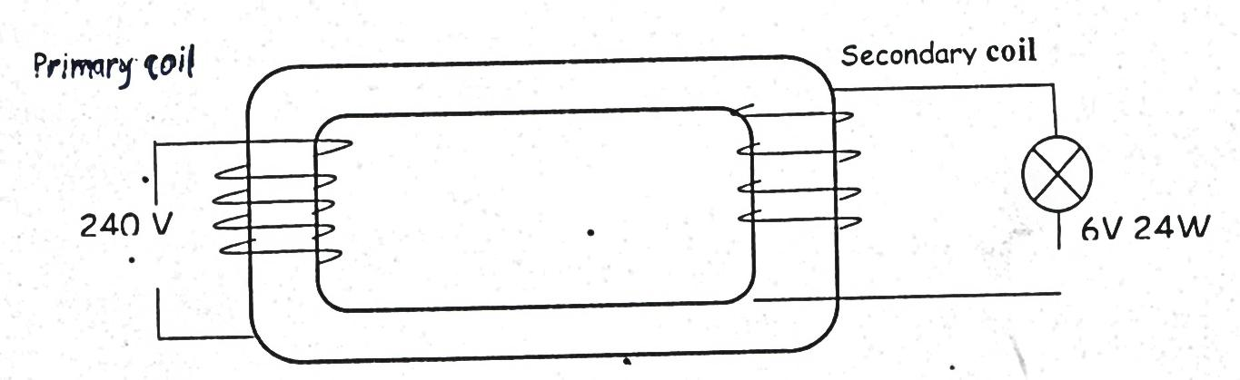Fig. 11
Primary coil
Find:
- The number of turns in the secondary coil. (3 marks)

- The current flowing in the primary coil. (3 marks)

- The Figure 12 below shows the main components of a cathode ray tube. Use it to answer the questions that follow.
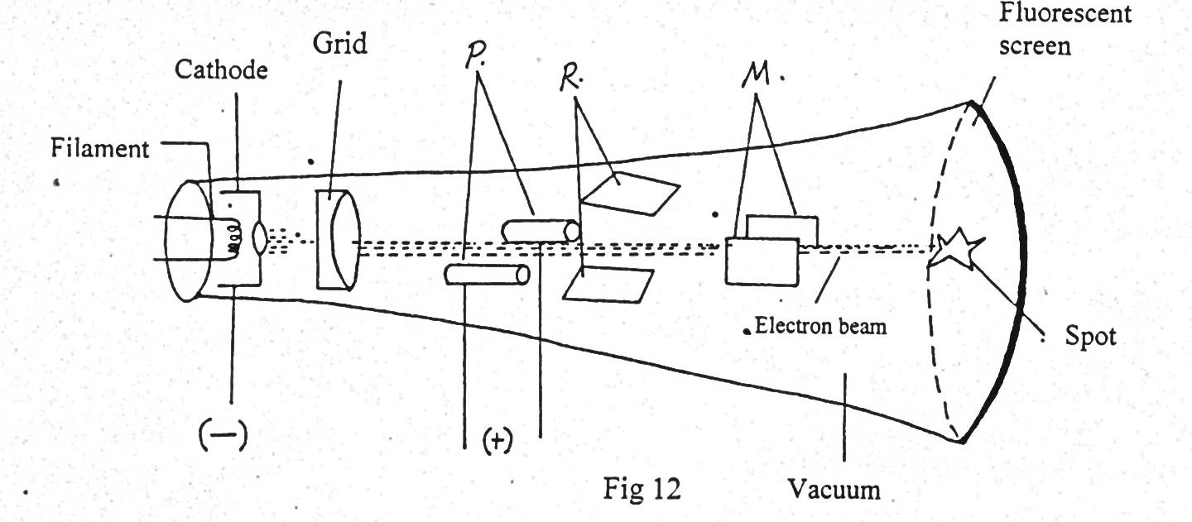
- Name the parts labelled P, R, and M. (3 marks)
___________________________________________________________________________________
___________________________________________________________________________________
___________________________________________________________________________________
- Explain how the electrons are produced in the tube. (2 marks)
___________________________________________________________________________________
___________________________________________________________________________________
- State and explain the function of the grid. (2 marks)
___________________________________________________________________________________
___________________________________________________________________________________
- State and explain what would be observed on the screen if an a.c voltage is connected across the
y-plate. (2 marks)
___________________________________________________________________________________
___________________________________________________________________________________
- State how the deflection system of a television differs from that of a C.R.O. (1 mark)
___________________________________________________________________________________
___________________________________________________________________________________
- a) Define Radioactivity. (1 mark)
___________________________________________________________________________________
___________________________________________________________________________________
b) An element R decays by giving off an alpha particle. Complete the equation below showing the values of a and b. (1 mark)
${}_{72}^{236}R = {}_{b}^{a}V +$ ${}_{2}^{4}{He}$
a = ____________________________________________________________________________
b = _____________________________________________________________________________
- Figure 13 below shows the features of a diffusion cloud chamber used for detecting radiations from radioactive sources.
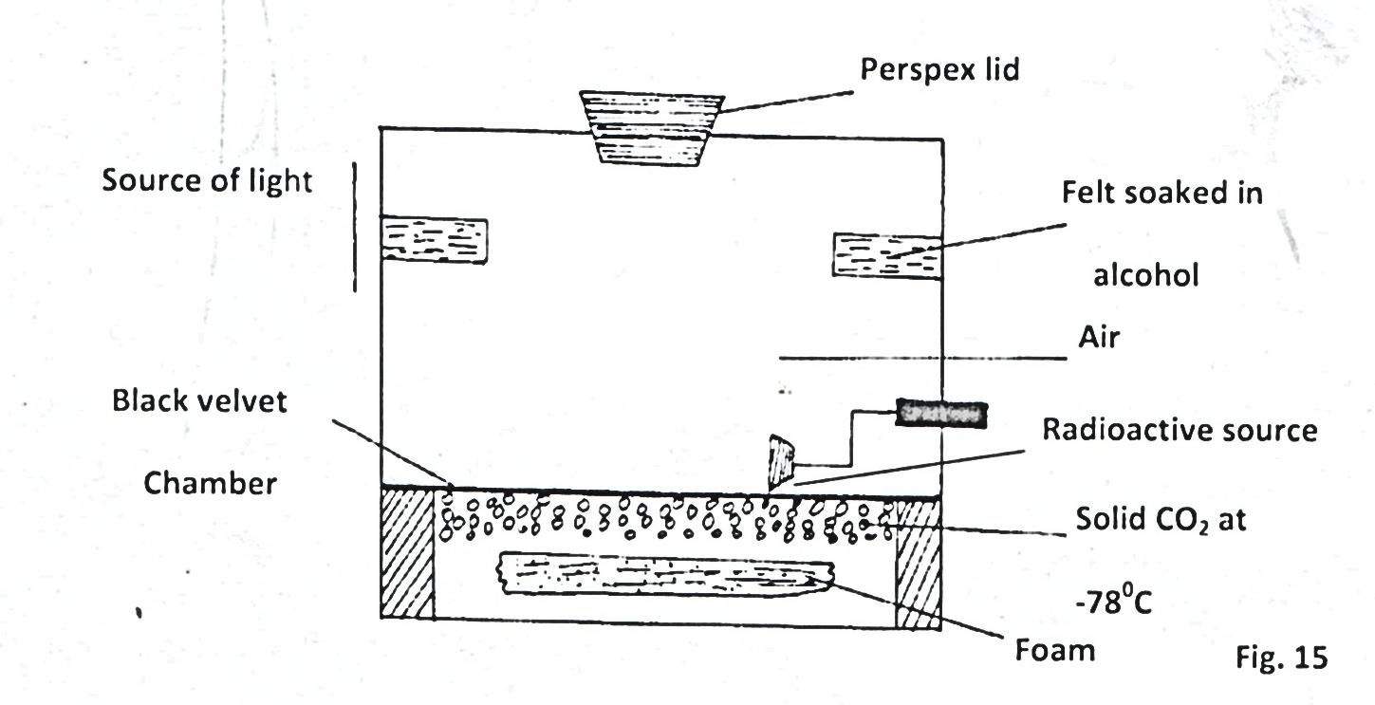
Fig 13
- State the property of alcohol that makes it suitable for use in the chamber. (1 mark)
___________________________________________________________________________________
___________________________________________________________________________________
- State the function of the perspex lid. (1 mark)
__________________________________________________________________________________ __________________________________________________________________________________
- Explain why the base velvet chamber is painted black. (2 marks)
__________________________________________________________________________________
__________________________________________________________________________________
- Explain how the radiation from the radioactive source is detected in the chamber. (4 marks)
__________________________________________________________________________________
__________________________________________________________________________________
__________________________________________________________________________________
__________________________________________________________________________________
- State one advantage of the cloud chamber over a charged leaf electroscope when used as detectors of
radiations. (1 mark)
__________________________________________________________________________________
__________________________________________________________________________________
- A student connected a circuit as shown in figure 14 below hoping to produce a rectified output.
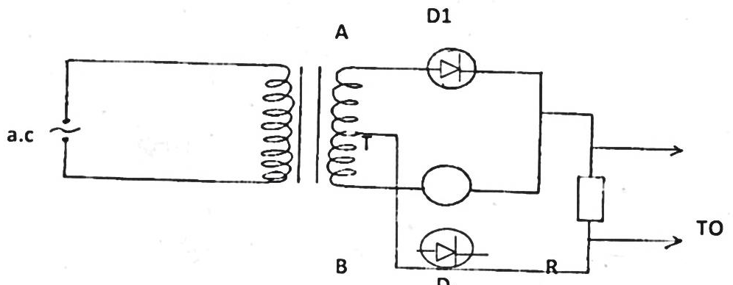
CRO
Fig 14
D
- Sketch the graph of the output on the CRO screen. (1 mark)

- Explain how the output above is produced. (2 marks)
___________________________________________________________________________________
___________________________________________________________________________________
___________________________________________________________________________________
___________________________________________________________________________________
- Name other two uses of a junction diode. (2 marks)
___________________________________________________________________________________
___________________________________________________________________________________
- Graph in figure 17 below shows a forward bias characteristic of a P-N junction.
Fig 15
The depletion layer decreases from O to A. Explain what is meant by depletion layer. (2 marks)
___________________________________________________________________________________
___________________________________________________________________________________
- i) Define the term doping. (1 mark)
___________________________________________________________________________________
___________________________________________________________________________________
ii) Explain how doping produces a P – type semi-conductor. (3 marks)
___________________________________________________________________________________
___________________________________________________________________________________
___________________________________________________________________________________
___________________________________________________________________________________

