NAME……………..………………………………………… INDEX NO……...........………………..………

SCHOOL…………………………………………………… CANDIDATE’S SIGNATURE………………

DATE………..………………….……………..

232/2
PHYSICS
(THEORY)
PAPER 2
JULY 2015
TIME: 2 HOURS

Kenya Certificate of Secondary Education
PHYSICS
PAPER 2
(THEORY)
TIME: 2 HOURS

INSTRUCTIONS TO CANDIDATES:
(a) Write your Name and Index Number in the spaces provided above.
(b) Sign and write the date of examination in the spaces provided above.
(c) This paper consists of two Sections; A and B.
(d) Answer ALL the questions in Sections A and B in the spaces provided.
(e) All workings must be clearly shown.
(f) Non-programmable silent electronic calculators and KNEC Mathematical tables and may be used.
(h) This paper consists of 12 printed pages. Candidates should check the question paper to ascertain that all pages are printed as indicated and that no questions are missing.

FOR EXAMINER’S USE ONLY:
Section | Question | Maximum  Score | Candidate’s  Score
A | 1 – 10 | 25
 | 11 | 12
 | 12 | 14
B | 13 | 9
 | 14 | 12
 | 15 | 8
Total Score |  | 80

SECTION A: (25 MARKS)

1. State the property of light suggested by the formation of shadows. (1 mark)

__________________________________________________________________________________

2. The figure below shows a sharp pin fixed on a cap of leaf electroscope. The electroscope is highly charged and then left for sometime.
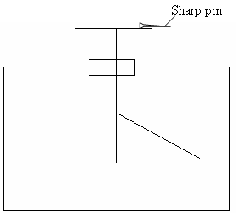

Explain why the leaf collapses. (2 marks)

__________________________________________________________________________________

__________________________________________________________________________________

__________________________________________________________________________________

__________________________________________________________________________________

3. The figure below shows an object O placed infront of a plane mirror.
Object O
•
(E)
eye

On the same diagram, draw rays to locate the position of the image I as seen from the eye E. (2 marks)

4. (a) State the basic law of magnetism. (1 mark)

____________________________________________________________________________

____________________________________________________________________________

____________________________________________________________________________

- The figure below shows how magnets are stored in pairs with keepers at the ends.
S
N
N
S
Bar magnets
Keeper
Keeper

Explain how this method of storing helps in retaining magnetism longer. (2 marks)

____________________________________________________________________________

____________________________________________________________________________

____________________________________________________________________________

____________________________________________________________________________

5. Why is a convex mirror better than plane mirror when used as a driving mirror? (1 mark)

__________________________________________________________________________________

__________________________________________________________________________________

__________________________________________________________________________________

6. The chart below shows an arrangement of different parts of the electromagnetic spectrum.

Radio | A | Infrared | Visible | B | X-Rays | Gamma Rays

(i) Name the radiation represented by B. (1 mark)

____________________________________________________________________________

(ii) Name a device that can be used to detect radiation A. (1 mark)

____________________________________________________________________________

7. (a) Distinguish between a transverse and a longitudinal wave. (1 mark)

____________________________________________________________________________

____________________________________________________________________________

____________________________________________________________________________

____________________________________________________________________________

(b) Determine the frequency of the wave shown below. (2 marks)
0.5
1.0
1.5
2.0
Time(s)
Displacement (m)

(c) State one reason why ultrasound is preferred to audible sound in echo-sounding. (1 mark)

____________________________________________________________________________

____________________________________________________________________________

____________________________________________________________________________
8. An electric heater rated 240V, 3000W is to be connected to a 240V mains supply, through a 10A fuse. Determine whether the fuse is suitable or not. (3 marks)

...…………………………………………………………………………………………………………………………………………………………………………………………………………………………………………………………………………………………………………………………………………………………………………………………………………………

9. (a) What are extrinsic semi-conductors. (2 marks)

____________________________________________________________________________

____________________________________________________________________________

____________________________________________________________________________

____________________________________________________________________________

(b) Explain what happens to the depletion layer when a diode is forward biased. (2 marks)

____________________________________________________________________________

____________________________________________________________________________

____________________________________________________________________________

____________________________________________________________________________
10. (a) State the purpose of cooling fins in the X-ray tube. (1 mark)

____________________________________________________________________________

____________________________________________________________________________

____________________________________________________________________________

(b) State two differences between X-rays and gamma rays. (2 marks)

____________________________________________________________________________

____________________________________________________________________________

____________________________________________________________________________

____________________________________________________________________________

SECTION B: (55 MARKS)

11. (a) State two ways in which one can increase the strength of an electromagnet. (2 marks)

____________________________________________________________________________

____________________________________________________________________________

____________________________________________________________________________

____________________________________________________________________________

(b) The following figure shows a conductor placed in a magnetic field. Indicate on the diagram the direction of motion of part AB of the conductor. (1 mark)
Magnetic field
A
B

- A cell drives a current of 5A through a 1.6Ω resistor. When connected to a 2.8Ω resistor,
the current that flows in 3.2A. Find E and r for the cell. (4 marks)

...…………………………………………………………………………………………………………………………………………………………………………………………………………………………………………………………………………………………………………………………………………………………………………………………………………………

- Calculate the length of a nichrome resistance wire of cross-sectional area 7 ×10ˉ⁸m²
required to make a resistor of 10 ohms. (Take resistivity of nichrome = 1.10 × 10ˉ⁶Ωm).
(3 marks)

...…………………………………………………………………………………………………………………………………………………………………………………………………………………………………………………………………………………………………………………………………………………………………………………………………………………

(e) In figure below, calculate the p.d across resistor R. (2 marks)
2A
3A
10Ω
R

2. (a) The half life of cobalt 60 is 5 years. How long will a sample take for the activity
to decrease to $1\text{16}$of its value. (2 marks)

...…………………………………………………………………………………………………………………………………………………………………………………………………………………………………………………………………………………………………………………………………………………………………………………………………………………

- The graph below shows radioactive decay of iodine.

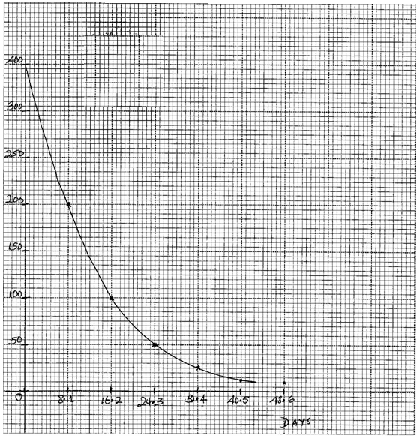
AMOUNT

Use the graph to determine the half-life of iodine. (2 marks)
……………………………………………………………………………………………………….

(c) The figure below shows a G.M tube.

Amplifier
400V
D.C

(i) Give the reason why the mica window is made thin. (1 mark)

______________________________________________________________________

______________________________________________________________________

______________________________________________________________________

- Explain how the radiation entering the tube through the tube is detected by the tube.
(3 marks)

______________________________________________________________________

______________________________________________________________________

______________________________________________________________________

______________________________________________________________________

(iii) What is the purpose of the halogen vapour. (1 mark)

______________________________________________________________________

______________________________________________________________________

______________________________________________________________________

II The figure below shows a simple cathode ray tube.
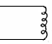
Electron
gun
Y
X
Y
X
Fluorescent screen
gun

(i) Explain how the electrons are produced in the tube. (2 marks)

______________________________________________________________________

______________________________________________________________________

______________________________________________________________________

______________________________________________________________________

(ii) State one function of the anode. (1 mark)

______________________________________________________________________

______________________________________________________________________

(iii) At what part of the cathode ray tube would the time base be connected. (1 mark)

______________________________________________________________________

______________________________________________________________________

______________________________________________________________________

(iv) Why is a vacuum created in the tube? (1 mark)

______________________________________________________________________

______________________________________________________________________

______________________________________________________________________

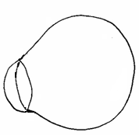
13. (a) The figures below shows diagrams of the human eye.

(a)

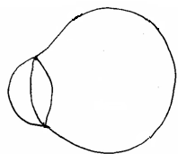

(b)

(i) Sketch in figure (a) a ray diagram to show long sightedness. (1 mark)

- Sketch in figure (b) a ray diagram to show how a lens can be used to correct the
long sightedness. (2 marks)

- Draw a ray diagram to show how a convex lens can be used as a magnifying glass. (2 marks)

(c) The diagram below shows a ray of light travelling between water-glass interface.
Water

Medium
28º

Calculate the value of $\overset{o}{ι}$given that $a^{n}g = 1\text{.}\text{52} \text{and} a^{n}w = \frac{4}{3}$. (3 marks)

...…………………………………………………………………………………………………………………………………………………………………………………………………………………………………………………………………………………………………………………………………………………………………………………………………………………

(d) State one conditions for total internal reflection to occur. (1 mark)

___________________________________________________________________________

___________________________________________________________________________

___________________________________________________________________________

14. (a) A transformer with 2000 turns in the primary circuit and 150 turns in the secondary circuit
has its primary circuit connected to a 800Va.c. source. It is found that when a heater is
connected to the secondary circuit it produces heat at the rate of 1000W. Assuming 100%
efficiency, determine the:
(i) Voltage in the secondary circuit. (2 marks)

(ii) Current in the primary circuit. (2 marks)

(iii) Current in the secondary circuit. (1 mark)

(iv) State the type of transformer represented above. (1 mark)

______________________________________________________________________

(b) (i) State the reason why long distance power transmission is done at a very high
voltage and using thick cables. (1 mark)

______________________________________________________________________

______________________________________________________________________

______________________________________________________________________

- Calculate the cost of using the following appliances in one month (30 days) of the company rate is Ksh.9.50 per unit.
I A 2000W water heater for 2 hours per day.
II A 75W bulb for 10 hours per day.
III An 1500W electric iron for 1 hour per day. (3 marks)

………………………………………………………………………………………………………………………………………………………………………………………………………………………………………………………………………………………………………………………………………………………………………………………………………………………………………………………………………………………………………………………………………………………………………………

15. (a) Define the term work function. (1 mark)

____________________________________________________________________________

____________________________________________________________________________

____________________________________________________________________________
(b) The minimum frequency of light that can cause photoelectric emission to occur from a
surface of metal is 6.94 × 10¹⁴H_{Z}. If the speed of the emitted electrons is 8.0 × 10⁵msˉ¹. Calculate:- ( h = 6.63 × 10⁻³⁴Js. m_{e} = 9.11 × 10⁻³¹kg).
(i) the work function of the metal. (2 marks)
………………………………………………………………………………………………………………………………………………………………………………………………………………………………………………………………………………………………………………
(ii) the maximum kinetic energy of the photoelectron. (2mks)

……………………………………………………………………………………………………………………………………………………………………………………………………………………………………………………………………………………………………………………………………………………………………………………………………………………
(iii) the frequency of the source. (3 marks)

……………………………………………………………………………………………………………………………………………………………………………………………………………………………………………………………………………………………………………………………………………………………………………………………………………………

