NAME: …………………………………………………….……INDEX NO. ……..……………
SCHOOL: ………………………………………………… DATE:…………………………
CANDIDATE’S SIGN. ………………………………

232/3
PHYSICS
PAPER 3
JULY MOCKS - 2015
TIME: 2 ½ HOURS
Kenya Certificate of Secondary Education (K.C.S.E.)

PHYSICS
PAPER 3

INSTRUCTIONS TO CANDIDATES:
- Write your name and index number in the spaces provided above.
- Sign and write the date of the examination in the spaces provided above.
- You are supposed to spend the first 15 minutes of the 2 ½ hours allowed for this paper reading the whole paper carefully.
- Marks are given for a clear record of the observations actually made, their suitability, accuracy and the use made of them.
For Examiner’s Use only:

QUESTIONS | MAXIMUM SCORE | CANDIDATE SCORE
1-4

This paper consists of 6 printed pages. Candidates should check to ascertain that all pages are printed as indicated and that no questions are missing.

- You are provided with the following apparatus:-
- A metre rule.
- One stop watch. one stand, clamp and boss.
- One spring.
- Two pieces of wood.
- A beam balance or electronic balance (to be shared)
- One mass labeled M.

Proceed as follows:
        - Hang the spring vertically by clamping one end as shown in figure 1. (The small pieces of wood to clamp the spring).
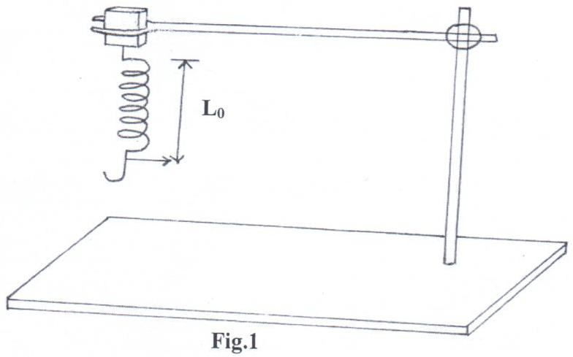
        - Measure the length, Lo, of the unloaded spring, and record below.
Lo ___________________________mm (½ mk)

        - Hang the mass M given from the lower end of the spring. Measure the length, L₁ of the loaded spring.
L₁ = _________________________ mm (½ mk)

        - Find the value of L₁ – Lo in centimeters
L = L₁ – Lo _____________________ cm (1mk)

        - Using the balance given, find the mass of the object M.
Mass of M = __________________ g (1mk)

        - Hang the mass M from the lower end of the spring. Displace it by a small vertical distance and release so that the spring makes vertical oscillations.

Measure and record, time for the number of oscillations given in the table below.
Oscillations, N | 5 | 7 | 10 | 13 | 15 | 18 | 20
Time in seconds, t (s)
(N + 10t) (s)
10
(N + 10t)² (s²)
19
Complete the table above. (7mks)
        - On the grid provided, plot a graph of N + 10t ² (y-axis) against N. (5mks)
10
        - (i) Determine the slope S, of the graph at N = 16. (3mks)
…………………………………………………………………………………………………………………………………………………………………………………………………………………………………………………………………………………………………………………………………………………………………………………………………………………………………………………………………………………………….
(ii) Find the constant k, given that:
K = MS (2mks)
13L
……………………………………………………………………………………………………………………………………………………………………………………………………………………………………………………………………………………………..

2. You are provided with the following apparatus

- A boiling tube with a strip of graph paper graduated in centimeters.
- Two 250ml measuring cylinders labelled A and B
- Sand
- Water approximately 250ml
- Liquid L
- A spatula
- Tissue paper

Proceed as follows
(a) Half fill cylinder A with water and B with liquid L
(b) Insert the boiling tube into a cylinder A.
(c) Put some sand carefully till the tube floats to a depth of 7cm as shown below. Record this depth as d₁

(d) Remove the tube from cylinder A wipe it and then float it in cylinder B. Record the depth to which it floats as d₂
(e) Wipe the tube and repeat the above process adding more sand to float the tube upright such that d₁ takes other values shown in the table below.
Depth in cylinder A d₁ (cm) | 7.0 | 7.5 | 8.0 | 8.5 | 9.0 | 9.5 | 10.
Depth in cylinder B d₂ (cm)
(6mks)
(f) Plot a graph of d₁ (y axis) against d₂ (5mks)
(g) Determine the slope S of the graph (2mks)
………………………………………………………………………………………………………………………………………………………………………………………………………………………………………………………………………………………………………………………
(h) What does S represent? (1mk)
………………………………………………………………………………………………………
(i) Given that the graph obeys, d₁ = $\frac{d2}{r}$ + R_{L}
a) Determine R_{L}, (1mk)
……………………………………………………………………………………………………………………………………………………………………………………………………………...
(j) Determine the constant r (2mks)
………………………………………………………………………………………………………………………………………………………………………………………………………………
3. You are provided with the following apparatus:

- A voltmeter (0 – 3 or 0 – 5V)
- An ammeter (0 – 1A)
- 10Ω resistor (fixed).
- A switch.
- One dry cell and a cell holder.
- Six connecting wires.

(a) (i) Using the apparatus provided, draw a set-up that can be used to determine the internal resistance of the cell (2mks).

- With the switch is open record E the voltmeter reading.
E ……………………………………………………………………(1 mark)
- Close the switch and record V, the voltmeter reading and I, the ammeter reading.
V…………………………………………………………………….(1 mark)

I……………………………………………………………………..(1 mark)
- Given that: E – V = Ir. Find r for the dry cell (2 marks)

