Name: …………………………………………………………….…Index No: ……………………..……………….……
School ………………………………………………............. …………………Candidate’s Signature:…………………
Date…………….………………………………..
443/1
AGRICULTURE
PAPER 1

TIME: 2 HOURS

Kenya Certificate of Secondary Education (K.C.S.E)
443/1
AGRICULTURE
PAPER 1
TIME: 2 HOURS

INSTRUCTIONS TO CANDIDATES:
- Write your name and index number in the spaces provided.
- Sign and write the date of examination in the spaces provided
- This paper consists of three section A,B and C
- Answer all the questions in sections A and B
- Answer any two questions in section C
- All the questions should answered in the spaces provided
- This paper consists of 10 printed pages.
- Candidates should check to ascertain that all pages are printed as indicated and that no questions are missing.

FOR EXAMINER’S USE ONLY
Section | Questions | Max score | Candidates score
A | 1-17 | 30
B | 18-21 | 20
C | 22 | 20
 | 23 | 20
 | 24 | 20
 | Total | 90

SECTION A 30MARKS
- Give three reasons why shifting cultivation is being discouraged. (1 ½ marks)
…………………………………………………………………………………………………………………………………………………………….…………………………………………………………………………………………………………………………………………………………...…………………
- State three ways in which agriculture supports agro-based industries (1 ½ marks)
…………………………………………………………………………………………………………………………………………………………….…………………………………………………………………………………………………………………………………………………………...………………….
- Give two symptoms common on crops deficient in nitrogen and potassium (1mark)
…………………………………………………………………………………………………………………………………………………………….………………………………………………………………..
- Give two sources of phosphorous in the soil. (1mark)
…………………………………………………………………………………………………………………………………………………………….………………………………………………………………...
- State two functions of iron in plants. (1mark)
…………………………………………………………………………………………………………………………………………………………….……………………………………………………………….
- Distinguish between Fertilizer grade and Fertilizer ratio. (2marks)
………………………………………………………………………………………………………………………………………………………………………………………………………………………………………………………………………………………………………………………............................................................................................................................................................................................................
- List six factors that determine the effectiveness of a herbicide (3marks)
………………………………………………………………………………………………………………………………………………………………………………………………………………………………………………………………………………………………………………………....................................................................................................................................................................................................................................................................................................................................................................................
………………………………………………………………………………………………………………
- State three disadvantages of tillage as a method of weed control in a maize field (1 ½ marks)
…………………………………………………………………………………………………………………………………………………………….…………………………………………………………………………………………………………………………………………………………...…………………
- Name the underground structures that make each of the following weeds difficult to control: (1mark)
(a)Nut grass (Cyperus rotundus)
……………………………………………………………………………………………………………
b) Couch grass (Digitaria scalarum)
………………………………………………………………………………………………………
- Give one mechanical method of controlling water hyacinth (1mark)
………………………………………………………………………………………………………………
- Give two advantages of drip irrigation over surface irrigation. (1mark)
…………………………………………………………………………………………………………………………………………………………….……………………………………………………………….
- Other than conservation of soil and water, state two other benefits of agro- forestry (1mark)
…………………………………………………………………………………………………………………………………………………………….……………………………………………………………….
- Distinguish between land subdivision and land fragmentation (2marks)
…………………………………………………………………………………………………………………………………………………………….………………………………………………………………………………………………………………………………………………………………………………………………………….…………………………………………………………………………………..
- Name the settlement schemes in Kenya at independence that: (2marks)
- consisted of 100-acre plots surrounding houses formerly owned by White settlers
………………………………………………………………………………………………………….
- were curved out from National forest
……………….……………………………………………………………………………………….
- (a) Outline the steps of making baled hay from mature Rhode grass in the field. (2 ½ marks)
…………………………………………………………………………………………………………………………………………………………….…………………………………………………………………………………………………………………………………………………………...…………………………………………………………………………………………………………………………………
(b) Give four factors that may affect the quality of the hay in (a) above (2marks)
…………………………………………………………………………………………………………………………………………………………….…………………………………………………………………………………………………………………………………………………………...…………………………………………………………………………………………………………………………………
- (a)What is meant by each of the following in agricultural economics? (2marks)
- Gross Domestic Product
………………………………………………………………………………………………………………………………………………………………………………………….…………………..
- Per capita income
………………………………………………………………………………………………………………………………………………………………………………..……………………………
(b) State four sources of agriculture credit to farmers (2marks)
…………………………………………………………………………………………………………………………………………………………….…………………………………………………………………………………………………………………………………………………………...…………………………………………………………………………………………………………………………………
17. Give two types of labour records (1mark)
……………………………………………………………………………………………………………………………………………………………………………………………………………………………..
SECTION B (20MARKS)
18. Below are illustrations of three stages of a life cycle of pest that attacks maize in the field. Study them and
answer the question that follows.
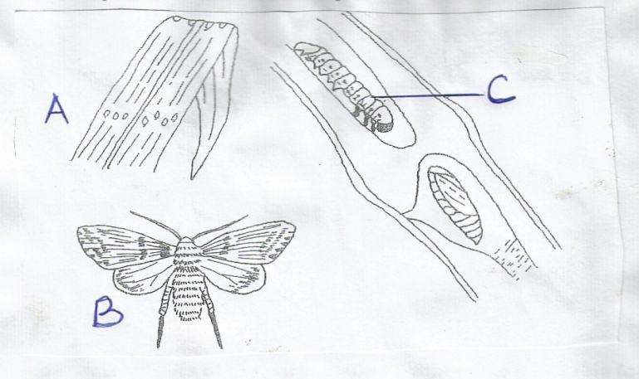

(a) Identify the pest
………………………………………………………………….....................................................(1mark)
- Name the stage of the pest labelled B
…………………………………………………………………………………..…………… (1mark)

(c ) Describe the damage done by the pest in stage C (1mark)
……………………………………………………………………………………………………………………………………………………………….…………………………………………………………………………………………………………………………………………………………...
(d) Give three control measures for the pest while the crop is in the field (3marks)
…………………………………………………………………………………………………………………………………………………………….…………………………………………………………………………………………………………………………………………………………...………………………………………………………………………………………………………………………………
19. Illustrated below is method of grafting in citrus trees. Study it and answer the questions that follows:
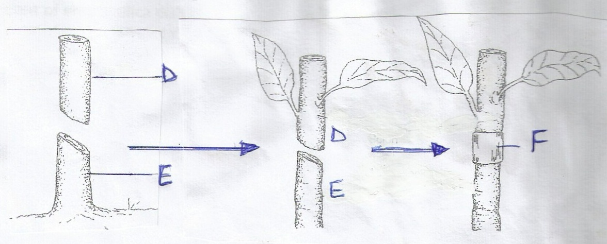

(a) Identify the method ……………………………………………………………………………………………………(1mark)
(b) What name is given to the part labelled
D…………………………………………………………………………… (1mark)
(c ) Give two characteristic of the part labelled E that makes it suitable for use in grafting. (2marks)
…………………………………………………………………………………………………………………………………………………………….………………………………………………………………..
(d) Name the appropriate materials for wrapping round the union at point F. (1mark)
………………………………………………………………………………………………………
20. (a)An experiment was done on a moist soil sample as outlined below:
Weight of empty silica dish =20grams
Weight of moist soil and the dish =50grams
Weight of the soil and the dish after being placed in oven (105⁰C) for several hours =40grams

Calculate the percentage of moisture in the soil sample (show your workings) (2marks)

(b)(i) The soil obtained in (a) above was ignited over a Bunsen burner for several hours to remove humus.
After heating and cooling in desicator severally, the constant weight of the dish and the residue was
found to be 35 grams.
Calculate the percentage of humus in the dry soil sample (show your workings) (2marks)

(ii)What is the role of humus in the soil? (1marks)
…………………………………………………………………………………………………………………………………………………………….……………………………………………………………….
21. The illustration below shows format a type of farm record kept in pig rearing .Study it and answer the questions that follow.
Sow No. | Sire no  Breed: | Date of service: | Date of farrowing Expected Actual | Remarks
- Identify the record …………………………………………………………………………… (1mark)

- Sow number 10 was served on 1st February, 2015. State the expected date of farrowing (1mark)
…………………………………………………………………………………………………………………………………………………………………………………………………………….……………….
- Give three reasons for keeping the above records. (3marks)
…………………………………………………………………………………………………………………………………………………………….…………………………………………………………………………………………………………………………………………………………………………………………………………………………………………………………………………………………….

SECTION C (40MARKS)
Answer only two question in this section in the spaces provided after question 24.
22. (a) Describe the field production of carrots for fresh vegetable market on a land that has been fallow under
the following subheadings:
(i) Varieties (2marks)
(ii) Land preparation (3marks)
(iii) Planting (4marks)
(iv) Field management practices and harvesting (6marks)
(b)Explain five post harvest practices in grains before processing (5marks)
23. (a)Describe the stages of chemical water treatment for human consumption (6marks)
(b) Describe four methods of draining marshy land for pasture production (4marks)
(c) State five physical methods of soil and water conservation carried out on arable land with 20% slope. Explain how each method works. (10marks)
24. (a) Explain five advantages of rotational grazing of livestock (5marks)
(b)Explain ten cultural practices that are carried out in the field to control crop diseases. (10 marks)
(c ) What are the advantages of propagating crops by use of seeds? (5marks)
…………………………………………………………………………………………………………………………………………………………….…………………………………………………………………………………………………………………………………………………………...…………………………………………………………………………………………………………………………………………………………….…………………………………………………………………………………………………………………………………………………………...…………………………………………………………………………………………………………………………………………………………….…………………………………………………………………………………………………………………………………………………………...…………………………………………………………………………………………………………………………………………………………….…………………………………………………………………………………………………………………………………………………………...………………………………………………………………………….
…………………………………………………………………………………………………………………………………………………...………………………………………………………………………….
…………………………………………………………………………………………………………………………………………………...………………………………………………………………………….
…………………………………………………………………………………………………………………………………………………...………………………………………………………………………….
…………………………………………………………………………………………………………………………………………………...………………………………………………………………………….
…………………………………………………………………………………………………………………………………………………...………………………………………………………………………….
…………………………………………………………………………………………………………………………………………………...………………………………………………………………………….
…………………………………………………………………………………………………………………………………………………...………………………………………………………………………….
…………………………………………………………………………………………………………………………………………………...………………………………………………………………………….
…………………………………………………………………………………………………………………………………………………...………………………………………………………………………….
…………………………………………………………………………………………………………………………………………………...………………………………………………………………………….
…………………………………………………………………………………………………………………………………………………...………………………………………………………………………….
…………………………………………………………………………………………………………………………………………………...………………………………………………………………………….
…………………………………………………………………………………………………………………………………………………...………………………………………………………………………….
…………………………………………………………………………………………………………………………………………………...………………………………………………………………………….
…………………………………………………………………………………………………………………………………………………...………………………………………………………………………….
…………………………………………………………………………………………………………………………………………………...………………………………………………………………………….
…………………………………………………………………………………………………………………………………………………...………………………………………………………………………….
…………………………………………………………………………………………………………………………………………………...………………………………………………………………………….
…………………………………………………………………………………………………………………………………………………...………………………………………………………………………….

