Name: ………………………………………………………………...…Index No: ……………………..……………….… School ……………………………………………….............………………Candidate’s Signature:……………………...
Date: ……………….……………….……
443/2
AGRICULTURE
PAPER 2

TIME: 2 HOURS

Certificate of Secondary Education (K.C.S.E)
INSTRUCTIONS TO CANDIDATES:
- Write your name and index number in the spaces provided.
- Sign and write the date of examination in the spaces provided
- This paper consists of three section A,B and C
- Answer all the questions in section A and B
- Answer any two questions in section C
- All the questions should answered in the spaces provided
- This paper consists of 9 printed pages.
- Candidates should check to ascertain that all pages are printed as indicated and that no questions are missing.

FOR EXAMINER’S USE ONLY
Section | Questions | Max score | Candidates score
A | 1-17 | 30
B | 18-21 | 20
C | 22 | 20
 | 23 | 20
 | 24 | 20
 | Total

- Mention any two examples of meat goats in Kenya (1mark)
…………………………………………………………………………………………………………………………………………………………….………………………………………………………………..
- Differentiate between
- Gestation period and incubation (1mark)
………………………………………………………………………………………………………………………………………………………………………………………..……………………………………………………………………………………………………………………………
- Kid and kindling (1mark)
…………………………………………………………………………………………………………………………………………………………….………………………………………………………………………………………………………………………………………………………
- State three factors that affect digestibility of a feeds in dairy animals (1 ½ marks)
…………………………………………………………………………………………………………………………………………………………….…………………………………………………………………………………………………………………………………………………………...…………………
- State three factors to consider when selecting eggs for sale (1 ½ marks)
…………………………………………………………………………………………………………………………………………………………….…………………………………………………………………………………………………………………………………………………………..…………………
- Give four factors that may cause infertility in dairy cows. (2marks)
…………………………………………………………………………………………………………………………………………………………….…………………………………………………………………………………………………………………………………………………………...…………………………………………………………………………………………………………………………………
- Differentiate between out crossing and cross breeding as used in livestock production. (2marks)
………………………………………………………………………………………………………………………………………………………………………………………………………………………………………………………………………………………………………………………...................................
- State three reasons for weighing livestock at weaning stage (1 ½marks)
…………………………………………………………………………………………………………………………………………………………….…………………………………………………………………………………………………………………………………………………………...…………………………………………………………………………………………………………………………………
- State four functions of vitamins (2marks)
…………………………………………………………………………………………………………………………………………………………….…………………………………………………………………………………………………………………………………………………………...…………………………………………………………………………………………………………………………………
- State two advantages of using wood as a construction material (2marks)
………………………………………………………………………………………………………………………………………………………………………………………………………………………………
- Mention four safety precautionary measures when using electric power in the farm (2marks)
…………………………………………………………………………………………………………………………………………………………….…………………………………………………………………………………………………………………………………………………………..…………………………………………………………………………………………………………………………………
- Give two functions of queen bee in a colony. (1mark)
………………………………………………………………………………………………………………………………………………………………………………………………………………………………
- Give two uses of footpath in a plunge dip (2marks)
………………………………………………………………………………………………………………………………………………………………………………………………………………………………
- Outline four signs of heat in sows. (2marks)
………………………………………………………………………………….…………………………………………………………………………………………………………………………………………………………...…………………………………………………………………………………………………………………………………………………………….……………………………………………
- State two disadvantages of using hurricane lamps and lanterns as providers of heat in a brooder (2marks)
…………………………………………………………………………………………………………………………………………………………….………………………………………………………………..
- Give four ways of stimulating milk let down in a dairy cow. (2marks)
…………………………………………………………………………………………………………………………………………………………….…………………………………………………………………………………………………………………………………………………………...…………………………………………………………………………………………………………………………………
- State two reasons for raddling in sheep management. (2marks)
…………………………………………………………………………………………………………………………………………………………….………………………………………………………………...
- State the uses of the following tools and equipments (1 ½ marks)
- Chipping harmer
- Tin snip
- Router

SECTION B (20MARKS)
Answer all the question in this section in the spaces provided
- (a) Identify each of the parasites of livestock shown below. (2marks)
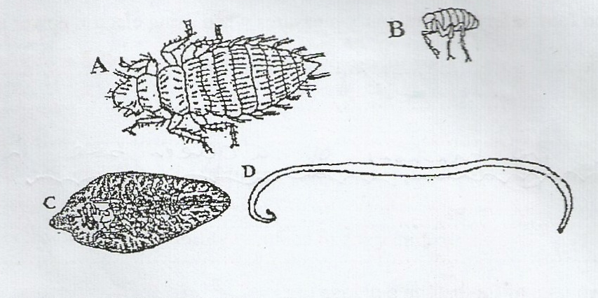

A……………………………………………………………………………………………………………
B……………………………………………………………………………………………………………
C……………………………………………………………………………………………………………
D……………………………………………………………………………………………………………
(b) What is the difference between parasites A and B and parasites C and D? (1mark)
…………………………………………………………………………………………………………………………………………………………………………………………………………………………………………………………………………………………………………...…………………………………………………………………………...…………………………………………………………………………...…………………………………………………………………………...…………………………
(c ) Suggest an effective control measure of the parasites labelled C (1mark)
…………………………………………………………………………………………………………………………………………………………….………………………………………………………………..
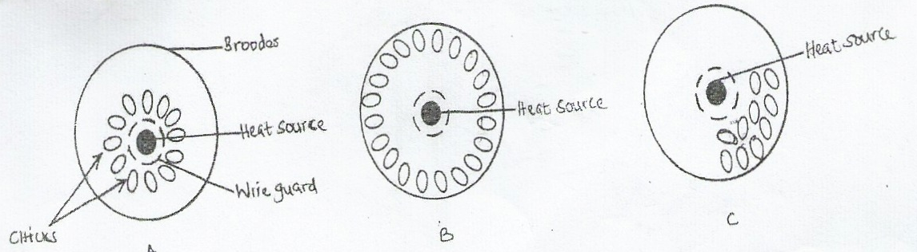
- Below are illustrations showing the behavior of chicks in various brooders. Study the diagrams and answer the questions that follow.

- State the environmental problem in each brooder as illustrated by the behavior of the chicks (3marks)
A………………………………………………………………………………………………………
B………………………………………………………………………………………………………
C………………………………………………………………………………………………………
- State two ways of overcoming the problem in B (2marks)
…………………………………………………………………………………………………………………………………………………………….…………………………………………………………………………………………………………………………………………………………...
- Below is a diagram of a farm implement
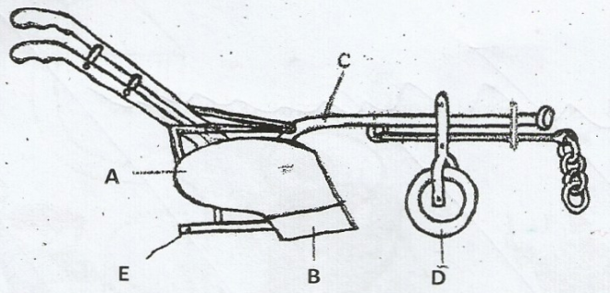

- Identify the implement

(½ mark)
(b) Label the parts marked A, B, C, D and E. (2 ½ marks)
A……………………………………………….…….……………………………………………………
B…………………………………………………….…………………………………………………….
C……………………………………………………….………………………………………………….
D……………………………………………………………..……………………………………………
E………………………………………………………………………………………………………….
(c ) state the functions of the parts labelled C and E (2marks)
……………………………………………………………………………………………………………………………………………………………….……………………………………………………………..…………………………………………………..…………………………………………………………..
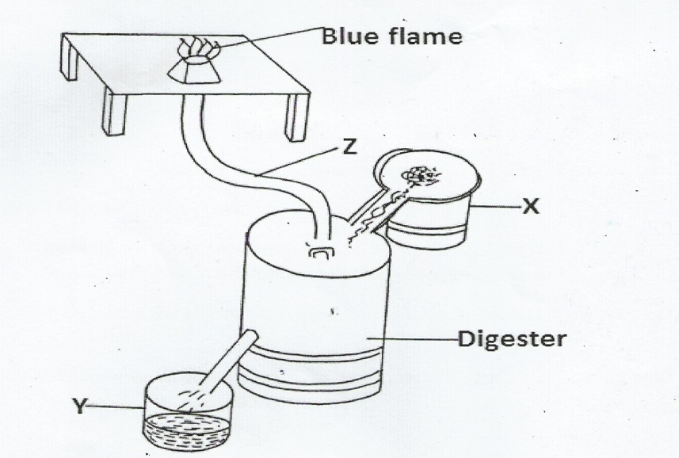
- The diagram below is a biogas digester

- Name the parts labelled X and Z (1mark)
…………………………………………………………………………………………………………………………………………………………….………………………………………………………
- Name two inputs periodically channeled through X (2marks)
…………………………………………………………………………………………………………………………………………………………….………………………………………………………
- Name the use to which material Y is put (1mark)
…………………………………………………………………………………………………………
- Name two uses of biogas on the farm. (1mark)
…………………………………………………………………………………………………………………………………………………………….………………………………………………………

SECTION C (40MARKS)
Answer any two questions from this section in the spaces provided.
- (a) Discuss the importance of keeping livestock healthy. (8marks)
(b) State the daily maintenance and servicing of a tractor (10marks)
(c) Explain two maintenance practices carried out in a fish pond (2marks)
- (a) Describe the structural requirement to be considered when constructing a calf pen (10marks)
(b) Describe mastitis disease in dairy cattle under the following sub headings
(i) Two causal organisms (2marks)
(ii) Predisposing factors (8marks)
- (a) Explain the factors to consider while sitting farm structure (10marks)
(b) Describe the process of training a calf to drink milk from a bucket (4marks)
(c) Explain three methods of acaricide application (6marks)

…………………………………………………………………………………………………………………………………………………………….…………………………………………………………………………………………………………………………………………………………...…………………………………………………………………………………………………………………………………………………………….…………………………………………………………………………………………………………………………………………………………...…………………………………………………………………………………………………………………………………………………………….…………………………………………………………………………………………………………………………………………………………...…………………………………………………………………………………………………………………………………………………………….…………………………………………………………………………………………………………………….
…………………………………………………………………………………………………………………………………………………………….…………………………………………………………………………………………………………………………………………………………...…………………………………………………………………………………………………………………………………………………………….…………………………………………………………………………………………………………………………………………………………...…………………………………………………………………………………………………………………………………………………………….…………………………………………………………………………………………………………………………………………………………...…………………………………………………………………………………………………………………………………………………………….…………………………………………………………………………………………………………………………………………………………...…………………………………………………………………………………………………………………………………………………………….…………………………………………………………………………………………………………………………………………
…………………………………………………………………………………………………………………………………………………………….…………………………………………………………………………………………………………………………………………………………...…………………………………………………………………………………………………………………………………………………………….…………………………………………………………………………………………………………………………………………………………...…………………………………………………………………………………………………………………………………………………………….…………………………………………………………………………………………………………………………………………………………...…………………………………………………………………………………………………………………………………………………………….…………………………………………………………………………………………………………………………………………………………...…………………………………………………………………………………………………………………………………………………………….…………………………………………………………………………………………………………………………………………………………...…………………………………………………………………………………………………………………………………………………………….…………………………………………………………………………………………………………………………………………………………...

…………………………………………………………………………………………………………………………………………………………….…………………………………………………………………………………………………………………………………………………………...…………………………………………………………………………………………………………………………………………………………….…………………………………………………………………………………………………………………………………………………………...…………………………………………………………………………………………………………………………………………………………….…………………………………………………………………………………………………………………………………………………………...…………………………………………………………………………………………………………………………………………………………….…………………………………………………………………………………………………………………………………………………………...…………………………………………………………………………………………………………………………………………………………….…………………………………………………………………………………………………………………………………………………………...…………………………………………………………………………………………………………………………………………………………….…………………………………………………………………………………………………………………………………………………………...
…………………………………………………………………………………………………………………………………………………………….…………………………………………………………………………………………………………………………………………………………...…………………………………………………………………………………………………………………………………………………………….…………………………………………………………………………………………………………………………………………………………...…………………………………………………………………………………………………………………………………………………………….
…………………………………………………………………………………………………………………………………………………………...…………………………………………………………………………………………………………………………………………………………….…………………………………………………………………………………………………………………………………………………………...…………………………………………………………………………………………………………………………………………………………….…………………………………………………………………………………………………………………………………………………………...…………………………………………………………………………………………………………………………………………………………….…………………………………………………………………………………………………………………………………………………………...…………………………………………………………………………………………………………………………………………………………….…………………………………………………………………………………………………………………………………………………………...…………………………………………………………………………………………………………………………………………………………….…………………………………………………………………………………………………………………………………………………………...…………………………………………………………………………………………………………………………………………………………….
…………………………………………………………………………………………………………………………………………………………...…………………………………………………………………………………………………………………………………………………………….…………………………………………………………………………………………………………………………………………………………...…………………………………………………………………………………………………………………………………………………………….…………………………………………………………………………………………………………………………………………………

