NAME ____________________________________ INDEX NO. _______________
SCHOOL ____________________________________ SIGNATURE _______________ DATE _______________
443/1
AGRICULTURE
PAPER 1

JULY/ AUGUST, 2015
TIME: 2 HOURS

443/1
AGRICULTURE
PAPER 1
TIME: 2 HOURS

INSTRUCTIONS TO CANDIDATES
- Write your name, school and index number in the spaces provided above.
- Sign and write the date of the examination in the spaces provided above.
- This paper consists of three sections: A, B and C.
- Answer all the questions in section A and B and any two questions from section C.
- All answers must be written in the spaces provided in this booklet.
- This paper consists of 12 printed pages.
- Candidates should check the question paper to ascertain that all pages are printed as indicated and that no questions are missing

For OFFICIAL use only
SECTION | QUESTIONS | MAXIMUM SCORE | CANDIDATE’S SCORE
A | 1 − 18 | 30
B | 19 − 22 | 20
C |  | 20
 |  | 20
 | TOTAL SCORE | 90

SECTION A (30 MARKS)
Answer ALL the questions in this section in the spaces provided.
- Give two factors which characterize small scale farming. (1 mark)
______________________________________________________________________________________________________________________________________________________________________
- State two effects of HIV/AIDS on agricultural production. (1 mark)
____________________________________________________________________________________________________________________________________________________________________________________________________________________________________________________________________________________________________________________________________________
- State four methods of treating water for domestic use. (2 marks)
____________________________________________________________________________________________________________________________________________________________________________________________________________________________________________________________________________________________________________________________________________
- Name the vegetative part of each of the following crops which is propagated. (2 marks)
i) Sweet potatoes _____________________________________________________________________
ii) Cassava _____________________________________________________________________
iii) Bananas _____________________________________________________________________
iv) Oranges _____________________________________________________________________
- State two ways by which soil pH may affect crop production. (1 mark)
____________________________________________________________________________________________________________________________________________________________________________________________________________________________________________________________________________________________________________________________________________
- State three causes of blossom end rot in tomatoes. (1½ marks)
_________________________________________________________________________________________________________________________________________________________________________________________________________________________________________________________
- Name two methods of weed control in pasture. (1 mark)
______________________________________________________________________________________________________________________________________________________________________
- State four problems that farmers are likely to face when marketing their produce. (2 marks)
____________________________________________________________________________________________________________________________________________________________________________________________________________________________________________________________________________________________________________________________________________
- State four effects of high temperature on crop production. (2 marks)
____________________________________________________________________________________________________________________________________________________________________________________________________________________________________________________________________________________________________________________________________________
- Name four suitable sites of agro forestry. (2 marks)
____________________________________________________________________________________________________________________________________________________________________________________________________________________________________________________________________________________________________________________________________________
- List four post harvesting practices. (2 marks)
____________________________________________________________________________________________________________________________________________________________________________________________________________________________________________________________________________________________________________________________________________
- State three functions of the Coffee Board of Kenya. (1½ marks)
__________________________________________________________________________________________________________________________________________________________________________________________________________________________________________________________________________________________________________________________________________________________________________________________________________________________________________________________________________________________________________________
- Give four factors determining the quality of hay. (2 marks)
____________________________________________________________________________________________________________________________________________________________________________________________________________________________________________________________________________________________________________________________________________
- List four methods of fertilizer application. (2 marks)
____________________________________________________________________________________________________________________________________________________________________________________________________________________________________________________________________________________________________________________________________________
- Give four objectives of land settlement and resettlement in Kenya. (2 marks)
____________________________________________________________________________________________________________________________________________________________________________________________________________________________________________________________________________________________________________________________________________
- List four methods used to drain farm land. (2 marks)
____________________________________________________________________________________________________________________________________________________________________________________________________________________________________________________________________________________________________________________________________________
- Give three benefits of conserving forage. (1½ marks)
____________________________________________________________________________________________________________________________________________________________________________________________________________________________________________________________________________________________________________________________________________
- State three problems facing agriculture based women groups in Kenya. (1½ marks)
__________________________________________________________________________________________________________________________________________________________________________________________________________________________________________________________________________________________________________________________________________________________________________________________________________________________________________________________________________________________________________________

SECTION B (20 MARKS)
Answer ALL questions from this section in the spaces provided
- a) Study the diagram below and answer the questions that follow.
i) What is layering? (1 mark)
______________________________________________________________________________________________________________________________________________________________________
ii) Identify the type of layering shown below. (1 mark)
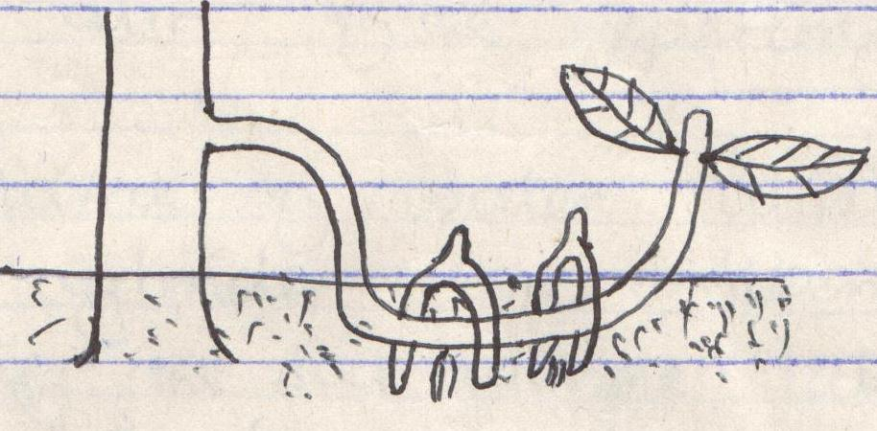
- Give two advantages of tissue culture in crop production. (2 marks)
____________________________________________________________________________________________________________________________________________________________________________________________________________________________________________________________________________________________________________________________________________

- a) Identify the type of erosion below. (1 mark)
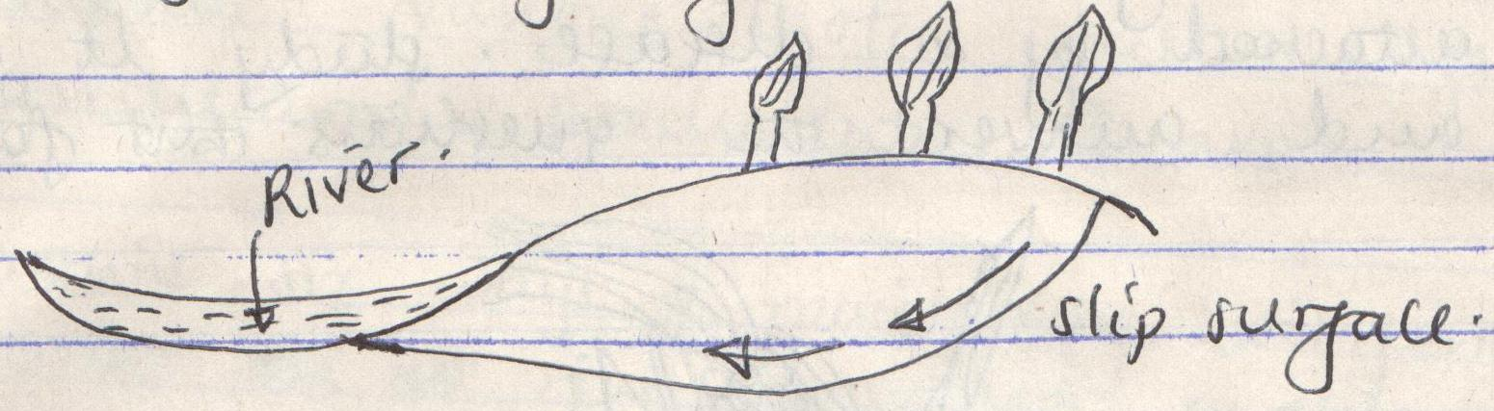
Slip surface
River

___________________________________________________________________________________
b) Name four agents of soil erosion. (4 marks)
____________________________________________________________________________________________________________________________________________________________________________________________________________________________________________________________________________________________________________________________________________

- The diagram below illustrates an experiment on soil. Study it carefully and answer the questions that follow.
- State the aim of the experiment. (1 mark)
______________________________________________________________________________________________________________________________________________________________________
- If the volume of water illustrated in the measuring cylinder was observed after one hour identify
the soil sample labelled A and B.
Soil sample A. (½ mark)
___________________________________________________________________________________
Soil sample B. (½ mark)
___________________________________________________________________________________
- State two ways in which the soil structure of the sample labelled C above can be improved. (2 marks)
_________________________________________________________________________________________________________________________________________________________________________________________________________________________________________________________

- The diagram below illustrates a maize cob attacked by a disease. Study it carefully and answer
the questions that follow.
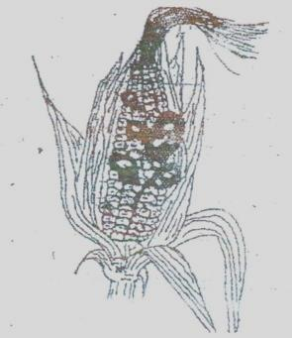
- Identify the disease. (1 mark)
___________________________________________________________________________________
- Apart from maize give four other crops that may be attacked by the disease. (2 marks)
____________________________________________________________________________________________________________________________________________________________________________________________________________________________________________________________________________________________________________________________________________
- State four methods of controlling the disease. (4 marks)
____________________________________________________________________________________________________________________________________________________________________________________________________________________________________________________________________________________________________________________________________________

SECTION C (40 MARKS)
Answer any TWO questions from this sections in the spaces provided.
- a) Explain six advantages of mulching in crop production. (6 marks)
b) Explain six factors that should be considered when siting a nursery bed. (6 marks)
c) Describe various biotic factors influencing agricultural production. (8 marks)

- a) Outline six ways of maintaining soil fertility. (6 marks)
b) Describe four advantages of tillage as a method of weed control. (4 marks)
c) Give four types of pesticide based on their mode of action. (4 marks)
d) Describe the steps followed in single stem pruning in coffee. (6 marks)

- a) Give the advantages of mixed grass pasture over a pure grass pasture. (6 marks)
b) Describe the establishment and management of grass pasture to the time it is ready for
grazing under the following sub-heading:
- Land preparation. (3 marks)
- Planting. (4 marks)
- Field management practices. (7 marks)

____________________________________________________________________________________________________________________________________________________________________________________________________________________________________________________________________________________________________________________________________________________________________________________________________________________________________________________________________________________________________________________________________________________________________________________________________________________________________________________________________________________________________________________________________________________________________________________________________________________________________________________________________________________________________________________________________________________________________________________________________________________________________________________________________________________________________________________________________________________________________________________________________________________________________________________________________________________________________________________________________________________________________________________________________________________________________________________________________________________________________________________________________________________________________________________________________________________________________________________________________________________________________________________________________________________________________________________________________________________________________________________________________________________________________________________________________________________________________________________________________________________________________________________________________________________________________________________________________________________________________________________________________________________________________________________________________________________________________________________________________________________________________________________________________________________________________________________________________________________________________________________________________________________________________________________________________________________________________________________________________________________________________________________________________________________________________________________________________________________________________________________________________________________________________________________________________________________________________________________________________________________________________________________________________________________________________________________________________________________________________________________________________________________________________________________________________________________________________________________________________________________________________________________________________________________________________________________________________________________________________________________________________________________________________________________________________________________________________________________________________________________________________________________________________________________________________________________________________________________________________________________________________________________________________________________________________________________________________________________________________________________________________________________________________________________________________________________________________________________________________________________________________________________________________________________________________________________________________________________________________________________________________________________________________________________________________________________________________________________________________________________________________________________________________________________________________________________________________________________________________________________________________________________________________________________________________________________________________________________________________________________________________________________________________________________________________________________________________________________________________________________________________________________________________________________________________________________________________________________________________________________________________________________________________________________________________________________________________________________________________________________________________________________________________________________________________________________________________________________________________________________________________________________________________________________________________________________________________________________________________________________________________________________________________________________________________________________________________________________________________________________________________________________________________________________________________________________________________________________________________________________________________________________________________________________________________________________________________________________________________________________________________________________________________________________________________________________________________________________________________________________________________________________________________________________________________________________________________________________________________________________________________________________________________________________________________________________________________________________________________________________________________________________________________________________________________________________________________________________________________________________________________________________________________________________________________________________________________________________________________________________________________________________________________________________________________________________________________________________________________________________________________________________________________________________________________________________________________________________________________________________________________________________________________________________________________________________________________________________________________________________________________________________________________________________________________________________________________________________________________________________________________________________________________________________________________________________________________________________________________________________________________________________________________________________________________________________________________________________________________________________________________________________________________________________________________________________________________________________________________________________________________________________________________________________________________________________________________________________________________________________________________________________________________________________________________________________________________________________________________________________________________________________________________________________________________________________________________________________________________________________________________________________________________________________________________________________________________________________________________________________________________________________________________________________________________________________________________________________________________________________________________________________________________________________________________________________________________________________________________________________________________________________________________________________________________________________________________________________________________________________________________________________________________________________________________________________________________________________________________________________________________________________________________________________________________________________________________________________________________________________________________________________________________________________________________________________________________________________________________________________________________________________________________________________________________________________________________________________________________________________________________________________________________________________________________________________________________________________________________________________________________________________________________________________________________________________________________________________________________________________________________________________________________________________________________________________________________________________________________________________________________________________________________________________________________________________________________________________________________________________________________________________________________________________________________________________________________________________________________________________________________________________________________________________________________________________________________________________________________________________________________________________________________________________________________________________________________________________________________________________________________________________________________________________________________________________________________________________________________________________________________________________________________________________________________________________________________________________________________________________________________________________________________________________________________________________________________________________________________________________________________________________________________________________________________________________________________________________________________________________________________________________________________________________________________________________________________________________________________________________________________________________________________________________________________________________________________________________________________________________________________________________________________________________________________________________________________________________________________________________________________________________________________________________________________________________________________________________________________________________________________________________________________________________________________________________________________________________________________________________________________________________________________________________________________________________________________________________________________________________________________________________________________________________________________________________________________________________________________________________________________________________________________________________________________________________________________________________________________________________________________________________________________________________________________________________________________________________________________________________________________________________________________________________________________________________________________________________________________________________________________________________________________________________________________________________________________________________________________________________________________________________________________________________________________________________________________________________________________________________________________________________________________________________________________________________________________________________________________________________________________________________________________________________________________________________________________________________________________________________________________________________________________________________________________________________________________________________________________________________________________________________________________________________________________________________________________________________________________________________________________________________________________________________________________________________________________________________________________________________________________________________________________________________________________________________________________________________________________________________________________________________________________________________________________________________________________________________________________________________________________________________________________________________________________________________________________________________________________________________________________________________________________________________________________________________________________________________________________________________________________________________________________________________________________________________________________________________________________________________________________________________________________________________________________________________________________________________________________________________________________________________________________________________________________________________________________________________________________________________________________________________________________________________________________________________________________________________________________________________________________________________________________________________________________________________________________________________________________________________________________________________________________________________________________________________________________________

