Name…………………………………… ………………….Serial No:…………………………………….
School ……………………………………………………… Candidate’s Signature …………..……………
231/2 Date: ………………………………………
PAPER 2
BIOLOGY
(THEORY)

TIME: 2 HOURS

Kenya Certificate of Secondary Education (K.C.S.E.)
(FORM FOUR)
231/2
Biology
Paper 2
2 Hours

INSTRUCTIONS TO CANDIDATES
- Write your name, Admission number and name of School in the spaces provided above
- Sign and write the date of examination in the spaces provided.
- This paper consists of sections A and B answer all questions in section A
- In section B answer question 6 compulsory and either question 7or 8 in spaces provided after question 8
- Answer all the questions in the spaces provided.
- This paper consists of 10printed pages.
- Candidates should check to ascertain that all pages are printed as indicated and that no questions are
missing.

For Examiners Use Only
Section | Question | Maximum score | Candidate’s score
A | 1  2  3  4  5 | 8  8  8  8  8
B | 6  7  8 | 20  20  20
Total Score |  | 80

SECTION A (40MARKS)
Answer all the question in this section in the spaces provided.
- (a) Suggest two reasons why cross pollination is considered advantageous over self pollination.
(2marks)
.………………………………………………………………………….…………………………………
…..……………………………………………………………………….…..……………………………
(b) State three mechanisms in plant that prevent self pollination. (3marks)
.……………………………………………………………………………………………………………
………………………………………………………………………………………….…………………
…...…………………………………………………………………………………………………………
(c) What are the functions of the following in a mammal?
(i) Sominiferous tubules. (1mark) …………………………………………………………………………………………………………..…
……………………………….……………………………………………………………………………
(ii) Oviduct (1mark)
.……………………………………………………………………………………………………………
………….……………………………………………………………………………………………………
(iii) Prostate glands (1mark)
….…………………………………………………………………………………………………………
………….………………………………………………………………………………………………….
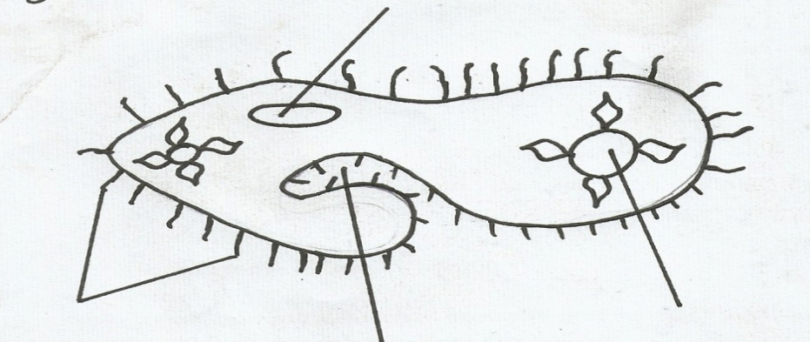
- (a) Study the organism shown below and answer the questions that follows
A
B
C
Nucleus

- State the kingdom to which the organism belongs and give reason for your answer. (2marks)
....………………………………………………………………………………………………………
….….…………………………………………………………………………………………………
- Name the structure labelled A. (1mark)
.………………………………………………………………………………………………………
………………………………………………………………………………………………………
- Give the function of the part labeled C. (1mark)
.………………………………………………………………………………………………………
………………………………………………………………………………………………………
(b) The diagram below shows the exchange site between circulatory system and body cells.
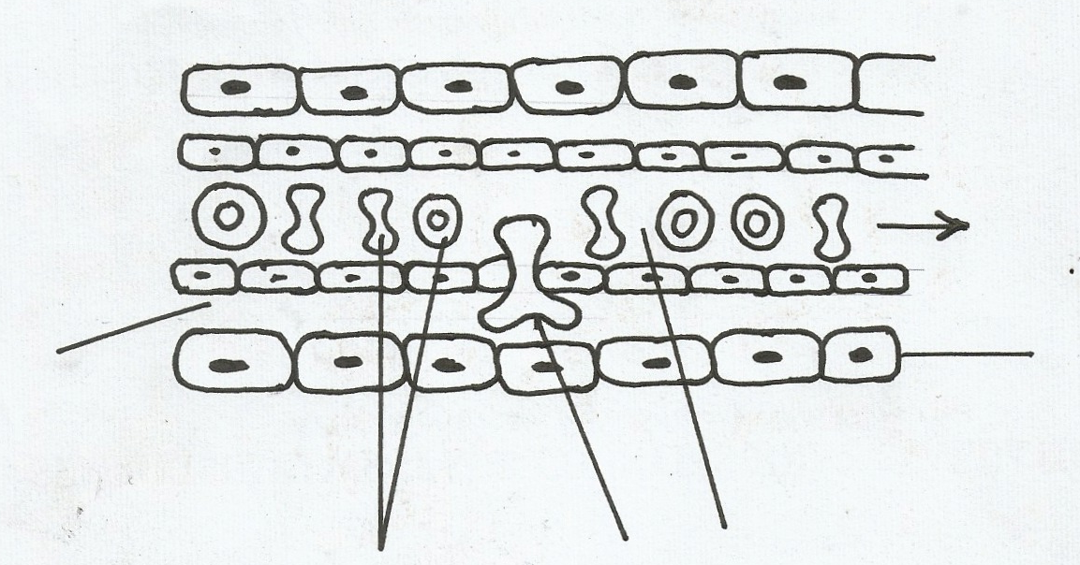
A
B
C
Tissue fluid
Flow of blood

Body cell

- Name the blood cell labelled B. (1mark)
.…………………………………………………………………………………………………………
……………………………………………………….…………………………………………………
- State the gas that diffuses from B to the tissue cell. (1mark)
.…………………………………………………………………………………………………………
………………………………………………………………………………………………………
- How is tissue fluid formed? (1mark)
.…………………………………………………………………………………………………………
………………………………………………………………………………………………………….
- Name the cell labeled C (1mark) .…………………………………………………………………………………………………………
- Hemophilia or bleeder’s disease is a condition in which blood takes a longer time than usual to clot. This is due to lack of a certain blood protein. The gene for hemophilia is recessive to the gene for normal clotting factor and is found on the X-chromosome.
(a) Explain why there are only female carriers for hemophilia and no male carriers for traits. (1mark)
.…………………………………………………………………………………………………………
………………………………………………………………………………………………………….
(b) A carrier female for hemophilia trait married a normal male. Work out the possible genotype of the children. Let letter H represent the normal gene, and let h represents the gene for hemophilia. (4marks)
.…………………………………………………………………………………………………………
…………………………………………………………………………………………………………..…………………………………………………………………………………………………………
………………………………………………………………………………………………………….
(c) Name one other disorder in humans that is determined by certain genes on the X-chromosome that lack a corresponding allele on the Y chromosome. (1mark)
.…………………………………………………………………………………………………………
(d) Explain how comparative embryology is an evidence for organic evolution. (2marks)
.…………………………………………………………………………………………………………
.…………………………………………………………………………………………………………
………………………………………………………………………………………………………….
- The diagram below shows the sequence of a hypothetical reaction catalyzed by enzymes.
M ^{q} N ^{s} P
- What would happen if enzyme q is inactivated? (2marks)
.…………………………………………………………………………………………………………
…………………………………………………………………………………………………………..
………………………………………………………………………………………………………….
- Given that the food product N is a peptide, state the identity of enzyme ‘S’ (1mark)
.…………………………………………………………………………………………………………
………………………………………………………………………………………………………….
- Explain what would happen in each of the following:
(i) Increasing concentration of enzymes q. (1mark)
.…………………………………………………………………………………………………………
………………………………………………………………………………………………………….
(ii) Inhibitor introduced that inhibits action of enzyme ‘S’. (1mark)
.…………………………………………………………………………………………………………
………………………………………………………………………………………………………….
- List three factors that affect the rate of enzyme action. (3marks)
.…………………………………………………………………………………………………………
………………………………………………………………………………………………………….
.…………………………………………………………………………………………………………

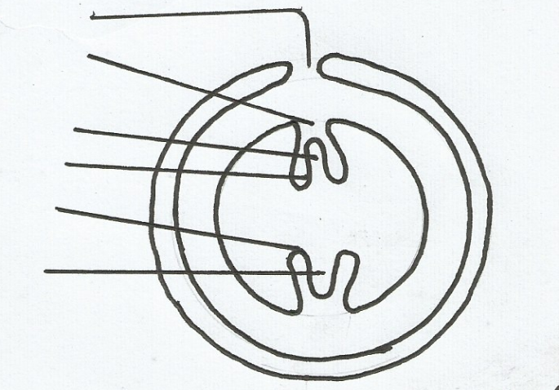
- The diagram below shows the internal structure of generalized seed .study it and answer the questions that follow;
N
V
U
P

M
T

- (i)Name the parts labelled on the diagram: N, P, U and V. (4marks)
.…………………………………………………………………………………………………………
…………………………………………………………………………………………………………..…………………………………………………………………………………………………………
………………………………………………………………………………………………………….
(ii) State the function of the parts labelled M and T. (2mark)
M…………………………………………………………………………………………………………………………………………………………………………………………………………… T-……………………………………………………………………………………………………
- State the type of germination exhibited by the Garden pea. (1mark)
.…………………………………………………………………………………………………………
- What is the difference between the germination type named in (b) above and that of abroad of a bean. (1mark)
.…………………………………………………………………………………………………………
………………………………………………………………………………………………………….

SECTION B (40MARKS)
Answer question 6 (compulsory) in the spaces provided and either question 7 or 8 on the spaces provided after question 8.
- Some students used a model to demonstrate the effect of sweating on human body temperature. Two boiling tube A and B were filled with hot water. The temperature of water in the tubes A was taken at the start of experiment and then at 5minutes interval. The surface of tube A was continuously wiped with a piece of cotton wool soaked in methylated spirit. The results obtained are shown in the table below.
Time | Temperature in ⁰C in tubes
Minutes | A | B
0 | 80 | 80
5 | 54 | 67
10 | 40 | 59
15 | 29 | 52
20 | 21 | 47
25 | 18 | 46

- On the same axes, plot graphs of temperature of water in the tubes against time. (Graph paper provided) (7marks)

- At what rate was the water-cooling in tube A? (1mark)
.…………………………………………………………………………………………………………
………………………………………………………………………………………………………….
- Why was tube B included in the set up? (1mark)
.…………………………………………………………………………………………………………
………………………………………………………………………………………………………….
- Account for the rate of cooling in tube A (3marks)
.…………………………………………………………………………………………………………
…………………………………………………………………………………………………………..…………………………………………………………………………………………………………
- State two processes of heat loss in tube B. (2marks)
.…………………………………………………………………………………………………………
………………………………………………………………………………………………………….
- What would be the expected results if tube A was insulated? (1mark)
.…………………………………………………………………………………………………………
………………………………………………………………………………………………………….
- What would the insulation be comparable to in:
(i) Birds ………………………………………………………………………………………………………………………………………………………………………………………………..…………………… (1mark)
(ii) Mammals
………………………………………………………………………………………………………………………………………………………………………………………………………..…………… (1mark)
- Name the structures in the human body that detect:
- External temperature changes
……………………………………………………………………………………………………. (1mark)
- Internal temperature changes
……………………………………………………………………………………………………. (1mark)
7. (a) Distinguish between tissue respiration and breathing. (4marks)
(b) Describe how carbon (IV) oxide produced by respiratory liver cells reaches the alveoli cavities in the mammalian lungs. (16marks)
8. (a) Describe the roles of Auxins and Ethylene in plant growth and Development. (10marks)
(b)How are xerophytes adapted to their habitat? (10marks)
.…………………………………………………………………………………………………………
………………………………………………………………………………………………………….
.…………………………………………………………………………………………………………
.…………………………………………………………………………………………………………
………………………………………………………………………………………………………….
.…………………………………………………………………………………………………………
………………………………………………………………………………………………………….
.…………………………………………………………………………………………………………
………………………………………………………………………………………………………….
.…………………………………………………………………………………………………………
………………………………………………………………………………………………………….
.…………………………………………………………………………………………………………
………………………………………………………………………………………………………….
.…………………………………………………………………………………………………………
………………………………………………………………………………………………………….
.…………………………………………………………………………………………………………
………………………………………………………………………………………………………….
.…………………………………………………………………………………………………………
………………………………………………………………………………………………………….
.…………………………………………………………………………………………………………
………………………………………………………………………………………………………….
.…………………………………………………………………………………………………………
………………………………………………………………………………………………………….
.…………………………………………………………………………………………………………
………………………………………………………………………………………………………
.…………………………………………………………………………………………………………
………………………………………………………………………………………………………….
.…………………………………………………………………………………………………………
………………………………………………………………………………………………………….
.…………………………………………………………………………………………………………
………………………………………………………………………………………………………….
.…………………………………………………………………………………………………………
………………………………………………………………………………………………………….
.…………………………………………………………………………………………………………
………………………………………………………………………………………………………….
.…………………………………………………………………………………………………………
………………………………………………………………………………………………………….
.…………………………………………………………………………………………………………
………………………………………………………………………………………………………….
.…………………………………………………………………………………………………………
………………………………………………………………………………………………………….
.…………………………………………………………………………………………………………
………………………………………………………………………………………………………….
.…………………………………………………………………………………………………………
………………………………………………………………………………………………………….
.…………………………………………………………………………………………………………
………………………………………………………………………………………………………….
.…………………………………………………………………………………………………………
………………………………………………………………………………………………………….
.…………………………………………………………………………………………………………
………………………………………………………………………………………………………….
.…………………………………………………………………………………………………………
………………………………………………………………………………………………………….
.…………………………………………………………………………………………………………
………………………………………………………………………………………………………….
.…………………………………………………………………………………………………………
………………………………………………………………………………………………………….
.…………………………………………………………………………………………………………
………………………………………………………………………………………………………….
.…………………………………………………………………………………………………………
………………………………………………………………………………………………………….
.…………………………………………………………………………………………………………
………………………………………………………………………………………………………….
.…………………………………………………………………………………………………………
………………………………………………………………………………………………………….
.…………………………………………………………………………………………………………
………………………………………………………………………………………………………….
.…………………………………………………………………………………………………………
………………………………………………………………………………………………………….
.…………………………………………………………………………………………………………
………………………………………………………………………………………………………….
.…………………………………………………………………………………………………………
………………………………………………………………………………………………………….
.…………………………………………………………………………………………………………
………………………………………………………………………………………………………….
.…………………………………………………………………………………………………………
………………………………………………………………………………………………………….
.…………………………………………………………………………………………………………
………………………………………………………………………………………………………….
.…………………………………………………………………………………………………………
………………………………………………………………………………………………………….
.…………………………………………………………………………………………………………
………………………………………………………………………………………………………….
.…………………………………………………………………………………………………………
………………………………………………………………………………………………………….
.…………………………………………………………………………………………………………
………………………………………………………………………………………………………….
.…………………………………………………………………………………………………………
…………………………………………………………………………………………………………..…………………………………………………………………………………………………………
………………………………………………………………………………………………………….
.…………………………………………………………………………………………………………
………………………………………………………………………………………………………….
.…………………………………………………………………………………………………………
………………………………………………………………………………………………………….
.…………………………………………………………………………………………………………

