NAME ____________________________________ INDEX NO. _______________

SCHOOL ____________________________________ SIGNATURE _______________

DATE _______________

**231/2**

**BIOLOGY**

**(THEORY)**

**PAPER 2**

JUNE/JULY, 2015

**TIME: 2 HOURS**

231/2

BIOLOGY

(THEORY)

PAPER 2

TIME: 2 HOURS

**INSTRUCTIONS TO CANDIDATES**

* Write your name, school and index number in the spaces provided above.
* Write the date of examination and sign in the spaces provided above.
* Answer **ALL** the questions in **section A** by filling in the spaces provided.
* In **section B**, answer **question 6 (compulsory question)** and any other **one question** from the remaining two questions. (i.e. 7 or 8)
* Candidates may be penalized for false information and even wrong spellings of technical terms.
* This paper consists of **10** printed pages.
* Candidates should check to ensure that all pages are printed as indicated and no questions are missing.

FOR OFFICIAL USE ONLY

|  |  |  |  |
| --- | --- | --- | --- |
|  | Questions | Maximum score | Candidate’s score |
| Section A | 1 | 8 |  |
| 2 | 8 |  |
| 3 | 8 |  |
| 4 | 8 |  |
| 5 | 8 |  |
| Section B | 6 | 20 |  |
| 7 | 20 |  |
| 8 | 20 |  |
|  | Total Score | 80 |  |

**SECTION A (40 MARKS)**

***Answer ALL the questions in this section in the spaces provided.***

1. The diagram below represents a circulatory system found in a certain class of chordates.



1. Identify the type of circulatory system shown above. (1 mark)

___________________________________________________________________________________

1. Name **one** class of animals having this type of circulatory system. (1 mark)

___________________________________________________________________________________

1. Identify parts labelled M, N and P. (3 marks)

M ________________________________________________________________________________

N ________________________________________________________________________________

P ________________________________________________________________________________

1. What disadvantages is faced by having the types of circulatory system shown above? (2 marks)

____________________________________________________________________________________________________________________________________________________________________________________________________________________________________________________________________________________________________________________________________________

1. Between blood vessels Q and T, which one carries oxygenated blood? (1 mark)

___________________________________________________________________________________

1. In cattle, a cross between a red bull and a white cow produces roan. (Offprings with patches of white and red). When the offspring are crossed red, roan and white offspring’s are produced in the ratio 1:2:1 respectively. Using R to represent red and W to represent white:
2. Give the genotypes of the bull and the cow. (2 marks)

______________________________________________________________________________________________________________________________________________________________________

1. Show how:
2. The roan cattle were produced. (4 marks)

________________________________________________________________________________________________________________________________________________________________________________________________________________________________________________________________________________________________________________________________________________________________________________________________________________________________________________________________________________________________________________________________________________________________________________________________________________________________________________________________________________________

1. The F2 generation after selfing F1. (2 marks)

____________________________________________________________________________________________________________________________________________________________________________________________________________________________________________________________________________________________________________________________________________

1. a) The following diagrams represent human sex cells.

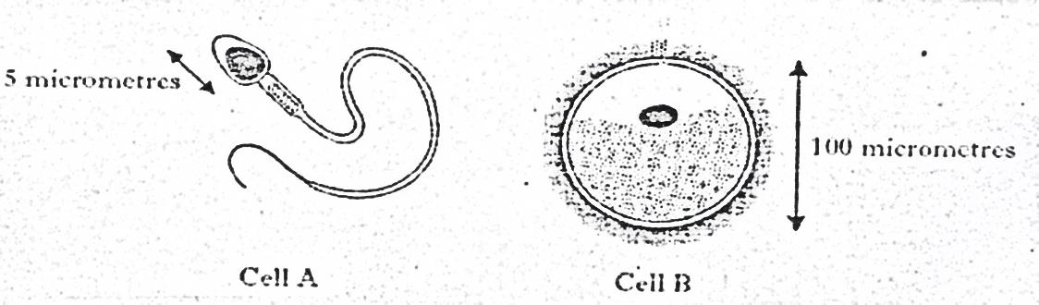

**5 micrometres**

**100 micrometres**

**Cell B**

**Cell A**

1. Name the cell B (1 mark)

___________________________________________________________________________________

1. Give **one** feature of cell A which makes it different from cell B. (1 mark)

______________________________________________________________________________________________________________________________________________________________________

b) The diagram below represents the female reproductive system

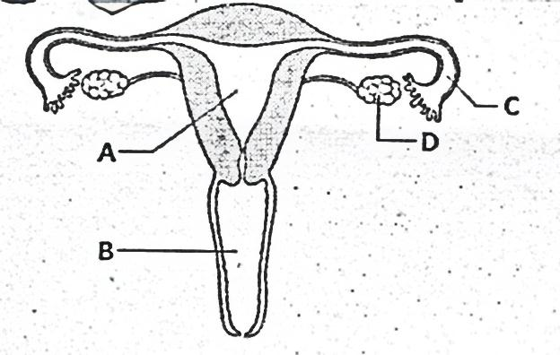

1. Name the part marked A. (1 mark)

___________________________________________________________________________________

1. State the role of the part marked D. (1 mark)

______________________________________________________________________________________________________________________________________________________________________

c) State **two** functions of amniotic fluid. (2 marks)

____________________________________________________________________________________________________________________________________________________________________________________________________________________________________________________________________________________________________________________________________________

d) i) Name the organism that causes syphilis. (1 mark)

___________________________________________________________________________________

ii) State **one** symptom of primary syphilis (1 mark)

___________________________________________________________________________________

1. The diagram below represents a mechanism that takes place in mammals. Study it and answer the questions that follow.

Further excess

***x***

Corrective mechanism A

Excess

Negative feedback

Norm

Norm

Negative feedback

Corrective mechanism B

Deficiency

***x***

Further deficiency

1. Name the principle labelled x. (1 mark)

___________________________________________________________________________________

1. If the above diagram represents blood sugar regulation:
2. State the corrective mechanism carried out at A. (2 marks)

___________________________________________________________________________________

___________________________________________________________________________________

___________________________________________________________________________________

___________________________________________________________________________________

___________________________________________________________________________________

1. The condition that may result from the further excess. (1 mark)

___________________________________________________________________________________

1. The hormone that would be responsible for correcting the deficiency. (1 mark)

___________________________________________________________________________________

1. Explain why plants have less elaborate excretory systems as compared to animals. (3 marks)

______________________________________________________________________________________________________________________________________________________________________

___________________________________________________________________________________

___________________________________________________________________________________

___________________________________________________________________________________

___________________________________________________________________________________

______________________________________________________________________________________________________________________________________________________________________

1. The figures below represent forelimb of several vertebrates. Use them to answer the questions that follow.

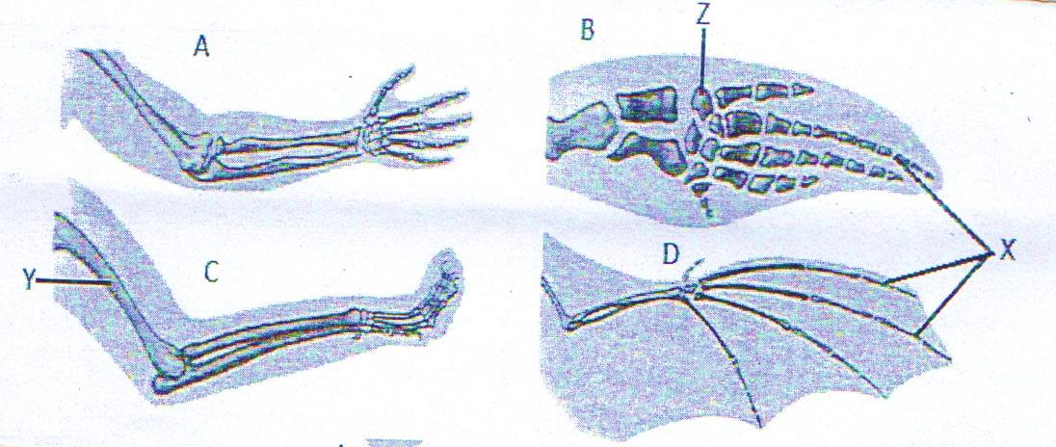

1. Name parts labelled X, Y, and Z. (3 marks)

X ________________________________________________________________________________

Y ________________________________________________________________________________

Z ________________________________________________________________________________

1. i) What common name is given to the structures shown above? (1 mark)

___________________________________________________________________________________

ii) State the name given to represent the type of change undergone by the structures. (1 mark)

___________________________________________________________________________________

iii) What is the ecological significance of such a change named in (ii) above? (1 mark)

___________________________________________________________________________________

1. Briefly explain why Lamarck’s theory was rejected by scientists. (2 marks)

_________________________________________________________________________________________________________________________________________________________________________________________________________________________________________________________

___________________________________________________________________________________

___________________________________________________________________________________

___________________________________________________________________________________

______________________________________________________________________________________________________________________________________________________________________

**SECTION B (40 MARKS)**

***Answer question 6 (compulsory) and either question 7 or 8 in the spaces provided after question 8.***

1. In an experiment to investigate the action of salivary amylase on starch, equal amounts of amylase was added to equal amounts of starch in different tubes. The test tubes were placed at different temperatures. The table below shows the time taken for the enzymes to digest starch.

|  |  |  |  |  |  |  |  |  |
| --- | --- | --- | --- | --- | --- | --- | --- | --- |
| Time (min) | 45 | 27.5 | 15 | 05 | 1.5 | 1 | 8 | 35 |
| Temperature (0C) | 0 | 20 | 20 | 30 | 35 | 38 | 40 | 45 |

1. On the grid provided, plot a graph of time in minutes against temperature. (5 marks)



1. What is the optimum temperature of the enzyme? (1 mark)

___________________________________________________________________________________

1. Account for the time taken to digest starch at:

i) 50C (2 marks)

______________________________________________________________________________________________________________________________________________________________________

ii) 450C (2 marks)

______________________________________________________________________________________________________________________________________________________________________

1. Other than temperature, name **two** factors that influence the rate of enzyme activity. (2 marks)

______________________________________________________________________________________________________________________________________________________________________

1. What is the rate of enzyme action at 150C? Work out using the graph drawn. (3 marks)

____________________________________________________________________________________________________________________________________________________________________________________________________________________________________________________________________________________________________________________________________________

1. Salivary amylase continues to digest starch to maltose in the food bolus from the mouth

down the oesophagus but stops in the stomach. Explain this observation. (2 marks)

_________________________________________________________________________________________________________________________________________________________________________________________________________________________________________________________

1. Name the secretions received in the duodenum from the pancreas to facilitate the process of

digestion. (1 mark)

___________________________________________________________________________________

1. During a scientific research on a rat, hydrochloric acid was carefully introduced in the pancreatic

duct to mix with the secretion before it was received in the duodenum. It was discovered that no digestion took place in the duodenum. Explain. (2 marks)

____________________________________________________________________________________________________________________________________________________________________________________________________________________________________________________________________________________________________________________________________________

7. a) Describe adaptations of flowers to cross pollination. (5 marks)

b) Describe double fertilization in flowering plants. (15 marks)

8. Explain the mechanism of water transport from the soil through the stem until transpiration. (20 marks)

________________________________________________________________________________________________________________________________________________________________________________________________________________________________________________________________________________________________________________________________________________________________________________________________________________________________________________________________________________________________________________________________________________________________________________________________________________________________________________________________________________________________________________________________________________________________________________________________________________________________________________________________________________________________________________________________________________________________________________________________________________________________________________________________________________________________________________________________________________________________________________________________________________________________________________________________________________________________________________________________________________________________________________________________________________________________________________________________________________________________________________________________________________________________________________________________________________________________________________________________________________________________________________________________________________________________________________________________________________________________________________________________________________________________________________________________________________________________________________________________________________________________________________________________________________________________________________________________________________________________________________________________________________________________________________________________________________________________________________________________________________________________________________________________________________________________________________________________________________________________________________________________________________________________________________________________________________________________________________________________________________________________________________________________________________________________________________________________________________________________________________________________________________________________________________________________________________________________________________________________________________________________________________________________________________________________________________________________________________________________________________________________________________________________________________________________________________________________________________________________________________________________________________________________________________________________________________________________________________________________________________________________________________________________________________________________________________________________________________________________________________________________________________________________________________________________________________________________________________________________________________________________________________________________________________________________________________________________________________________________________________________________________________________________________________________________________________________________________________________________________________________________________________________________________________________________________________________________________________________________________________________________________________________________________________________________________________________________________________________________________________________________________________________________________________________________________________________________________________________________________________________________________________________________________________________________________________________________________________________________________________________________________________________________________________________________________________________________________________________________________________________________________________________________________________________________________________________________________________________________________________________________________________________________________________________________________________________________________________________________________________________________________________________________________________________________________________________________________________________________________________________________________________________________________________________________________________________________________________________________________________________________________________________________________________________________________________________________________________________________________________________________________________________________________________________________________________________________________________________________________________________________________________________________________________________________________________________________________________________________________________________________________________________________________________________________________________________________________________________________________________________________________________________________________________________________________________________________________________________________________________________