Name……………………………………..………………….…Index No:…………………………………………….

School ………………………………………………………. Candidate’s Signature …………..……………………..
233/2 Date: ………………………………………………..
CHEMISTRY
PAPER 2
THEORY

TIME: 2 HOURS

Kenya Certificate of Secondary Education (K.C.S.E.)

233/2
Chemistry
Paper 2
2 Hours

INSTRUCTIONS TO CANDIDATES

- Write your name index No and school in spaces provided above.
- Sign and write the date of examination in the spaces provided above
- Answer all the questions in the spaces provided below each question. .
- KNEC Mathematical tables and silent electronic calculators may be used.
- All working must be clearly shown where necessary.
- Candidates should answer the questions in English.
- This paper consists of 8 printed pages.
- Candidates should check to ascertain that all pages are printed as indicated and that no questions are missing.

For Examiners Use Only

Question | Maximum score | Candidate’s score
1 | 12
2 | 13
3 | 11
4 | 10
5 | 12
6 | 8
7 | 14
Total score | 80

- The grid below shows part of the periodic table. Use it to answer question that follow. The letters do not represent actual symbols.

S U V
P R T W
Q

- Which of the elements has the highest atomic radius? Explain (2marks)
…………………………………………………………………………………………………………
…………………………………………………………………………………………………………
- Identify the most reactive non- metal. Explain (2marks)
…………………………………………………………………………………………………………
…………………………………………………………………………………………………………
- Give the electron configuration of: (1mark)
(i)Element S
…………………………………………………………………………………………………………
(ii)Element Q
………………………………………………………………………………………………………….
- Compare the atomic radius of P and R. Explain (2marks)
…………………………………………………………………………………………………………
…………………………………………………………………………………………………………
- Given that the atomic mass of W is 40. Write down the composition of its nucleus. (1mark)
…………………………………………………………………………………………………………
- Write the formula of compounds formed between:
(i) Element P and S …………………………………………………………………………………….................... (1mark)
(ii)Element R and T …………………………………………………………………………………….................. (1mark)
- Give the formula of one stable ion with an electron arrangement of 2.8 which is:
(i)Negatively charged……………………………………………………………………… (1mark)
(ii)Positively charged ………………………………………………………………………. (1mark)
- The diagram below represent a set up that was used for electrolysis aqueous copper (II) nitrate.

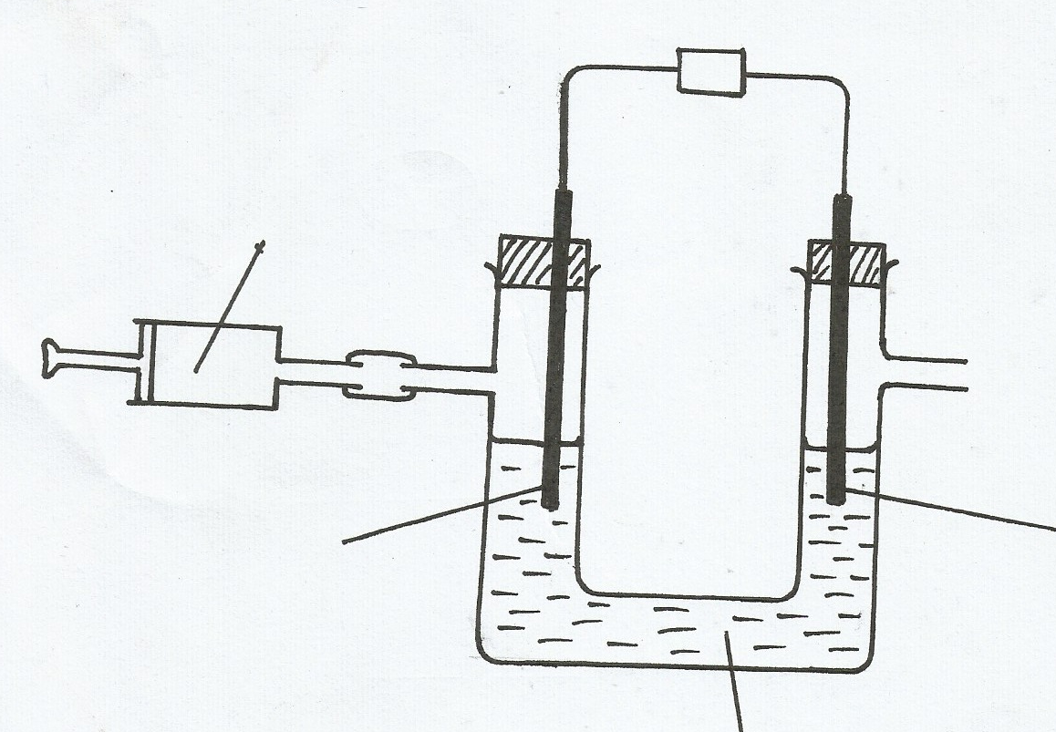
Copper (II) nitrate
Gas X
Carbon Electrode
B

Carbon electrode
A

(a) A gas that relights a glowing splint was produced of electrode A
(i) Which electrode is the cathode? Explain (2marks)
…………………………………………………………………………………………………………
…………………………………………………………………………………………………………
(ii) State any other method of collecting gas ……………….……………………………..…….. mark)
(iii) Write the half cell equation to show the reaction that takes place at the
- Anode

- Cathode

(iv) Explain how the identity of product of the cathode of this electrolysis can be confirmed (2marks)
…………………………………………………………………………………………………………
…………………………………………………………………………………………………………
(v)A current of 5A was passed through the copper II nitrate solution for three hours.
Calculate the mass of copper deposited ( Cu=63.5, F=96500c) (2marks)
…………………………………………………………………………………………………………
……………………………………………………………………………………………………………………………………………………………………………………………………………………
…………………………………………………………………………………………………………
(b) The following are standard electrodes potential for some electrodes. The letters do not represent actual symbols of the element.
E^{θ} (volts)
A²⁺_{(aq)} + 2e- A_{(s)} -2.92
B²⁺_{(aq)} +2e- B _{(s)} -2.28
C²⁺_{(aq)} +2e- C _{(s)} 0.00
D²⁺_{(aq)} +2e- D _{(s)} +0.34
E²⁺_{(aq)} +2e- E _{(s)} + 2.87
(i)Which is the strongest reducing agent .Explain (1mark)

(ii) Write the cell representation for the electrochemical cell obtained by combining the half-cell B and D. (1mark)

(iii)Calculate the emf of the cell in b (ii) above. (1mark)

- A student set up the apparatus shown below to prepare and collect dry carbon (IV) oxide gas.
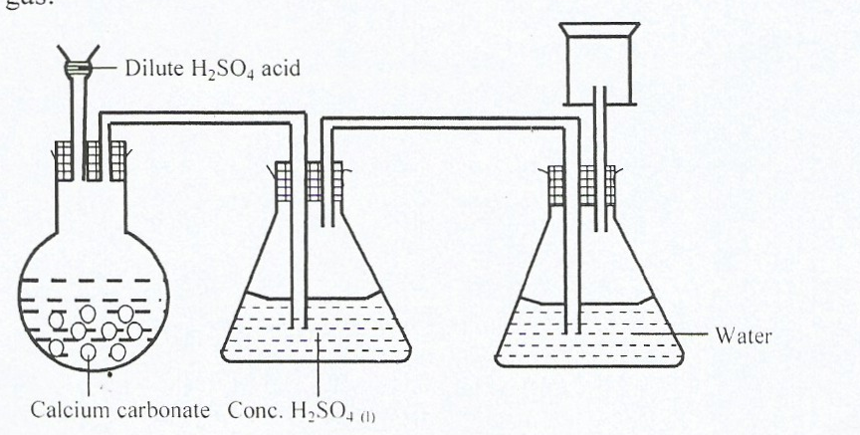
Carbon (IV) oxide
Dilute H₂SO₄ acid.
- State corrections for three mistakes in the set up above (3marks)
Calcium Carbonate Conc. H₂SO_{4 (l)}
(i) ……………………………………………………………………………………………
(ii)…………………………………………………………………………………………….
(iii)……………………………………………………………………………………………
- Give two reasons why carbon(IV) oxide is used as a fire extinguisher (1mark)
…………………………………………………………………………………………………………
…………………………………………………………………………………………………………
- The flow chart below is for the manufacture of sodium carbonate by Solvay process. Use is to answer the questions that follow.
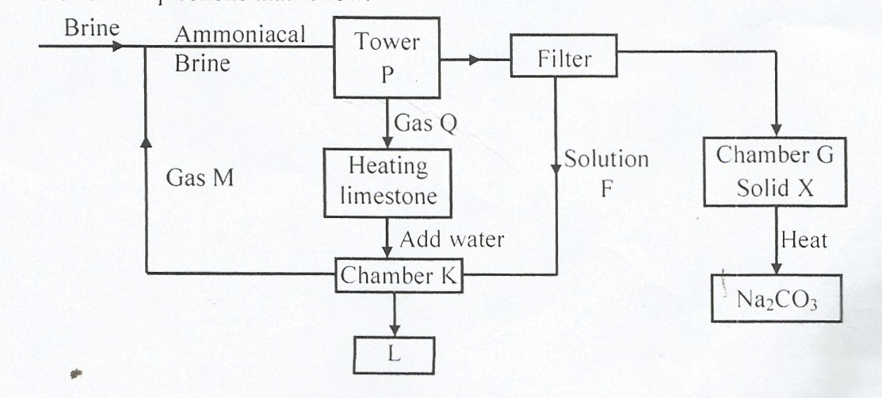

- Name gas M
……….…………………………………………………………………………………………(1mark)
(ii)Name solution F and solid X (2marks)
F: ……………………………………………………………………………………………….
X:………………………………….…………………………………………………………….
(iii) Name the product L formed and gives one of its uses (2marks)

(iv) Write equation of the reaction in (2marks)
Tower:

Chamber K:

(v)Name the two raw materials required in the manufacture of sodium carbonate (2marks)
…………………………………………………………………………………………………………
…………………………………………………………………………………………………………
- Study the flow chart below and answer the question that follows:
M
CH₃CHCH₃
Q
Polymer P
Substance T
Substance W
Gas V
Step I H₂, Nickel
Step III
Step II
Br₂
Step IV
Conc. H₂SO₄
Step V
Na₂CO_{3(s)}

Step VI
H⁺/KmnO₄

- Identify the following:
- Substance W…………………………….…………………………………………………….(1mark)
(ii) Gas V …………………………………………………………………………………… (1mark)
- Name the processes involved in the following steps
(i) Step I ………………………………………………………………………………………(1mark)
(ii) Step II …………………………………………………………………………………..…(1mark)
- (i)What type of reaction is taking place in step VI? ……………………………………………………………………………………..…………(1mark)
(ii) Draw the structure and give their VIPAC name for the following compounds.

Compound | Structure | Name
Q
P
(4marks)
- Write the equation that took place in step III. (1mark)

- (a) Study the table given and answer the questions that follow.
Chloride | Boiling point | Conductivity of electricity in molten form | (Kmjmol⁻¹) | PH of aqueous solution of chloride
E  F  G  H  J  K | 1465  74  423  1418  57  136 | GOOD  NIL  VERY POOR  GOOD  Good  NIL | -1411  -320  -1408  -642  -640  -60 | 7  2  3  6.5  2  2
(i) Name one chloride that is likely to be a liquid at room temperature? (1mark)
…………………………………………………………………………………………………………
(ii) Which chloride has a giant ionic structure? Explain (2marks)
…………………………………………………………………………………………………………
…………………………………………………………………………………………………………
(iii) Explain why chloride E has a pH of 7. (1mark)
…………………………………………………………………………………………………………
…………………………………………………………………………………………………………
(iv) Which chloride has heat of formation that is least exothermic (1mark)
…………………………………………………………………………………………………………
(b)Aluminium is Malleable and ductile and a very good conductor of electricity:
(i) State the meaning of the term:
(I) Malleable (1mark)
…………………………………………………………………………………………………………
(II) Ductile (1mark)
…………………………………………………………………………………………………………
(ii) Explain why aluminium is better conductor of electricity than sodium (Al=13) (2marks)
…………………………………………………………………………………………………………
…………………………………………………………………………………………………………
(iii)Using dot (.) and cross(X) to represent electrons, show how aluminum react with Nitrogen (2marks)

- (a) Study the flow chart below an answer the question that follows.
KMnO₄
Water
HCI _{(g)} HCI _{(aq)} Gas Q
Heated iron

SOLID Y
Water
NaOH _{(aq)}
Brown ppt SOLUTION Y
(i) Identify solid Y (1 mark)
…………………………………………………………………………………………………………
(ii) Identify gas Q (1 mark)
…………………………………………………………………………………………………………
(iii) Write an equation for the formation of a white precipitate (1mark)

(b) The set below was used to react dry chloride gas with iron powder. The product Z was collected in flask B.

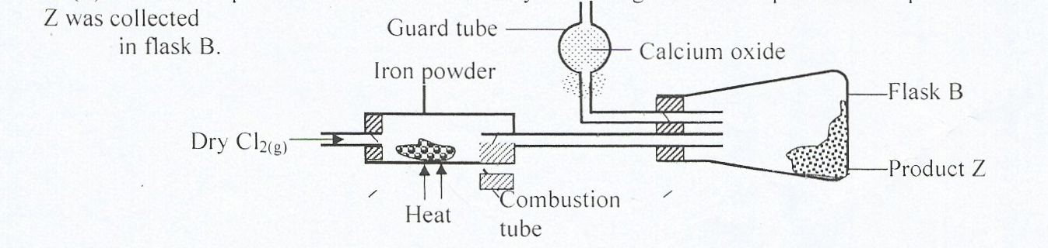

(i) Identify product Z (1mark)
…………………………………………………………………………………………………………
(ii) What property of product Z makes it possible to collect as shown below in the diagram. (1mark)
…………………………………………………………………………………………………………
(iii)Explain why calcium oxide would be preferred to calcium II chloride in the guard tube (1mark)
…………………………………………………………………………………………………………
…………………………………………………………………………………………………………
(iv) The total mass product Z formed was found to be 0.5g. Calculate the volume of chlorine gas that reacted with iron. (Fe=56, CI=35, M.G.V at 298k=24000cm³ (3marks)

- (a) Name each of the processes describe below which takes place when salts exposed to air for sometimes.
(i) Anhydrous copper (II) sulphate becomes wet (1mark)
…………………………………………………………………………………………………………
(ii)Common table salt forms an aqueous solution (1mark)
…………………………………………………………………………………………………………
(iii) Fresh crystal of sodium carbonate Na₂CO₂.10H₂O becomes covered with white powder of formula Na₂CO₃.10H₂O (1mark)
…………………………………………………………………………………………………………
(b) Write the formula of the complex ion formed in each of the reaction described below.
(i)Zinc metal dissolves in hot alkaline solution (1mark)

(ii)Copper hydroxide dissolves in excess ammonia solution. (1mark)

(c)Hydrated salt has the following composition by mass. Iron 20.2%, oxygen23%, sulpher 11.5% and water 45.3%. Its relative formula mass is 278
(i) Determine the formula of hydrated salt. (Fe=56, S=32, O=1, H=1) (3marks)

(ii) 6.9 of hydrated salt was dissolved in distilled water and the total volume made to 250cm³ of solution. Calculate the concentration of the salt solution in moles per Liter. (3marks)

(d) Describe how a solid sample of lead II chloride can be prepared using the following reagents:-
Dilute nitric acid,Dilute hydrochloric acid,Lead carbonate, (3marks)

