NAME ____________________________________ INDEX NO. _______________
SCHOOL ____________________________________ SIGNATURE _______________ DATE _______________

312/1
GEOGRAPHY

PAPER 1
JULY/AUGUST, 2015

TIME: 2¾ HOURS

312/1
GEOGRAPHY
PAPER 1
TIME: 2¾ HOURS

INSTRUCTIONS TO CANDIDATES
- This paper has two sections: A and B.
- Answer all the questions in section A.
- Answer question 6 and any other two questions from Section B.
- All answers must be written in the answer booklet provided.
- Candidates should answer the questions in English.
- This paper consists of 4 printed pages.
- Candidates should check the question paper to ascertain that all pages are printed as indicated and that no questions are missing.

SECTION A (25 MARKS)
Answer all questions in this section in the answer booklet provided.
1. a) What is a:
i) Sea breeze? (2 marks)
ii) Land breeze? (2 marks)
b) Name one effect of land and sea breezes in places where they occur. (1 mark)

2. State five factors that influence landslides in Kenya. (5 marks)

3. The sketch below is a coastal landscape. Study the sketch and answer the questions below.
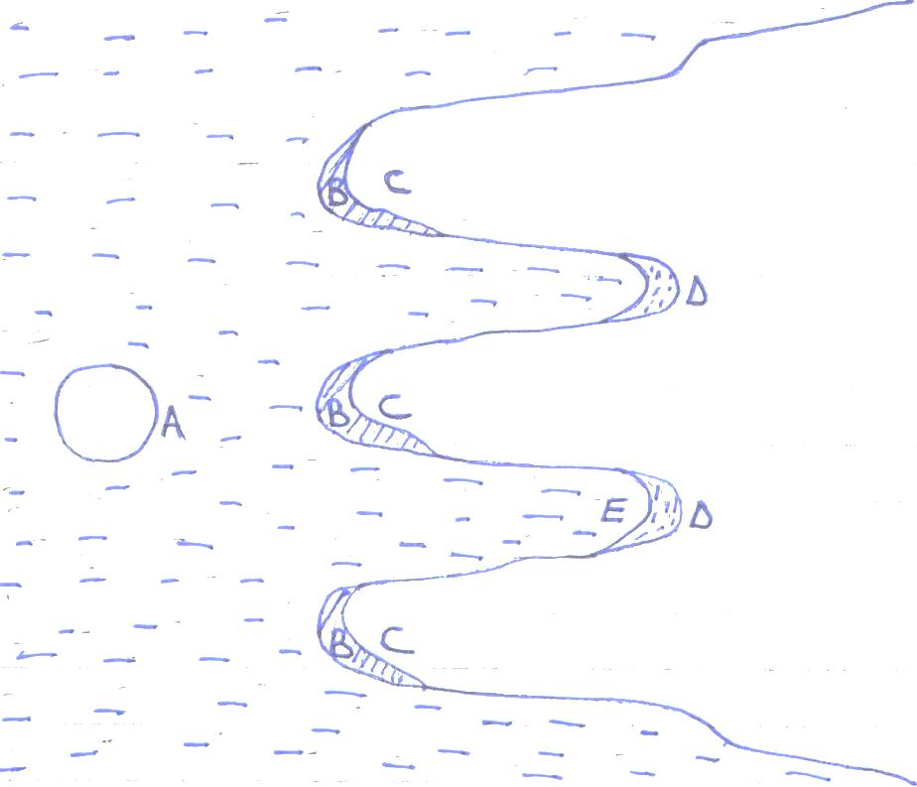
D
E

A
B
B
B

D
C
- Name features A to D. (2 marks)
- State three evidences of emerged coastline. (3 marks)

4. a) What is ice cap? (2 marks)
b) Name three resultant features of glacial erosion. (3 marks)

5. a) Define an equinox. (2 marks)
b) State three characteristics of the summer solstice. (3 marks)

SECTION B (75 MARKS)
Answer question 6 and any other two questions from this section in the answer booklet provided.
6. Study the map of Migwani 1:50,000 (sheet 151/1) provided and answer the following questions.
a) i) What is the four figure grid reference of the school at Mui? (2 marks)
ii) What is the bearing of the school at Usiani from the trigonometrical station near
Kyawea? (2 marks)
iii) Measure the distance in kilometres of the dry weather road from grid reference 800989
to grid reference 840002. (2 marks)
b) Citing evidence from the map, state three functions served by Mutitu (Ndoa) town. (6 marks)
c) Explain three factors that influence settlement in the area. (6 marks)
d) Identify three sources of water in the area covered by the map. (3 marks)
e) You intend to carry out a field study in Mutitu forest. Explain four problems you are
likely to encounter. (4 marks)

7. a) Give an account of:
i) A lava volcano (6 marks)
ii) A composite volcano (6 marks)
b) Explain advantages and disadvantages of vulcanicity. (8 marks)
c) When conducting field study in an area that has experienced vulcanicity, what aspects
would you address? (5 marks)

8. a) Differentiate between aridity and desertification. (4 marks)
b) Explain five causes of aridity and desertification. (10 marks)
c) Discuss three causes of climate change. (6 marks)
d) Give five characteristics of savanna vegetation. (5 marks)

9. a) Describe the following processes in arid areas.
i) Abrasion (2 marks)
ii) Deflation (2 marks)
iii) Attrition (2 marks)
b) With the aid of a diagram, explain how an oasis is formed in a desert landscape. (8 marks)

c) The diagram below represents features found in a Karst topography.
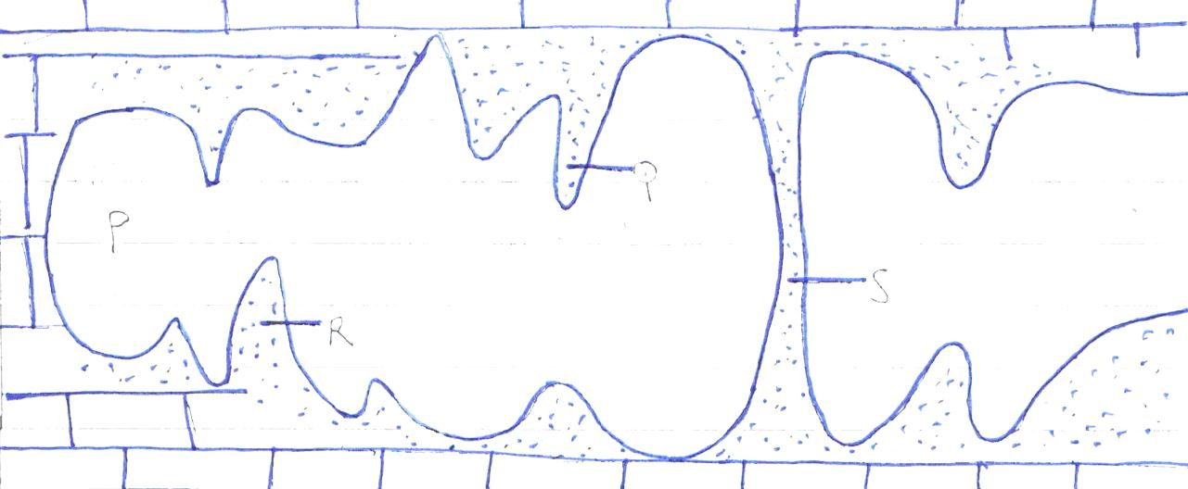
S
Q
R
P
- Identify features marked P, Q, R, S. (4 marks)
ii) Explain the formation of feature P. (3 marks)
d) Explain two effects of karst topography to farming. (4 marks)

10. a) i) What is a river’s load? (1 mark)
ii) Explain how a river transports its load. (8 marks)
iii) What is river capture? (1 mark)
iv) With the use of a diagram, explain how river capture occurs. (4 marks)
b) Name any four features of river deposition. (4 marks)
c) List six economic uses of rivers. (3 marks)
d) If you were to carry out a field study on the upper course of river Tana, name four
features you are likely to observe. (4 marks)

