Name…………………………………… ………………….. Index No:…………………………………….
School ……………………………………………………… Candidate’s Signature …………..……………
502/3 Date: ………………………………………
PAPER 3
GERMAN ORAL

TIME: 2 HOURS

Kenya Certificate of Secondary Education (K.C.S.E.)

502/3
German oral
Paper 3

INSTRUCTIONS TO CANDIDATES
- This paper consists of 2 printed pages.
- Candidates should check the question paper to ascertain that all pages are printed as indicated and that no question is missing.

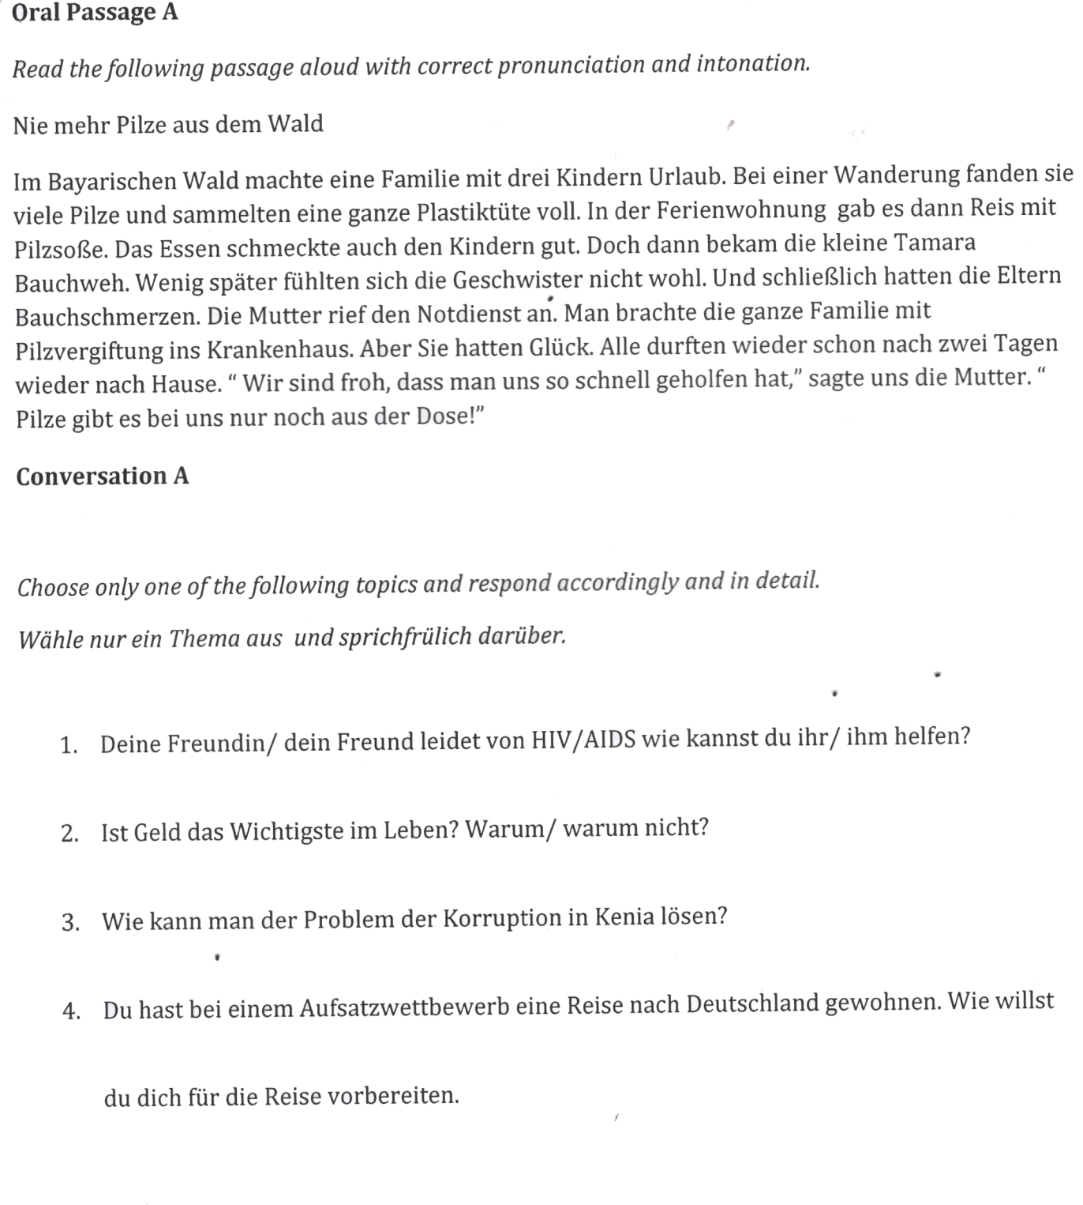

ORAL PASSAGE B
Read the following text with correct pronunciation and intonation
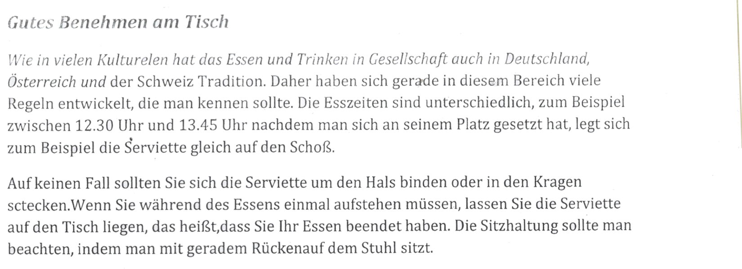
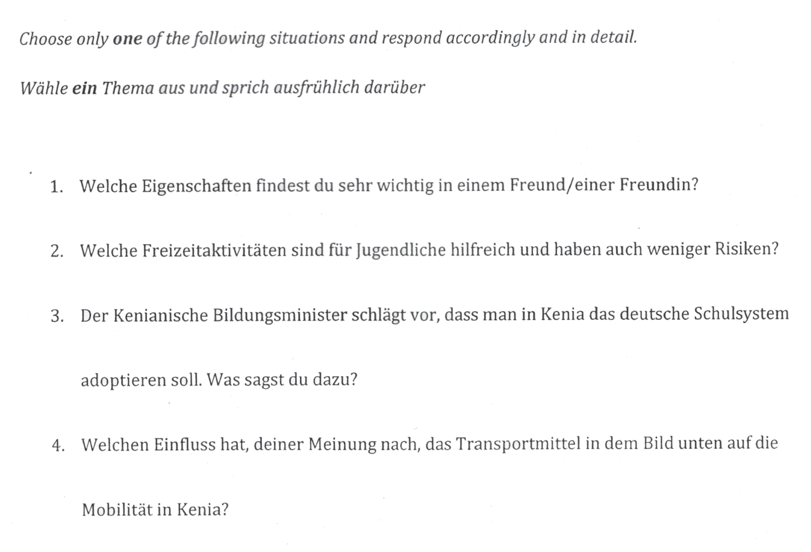
CONVERSATION B

