NAME ____________________________________ INDEX NO. _______________
SCHOOL ____________________________________ SIGNATURE _______________ DATE _______________

121/2
MATHEMATICS ALT A
PAPER 2
JUNE/JULY, 2015
TIME: 2½ HOURS

121/2
MATHEMATICS ALT A
PAPER 2
TIME: 2½ HOURS

INSTRUCTIONS TO CANDIDATES
- Write your name and index number in the spaces provided above.
- Sign and write the date of examination in the space provided above.
- This paper consists of TWO sections: Section I and Section II.
- Answer ALL the questions in section I and only FIVE questions from Section II.
- All answers and working must be written on the question paper in the space provided below each question.
- Show all the steps in your calculations, giving your answers at each stage in the spaces below each question.
- Marks may be given for correct working even if the answer is wrong.
- Non-programmable silent calculators and KNEC mathematical tables may be used except where stated otherwise.
- This paper consists of 16 printed papers.
- Candidates should check the question paper to ascertain that all the pages are printed as indicated and that no questions are missing.

FOR EXAMINER’S USE ONLY
SECTION I
1 | 2 | 3 | 4 | 5 | 6 | 7 | 8 | 9 | 10 | 11 | 12 | 13 | 14 | 15 | 16 | TOTAL

SECTION II
17 | 18 | 19 | 20 | 21 | 22 | 23 | 24 | TOTAL |  | GRAND TOTAL

SECTION I (50 MARKS)
Answer ALL questions in the spaces provided.
- Use logarithms to evaluate;
$\sqrt{\frac{({3196)}^{2}×{(0.024)}^{3}}{204.6}}$ (4 marks)

- Make t the subject of the formula. V=$\sqrt{\frac{{tv}^{2}-w}{m}}$ (3 marks)

- Solve the inequalities 2x – 5 > -11 and 3 + 2x$≤$ 13, giving the answer as a combined inequality. (3 marks)

- Use matrix method to determine the coordinates of the point of intersection of the two lines.
3x − 2y = 13, 2y + x + 1= 0 (3 marks)

- P and Q are the points on the ends of the diameter of the circle below.
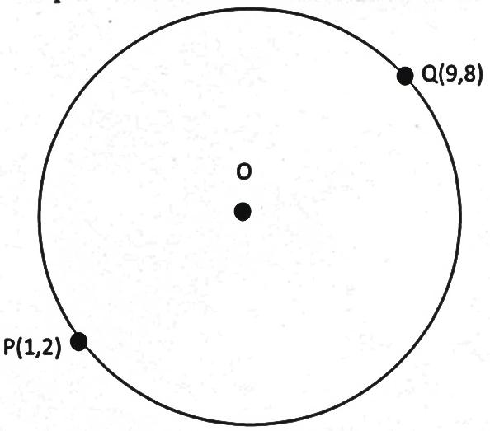
O
P (1,2)
Q (9,8)
- Write down in terms of x and y the equation of the circle in the form;
ax² + by² + x + y + c = 0 (2 marks)

- Find the equation of the tangent at Q in the form ax + by + c = 0 (2 marks)

- Use binomial expansion to expand (1− $\frac{1}{3}x$)⁴ up to the 4th term. (2 marks)

- Solve for x in [log₂ x]² + log₂ 8 = log₂ x⁴ (3 marks)

- An arc of a circle radius 3.5cm is 9.1 cm long. Find the angle it subtends at the centre of the circle. (3 marks)

- Simplify $\frac{4}{\sqrt{5}+\sqrt{2}}-\frac{3}{\sqrt{5}\sqrt{2}}$ (3 marks)

- In Mr. Mukala’s shop, a radio has marked price of ksh 10,000. Mr. Mukala can allow a reduction of 15% on the marked price and still make a profit of 25% on the cost price of the radio. What was the
cost price of the radio? (3 marks)

- A point T divides a line AB internally in the ratio 5:2. Given that A is (4,10) and B is (11, 3).
Find the coordinates of T. (4 marks)

- Grade x and grade y sugar cost sh 60 and sh 50 per kilogram respectively. In what proportion must
the two grades be mixed to produce a blend that cost sh 53 per kilogram. (3 marks)

- Use the identity sin²θ + cos²θ = 1 to find the values of sin θ, given that cos θ = $\frac{5}{13}$ (3 marks)

- A two digit number is made by combining any of the two digits 1,3,5,7 and 9 at random.
- Make an array of possible combinations (2 marks)

- Find the probability that the number formed is prime. (1 mark)

- Simplify completely $\frac{\log{49}+2\log{\sqrt{7}}}{\log{7}-\frac{1}{4}\log{7}}$ (3 marks)

- Mukai travels from A to B at x km/h. The two towns are 40km apart. She then travels to town C at
(x + 6) km/h. Town B and C are 100km apart. If the time she takes from B to C is the same time from
A to B, find the value of x. (3 marks)

SECTION II (50 MARKS)
Answer ANY FIVE questions from this question.
- Income tax is charged on annual income at the rate shown below.
Taxable income (K£) | Rate (sh per K£)
1 - 1500  1501 - 3000  3001 - 4500  4501 - 6000  6001 - 7500  7501 - 9000  9001 - 12000  Over 12000 | 2  3  5  7  9  10  12  13
- A certain headmaster earns a monthly salary of Ksh 8570. He is housed in the school and as a result his taxable income is 15% more than his salary. He is entitled to a family relief of ksh 150 per month. How much tax does he pay in a year? (6 marks)

- From the headmasters salary the following deductions are also made every month.
WCPS 2% of gross salary
NHIF Ksh 20
House rent, water and furniture charges ksh 246. Calculate the headmaster’s net salary for each month. (4 marks)

- The figure below is a solid in which base ABCD is a rhombus. AC = 16cm, BD = 12cm and CE = 12cm. calculate the angle between the planes.
- EBD and ABCD. (4 marks)

- ECB and EBD (3 marks)

- Length BC and BE (3 marks)

- a) Fill the table below.
x | 0 | 15 | 30 | 45 | 60 | 75 | 90 | 120 | 150 | 180
3sin x−1 | -1 |  | 0.5 |  | 1.6 |  | 2
Cos x | 1 |  | 0.87 | 0.71 | 0.5 |  | 0 | -0.5 | -0.87 | -1
(2 marks)
b) Using the same axis draw the on the graph paper provided, the graph of y = 3sin x − 1 and
y = cos x for 0º $≤$ x $≤$ 180º (6 marks)

c) Use your graph to solve the equations:
- 3sin x − cos x = 1 (1 mark)

- 3sin x = 1 (1 mark)

- The probability of Mary, Esther and Joan coming to school late on Friday are $\frac{1}{5}$, $\frac{2}{7}$ and $\frac{1}{4}$ respectively
- Draw a tree diagram to represent the information. (2 marks)

- Calculate the probability that:
- All the three students are late. (2 marks)

- All except Esther are late. (2 marks)

- At least one is late. (2 marks)

- At most two girls are late. (2 marks)

- A particle moving along a straight line covers a distance of 5 metres in time t seconds from a fixed
point O on the line where s = t³ − 6t² + 8t − 4.
Find:
- The velocity of the particle when t = 5. (3 marks)

- The acceleration when t = 5 seconds. (3 marks)

- The time when the velocity of the particle is constant. (4 marks)

- a) Using a ruler and a pair of compass only construct a triangle ABC in which ∠BAC = 120°,
AB = 6.4cm and AC = 7.0 cm. (4 marks)

Measure
- ∠ABC (1 mark)

- BC (1 mark)

c) Construct the circumscribed circle of triangle ABC with O as its centre. Describe the circumscribed circle as a locus. (4 marks)

- Two aircrafts A and B took off at the same time on Monday from Jomo Kenyatta international airport
(1°S, 37°E) at 11.00 pm. Aircraft A flew due east and aircraft B flew due west. If they met again after 18 hours at (1°S, 117°W), calculate: (Take radius of earth = 6370km)
- Speed of aircraft A in km/h (to 2 d.p) (4 marks)

- Speed of aircraft B in km/h (to 2 d.p) (4 marks)

- The time they met again. (2 marks)

- In the figure below DA is a diameter of the circle ABCD centre O and radius 10cm. TCS is a tangent to the circle at C, AB = BC and ∠DAC = 38⁰.
- Find the size of the angle;
- ACS (2 marks)

- BCA (2 marks)

- Calculate the length of;
- AC (2 marks)

- AB (4 marks)

