MACHAKOS COUNTY KCSE TRIAL & PRACTICE EXAMINATION 2015
Kenya Certificate of Secondary Education (K.C.S.E)

231/3
BIOLOGY
PAPER 3
(PRACTICAL)
1³/₄ HOURS
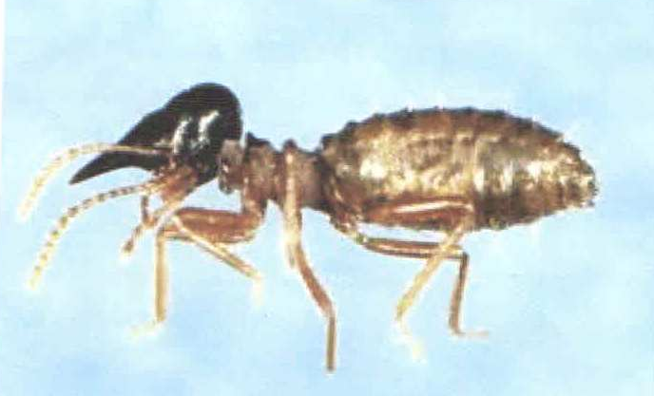
Q2
Q1
Q3

