NAME: ……………………………………………… INDEX NO ……..…....................................
CANDIDATE’S SIGN …...………….……….…..
DATE: …………..………………
232/1
PHYSICS THEORY
PAPER 1

TIME: 2 HOURS

Kenya Certificate of Secondary Education (K.C.S.E.)

232/1
PHYSICS THEORY
PAPER 1
TIME: 2 HOURS

INSTRUCTIONS TO THE CANDIDATES:

- Write your name and index number in the spaces provided above.
- Sign and write the date of the examination.
- This paper consists of two sections I and II.
- Answer all the questions in section I and II in the spaces provided.
- All working must be clearly shown.
- Non- programmable silent electronic calculators and KNEC Mathematical tables and electronic calculators may be used.

FOR EXAMINERS’ USE ONLY

SECTION | QUESTION | MAXIMUM SCORE | CANDIDATE’S SCORE
A | 1-11 | 25
B | 12 | 13
 | 13 | 8
 | 14 | 10
 | 15 | 12
 | 16 | 12
 | TOTAL | 80

This paper consists of 8 printed pages.
Candidates should check to ascertain that all pages are printed as indicated
And that no questions are missing.

SECTION A (25MKS)
Answer all questions in this section

1. The vernier calipers in the figure below has a zero error of -0.05cm. It was used to measure the diameter
of an object and the reading was as shown
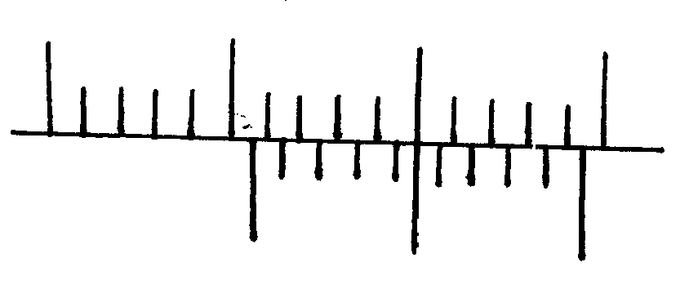
2
3
10
0
Fig 1

Determine the actual diameter of the object. (2mks)

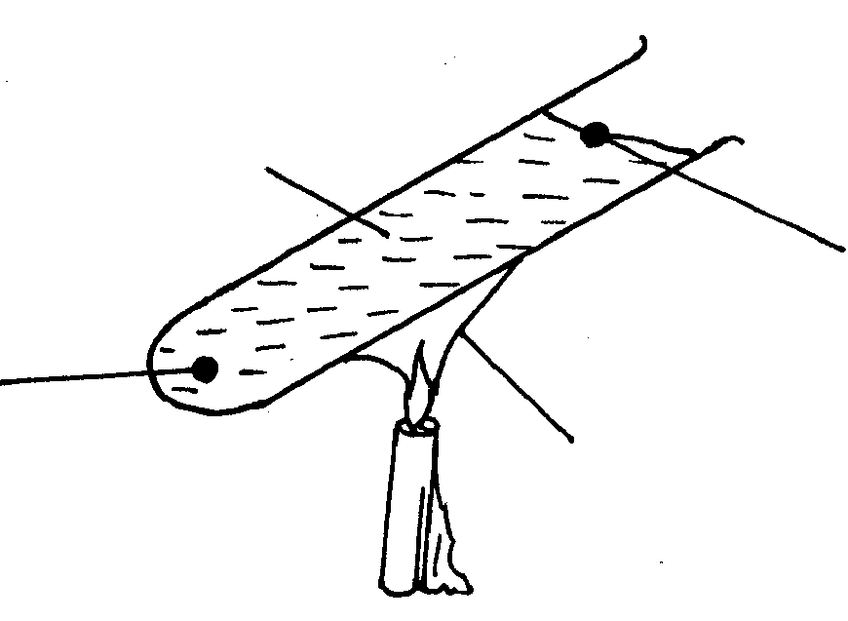
2. A form one student set up the apparatus as shown below.
Floating wax
Flame
Water
Wax fitted with lead shot
Fig 2

The boiling tube was heated in the middle as shown
(i) Which wax melted first? (1mk)
.................................................................................................................................................................
.................................................................................................................................................................
(ii) Explain your answer in (i) above. (1mk)
.................................................................................................................................................................
.................................................................................................................................................................
3. A lorry of mass 13.4 tonnes is moving at a speed of 72 km/hr. determine it’s momentum giving your
answer in S.I units. (3mks )

4. A catapult is used to project a stone of mass 40g vertically upwards to height of 5cm calculate the
potential energy gained by the stone. (2mks )

5. A piece of glass weighs 0.5N in air and 0.3N while completely submerged in water. Determine the density
of the glass material. (3mks )

6. State two physical properties of a material medium which may be used to measure temperature. (2mks)
.................................................................................................................................................................
.................................................................................................................................................................
7. A person of mass 60kg stand on a spring balance inside a lift. The lift accelerated upwards at
3ms⁻².calcualte the reading on the spring balance. (3mks)

8. A quantity of gas occupies a volume of 4m³ when the pressure of the gas is 4 atmospheres when it’s
temperature is 27ºC. What will be its pressure if it is compressed into half the volume and heated to a
temperature of 127ºC (2mks)

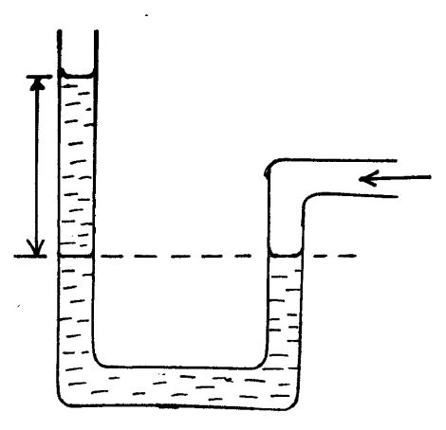
9. The figure below shows a u- tube manometer containing oil density 900kgm⁻³ one end is connected to a
gas tap
From gas tap
60mm
Fig 3

Given that the atmospheric pressure is 1.0x 10⁵ pa determine the pressure of the gas. (3mks)

10. Explain why it is difficult to steer a bicycle by gripping the centre of the handle bars. (1mk)
.................................................................................................................................................................
.................................................................................................................................................................

11. Three identical spring each of springs constant 10Nm⁻¹ and weight 0.5N are used to support a load as
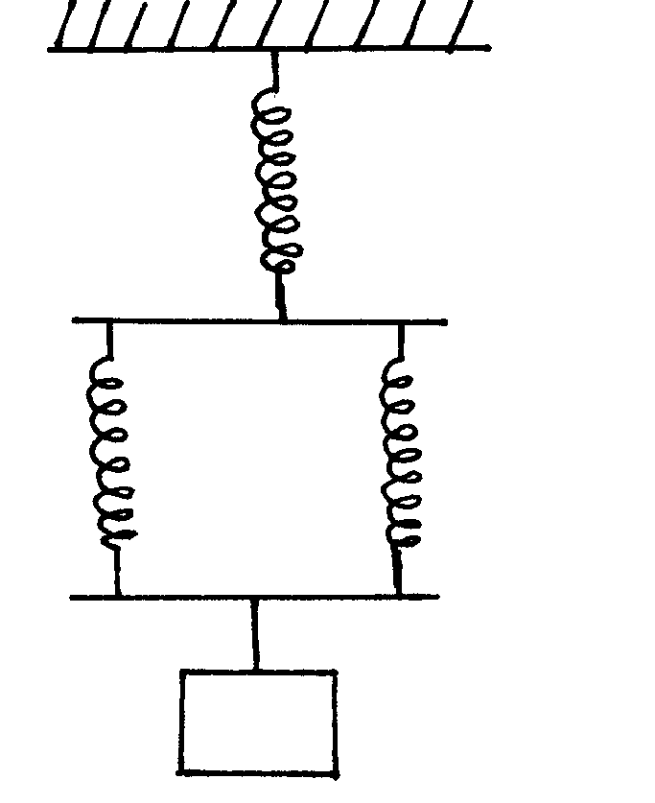
shown
A
C
B
6N
Fig 4

Determine the total extension of the system. (2mks)

SECTION B ( 55 MARKS)
Answer all questions in this section in spaces provided.
12. (a) State the characteristics of a perfectly inelastic collisions. (2mks)
.................................................................................................................................................................
.................................................................................................................................................................
(b) A body of mass 4.0kg held at a vertical height of 500cm is released to travel a long a frictionless
curved path as shown below.
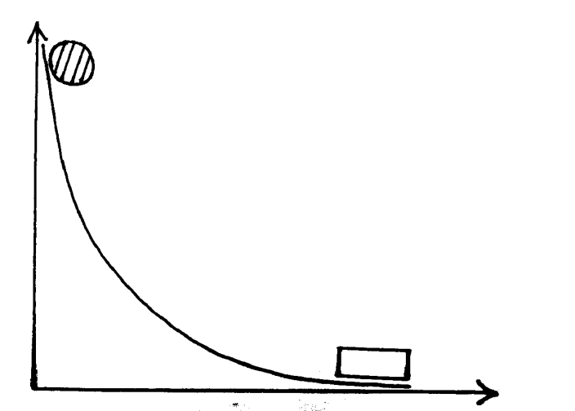
Mass = 4.0kg
Mass = 6.0kg
Fig 5

The 4.0kg mass strikes another body of mass 6.0kg at rest immediately it reaches the horizontal the
bodies stick together and move in the same direction. Determine the velocity of the bodies
immediately after collision. (4mks)

c (i) A matatu whose mass is 2500kg is lifted using a screwjack of 10mm pitch. If the handle is 30cm from
the screw. Find the force applied (neglect friction and take π = 3.14) ( 4mks)

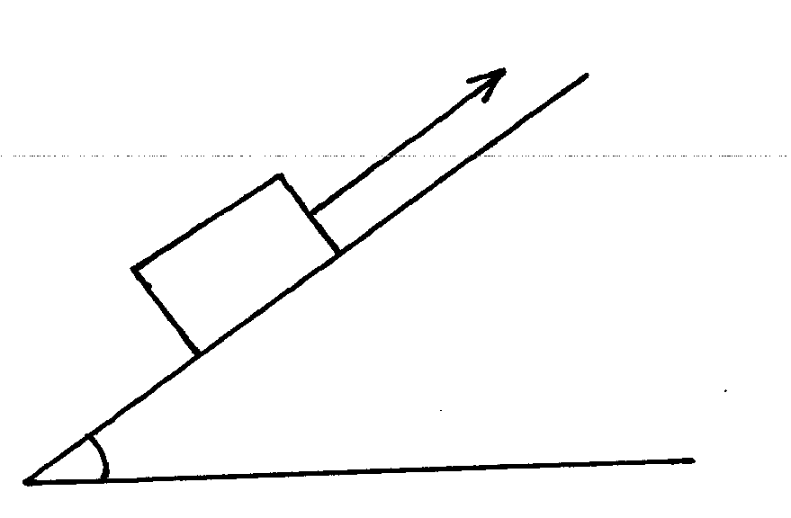
(ii) The figure below shows an inclined plane and a load of mass 15 kg pulled by an effort of 100N
100 N
15 kg
30º
Fig 6

Find the efficiency of the machine. (3mks )

13. The graph below represents the relationship between 1 and pressure at constant temperature
volume
fig 7
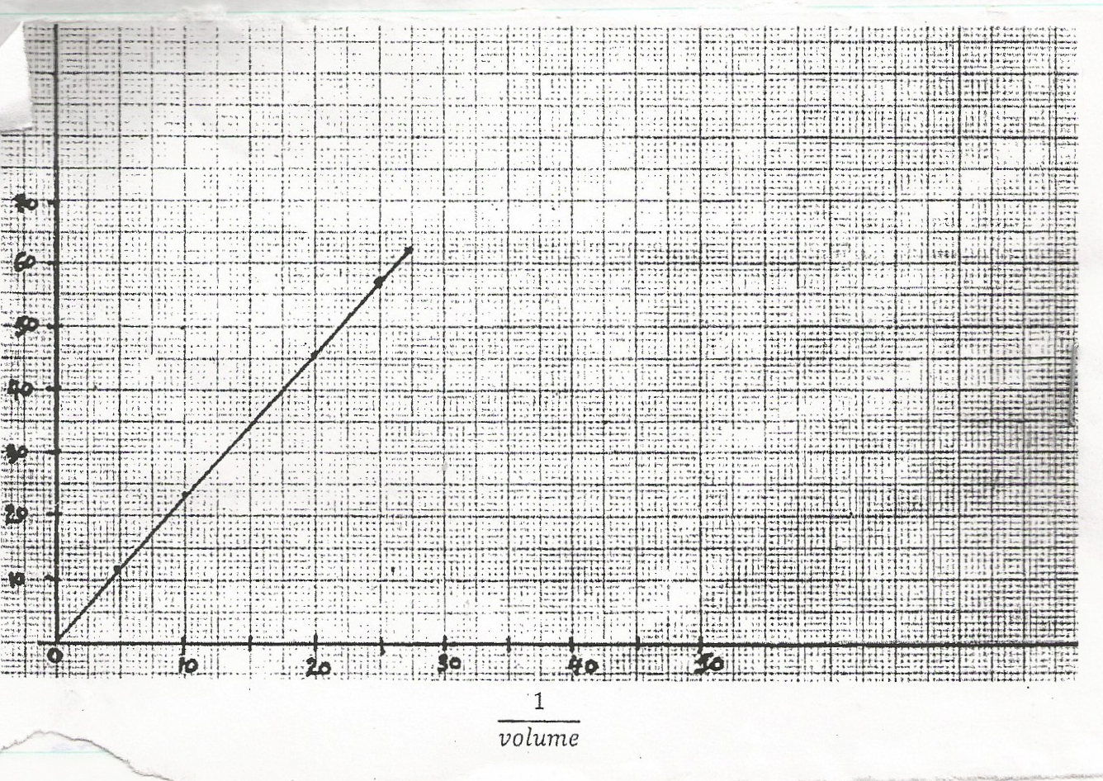

ρ Pressure

¹/_{Volume}

(i) With the aid of a labeled diagram describe the apparatus and the arrangement used in getting results used to plot the graph above. (4mks)

(ii) From the graph state the law under investigations. (1mk)
.................................................................................................................................................................
.................................................................................................................................................................
(iii) State and explain how the graph can be used to verify the law you have stated above. (3mks)
.................................................................................................................................................................
.................................................................................................................................................................
14. (a) State the Archimedes Principle. (1mk)
.................................................................................................................................................................
.................................................................................................................................................................
(b) (i) The reading on a spring balance is 7.2N when a metal ball bearing is hung from it’s lower end in air.
The density of the metal is 9.00gcm⁻³ and that of water is 1. 00 gcm⁻³ .The ball is immersed in
water in a Eureka can until it is completely submerged.
(i) What is the volume of the water displaced. (3mks)

(ii) What is the reading of the spring balance in Newtons when the ball is completely submerged
in water.
(3mks)

(c) Using the diagram below show all that forces acting on the metal ball bearing as it is submerged in the
water. (indicate with arrows) (3mks)
Fig 8
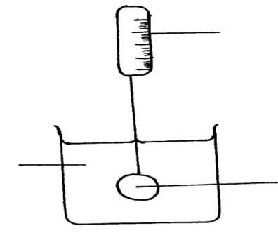
Spring balance
Ball Bearing
Water

15. (a) The figure below shows a bucket filled with water of mass 5kg tied on a string 3.6m long and rotated
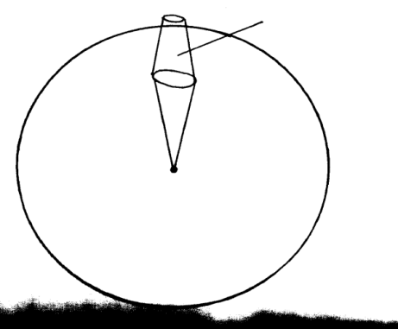
in a vertical circle with constant speed V m/s
Bucket
Fig 9

Calculate the minimum speed the bucket should be rotated at so as to pass position A without the water spilling ( Take g = 10ms⁻²) (3mks)
(b) The table below gives centripetal force F acting on a body moving in a circle of radius 2m for
different speeds v of the body.
Force f(N) | 0.4 | 1.6 | 3.6 | 6.4 | 10.0 | 14.4
Speed V (ms⁻¹) | 1.0 | 2.0 | 3.0 | 4.0 | 5.0 | 6.0
V²

(i) Complete the table above (1mk)
(ii) Plot a graph of F against V² (5mks)

(ii) Use your graph to determine the mass of the body. (3mks)

16. Explain why water kept in a porous pot on a hot day remain cooler than that contained in a metallic
vessel. (1mk)

(b) (i) An immersion heater takes 30 minutes to heat 20kg of water from 25ºC to 60ºC. How long would the same heater take to heat the same mass of kerosene through the same temperature change assuming no heat is lost to the surroundings?
Specific heat capacity of water = 4200JKg⁻¹K⁻¹
Specific heat capacity of Kerosene = 2200JKg⁻¹k⁻¹ (4mks)

(ii) How long would the same heater take to vaporize the whole amount of water.
Specific latent heat of vaporization of water = 2.26 x 10⁶ JKg⁻¹ (4mks)

(c) State two factors that affect the boiling point of water and in each case explain how it affected. (3mks)

.................................................................................................................................................................
.................................................................................................................................................................
.................................................................................................................................................................

