NAME: ………………………………………………………………………ADM NO:………

CLASS: .………

BIOLOGY
PAPER 2
THEORY
APRIL,2008
TIME 2 HOURS

KAPSABET GIRLS’ HIGH SCHOOL
PRE-MOCK EXAMINATION
Kenya Certificate Of Secondary Education 2008

INSTRUCTIONS TO CANDIDATES
- Write your name and Index number in the space provided above.
- Answer ALL the questions in section A in the spaces provided on the question paper.
- In section B answer question 6(compulsory) and either question 7 or 8 in the spaces provided after question 8.

For Examiner’s Use Only.

SECTION | QUESTIONS | MAXIMUM  SCORE | CANDIDATES  SCORE
 | 1 | 8
 | 2 | 8
 | 3 | 8
 | 4 | 8
 | 5 | 8
 | 6 | 20
 | 7 | 20
 | 8 | 20
TOTAL SCORE |  | 80

SECTION A( 40 MARKS)
Answer all the questions in the spaces provided.
- In an experiment to investigate a factor affecting photosynthesis, a leaf of a potted plant which had been kept in the dark overnight was covered with aluminium foil as shown in the diagram below.
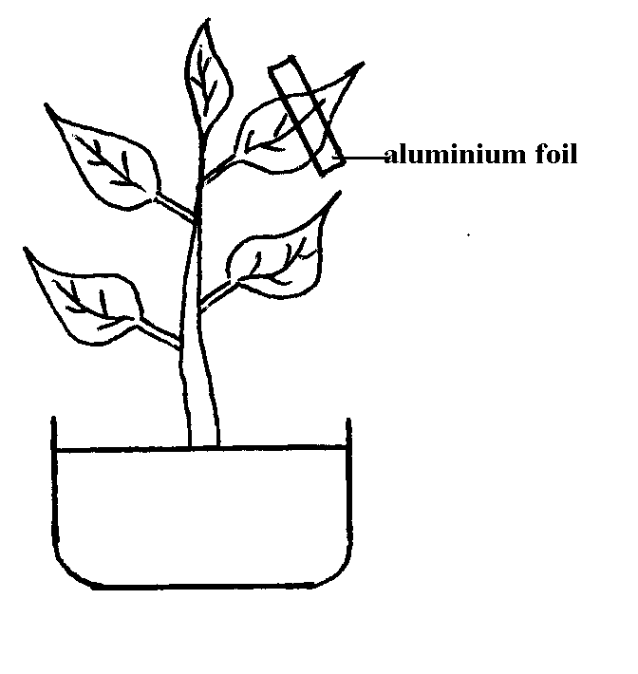

The setup was kept in sunlight for three hours after which a food test was carried out on the leaf.
- Which food test was carried out? (1mk)
………………………………………………………………………………………………
- (i) State the results of the food test. (2mks)
………………………………………………………………………………………………
………………………………………………………………………………………………
(ii) Account for the result of the food test. (2mks)
………………………………………………………………………………………………
………………………………………………………………………………………………
………………………………………………………………………………………………
………………………………………………………………………………………………
- (i) Why was the set up kept in sunlight for three hours. (1mk)
………………………………………………………………………………………………
(ii) Why was it necessary to keep the plant in the darkness before the experiment? (1mk)
………………………………………………………………………………………………
- Other than light state one other factor that affects the rate of photosynthesis. (1mk)
………………………………………………………………………………………………

- (a) Write the sequence of messenger RNA (m – RNA) that would be coded from the DNA strand shown below.
C – A – T – G – A – A – G – T
Sequence of m-RNA
……………………………………………………………………………………………. (1mk)

(b) (i) What is gene mutation? (1mk)
………………………………………………………………………………………………
………………………………………………………………………………………………

(ii) State two disorders in human beings caused by gene mutations. (2mks)
………………………………………………………………………………………………
………………………………………………………………………………………………
(c) A cow produced a calf with an extra tail.

  - What is the genetic name given to the calf? (1mk)
………………………………………………………………………………………………

  - What name is given to the factors in the environment that encourage or speed up mutation? (1mk)
………………………………………………………………………………………………
(d) State the significance of chiasma formation during meiotic cell division. (2mks)
………………………………………………………………………………………………
………………………………………………………………………………………………

- The diagram below represents part of a phloem tissue. (3mks)
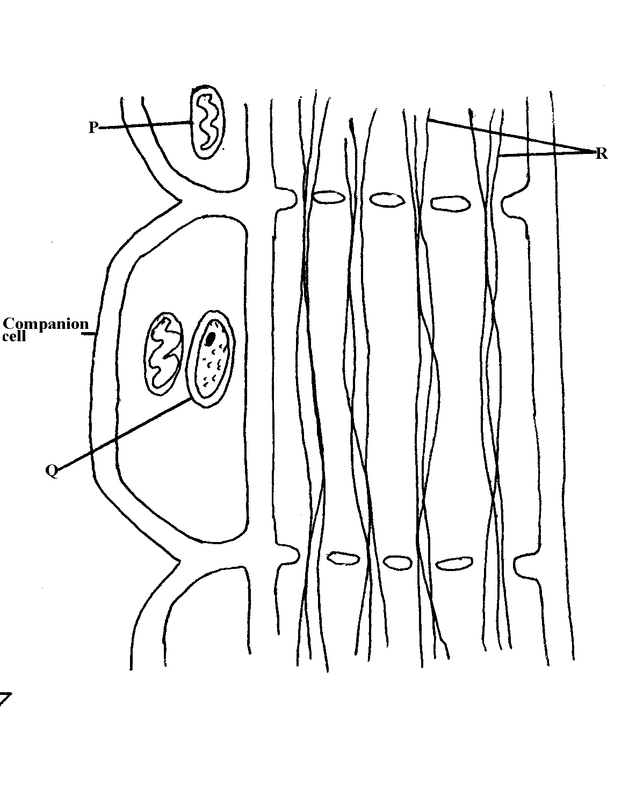
- Name the structures labelled P, Q, and R (3mks)
P …………………………………………………………………………..
Q ………………………………………………………………………….
R ………………………………………………………………………….
- State the function of the phloem tissue. (1mk)
………………………………………………………………………………………………
………………………………………………………………………………………………

- (i) State how the functioning of the phloem tissue is affected if the companion cell is destroyed. (1mk)
………………………………………………………………………………………………
………………………………………………………………………………………………
(ii) Give a reason for your answer. (1mk)
………………………………………………………………………………………………
………………………………………………………………………………………………
- State two structural differences between phloem and xylem tissues. (2mks)
………………………………………………………………………………………………
………………………………………………………………………………………………
………………………………………………………………………………………………
………………………………………………………………………………………………

- The table below shows different percentage composition in inhaled, alveolar and exhaled air.
 | Percentage of total volume
 | Oxygen | Carbon (IV) oxide | Water vapour | Temperature (⁰C)
Atmospheric  Alveolar  Exhaled | 20.85  13.8  15.30 | 0.04  5.5  4.0 | Variable  Saturated  Saturated | Variable  37  37
- Using the table explain why :-
  - The volume of oxygen decreases in exhaled air. (2mks)
………………………………………………………………………………………………
………………………………………………………………………………………………
  - The volume of carbon (IV) oxide increases in the exhaled air. (1mk)
………………………………………………………………………………………………
………………………………………………………………………………………………
- Suggest the reason for the sarutation of water vapour in exhaled and alveolar air. (3mks)
……………………………………………………………………………………………
………………………………………………………………………………………………
………………………………………………………………………………………………
- Other than health status, state two other factors that affect the rate of breathing in man.
(2mks)
………………………………………………………………………………………………
………………………………………………………………………………………………
- The diagram below represents a flower.
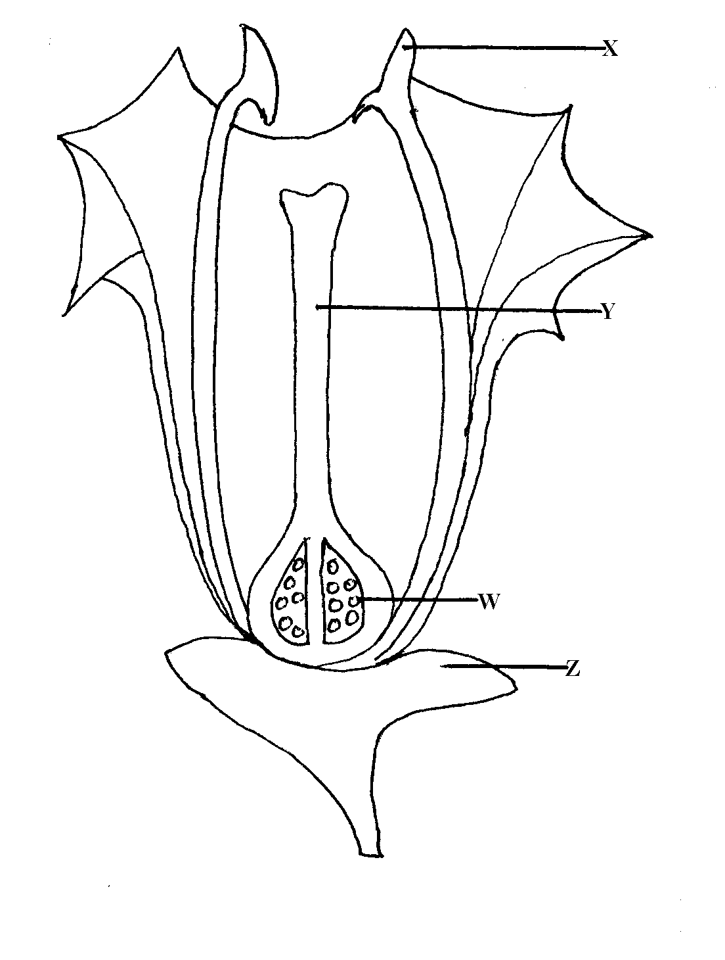
- Name the parts labelled X and Y. (2mks)
X ………………………………………………………………………………………
Y ………………………………………………………………………………………
- Describe the ovary position. (1mk)
………………………………………………………………………………………………
………………………………………………………………………………………………
- (i) Suggest an agent of pollination of the flower above. (1mk)
………………………………………………………………………………………………
………………………………………………………………………………………………
(ii) Give a reason for your answer above. (1mk)
………………………………………………………………………………………………
………………………………………………………………………………………………
- On the diagram above, which part do you expect to find haploid nucleus after meiosis? (1mk)
………………………………………………………………………………………………
- In the flower above its sepals cell was found to have 20 chromosomes. What would be the number of chromosomes found in the endosperm cell of the flower embryo sac after fertilization? (1mk)
………………………………………………………………………………………………
………………………………………………………………………………………………
- State one way in which flowers prevent self – pollination. (1mk)
………………………………………………………………………………………………
………………………………………………………………………………………………

SECTION B (40 MARKS)
Answer question 6 (compulsory) and either question 7 or 8 in the spaces provided.
- A group of students estimated the population of grasshoppers in the school compound. The table below shows the number of grasshoppers collected from the eight sites within the compound.
Site | 1 | 2 | 3 | 4 | 5 | 6 | 7 | 8
No. of grasshoppers | 280 | 50 | 190 | 220 | 85 | 300 | 175 | 30

- Draw histograms to represent the number of grasshoppers collected from each site. (5mks)

- The students caught 240 grasshoppers marked them and then released them. After five days they caught 160 grasshoppers and found that 40 were marked. Work out the grasshoppers population in the compound. (2mks)
………………………………………………………………………………………………
………………………………………………………………………………………………
………………………………………………………………………………………………
- Identify the method used in (b) above. (1mk)
………………………………………………………………………………………………
- Name the instrument the students used to collect and mark the grasshoppers. (2mks)
………………………………………………………………………………………………
- State the limitations of the method identified in (c) above. (3mks)
………………………………………………………………………………………………
………………………………………………………………………………………………
………………………………………………………………………………………………
………………………………………………………………………………………………
- State observable adaptations the students would have noted in the grasshopper regarding.
  - Locomotion. (3mks)
………………………………………………………………………………………………
………………………………………………………………………………………………
………………………………………………………………………………………………
  - Protection. (2mks)
………………………………………………………………………………………………
………………………………………………………………………………………………
………………………………………………………………………………………………
  - Feeding. (2mks)
………………………………………………………………………………………………
………………………………………………………………………………………………
- (a) Name Five methods of excretion in plants. (5mks)
(b)Give Three reasons why plants lack complex excretory system (3mks)
(b) State six excretory products in plants and give their economic uses. (12mks)

8 . Describe the adaptations of the mammalian heart to it’ s functions ( 20 mks )

………………………………………..………………………………………
…………………………………………………………………..………………………………………
…………………………………………………………………..………………………………………
…………………………………………………………………..………………………………………
…………………………………………………………………..………………………………………
…………………………………………………………………..………………………………………
…………………………………………………………………..………………………………………
…………………………………………………………………..………………………………………
…………………………………………………………………..………………………………………
…………………………………………………………………..………………………………………
…………………………………………………………………..………………………………………
…………………………………………………………………..………………………………………
…………………………………………………………………..………………………………………
…………………………………………………………………..………………………………………
…………………………………………………………………..………………………………………
…………………………………………………………………..………………………………………
…………………………………………………………………..………………………………………
…………………………………………………………………..………………………………………
…………………………………………………………………..………………………………………
…………………………………………………………………..………………………………………
…………………………………………………………………..………………………………………
…………………………………………………………………..………………………………………
…………………………………………………………………..………………………………………
…………………………………………………………………..………………………………………
…………………………………………………………………..………………………………………
…………………………………………………………………..………………………………………
…………………………………………………………………..………………………………………
…………………………………………………………………..………………………………………
…………………………………………………………………..………………………………………
…………………………………………………………………..………………………………………
…………………………………………………………………..………………………………………
…………………………………………………………………..………………………………………
…………………………………………………………………..………………………………………
…………………………………………………………………..………………………………………
…………………………………………………………………..………………………………………
…………………………………………………………………..………………………………………
…………………………………………………………………..………………………………………
…………………………………………………………………..………………………………………
…………………………………………………………………..………………………………………
…………………………………………………………………..………………………………………
…………………………………………………………………..………………………………………
…………………………………………………………………..………………………………………
…………………………………………………………………..………………………………………
…………………………………………………………………..………………………………………
…………………………………………………………………..………………………………………
…………………………………………………………………..………………………………………
…………………………………………………………………..………………………………………
…………………………………………………………………..………………………………………
…………………………………………………………………..………………………………………
…………………………………………………………………..………………………………………
…………………………………………………………………..………………………………………
…………………………………………………………………..………………………………………
…………………………………………………………………..………………………………………
…………………………………………………………………..………………………………………
…………………………………………………………………..………………………………………
…………………………………………………………………..………………………………………
…………………………………………………………………..………………………………………
…………………………………………………………………..………………………………………
…………………………………………………………………..………………………………………
…………………………………………………………………..………………………………………
…………………………………………………………………..………………………………………
…………………………………………………………………..………………………………………
…………………………………………………………………..………………………………………
…………………………………………………………………..………………………………………

