Name:………………………………………………………………………….. Index No. ……………………………..
School: ……………………………………………………………Date: …………………….. Sign……………………
232/1
PHYSICS
PAPER 1
JULY /AUGUST 2012
TIME: 2 HOURS

JOINT INTER-SCHOOLS EVALUATION TEST (JISET)
Kenya Certificate of Secondary Education (K.C.S.E.) 2012

232/1
PHYSICS
PAPER1
JULY /AUGUST 2012
INSTRUCTIONS:
- Write your name and index number in the space provided above
- Sign and write the date of examination in the spaces provided above.
- This paper consist of TWO section A and B
- Answer ALL questions in section A and B in the spaces provided.
- ALL working must be clearly shown.
- Mathematical tables and electronic calculators may be used. Take g =10m/s²
FOR EXAMINERS USE ONLY
SECTION | QUESTION | MAXIMUM SCORE | CANDIDATES SCORE
A | 1-14 | 25
B | 15 | 9
B | 16 | 13
B | 17 | 9
B | 18 | 10
B | 19 | 14
 | TOTAL SCORE | 80

SECTION A (25MARKS)
- An air bubble expands as it rises to the surface of water in a deep pond. State the cause of this given that the temperature remains constant. (1mrk)
………………………………………………………………………………………………………………………………………………………………………………………………………………………………………………………………………………………………………………………………………………………………………………………………………………………………………………………………………………………
- The simple pulley in figure 1 is used to lift a 3kg mass.
F
3kg

Through what distance must the string at F be pulled to lift the mass 0.2m high. (2mrks)
……………………………………………………………………………………………………………………………………………………………………………………………………………………………………………………………………………………………………………………………………………………………………………………………………………………………………………………………………………………………………………………………………………………………………………………………………………………………………………………
- The thermal conductivity of a metal increases with the increase cross-sectional area of the metal. Explain how the cross-section affects conductivity using the electron movement. (1mrk)
………………………………………………………………………………………………………………………………………………………………………………………………………………………………………………………………………………………………………………………………………………………………………………………………………………………………………………………………………………………
- The set up figure 2 is used to investigate the effect of pressure on melting point. It is observed that the thin wire cuts through the ice block but it remains one piece.
Masses
Ice
Thin wire

Explain the observation above. (2mrks)
………………………………………………………………………………………………………………………………………………………………………………………………………………………………………………………………………………………………………………………………………………………………………………………………………………………………………………………………………………………
- (i). Explain why a liquid and not a gas is used as a hydraulic machine fluid. (1mrk)
………………………………………………………………………………………………………………………………………………………………………………………………………………………………………………………………………………………………………………………………………………………………………………………………………………………………………………………………………………………
ii). State the other important property of a liquid that hydraulic machines depend on. (1mrk)
……………………………………………………………………………………………………………………………………………………………
…………………………………………………………………………………………………………………………………………………………………………………………………………………………………………………………………………………………………………………………
- Figure 3 shows a marble placed on an inverted bowl.
Marble
Bowl

State and explain the type of equilibrium the marble is. (2mrk)
………………………………………………………………………………………………………………………………………………………………………………………………………………………………………………………………………………………………………………………………………………………………………………………………………………………………………………………………………………………
- i) Figure 4 shows two forces acting on an object, P is a force of 20N and the object moves with constant velocity. What is the value of the opposing force F? (1mrk)
P
F

Figure 4
……………………………………………………………………………………………………………………………………………………………
ii).Figure 5 shows the forces acting on a rain drop which is falling to the ground
B
A

a).i). Name the force A causing the raindrop to fall. (1mrk)
……………………………………………………………………………………………………………………………………………………………
ii).Force B opposes the motion of the drop. State one possible cause of this force. (1mrk)
…………………………………………………………………………………………………………………………………………………………………………………………………………………………………………………………………………………………………………………………
b). State what happens to the drop when force A = force B (1mrk)
…………………………………………………………………………………………………………………………………………………………………………………………………………………………………………………………………………………………………………………………
- State two molecular differences between a real gas and ideal gas. (2mrks)
……………………………………………………………………………………………………………………………………………………………………………………………………………………………………………………………………………………………………………………………………………………………………………………………………………………………………………………………………………………………………………………………………………………………………………………………………………………………………………………

- A man lifts a weight of 300N through a vertical height of 2m in 6 seconds. Determine the power developed. (2mrks)
……………………………………………………………………………………………………………………………………………………………………………………………………………………………………………………………………………………………………………………………………………………………………………………………………………………………………………………………………………………………………………………………………………………………………………………………………………………………………………………
- A drop of Methylated spirit placed on the back of the hand feels colder than a drop of water at the same temperature. (1mrk)
………………………………………………………………………………………………………………………………………………………………………………………………………………………………………………………………………………………………………………………………………………………………………………………………………………………………………………………………………………………
- “Air flow over the wings of an air craft causes a lift”. Explain this statement with the aid of a labeled diagram. (2mrks)

- Figure 6 shows a suspended copper solid immersed in a fluid.
String
Copper Block
Liquid

Figure 6
Explain what will happen to the tension in the string if a liquid of higher density is used. (1mrk)
……………………………………………………………………………………………………………………………………………………………………………………………………………………………………………………………………………………………………………………………………………………………………………………………………………………………………………………………………………………………………………………………………………………………………………………………………………………………………………………
- A bucket containing water is rotated in vertical circle of radius 80cm. What should be its velocity so that the water may not spill out. (2mrks)
…………………………………………………………………………………………………………………………………………………………………………………………………………………………………………………………………………………………………………………………………………………………………………………………………………………………………………………………………………………………………………………………………………………………………………………………………………………………………………………………………………………………………………………………………………………………………………………………………………………
- A rubber ball of mass 400g strikes a wall horizontally at 6.0m/s and bounces back at 4m/s. In 0.02 second. Determine the total force it exerts on the wall. (2mrks)
…………………………………………………………………………………………………………………………………………………………………………………………………………………………………………………………………………………………………………………………………………………………………………………………………………………………………………………………………………………………………………………………………………………………………………………………………………………………………………………………………………………………………………………………………………………………………………………………………………………………………………………………………………………………………………………………………………………………………………………………………………………………………………………………………………………………………………………………………………………………………………………………………………………………………………………………………………………………………………

SECTION B (55MARKS)
- a) State the pressure law of an ideal gas. (1mrk)
……………………………………………………………………………………………………………………………………………………………………………………………………………………………………………………………………………………………………………………………………………………………………………………………………………………………………………………………………………………………………………………………………………………………………………………………………………………………………………………
b). At 20⁰c the pressure of a gas is 50cm of mercury. At what temperature would the pressure of the gas fall by 30cm of mercury. Give the temperature in degrees Celsius. (2mrks)
…………………………………………………………………………………………………………………………………………………………………………………………………………………………………………………………………………………………………………………………………………………………………………………………………………………………………………………………………………………………………………………………………………………………………………………………………………………………………………………………………………………………………………………………………………………………………………………………………………………
c). Define the absolute zero of the Kelvin temperature scale. (1mrk)
………………………………………………………………………………………………………………………………………………………………………………………………………………………………………………………………………………………………………………………………………………………………………………………………………………………………………………………………………………………
d) A hole of area 2.0 cm² at the bottom of a tank 2m deep is closed with a cork. Determine the force on the cork when the tank if filled with water. Take density of water = 1000kgm⁻³ and g = 10m/s² (4mrks)
……………………………………………………………………………………………………………………………………………………………………………………………………………………………………………………………………………………………………………………………………………………………………………………………………………………………………………………………………………………………………………………………………………………………………………………………………………………………………………………………………………………………………………………………………………………………………………………………………………………………………………………………………………………………………………………………………………………………………………………………………………………………………………………………………………………………………………………………………………
……………………………………………………………………………………………………………………………………………………………

- Ian has a mass of 70kg. He dives from a high diving pond. His vertical velocity at different times is shown in the graph in figure 7.
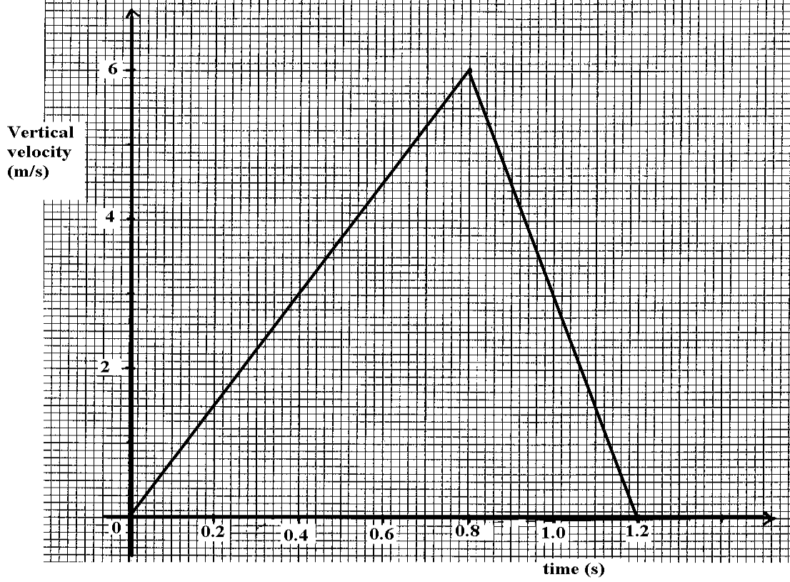
a). From the graph
i) Determine the height of the diving board (3mrks)
…………………………………………………………………………………………………………………………………………………………………………………………………………………………………………………………………………………………………………………………
ii) Determine the retarding force on Ian in the water. (3mrks)
…………………………………………………………………………………………………………………………………………………………………………………………………………………………………………………………………………………………………………………………
b) i) Calculate the loss of Ian’s Potential energy after 0.5sec diving. (3mrks)
…………………………………………………………………………………………………………………………………………………………………………………………………………………………………………………………………………………………………………………………………………………………………………………………………………………………………………………………………………………………………………………………………………………………………………………………………………………………………………………………………………………………………………………………………………………………………………………………………………………

ii).Determine Ian’s kinetic energy 0.5s after he started the dive. (3mrks)
…………………………………………………………………………………………………………………………………………………………………………………………………………………………………………………………………………………………………………………………………………………………………………………………………………………………………………………………………………………………………………………………………………………………………………………………………………………………………………………………………………………………………………………………………………………………………………………………………………………
iii) Give an explanation for the differences between the answer to part b) (i) and (ii). (1mrk)
…………………………………………………………………………………………………………………………………………………………………………………………………………………………………………………………………………………………………………………………
- Figure 8 shows a child of mass 40kg at point A of a fair ground ride. If the velocity of the child at A is 8m/s and the wheel exhibits uniform circular motion,
C
A
B
D
6m

a). Determine the velocity of the child at point B. (2mrks)
………………………………………………………………………………………………………………………………………………………………………………………………………………………………………………………………………………………………………………………………………………………………………………………………………………………………………………………………………………………
b) Determine the centripetal force acting on the child. (3mrks)
……………………………………………………………………………………………………………………………………………………………………………………………………………………………………………………………………………………………………………………………………………………………………………………………………………………………………………………………………………………………………………………………………………………………………………………………………………………………………………………
c). At which position will the normal reaction of the seat be maximum? Give a reason for your
answer. (2mrks)
…………………………………………………………………………………………………………………………………………………………………………………………………………………………………………………………………………………………………………………………………………………………………………………………………………………………………………………………………………………………………………………………………………………………………………………………………………………………………………………………………………………………………………………………………………………………………………………………………………………
d). Sketch a graph of gravitational potential energy of the child against height as she moves from
point A to Point C. On the graph indicate the values of gravitational potential energy at points A B
and C. (3mrks)
Gravitational potential
Energy (J)
Height (m)

- a) Define specific heat capacity. (1mrk)
………………………………………………………………………………………………………………………………………………………………………………………………………………………………………………………………………………………………………………………………………………………………………………………………………………………………………………………………………………………
b) In an experiment to determine the specific latent heat of water, steam at 100⁰C was passed into water contained in a well lagged copper calorimeter.
The following measurements were made
    - Mass of colorimeter = 60g
    - Initial mass of water = 80g
    - Initial room temperature of water = 15⁰c
    - Final temperature of the mixture 45⁰c
    - Final mass of water + calorimeter + condensed steam =160g
    - Specific heat capacity of water = 4200Jkg⁻¹k⁻¹ and specific heat capacity of copper = 390Jkg⁻¹k⁻¹
i). Calculate:
a) Mass of condensed steam (1mrk)
………………………………………………………………………………………………………………………………………………………………………………………………………………………………………………………………………………………………………………………………………………………………………………………………………………………………………………………………………………………

b) Heat gained by the calorimeter and water. (4mrks)
…………………………………………………………………………………………………………………………………………………………………………………………………………………………………………………………………………………………………………………………………………………………………………………………………………………………………………………………………………………………………………………………………………………………………………………………………………………………………………………………………………………………………………………………………………………………………………………………………………………
ii) Given that Lv is the specific latent heat of evaporation of steam,
a). Write an expression for the latent heat of vaporization of steam. (2mrks)
…………………………………………………………………………………………………………………………………………………………………………………………………………………………………………………………………………………………………………………………
b) Determine the value of Lv. (2mrks)
……………………………………………………………………………………………………………………………………………………………………………………………………………………………………………………………………………………………………………………………………………………………………………………………………………………………………………………………………………………………………………………………………………………………………………………………………………………………………………………
19. Figure 9 shows the same metal block weighted in the air, water and liquid. Given that the reading of the level of water becomes 75cm³ when the metal is fully immersed,
Figure 9
0.9N
0.80N
Water
Liquid
0.82N

- b) c)

Determine ( i) Density of the metal (3mrks)
……………………………………………………………………………………………………………………………………………………………………………………………………………………………………………………………………………………………………………………………………………………………………………………………………………………………………………………………………………………………………………………………………………………………………………………………………………………………………………………
ii) Water level before the solid was immersed. (2mrks)
………………………………………………………………………………………………………………………………………………………………………………………………………………………………………………………………………………………………………………………………………………………………………………………………………………………………………………………………………………………

iii) Explain why the spring balance gives different reading in figure 9 (b) and 9 (c) with the same
metal block. (2mrks)
………………………………………………………………………………………………………………………………………………………………………………………………………………………………………………………………………………………………………………………………………………………………………………………………………………………………………………………………………………………
b) A piece of wood of mass 16g and volume 20cm³ floats on water. What additional mass should be placed on it so that it may float with its surface level within the surface of water. (2mrks)
………………………………………………………………………………………………………………………………………………………………………………………………………………………………………………………………………………………………………………………………………………………………………………………………………………………………………………………………………………………
c) i). State one conditions of equilibrium for a body acted upon by a number of parallel forces.(1mrk)
…………………………………………………………………………………………………………………………………………………………………………………………………………………………………………………………………………………………………………………………

ii).Figure 10 below shows a uniform plank of length 6.0cm acted upon by forces shown. If the plank has a weight of 30N, determine the weight of W given that volume of metal block is 5000cm³, density of water = 1g/cm³ (4mrks)
1m
1m
1.0m
W
10N

Figure 10.

