Name:………………………………………………………………………….. Index No. ……………………………..
School: ……………………………………………………………Date: …………………….. Sign……………………
232/2
PHYSICS
PAPER 2
JULY /AUGUST 2012
TIME: 2 HOURS

JOINT INTER-SCHOOL EVALUATION TEST (JISET)
Kenya Certificate of Secondary Education (K.C.S.E.) 2012

232/2
PHYSICS
PAPER 2
JULY /AUGUST 2012

INSTRUCTIONS TO THE CANDIDATES:
- Write your name and index number in the spaces provided above
- This paper consists of two sections A and B.
- Answer all questions in section A and B in the spaces provided.
- All working must be clearly shown in the spaces provided.
- Mathematical tables and electronic calculators may be used.
- Take h = 6.64 x 10⁻³⁴js
- M_{e} = 9.1 x 10⁻³¹ Kg,
For Examiners’ Use Only
SECTION | QUESTION | MAXIMUM SCORE | CANDIDATE’S SCORE
A | 1-16 | 25
B | 17 | 12
B | 18 | 10
B | 19 | 14
B | 20 | 12
B | 21 | 7
 | TOTAL | 80

SECTION A (25 marks)
Answer all questions in this section in the spaces provided
- Figure 1 shows an object AB placed in front of a pin-hole camera. Using a ray diagram, show how the image is formed on the screen.
A
B
Pin hole
Screen

- State the conditions necessary for a wave incident on a slit to be diffracted. (2mrks)
…………………………………………………………………………………………………………………………………………………………………………………………………………………………………………………………………………………………………………
- Figure 2 represents a transformer connected to an Ac source and a resistor R.
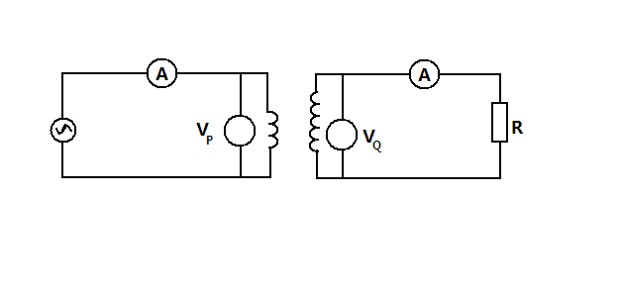
Circuit P
Circuit Q

a). Compare the ratios and where I_{p} and I_{Q} are the currents flowing through the circuits P and Q respectively while V_{P} and V_{Q} are the potential differences across the circuits P and Q respectively. (1mrk)
………………………………………………………………………………………………………………………………………………………………………………………………………………………………………………………………………………………………………………………………………………………………………………………………………………………………………………………………
……………………………………………………………………………………………………………………………………………………
b) State the assumption made in question 3 (a) above. (1mrk)
…………………………………………………………………………………………………………………………………………………………………………………………………………………………………………………………………………………………………………
……………………………………………………………………………………………………………………………………………………
- Figure 3 below shows a simple experiment using a permanent magnet and two metal bars X and Y put closer the iron fillings.
S
N
Y
X
a).During attraction
X
Y
b).After attraction

State with a reason which bar is made from a soft magnetic material. (2mrks)
…………………………………………………………………………………………………………………………………………………………………………………………………………………………………………………………………………………………………………
…………………………………………………………………………………………………………………………………………………………………………………………………………………………………………………………………………………………………………
- State one difference between a chemical reaction and radioactivity. (1mrk)
…………………………………………………………………………………………………………………………………………………………………………………………………………………………………………………………………………………………………………
- Figure 4 shows a Zener diode connected in a circuit in series with a bulb.
S2
S1
Bulb

It is observed that the bulb lights when both switches S₁ and S₂ are closed. State and explain the observation made on the bulb when S₁ is closed and S₂ is open. (2mrks)
…………………………………………………………………………………………………………………………………………………………………………………………………………………………………………………………………………………………………………
…………………………………………………………………………………………………………………………………………………………………………………………………………………………………………………………………………………………………………
- State the advantage of generating an Ac supply rather than DC voltage supply in a power station. (1mrk)
…………………………………………………………………………………………………………………………………………………………………………………………………………………………………………………………………………………………………………
- Figure 5 shows a force on a conductor carrying current when placed in a magnetic field.
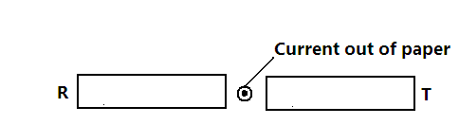
Figure 5
State the polarities R and T. (1mrk)
T _____________________________________________________
R _____________________________________________________
- What is the purpose of a fuse in domestic wiring system? (1mrk)
……………………………………………………………………………………………………………………………………………………
……………………………………………………………………………………………………………………………………………………
- The period of a wave is T seconds. Its wavelength is λ metres. Show that v = fλ where v is the speed of the wave and f is the frequency. (2mrks)
……………………………………………………………………………………………………………………………………………………
……………………………………………………………………………………………………………………………………………………
……………………………………………………………………………………………………………………………………………………
- In determining the depth of an ocean, an echo sounder producing ultrasonic sound is used. Give one reason why this sound is preferred. (1mrk)
……………………………………………………………………………………………………………………………………………………
……………………………………………………………………………………………………………………………………………………
- What causes electrical resistance in conductors? (1mrk)
……………………………………………………………………………………………………………………………………………………
……………………………………………………………………………………………………………………………………………………
- State one advantage of a CRO as a voltmeter over other voltmeters. (1mrk)
……………………………………………………………………………………………………………………………………………………
……………………………………………………………………………………………………………………………………………………
- A ray of light incident on the surface of a glass prism is observed as represented in the
White Light
Colours of the spectrum

Figure 6.
Explain this observation. (2mrks)
……………………………………………………………………………………………………………………………………………………
……………………………………………………………………………………………………………………………………………………
……………………………………………………………………………………………………………………………………………………
- Figure 7 shows how a distant object is focused in defective eye.

Parallel Rays

Figure 7
a).State the nature of effect. (1mrk)
……………………………………………………………………………………………………………………………………………………
b). Suggest a suitable lens to correct the defect. (1mrk)
……………………………………………………………………………………………………………………………………………………
……………………………………………………………………………………………………………………………………………………
- One of the isotopes of Uranium has a half life of 576 hours.
- Complete the table below to show how the mass varies with time from the initial mass of 4000mg.
Time (minutes) | 34560 | 69120
Mass (mg) | 4000
- Explain why the mass of the isotope will not eventually reduce to zero. (1mrk)
……………………………………………………………………………………………………………………………………………………
…………………………………………………………………………………………………………………………………………………………………………………………………………………………………………………………………………………………………………
……………………………………………………………………………………………………………………………………………………
SECTION B (55Marks)
Answer ALL the questions in this section in the spaces provided
- a).The following nuclear reaction is part of radioactive series.
${}_{\text{82}}^{\text{210}}{}A \vec{ β} {}_{x}^{\text{210}}{}B \vec{r} {}_{\text{84}}^{\text{210}}{}C \vec{s} {}_{\text{82}}^{y}{}D$
i). Name the radiations represented by r and s (2mrks)
s_____________________________________________________
r_____________________________________________________
ii). Determine the numbers represented by x and y. (2mrks)
y
……………………………………………………………………………………………………………………………………………………
……………………………………………………………………………………………………………………………………………………
X
……………………………………………………………………………………………………………………………………………………
……………………………………………………………………………………………………………………………………………………
b) Figure 8 shows the features of a diffusion cloud chamber used for detecting radiations for radioactive sources.
Black velvet chamber
Perspex lid
Trans-parent glass
Source of light
Felt soaked in alcohol
Air
Radioactive source
Solid Co₂ at -78⁰c
Foam

- State the property of alcohol that makes it suitable for use in the chamber. (1mrk)
……………………………………………………………………………………………………………………………………………………
……………………………………………………………………………………………………………………………………………………
- State the function of the Perspex lid. (1mrk)
……………………………………………………………………………………………………………………………………………………
……………………………………………………………………………………………………………………………………………………
- Explain why the base velvet chamber is painted black. (1mrk)
……………………………………………………………………………………………………………………………………………………
……………………………………………………………………………………………………………………………………………………
- Explain how the radiation from the radioactive source is detected in chamber. (4mrks)
……………………………………………………………………………………………………………………………………………………
…………………………………………………………………………………………………………………………………………………………………………………………………………………………………………………………………………………………………………
……………………………………………………………………………………………………………………………………………………
- State two advantages of the cloud chamber over a charged gold leaf electroscope when used as detectors of radiations. (2mrks)
……………………………………………………………………………………………………………………………………………………
……………………………………………………………………………………………………………………………………………………
……………………………………………………………………………………………………………………………………………………
- a). Figure 8 shows an object AB, placed in front of a converging mirror. C is the center of curvature of the mirror.
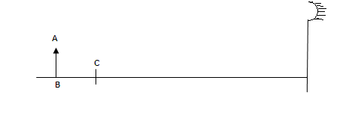
Using a ray diagram, determine the size of the image of AB as reflected by the mirror. (4mrks)
b). In an experiment to determine the local length of a convex lens, the corresponding values of the object distance u, and the image distance v, both measured from the optical center of the lens were obtained. The graph below shows the relationship between v and u.
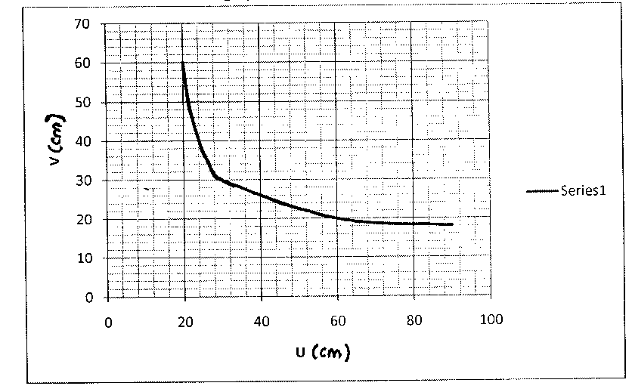
- Using the graph above and without using the lens formula, determine the value of the focal length of the lens. (3mrks)
……………………………………………………………………………………………………………………………………………………
……………………………………………………………………………………………………………………………………………………
……………………………………………………………………………………………………………………………………………………
- A convex mirror of focal length 10cm forms an image 5cm from the mirror. By calculations, determine the position of the object as measured from the mirror. (3mrks)
……………………………………………………………………………………………………………………………………………………
…………………………………………………………………………………………………………………………………………………………………………………………………………………………………………………………………………………………………………
……………………………………………………………………………………………………………………………………………………
- a) State Ohm’s law. (1mrk)
……………………………………………………………………………………………………………………………………………………
…………………………………………………………………………………………………………………………………………………………………………………………………………………………………………………………………………………………………………
b). A dry cell of emf E and an internal resistance of r is used to drive a current through various resistors of resistance R and the values of and R plotted on a graph in figure 9.
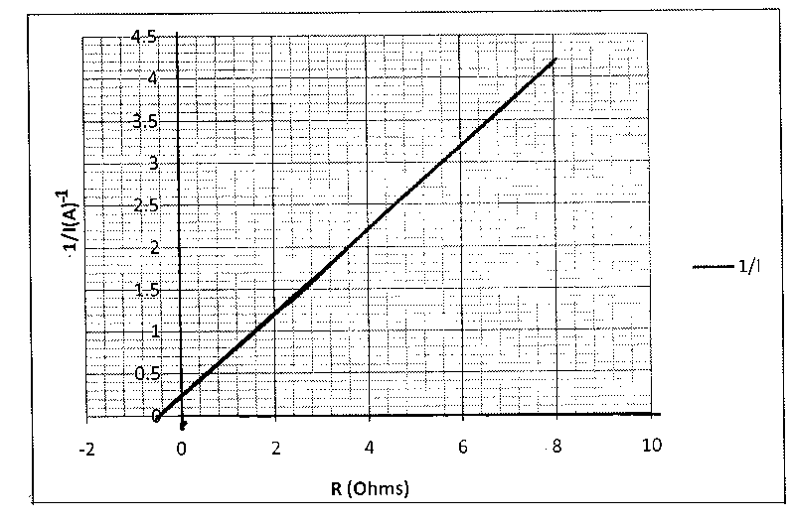
Figure 9.

The variables I and R are related by the equation = +
- Using the graph in figure 9, determine the emf, E of the cell. (4mrks)
……………………………………………………………………………………………………………………………………………………
…………………………………………………………………………………………………………………………………………………………………………………………………………………………………………………………………………………………………………
……………………………………………………………………………………………………………………………………………………
- Show that the internal resistance r of the cell is given by r = -R intercept and hence determine r. (3mrks)
……………………………………………………………………………………………………………………………………………………
…………………………………………………………………………………………………………………………………………………………………………………………………………………………………………………………………………………………………………
……………………………………………………………………………………………………………………………………………………
c). Figure 10 shows part of a ring main circuit connected to hair drier salon heater.
a
Heater
Fuse
Drier’s metal case
b
c

Figure 10.
Identify by giving a reason the wire labeled c. (2mrks)
……………………………………………………………………………………………………………………………………………………
……………………………………………………………………………………………………………………………………………………
……………………………………………………………………………………………………………………………………………………
d). Two lamps marked 75W 250V and an electric heater marked 2KW 250V are used for a period of 10 hours. Calculate the total cost of using them for this period if electricity costs Khs.4.5 per kWh unit. (4mrks)
……………………………………………………………………………………………………………………………………………………
…………………………………………………………………………………………………………………………………………………………………………………………………………………………………………………………………………………………………………
……………………………………………………………………………………………………………………………………………………
- a) State one property of X – rays that is not exhibited by visible light. (1mrk)
……………………………………………………………………………………………………………………………………………………
……………………………………………………………………………………………………………………………………………………
b).Figure 11 shows the features of an X- ray tube.
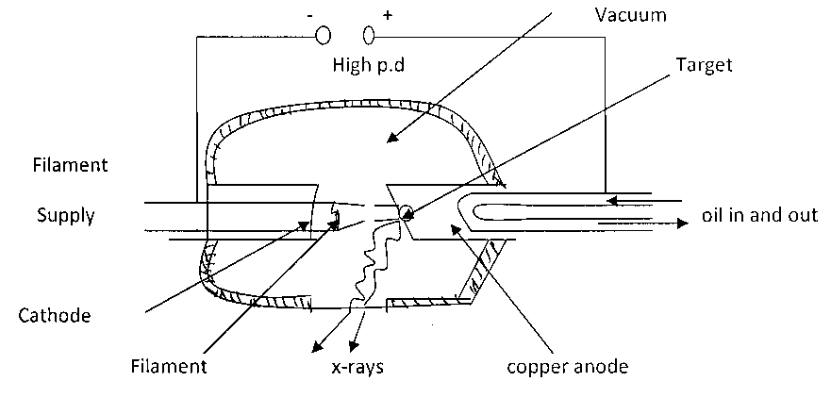
i). State how the electrons are produced. (1mrk)
……………………………………………………………………………………………………………………………………………………
……………………………………………………………………………………………………………………………………………………
ii).What is the effect on the wavelength of the X- rays produced when
- P.d across the tube is decreased. (1mrk)
……………………………………………………………………………………………………………………………………………………
……………………………………………………………………………………………………………………………………………
- The number of electrons hitting the metal target is increased. (1mrk)
……………………………………………………………………………………………………………………………………………………
……………………………………………………………………………………………………………………………………………………
iii). Why is copper metal used at the anode? (1mrk)
……………………………………………………………………………………………………………………………………………………
……………………………………………………………………………………………………………………………………………………
iv).State with a reason the property of molybdenum that makes it suitable as a target.(2mrks)
……………………………………………………………………………………………………………………………………………………
…………………………………………………………………………………………………………………………………………………………………………………………………………………………………………………………………………………………………………
……………………………………………………………………………………………………………………………………………………
v). Explain how soft X – rays are produced in this X – ray tube. (2mrks)
……………………………………………………………………………………………………………………………………………………
……………………………………………………………………………………………………………………………………………………
c). Calculate the maximum velocity of electrons that would produce X- rays of frequency 8.0 x 10⁸ Hz if only 20% of the kinetic energy is converted to X rays. (3mrks)
……………………………………………………………………………………………………………………………………………………
…………………………………………………………………………………………………………………………………………………………………………………………………………………………………………………………………………………………………………
……………………………………………………………………………………………………………………………………………………
21.a) Figure 12 shows a transverse stationary wave along a string
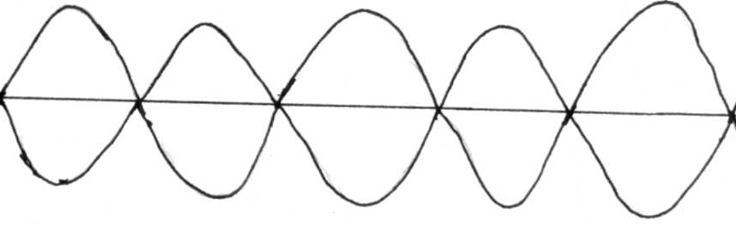

i). Label the nodes and antinodes on the diagram above. (1mrk)
ii). If the distance between an anti-node and consecutive node is 1.0 x 10⁻³m, determine the wavelength of the stationary wave. (2mrks)
……………………………………………………………………………………………………………………………………………………
…………………………………………………………………………………………………………………………………………………………………………………………………………………………………………………………………………………………………………
……………………………………………………………………………………………………………………………………………………
b). Five successive wave frequency in a ripple tank are observed to spread a distance of 6.4cm. If the vibrator has a frequency of 8 Hz, determine the speed of the wave. (2mrks)
……………………………………………………………………………………………………………………………………………………
…………………………………………………………………………………………………………………………………………………………………………………………………………………………………………………………………………………………………………
……………………………………………………………………………………………………………………………………………………

d). Figure 13 shows a transmitter producing both TV and radio waves.
Home
Hill
Transmitter
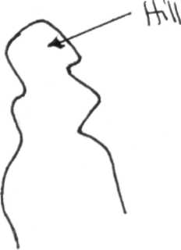

Briefly explain why radio reception will be better than TV beyond the hill. (2mrks)
……………………………………………………………………………………………………………………………………………………
…………………………………………………………………………………………………………………………………………………………………………………………………………………………………………………………………………………………………………
…………………………………………………………………………………………………………………………………………………………………………………………………………………………………………………………………………………………………………
……………………………………………………………………………………………………………………………………………………

