Name:………………………………………………………………………….. Index No. ……………………………..
School: ……………………………………………………………Date: …………………….. Sign……………………
232/3
PHYSICS
PAPER 3
JULY /AUGUST 2012
TIME: 2 ½ HOURS

JOINT INTER-SCHOOL EVALUATION TEST (JISET)
Kenya Certificate of Secondary Education (K.C.S.E.) 2012

232/3
PHYSICS
PAPER 3
JULY /AUGUST 2012
INSTRUCTIONS TO CANDIDATES

- Write your name and index number in the spaces provided above.
- Sign and write the date of the examination in the spaces provided.
- This paper consists of two question
- Answer all the questions in the spaces provided.
- You are supposed to spend the first 15 minutes of the 2½ hours allowed for this paper reading the whole paper carefully.
- Marks are given for clear recording of the observation actually made, accuracy and use of them
- Record your observation as soon as you get them.
- All working must be clearly shown.
- Non programmable silent electronic calculators and KNEC mathematical tables may be used

For examiners use only
Question | Maximum score | Candidates score
1 | 20
2 | 20
TOTAL | 40

Question 1 part (a) (13marks)
You are provided with the following apparatus.
-Clamp
-Stand
- Optical pin
-Copper wire
-Protractor (your own)
-Two pieces of plasticine
-Stop watch
-Cork
- Set up the apparatus as shown below.
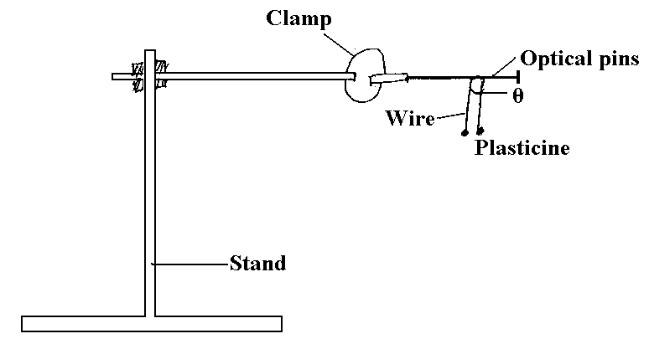
- Bend the wire in the middle so as to make an angle of 50⁰. Attach the two small pieces of plasticine at both ends of the wire as shown in the diagram.
- Place the bent wire on the optical pin and give a small horizontal displacement. Take the time for 10 oscillations and record in the table below.
- Repeat the procedure above for other values of θ and complete the table below.
Angle θ | Time t for 10 oscillation (sec) | Periodic time T (sec) | Frequency f (HZ) | f² (HZ)² | Cos (θ/2)
50
60
70
80
90
100

- i). on the graph provided, plot a graph of f² (y-axis) against cos (θ/2) (4mrks)

Grid

ii). Determine the gradient of the graph. (1mrk)

iii). The equation for the oscillation of the wire is given by the formula
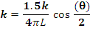
Given that L =0.15m, Use the gradient of the graph to determine the value of K. (2mrks)

(Question1 part b)
You are provided with the following apparatus:
-Prism
-4 optical pins
-plain paper
-Protractor
-Some plasticine
-Soft board
- Set up the apparatus as shown below.
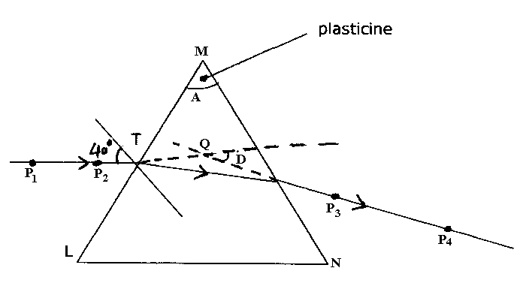
- Measure angle A of the prism using a protractor. (1mrk)

- Place the prism on a plain paper and trace its outline with a pencil. Attach some plasticine to the prism to indicate the prism angle A, construct a normal at point T along LM. Draw an incident ray to strike the prism at 40⁰. Replace the prism and stick pins p₁and p₂ to define the incident ray. View p₁ and p₂ from the opposite face (MN). Insert pins p₃ and p₄ so that they appear to be in line with images of p₁ and p₂. Remove the prism and join p3 to p4 to give emergent ray. Extrapolate the emergent ray into the prism so as to meet the extrapolated incident ray at Q.
- a) Measure angle D. (2mrks)

b) Calculate the value of $η = \frac{\text{cos} \left({\text{90}}^{0} − \left\{\frac{A+D}{2}\right\}\right)}{\text{sin} \frac{A}{2}}$ (3mrks)

c).What is the significance ofη? (1mrk)

Question 2 (20 marks)
You are provided with the following
-Two dry cell
-One bulb
-Voltmeter (0 3v or 0 5v)
-Ammeter (0 25a)
-Amounted nicrome wire mounted on a millimeter scale
-Switch
-Seven connecting wire at least two with crocodile clips
-Micrometer screw gauge
Proceed as follows:
a)i). Set up the circuit as shown in the figure below.
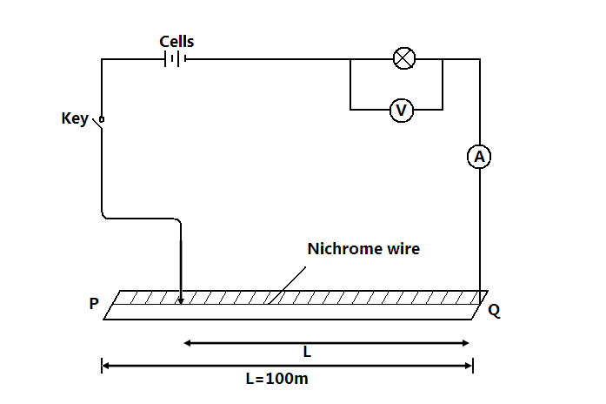
ii) With the crocodile clip at p, take the voltmeter reading and ammeter reading. Record v and 1 repeat the readings for L=80, 60, 40, 20 and 0cm respectively and complete the table below.
Length, L(cm) | 100 | 80 | 60 | 40 | 20 | 0
Voltage, V(V)
Current, I (A)

iii). What changes do you observe on the bulb as L decreases from p? (1mrk)

iv).Plot a graph of ammeter reading (y=axis) against voltmeter readings. (5mrks)

Grid

v). Determine the slope of the graph at V=1 volt. (2mrks)

vi). What physical quantity is represented by the slope of the graph at any given point? (1mrk)

b. (i).Given the apparatus in a (i) above, draw a diagram of the circuit you would use to determine the current through the resistant wire and the potential difference across. (1mrk)

ii).Set up the circuit you have drawn. Record the ammeter reading 1 and the wire reading v when 1=100cm
V=…………………… I=………………………………………..

iii). Using a micrometer screw gauge, measure the diameter of the wire. (1mrk)

d=……………………………………………m
iv). Calculate the quantity:
p= 0.785 and give its units, where L is one meter. (2mrks)

