Name…………………………………………………………………………… Index No……………..

School………………………………………………………………………….. Date………………….

Candidate’s signature…………………………………..

232/1
PHYSICS
Paper 1
July / August 2012
Time 2 HOURS

BURETI DISTRICT JOINT EVALUATION TEST - 2012
Kenya Certificate of Secondary Education (K.C.S.E)

232/1
PHYSICS
Paper 1
July / August 2012
Time 2 HOURS

INSTRUCTIONS TO CANDIDATES
1. Write your index no in spaces provided.
2. This paper consists of two sections A and B
3. Answer all questions in the spaces provided
4. Non-programmable calculators and mathematical tables may be used
5. Show all your workings

SECTION | QUESTION | MAX. SCORE | CANDIDATES SCORE
A | 1 – 11 | 25
B | 12 | 14
B | 13 | 14
B | 14 | 10
B | 15 | 9
B | 16 | 8
 | TOTAL | 80

This paper consists of 12 printed pages.
Candidates should check the question paper to ensure that all
pages are printed as indicated and no questions are missing
SECTION A (25 MARKS)
1. (i) What is the name of the instrument shown below (1mk)
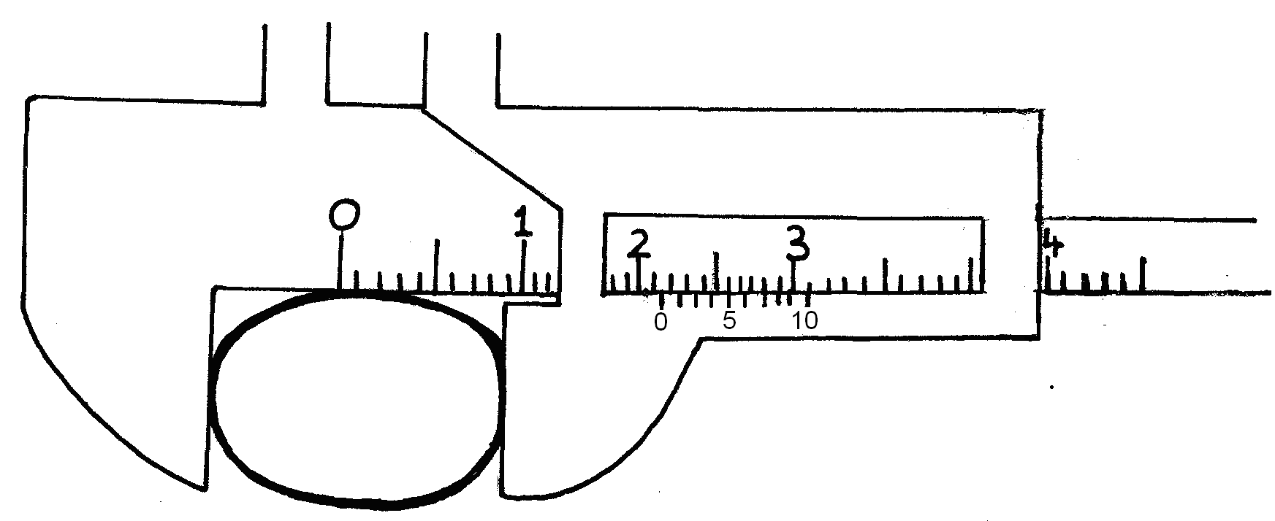
……………………………………………………………………………………………………..
(ii) If the instrument has zero error of 0.04cm, find the diameter of the sphere (2mks)
……………………………………………………………………………………………………..
……………………………………………………………………………………………………..
……………………………………………………………………………………………………..
……………………………………………………………………………………………………..
2. A block of copper of mass 2kg and specific heat capacity of 400J/kg/K initially at 121⁰C is
immersed in water at 20⁰C. If the final temperature is 21⁰C, determine the mass of water.
(specific heat capacity of water is 4200J/kgk) (3mks)
……………………………………………………………………………………………………..
……………………………………………………………………………………………………..
……………………………………………………………………………………………………..
……………………………………………………………………………………………………..
……………………………………………………………………………………………………..
……………………………………………………………………………………………………..
……………………………………………………………………………………………………..
……………………………………………………………………………………………………..
……………………………………………………………………………………………………..
……………………………………………………………………………………………………..
……………………………………………………………………………………………………..

3. Sketch a graph of velocity against time of a steel ball which is dropped to fall through glycerine in
a measuring cylinder (3mks)

4. Oil drop of mass 1.0 x 10⁻³kg falls on water and spread out to form a circular patch 1.0m in
diameter. Find the density of oil if thickness of the film on water is 1.3 x 10⁻⁶m (2mks)
……………………………………………………………………………………………………..
……………………………………………………………………………………………………..
……………………………………………………………………………………………………..
……………………………………………………………………………………………………..
……………………………………………………………………………………………………..
5. Some water in a tin can was boiled for some time. The tin can was then sealed and cooled. After
sometime it collapsed. Explain this observation (2mks)
……………………………………………………………………………………………………..
……………………………………………………………………………………………………..
……………………………………………………………………………………………………..
……………………………………………………………………………………………………..
……………………………………………………………………………………………………..
6. The figure below shows a uniform metre rule pivoted at 30cm mark. It is balanced by
weight of 2Nsuspended at the 5cm mark.
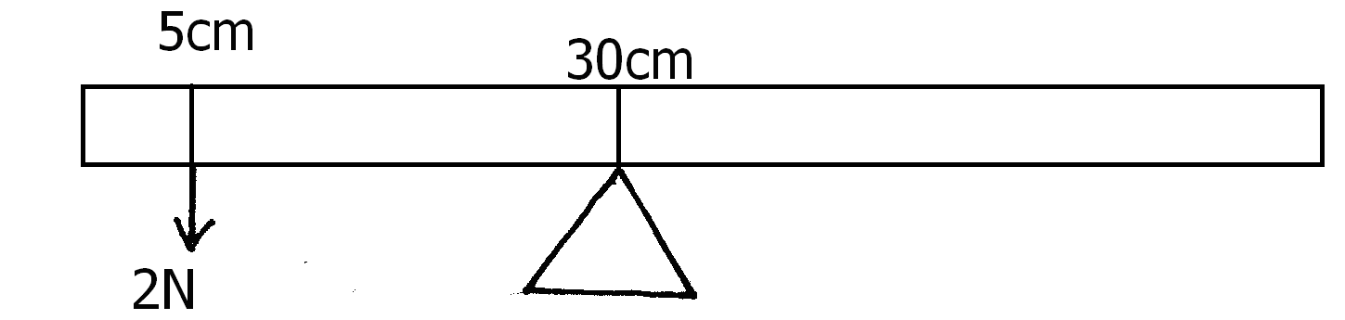
Determine the weight of the meter rule (3mks)
……………………………………………………………………………………………………..
……………………………………………………………………………………………………..
……………………………………………………………………………………………………..
……………………………………………………………………………………………………..
……………………………………………………………………………………………………..
7. The weight of a solid in air is 5.0N. When it is fully immersed in a liquid of density
800kgm⁻³ its weight is 4.04N determine the volume of liquid displaced. (2mks)
……………………………………………………………………………………………………..
……………………………………………………………………………………………………..
……………………………………………………………………………………………………..
……………………………………………………………………………………………………..

8. The figure below shows a mass of 200g connected by a string through a hollow tube to
mass of 0.5kg. The 0.5kg mass is kept stationary in the air by whirling the 200g mass round
in a horizontal circle of reading 1.0metre
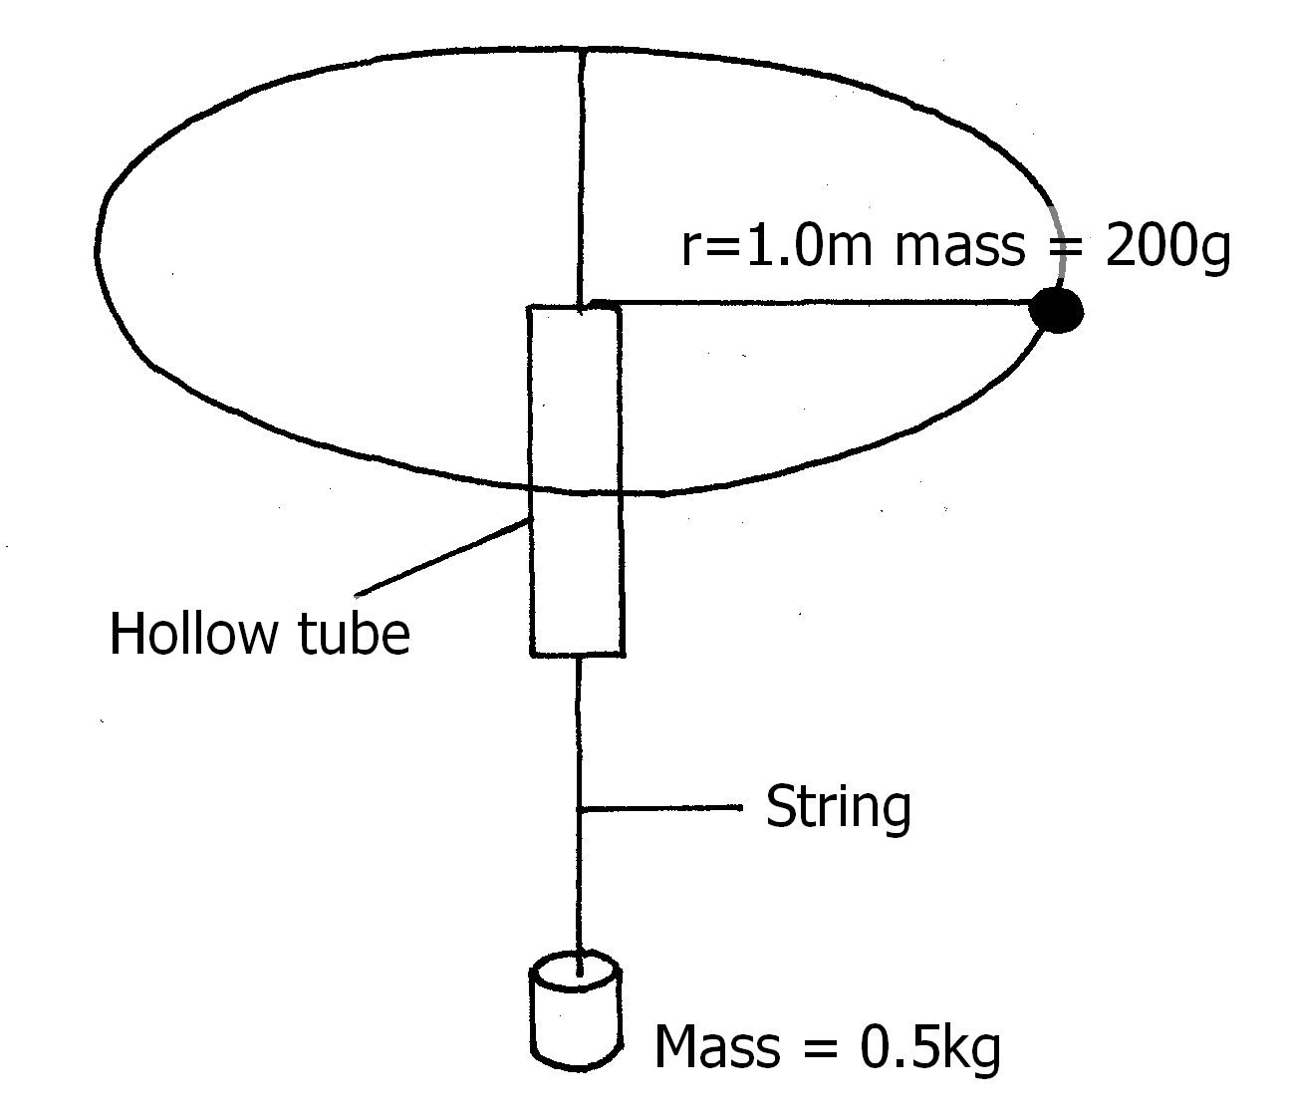
Determine the angular velocity of the 200g mass (3mks)
……………………………………………………………………………………………………..
……………………………………………………………………………………………………..
……………………………………………………………………………………………………..
……………………………………………………………………………………………………..
9. A steel ball bearing is allowed to fall freely in a viscous liquid. State the condition
necessary for it to attain terminal velocity (1mk)
……………………………………………………………………………………………………..
……………………………………………………………………………………………………..
……………………………………………………………………………………………………..
10. State reason why heat transfer by radiation is faster than by conduction (1mk)
……………………………………………………………………………………………………..
……………………………………………………………………………………………………..
11. A body is projected vertically upwards from the top of a building. If it lands on the base of the
building, sketch the velocity time graph for the motion (2mks)
……………………………………………………………………………………………………..
……………………………………………………………………………………………………..
……………………………………………………………………………………………………..
……………………………………………………………………………………………………..
……………………………………………………………………………………………………..

SECTION B
12. The figure below shows the motion of a trolley on a ticker timer. The ticker has frequency of
50HZ
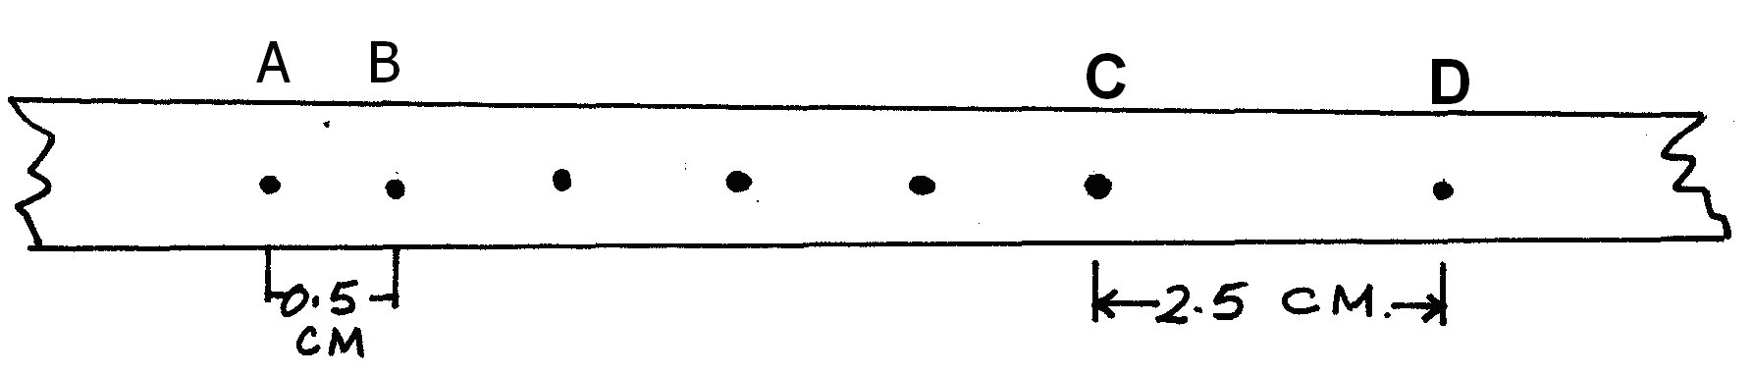
(a) (i) Calculate the initial velocity between A and B (2mks)
……………………………………………………………………………………………………..
……………………………………………………………………………………………………..
……………………………………………………………………………………………………..
……………………………………………………………………………………………………..
……………………………………………………………………………………………………..
……………………………………………………………………………………………………..
(ii) Calculate the final velocity between C and D (2mks)
……………………………………………………………………………………………………..
……………………………………………………………………………………………………..
……………………………………………………………………………………………………..
……………………………………………………………………………………………………..
……………………………………………………………………………………………………..
……………………………………………………………………………………………………..
(iii) Calculate the acceleration of the trolley during the motion (3mks)
……………………………………………………………………………………………………..
……………………………………………………………………………………………………..
……………………………………………………………………………………………………..
……………………………………………………………………………………………………..
……………………………………………………………………………………………………..
……………………………………………………………………………………………………..
(b) A ball is dropped from the top of a vertical cliff 45m high. Given that the velocity just
before striking the sandy beach is 30m/s and the ball penetrate the sand to a depth of
10cm. Determine its average retardation. (3mks)
……………………………………………………………………………………………………..
……………………………………………………………………………………………………..
……………………………………………………………………………………………………..
……………………………………………………………………………………………………..
……………………………………………………………………………………………………..
……………………………………………………………………………………………………..
(c) Figure below shows a force distance graph for a car being towed on a level ground
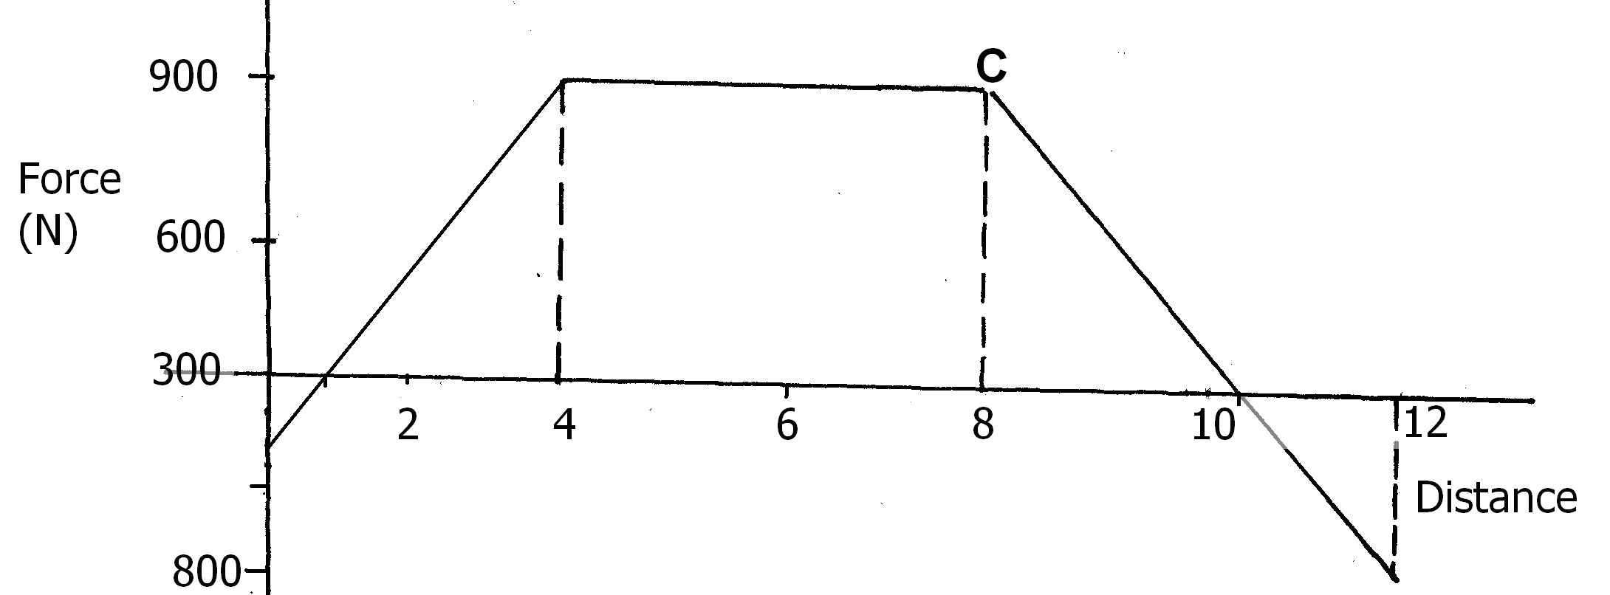
(i) Calculate the total work done (2mks)
……………………………………………………………………………………………………..
……………………………………………………………………………………………………..
……………………………………………………………………………………………………..
……………………………………………………………………………………………………..
(ii) If the velocity just before reaching point C is 0.6m/s. Calculate the power
developed by the engine at this point (2mks)
……………………………………………………………………………………………………..
……………………………………………………………………………………………………..
……………………………………………………………………………………………………..
……………………………………………………………………………………………………..
13. The figure below shows a hydraulic press
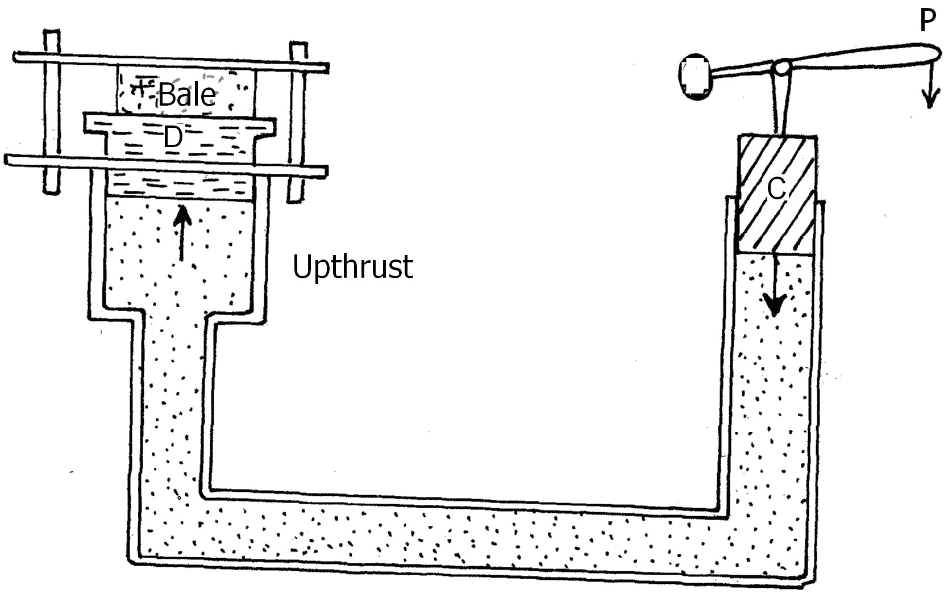

The two pistons C and D are of areas 100cm² and 2m² respectively. A force of 100N is applied
on the smaller piston, find the load that can be lifted on the large piston if :-
(a) The piston has negligible weights and no frictional forces (3mks)
……………………………………………………………………………………………………..
……………………………………………………………………………………………………..
……………………………………………………………………………………………………..
……………………………………………………………………………………………………..
(b) The small and larger pistons have negligible weights and frictional forces 10N and 40N
respectively (3mks)
……………………………………………………………………………………………………..
……………………………………………………………………………………………………..
……………………………………………………………………………………………………..
……………………………………………………………………………………………………..
……………………………………………………………………………………………………..
……………………………………………………………………………………………………..
(c) The small piston has a weight of 5N, the larger piston has weight of 10N and the frictional
forces are negligible (3mks)
……………………………………………………………………………………………………..
……………………………………………………………………………………………………..
……………………………………………………………………………………………………..
……………………………………………………………………………………………………..
……………………………………………………………………………………………………..
……………………………………………………………………………………………………..
(d) In a hydraulic brake the master piston has an area of 4mm² and the wheel piston
each has an area 4cm². Find the forces applied to the wheel when a force of 10N is
applied on the master piston (3mks)
……………………………………………………………………………………………………..
……………………………………………………………………………………………………..
……………………………………………………………………………………………………..
……………………………………………………………………………………………………..
(e) State two properties of the liquid used in the hydraulic system. (2mks)
……………………………………………………………………………………………………..
……………………………………………………………………………………………………..
……………………………………………………………………………………………………..

14. In an experiment to determine the density of sand using a density bottle, the following
measurements were recorded.
Mass of empty density bottle = 43.2g
Mass of density bottle full of water = 66.4g
Mass of density bottle with some sand = 67.5g
Filled up with water (sand, watered bottle) = 82.3g
Use the above information to determine the;
(a) Mass of the water that completely fill the bottle (2mks)
……………………………………………………………………………………………………..
……………………………………………………………………………………………………..
……………………………………………………………………………………………………..
……………………………………………………………………………………………………..
(b) Volume of water that completely filled the bottle (1mk)
……………………………………………………………………………………………………..
……………………………………………………………………………………………………..
……………………………………………………………………………………………………..
……………………………………………………………………………………………………..
(c) Volume of the density bottle (1mk)
……………………………………………………………………………………………………..
……………………………………………………………………………………………………..
……………………………………………………………………………………………………..
……………………………………………………………………………………………………..
(d) Mass of sand (1mk)
……………………………………………………………………………………………………..
……………………………………………………………………………………………………..
……………………………………………………………………………………………………..
……………………………………………………………………………………………………..
(e) Mass of water that filled the space above the sand (1mk)
……………………………………………………………………………………………………..
……………………………………………………………………………………………………..
……………………………………………………………………………………………………..
……………………………………………………………………………………………………..
(f) Volume of the sand (2mks)
……………………………………………………………………………………………………..
……………………………………………………………………………………………………..
……………………………………………………………………………………………………..
……………………………………………………………………………………………………..
(g) Density of the sand (2mks)
……………………………………………………………………………………………………..
……………………………………………………………………………………………………..
……………………………………………………………………………………………………..
……………………………………………………………………………………………………..
15. (a) Explain why it is advisable to use the pressure cooker for cooking at high altitudes (2mks)
……………………………………………………………………………………………………..
……………………………………………………………………………………………………..
……………………………………………………………………………………………………..
……………………………………………………………………………………………………..
(b) Water of mass 3kg initially at 20⁰C is heated in an electric kettle rated 3.0kw. The
water is heated until it boils at 100⁰C. Taking specific heat capacity of water to be 4200Jkg⁻¹ K⁻¹, heat capacity of kettle = 450J/kg, specific latent heat of vaporization of water = 2.3MJ/kg, calculate
(i) The heat absorbed by the water (1mk)
……………………………………………………………………………………………………..
……………………………………………………………………………………………………..
……………………………………………………………………………………………………..
……………………………………………………………………………………………………..
(ii) Heat absorbed by the electric kettle (2mks)
……………………………………………………………………………………………………..
……………………………………………………………………………………………………..
……………………………………………………………………………………………………..
……………………………………………………………………………………………………..
(iii) The time taken for the water to boil (2mks)
……………………………………………………………………………………………………..
……………………………………………………………………………………………………..
……………………………………………………………………………………………………..
……………………………………………………………………………………………………..
(iv) How much longer it will take to boil away all the water (2mks)
……………………………………………………………………………………………………..
……………………………………………………………………………………………………..
……………………………………………………………………………………………………..
……………………………………………………………………………………………………..
16. (a) Define angular velocity (1mk)
……………………………………………………………………………………………………..
……………………………………………………………………………………………………..
(b) The figure below shows an object of mass 0.2kg whirled in vertical circle of radius
0.5m at uniform speed of 5m/s
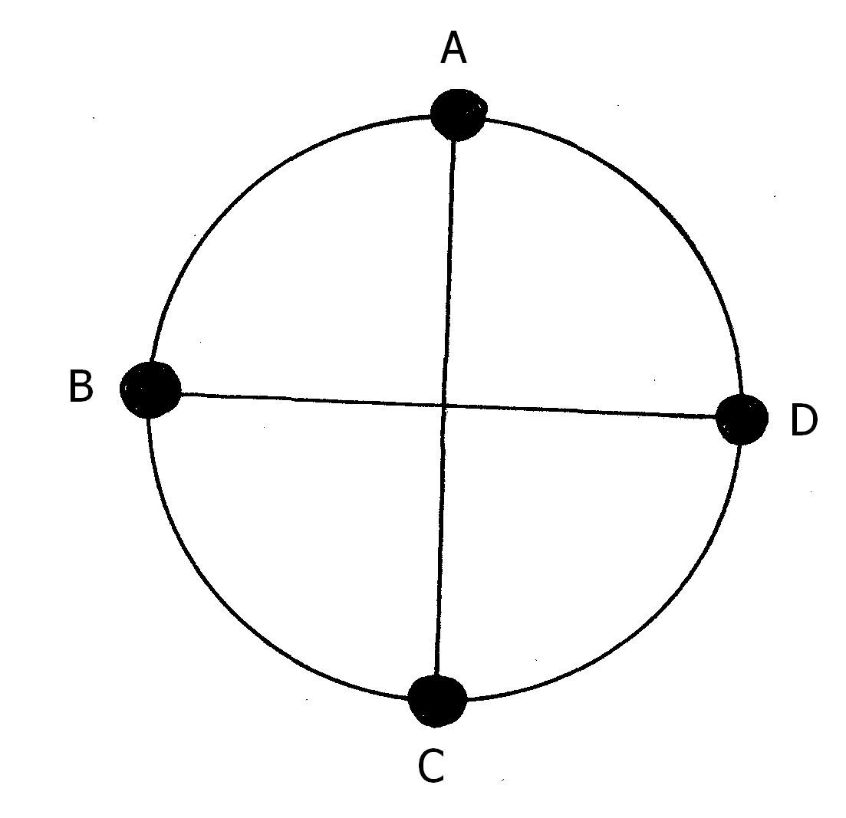
Determine the tension in the string at
(i) Position A (3mks)
……………………………………………………………………………………………………..
……………………………………………………………………………………………………..
……………………………………………………………………………………………………..
……………………………………………………………………………………………………..
……………………………………………………………………………………………………..
……………………………………………………………………………………………………..
(ii) Position B (3mks)
……………………………………………………………………………………………………..
……………………………………………………………………………………………………..
……………………………………………………………………………………………………..
……………………………………………………………………………………………………..
……………………………………………………………………………………………………..
……………………………………………………………………………………………………..
(iii) At what point is the string likely to cut. Explain (2mks)
……………………………………………………………………………………………………..
……………………………………………………………………………………………………..
……………………………………………………………………………………………………..
……………………………………………………………………………………………………..

End
End

