Name…………………………………………………………………………… Index No……………..

School………………………………………………………………………….. Date………………….

Candidate’s signature…………………………………..

232/2
PHYSICS
Paper 2
July / August 2012
Time 2 HOURS

BURETI DISTRICT JOINT EVALUATION TEST - 2012
Kenya Certificate of Secondary Education (K.C.S.E)

232/2
PHYSICS
Paper 2
July / August 2012
Time 2 HOURS

INSTRUCTIONS TO CANDIDATES
1. Write your name and index number in the spaces provided
2. Sign and write the date of examination in the spaces provided
3. This paper consists of TWO sections A and B
4. Answer ALL questions in the spaces provided
5. Non-programable calculators and mathematical tables may be used where necessary
6. ALL working MUST be shown clearly where necessary

FOR EXAMINERS USE ONLY

SECTION | QUESTION | MAX. SCORE | CANDIDATES SCORE
A | 1 – 12 | 25
B | 13 | 8
B | 14 | 12
B | 15 | 11
B | 16 | 12
B | 17 | 12
 | TOTAL | 80

This paper consists of 12 printed pages.
Candidates should check the question paper to ensure that all
pages are printed as indicated and no questions are missing
SECTION A (25 MARKS)
1. Two magnets A and B in figure 1 were brought from a point high above a table towards a steel
pin.
Fig. 1
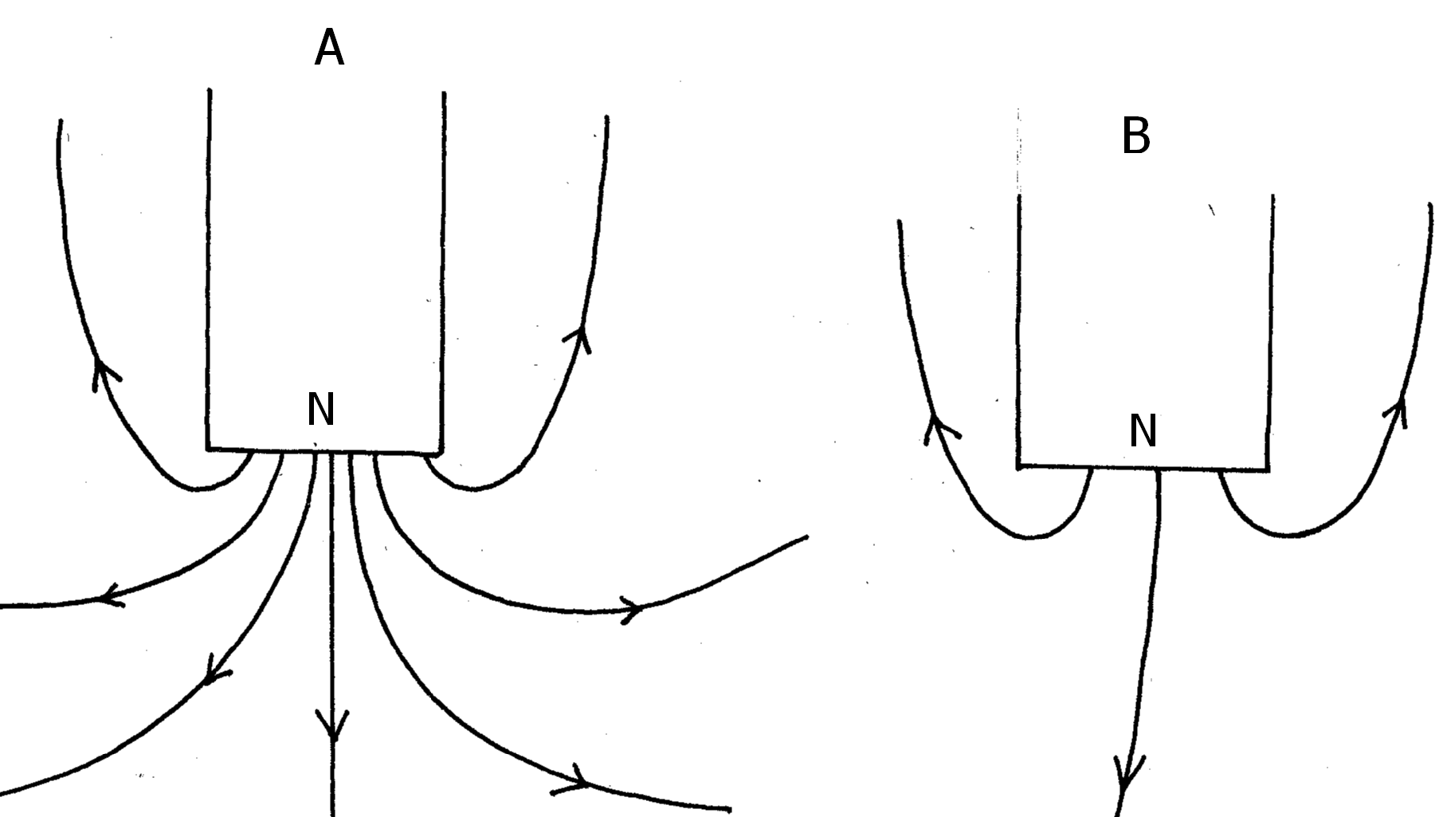
State with reason which magnet will attract the pin at a bigger height above the table. (2mks)
………………………………………………………………………………………………………
………………………………………………………………………………………………………
2. The figure 2 below shows container loader which uses electromagnet to offload containers
from a ship.
Fig. 2
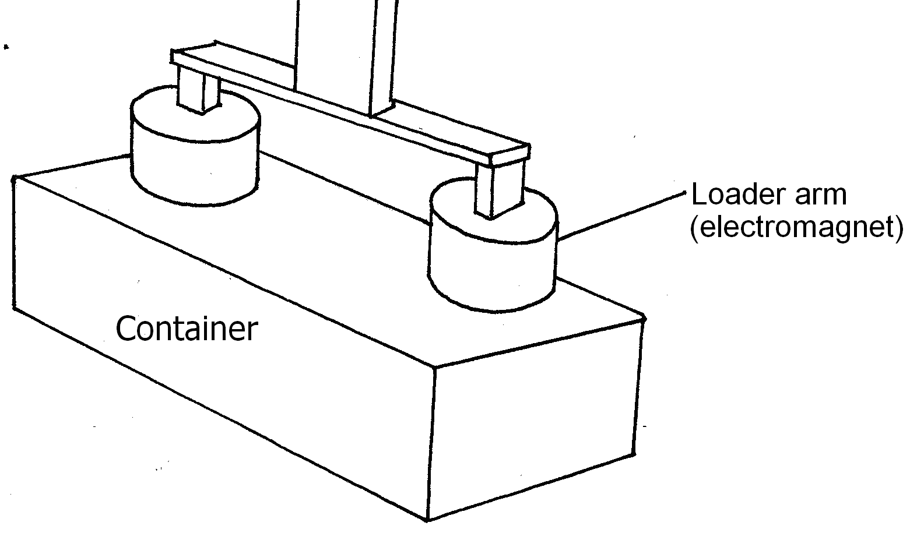
(i) Why should the container be made of iron or steel (1mk)
………………………………………………………………………………………………………
………………………………………………………………………………………………………
(ii) State two ways in which the loader can be made to lift heavier container (2mks)
………………………………………………………………………………………………………
………………………………………………………………………………………………………
3. Explain why sound cannot be heard from far when one shouts in a forest (1mk)
………………………………………………………………………………………………………
………………………………………………………………………………………………………

4. The figure 3 shows a ray of light incident on a mirror.
Fig. 3
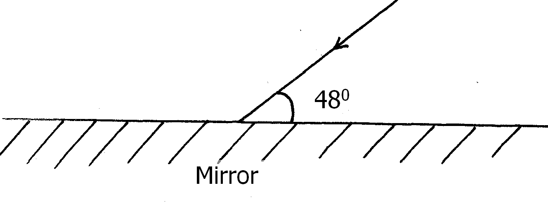
Determine the angle of reflection when the mirror is rotated 10⁰ anticlockwise (2mks)
………………………………………………………………………………………………………
………………………………………………………………………………………………………
5. A positively charged material was brought close to an insulated metallic ball as shown in
Fig 4. State and explain the distribution of charge in the ball (2mks)
Fig. 4
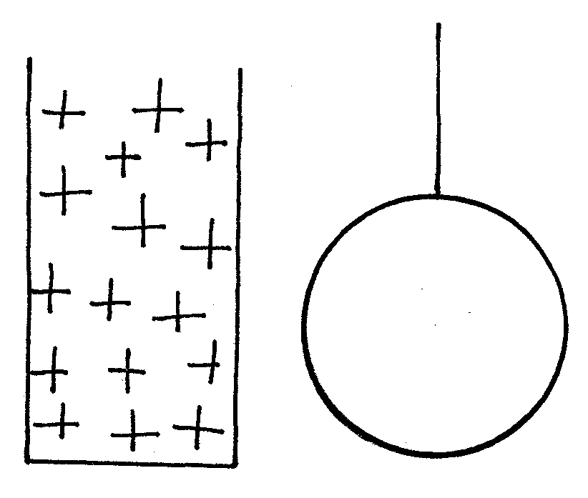
………………………………………………………………………………………………………
………………………………………………………………………………………………………
………………………………………………………………………………………………………
………………………………………………………………………………………………………
6. Two 12V lead acid accumulators are vated 60Ah and 70Ah. State two physical differences
between the accumulators (2mks)
………………………………………………………………………………………………………
………………………………………………………………………………………………………
………………………………………………………………………………………………………
………………………………………………………………………………………………………

7. When a new dry cell is connected in series with a 2.7$Ω$ resistor, a current of 0.5A flows in
the circuit. Determine the internal resistance of the cell. (3mks)
………………………………………………………………………………………………………
………………………………………………………………………………………………………
………………………………………………………………………………………………………
………………………………………………………………………………………………………
8. A vibrating tunning fork of frequency 512Hz was brought close to two test tubes X and Y
with water levels as shown in fig. 5
Fig. 5
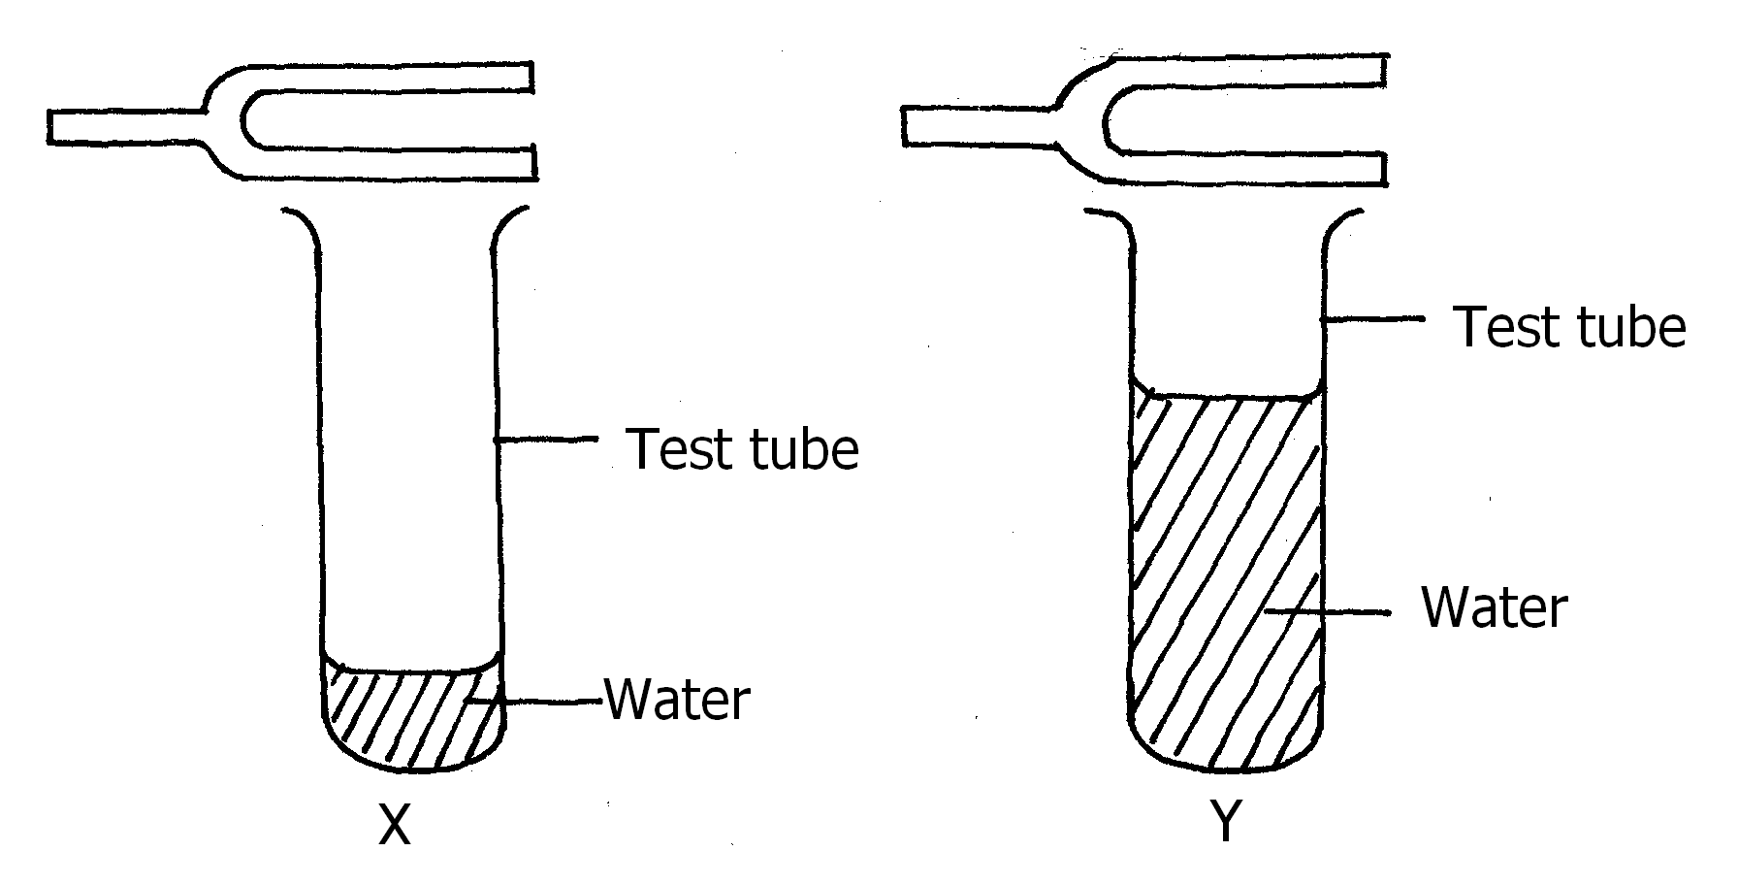
It was observed that loud sound is produced in test tube X but not in Y. Explain this observation.
(2mks)
………………………………………………………………………………………………………
………………………………………………………………………………………………………
………………………………………………………………………………………………………
………………………………………………………………………………………………………
9. A form 4 student observed that his grandfather positions a book far from his eyes when
reading it. Explain the type of lenses that the student should advice his grandfather to wear(2mks)
………………………………………………………………………………………………………
………………………………………………………………………………………………………
………………………………………………………………………………………………………
………………………………………………………………………………………………………
10. Explain how earth wire provides safety in an electrical installation (2mks)
………………………………………………………………………………………………………
………………………………………………………………………………………………………

11. In a cathode ray oscilloscope the time base is set at 25cs/mm. Given that crest to crest of a signal
covers a length of 6cm, determine the frequency of the signal (3mks)
………………………………………………………………………………………………………
………………………………………………………………………………………………………
………………………………………………………………………………………………………
………………………………………………………………………………………………………
12. The chart below shows an arrangement of different parts of the electromagnetic spectrum.
Radio | A | Visible | Ultra-violet | X-rays | Gamma-Rays

Name the radiation represented by A (1mk)
………………………………………………………………………………………………………
………………………………………………………………………………………………………

SECTION B (55 MARKS)
13. Students set up a mass attatched to spring such that when it oscillates it taps on water surface in a
wide shallow tank.
Fig. 6
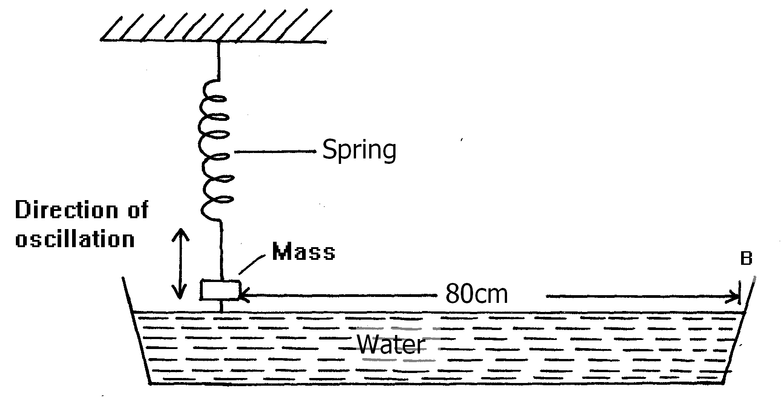
The students measured time for 20 oscillations and found that the mass takes 36 seconds.
(i) Determine the periodic time of the mass (2mks)
………………………………………………………………………………………………………
………………………………………………………………………………………………………
(ii) Calculate the frequency of the waves produced on the water surface (3mks)
………………………………………………………………………………………………………
………………………………………………………………………………………………………
………………………………………………………………………………………………………
………………………………………………………………………………………………………
(iii) Given that the student counted four ripples between the mass and end B of the tank,
Determine the speed of the waves. (3mks)
………………………………………………………………………………………………………
………………………………………………………………………………………………………
………………………………………………………………………………………………………
………………………………………………………………………………………………………
………………………………………………………………………………………………………
………………………………………………………………………………………………………
14. (a) (i) State Snell’s law of refraction of light (1mk)
………………………………………………………………………………………………………
………………………………………………………………………………………………………
(ii) Give two advantages of totally internally reflecting prisms over plane
mirrors. (2mks)
………………………………………………………………………………………………………
………………………………………………………………………………………………………
(b) A ray of light is incident on a kerosene water interfaces as shown in figure 7
Fig. 7
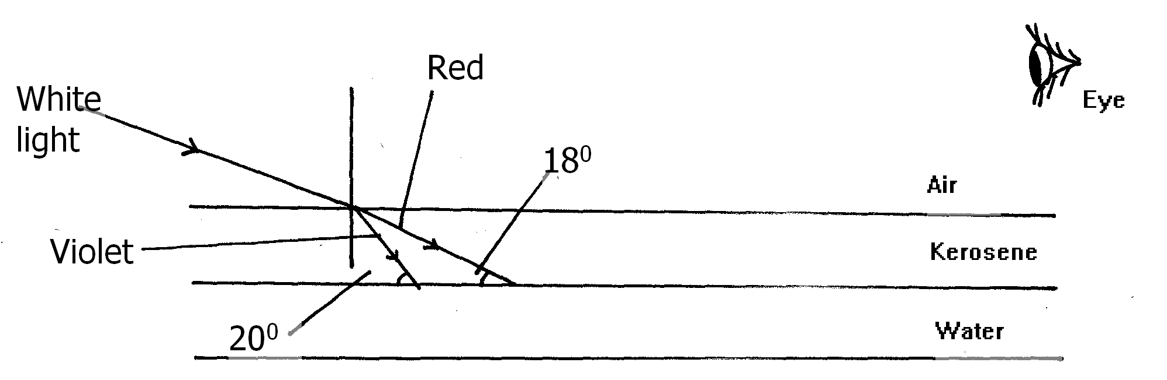
Given that the refractive index of water and kerosene are 1.33 and 1.44 respectively,
Determine
(i) the refractive index for the kerosene – water interface (3mks)
………………………………………………………………………………………………………
………………………………………………………………………………………………………
………………………………………………………………………………………………………
………………………………………………………………………………………………………
………………………………………………………………………………………………………
………………………………………………………………………………………………………

(ii) determine and show on the figure the path of the rays of light between the
Kerosene-water surface (3mks)
………………………………………………………………………………………………………
………………………………………………………………………………………………………
………………………………………………………………………………………………………
………………………………………………………………………………………………………
………………………………………………………………………………………………………
………………………………………………………………………………………………………
(iii) Why does the colours of the light separate at the kerosene layer. (1mk)
………………………………………………………………………………………………………
………………………………………………………………………………………………………
- State and explain the observation that the eye above the two surfaces would
see (2mks)
………………………………………………………………………………………………………
………………………………………………………………………………………………………
………………………………………………………………………………………………………
………………………………………………………………………………………………………
15. (a) State Ohm’s law (1mk)
………………………………………………………………………………………………………
………………………………………………………………………………………………………
(b) The figure 8 below shows a circuit with a coil used to warm oil in a beaker.
Fig. 8
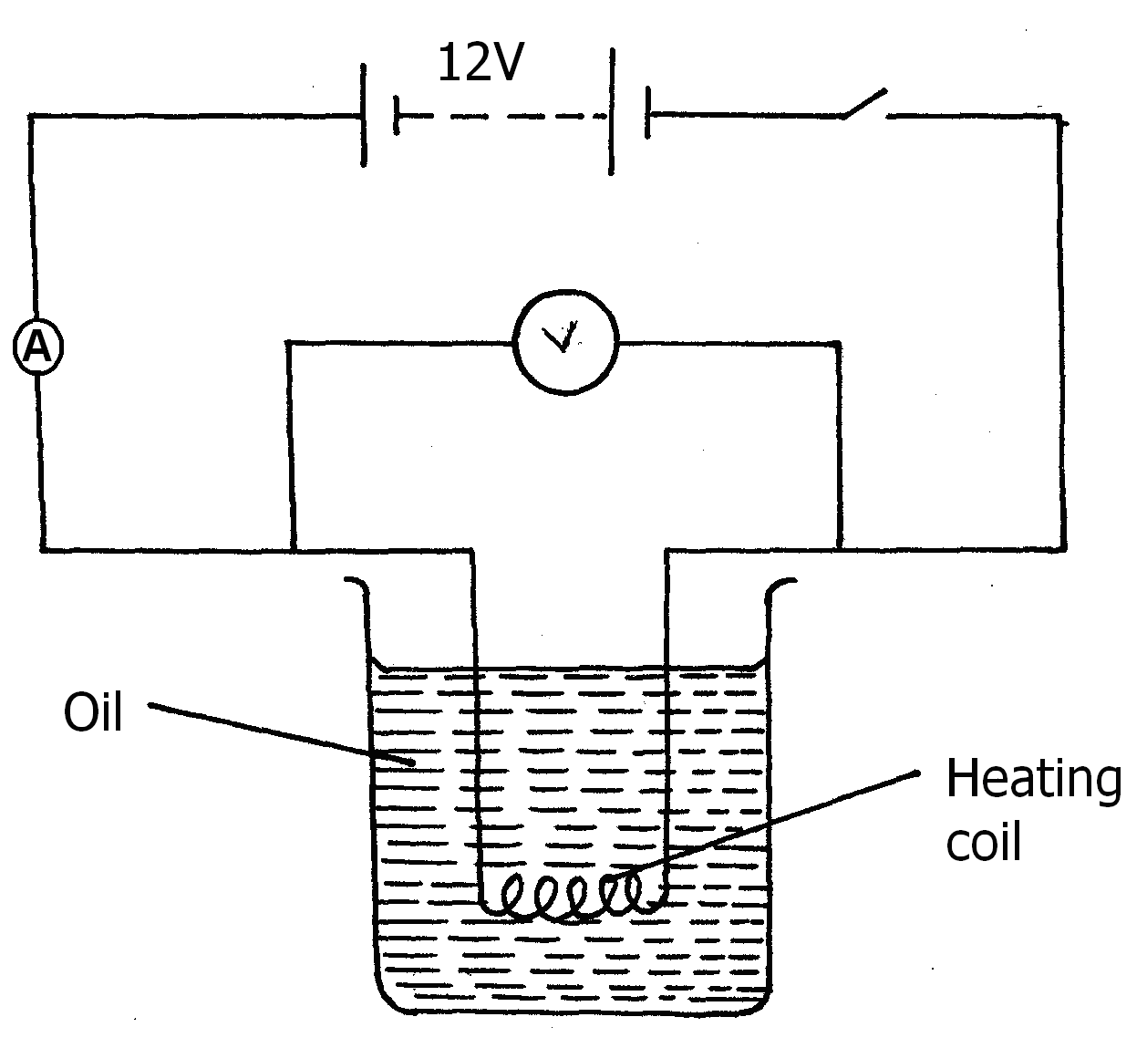

(i) Explain how heat is produced in the coil (2mks)
………………………………………………………………………………………………………
………………………………………………………………………………………………………
………………………………………………………………………………………………………
………………………………………………………………………………………………………
(ii) Given that the reading of the ammeter is 2.4A determine the resistance of
the coil. (3mks)
………………………………………………………………………………………………………
………………………………………………………………………………………………………
………………………………………………………………………………………………………
………………………………………………………………………………………………………
(iii) How much heat is produced in the coil in a minute? (3mks)
………………………………………………………………………………………………………
………………………………………………………………………………………………………
………………………………………………………………………………………………………
………………………………………………………………………………………………………
(iv) Give two changes that can be made in the set up in order to produce more
heat per minute. (2mks)
………………………………………………………………………………………………………
………………………………………………………………………………………………………
………………………………………………………………………………………………………
16. (a) The set up in fig. 9 shows two coils A and B close to each other.
Figure 9
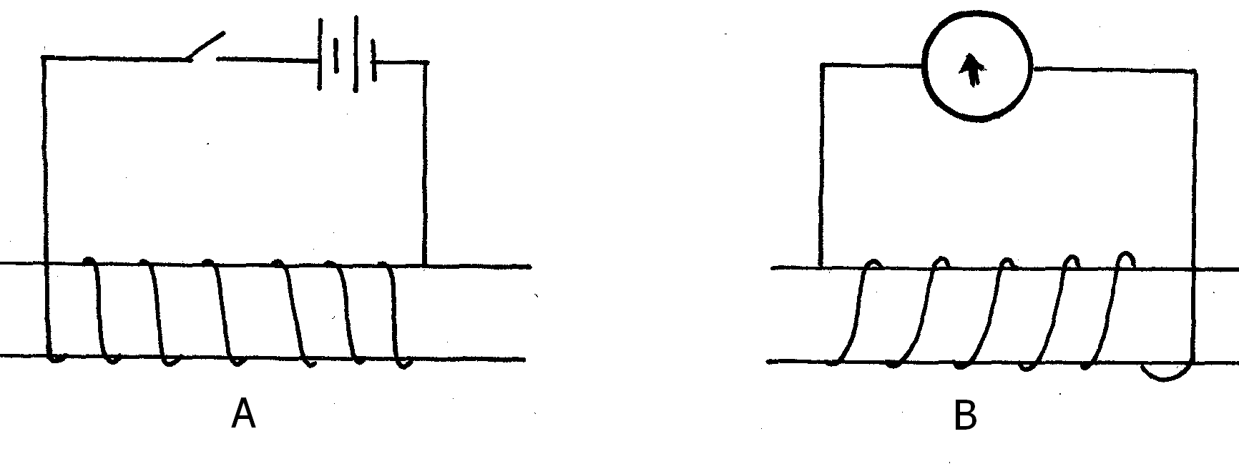
Show on coil B the direction of current when switch is closed. (1mk)
………………………………………………………………………………………………………
………………………………………………………………………………………………………

(b) A transformer that is 80% efficient has 4000 turns in primary coil and 500 turns in
secondary coil is used to supply power to a 15Ω motor, from 240V mains.
(i) Calculate the voltage in the secondary coil (3mks)
………………………………………………………………………………………………………
………………………………………………………………………………………………………
………………………………………………………………………………………………………
………………………………………………………………………………………………………
………………………………………………………………………………………………………
………………………………………………………………………………………………………
(ii) Power rating of the motor (3mks)
………………………………………………………………………………………………………
………………………………………………………………………………………………………
………………………………………………………………………………………………………
………………………………………………………………………………………………………
………………………………………………………………………………………………………
………………………………………………………………………………………………………
(iii) Current in the primary coil (3mks)
………………………………………………………………………………………………………
………………………………………………………………………………………………………
………………………………………………………………………………………………………
………………………………………………………………………………………………………
………………………………………………………………………………………………………
………………………………………………………………………………………………………
(c) In a step-down transformer the secondary coil is made of thick copper coil.
Explain (2mks)
………………………………………………………………………………………………………
………………………………………………………………………………………………………
………………………………………………………………………………………………………
………………………………………………………………………………………………………
17. (a) State one property of X-rays (1mk)
………………………………………………………………………………………………………
………………………………………………………………………………………………………

(b) Figure 11 below shows an X-ray tube drawn by a student. Use it to answer questions
which follows
Fig. 11
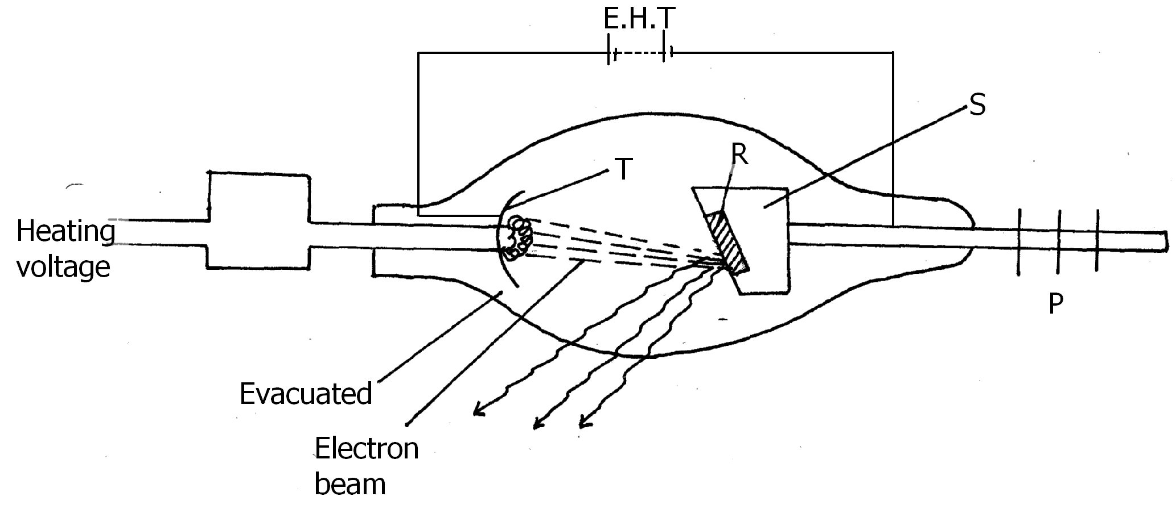
(i) Why is the tube evacuated? (1mk)
………………………………………………………………………………………………………
………………………………………………………………………………………………………
(ii) What adjustment can be made to increase the penetrating power of the
X-ray produced (1mk)
………………………………………………………………………………………………………
………………………………………………………………………………………………………
(iii) Name a suitable material for the target. (1mk)
………………………………………………………………………………………………………
………………………………………………………………………………………………………
(iv) Name the part labelled T (1mk)
………………………………………………………………………………………………………
………………………………………………………………………………………………………

(c) Figure 12 shows a circuit used to study behaviour of diode.
Fig. 12
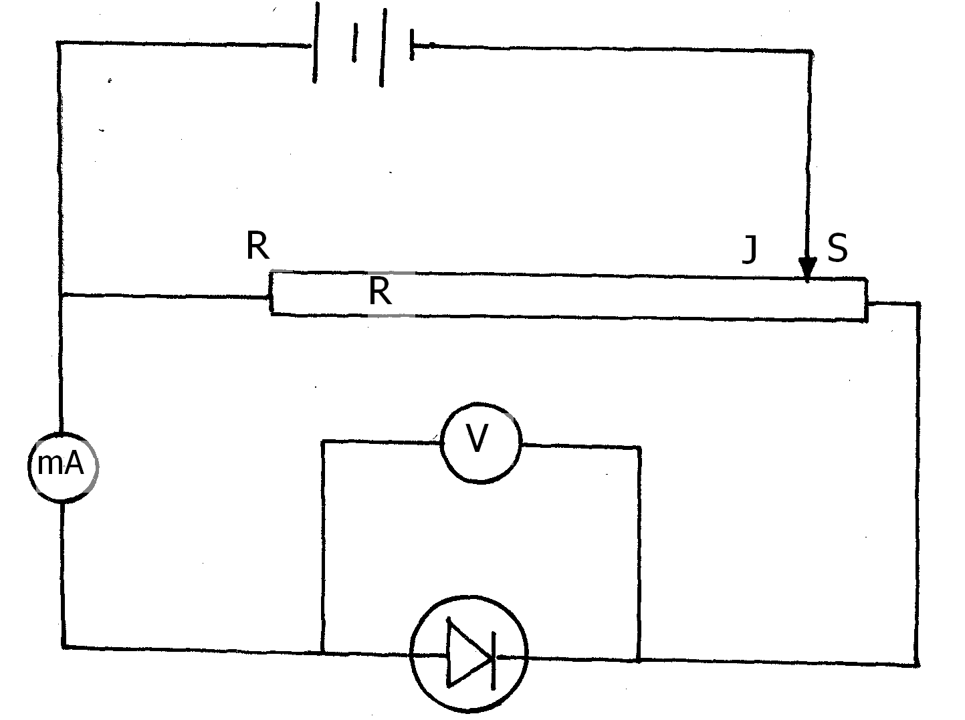
State the behaviour of voltmeter reading as Jockey J is moved from S to R (1mk)
………………………………………………………………………………………………………
………………………………………………………………………………………………………

(d) The graph below shows stopping potential V against frequency for a photocell
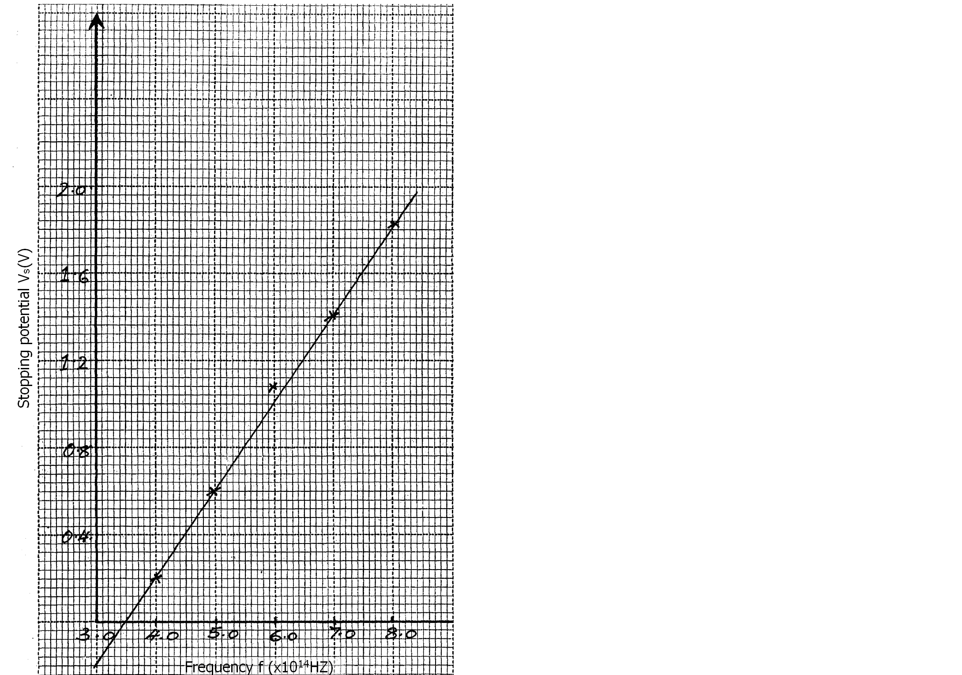
From the graph determine
(i) the threshold wavelength (2mks)
………………………………………………………………………………………………………
………………………………………………………………………………………………………
(ii) Planck’s constant (2mks)
………………………………………………………………………………………………………
………………………………………………………………………………………………………
(iii) Work function of the metal (2mks)
(Take C = 3.0 x 10⁸m/s, e = 1.6 x 10⁻¹⁹C)
………………………………………………………………………………………………………
………………………………………………………………………………………………………
………………………………………………………………………………………………………
………………………………………………………………………………………………………
End

