NAME:……………………………………………………………. INDEX NO:……………………/……….
SCHOOL:………………………………………………………… CANDIDATE’S SIGN…………………
DATE:…………………………………………………………

232/1
PHYSICS
PAPER 1
JUNE/JULY 2011
TIME: 2 HOURS

BUTERE DISTRICT JOINT EVALUATION - 2012
Kenya Certificate of Secondary Education (K C.S.E.)

232/1
PHYSICS
PAPER 1

INSTRUCTIONS TO THE CANDIDATES:
• Write your name and index number in the spaces provided above.
• Answer all the questions both in section A and B in the spaces provided below each question
• All workings must be clearly shown; marks may be awarded for correct steps even if the answers are wrong.
• Mathematical tables and silent electronic calculators may be used.
• Take g = 10m/s²

For Examiners’ Use Only
SECTION | QUESTION | MAXIMUM SCORE | CANDIDATE’S SCORE
A | 1 - 10 | 25
B | 11 | 11
 | 12 | 10
 | 13 | 10
 | 14 | 13
 | 15 | 11
TOTAL |  | 80

This paper consists of 12 Printed pages. Candidates should check to ascertain that all pages are printed as indicated and that no questions are missing.
SECTION A (25 MARKS)
Answer questions in this section.
1. The figure below shows part of a vernier callipers when the jaws are closed without an object in between the jaws.
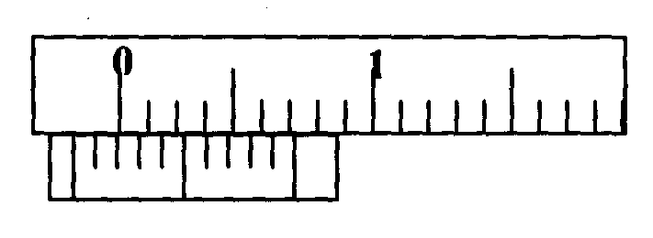
a) State the zero error of the vernier callipers. (1mk)
………………………………………………………………………………………………………………………………………………………………………………………………………………………………………………………………………………………………
b) A student used the same vernier calipers to measure the diameter of a test tube of actual diameter 2.15cm. What was the reading shown by the vernier callipers? (2mks)
………………………………………………………………………………………………………………………………………………………………………………………………………………………………………………………………………………………………………………………………………………………………………………………………………………………………………………………………………………………………………………………………………………………………………………………………
2. The diagram below shows a bimetallic wheel whose diameter is not affected by changes in temperature. Briefly explain how the diameter of the wheel remains unchanged as the temperature increases. (3mks) 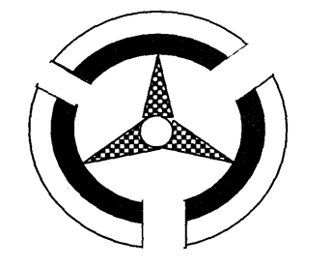
…………………………………………………………………………………………………………………………………………………………………………………………………………………………………………………………………………………………………………………………………………………………………………………………………………………………………………………………………………………………………………………………………………………………………………………………………………………………………………………………………………………………………………………
3. The figure below shows a pith ball being lifted into a funnel end of a blower.
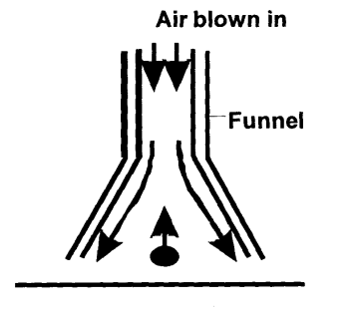
Explain this observation (2mks)
………………………………………………………………………………………………………………………………………………………………………………………………………………………………………………………………………………………………………………………………………………………………………………………………………………………………………………………………………………………………………………………………………………………………………………………………
4. A uniform meter rule of mass 40g is pivoted at the 60cm mark and held horizontal with a vertical rope as shown below. Determine the tension in the rope. (3 mks)
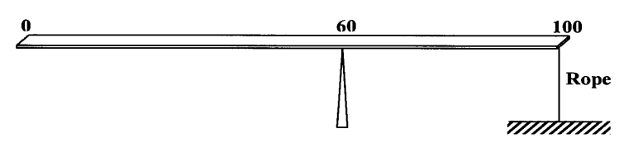
……………………………………………………………………………………………………………………………………………………………………………………………………………………………………………………………………………………………………………………………………………………………………………………………………………………………………………………………………………………………………………………………………………………………………………………………………………………………………………………………………………………………………………………………………………………………………………………………………………………………………………………………………………………………………………………………………………………………………………………………….
5. A uniform mixture consists of 30cm³ of water and 40cm³ of ethanol. If the densities of water and ethanol are 1 g/cm³ and 0.85 g/cm³ respectively. Calculate the density of the mixture. (3mks)

6. Water flows through a narrow pipe of radius 6cm connected to another pipe of radius 9mm. If the speed of water in the narrow pipe is 3mIs, determine the speed of water in the wider section. (3mks)
………………………………………………………………………………………………………………………………………………………………………………………………………………………………………………………………………………………………………………………………………………………………………………………………………………………………………………………………………………………………………………………………………………………………………………………………………………………………………………………………………………………………………………………………………………………………………………………………………………………………………………………………………………………………………………………………………………………………………………
7. State one way of making the surface tension of a liquid stronger. (1mk)
…………………………………………………………………………………………………………………………………………………………………………………………………………………………………………………………………………………………………………………………
8. A car undergoes uniform retardation from 36km/h covering a distance of 25m. Calculate its deceleration (2mks)
……………………………………………………………………………………………………………………………………………………………………………………………………………………………………………………………………………………………………………………………………………………………………………………………………………………………………………………………………………………………………………………………………………………………………………………………………………………………………………………
9. A constant mass of hydrogen occupies a volume of 4.0 cm³ at a pressure of 2.0 x 10⁵ Pa and a temperature of 288K. Calculate the volume of this gas at a pressure of 1.6x 10⁵ Pa when the temperature is 125K. (3mks)
…………………………………………………………………………………………………………………………………………………………………………………………………………………………………………………………………………………………………………………………………………………………………………………………………………………………………………………………………………………………………………………………………………………………………………………………………………………………………………………………………………………………………………………………………………………………………………
10. The figure below shows the change in volume of a liquid in a measuring cylinder when an irregular solid is immersed in it.
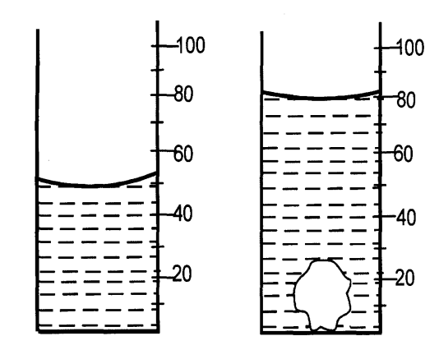
Given that the mass of the solid is 540g, determine the density of the solid in g/cm³. (2 mks)
…………………………………………………………………………………………………………………………………………………………………………………………………………………………………………………………………………………………………………………………………………………………………………………………………………………………………………………………………………………………………………………………………………………………………………………………………………………………………………………………………………………………………………………………………………………………………………
SECTION B (55 MARKS)
Answer ALL questions in this section.
11. a) A machine is a device that enables work to be done more easily and conveniently. State any two ways in which a machine makes work easier. (2 marks)
……………………………………………………………………………………………………………………………………………………………………………………………………………………………………………………………………………………………………………………………………………………………………………………………………………………………………………………………………………………………………………………………………………………………………………………………………………………………………………………
b) Figure 7 shows a wheel and axle being used to raise a load W by applying an effort E. The radius of the wheel is R and of the axle is r.

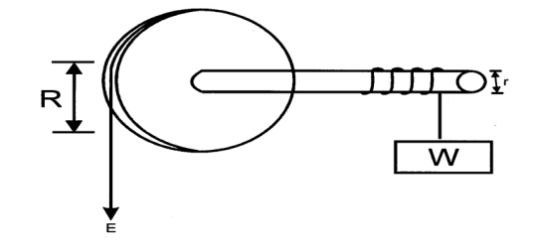
i) Show that the velocity ratio (V.R) of this machine is given by $\frac{R}{r}$ (3 Marks)
………………………………………………………………………………………………………………………………………………………………………………………………………………………………………………………………………………………………………………………………………………………………………………………………………………………………………………………………………………………………………………………………………………………………………………………………………………………………………………………………
ii) Given that r = 5cm and R = 50cm, determine the effort required to raise a load of 200N if the efficiency of the machine is 90%. (3 mks)
………………………………………………………………………………………………………………………………………………………………………………………………………………………………………………………………………………………………………………………………………………………………………………………………………………………………………………………………………………………………………………………………………………………………………………………………………………………………………………………………
c) An airtight flask containing a gas is connected to a mercury manometer. The levels of mercury in the two limbs of the manometer are as shown in the diagram below.
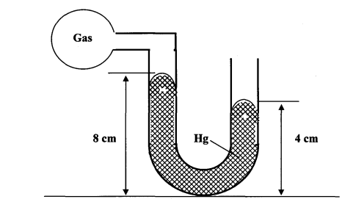
Calculate the pressure of the gas (Density of mercury = 1.36 x 10⁴ kg/m³ and atmospheric pressure = 1.0 x10⁵ N/m²) (3mks)
…………………………………………………………………………………………………………………………………………………………………………………………………………………………………………………………………………………………………………………………………………………………………………………………………………………………………………………………………………………………………………………………………………………………………………………………………………………………………………………………………………………………………………………………………………………………………………

12. a) State the law of flotation. (1 mk)
……………………………………………………………………………………………………………………………………………………………………………………………………………………
b) A block of glass of mass 0.25kg floats in mercury of density 1.36 x 10⁴kgm⁻³. What volume of the glass lies under the surface of mercury? (3 mks)
………………………………………………………………………………………………………………………………………………………………………………………………………………………………………………………………………………………………………………………………………………………………………………………………………………………………………………………………………………………………………………………………………………………………………………………………………………………………………………………………
c) A steady force of 3000N is applied to stop a car of mass 1500Kg moving at a velocity of 40m/s. How long does the vehicle take to stop? (3 mks)
………………………………………………………………………………………………………………………………………………………………………………………………………………………………………………………………………………………………………………………………………………………………………………………………………………………………………………………………………………………………………………………………………………………………………………………………………………………………………………………………
d) A lift car carries 16 passengers of total mass 1200 Kg. Calculate the force exerted on the lift floor when the lift accelerates upwards at 1.5 m/s². (3mks)
………………………………………………………………………………………………………………………………………………………………………………………………………………………………………………………………………………………………………………………………………………………………………………………………………………………………………………………………………………………………………………………………………………………………………………………………………………………………………………………………………………………………………………………………………………………………………………………………………………………………………………………………………………………………………………………………………………………………………………

13. a) Define a radian (1mk)
……………………………………………………………………………………………………………………………………………………………………………………………………………………
b) Three masses are placed on a rotating table at distances 6cm, 9cm and 12cm respectively from the centre of rotation. When the frequency of rotation is varied it is noted that each mass slides off at a different frequency of rotation of the table. The table below shows the frequency at which each mass slides off.
Radius, r (cm) | 12 | 9 | 6
Sliding off frequency (rev/s) | 0.5 | 0.8 | 1.1

i) State two factors that determine the frequency at which each mass slides off. (2 marks)
…………………………………………………………………………………………………………………………………………………………………………………………………………………………………………………………………………………………………………………………………………………………………………………………………………
ii) Oil is now poured on the table before placing the masses. Explain the effect of this on the frequency at which the mass slides off. (2 mks)
…………………………………………………………………………………………………………………………………………………………………………………………………………………………………………………………………………………………………………………………………………………………………………………………………………
c) A marked point on a rim of a wheel has a linear velocity of 11 .2m/s. If the rim has a radius of 0.8m, calculate;
i) The angular velocity of the point (3 mks)

ii) The centripetal acceleration. (2 mks)

14. (a) What is meant by specific latent heat of Vaporization? (1mk)
……………………………………………………………………………………………………………………………………………………………………………………………………
(b) In an experiment to determine the specific latent heat of vaporization of water, steam at 100°C was passed into water contained in a well lagged copper calorimeter.
The following measurements were made:
Mass of calorimeter = 50g
Initial mass of water =70g
Initial temperature of water = 5°C
Final mass of water + Calorimeter + condensed steam = 123g
Final temperature of mixture =30°C
Specific heat capacity of water = 4200Jkg⁻¹k⁻¹
Specific heat capacity of copper =390J kg⁻¹k⁻¹.
Determine the
(i) Mass of condensed steam (2mks)

(ii) Heat gained by water and calorimeter. (3mks)

(c) Given that L is the specific latent heat of vaporization of steam
(i) Write an expression for the heat given out by steam. (1 mk)

(ii) Determine the value of L (3mks)

(d) 500g of water at 20°C is mixed with 200g of water at 55°C Find the final temperature of the
mixture. (3mks)
………………………………………………………………………………………………………………………………………………………………………………………………………………………………………………………………………………………………………………………………………………………………………………………………………………………………………………………………………………………………………………………………………………………………………………………………………………
15. a) State Hooke’s law. (1mk)
……………………………………………………………………………………………………………………………………………………………………………………………………

b) The graph shows how extension e of a helical spring varied with load, hanging on it.
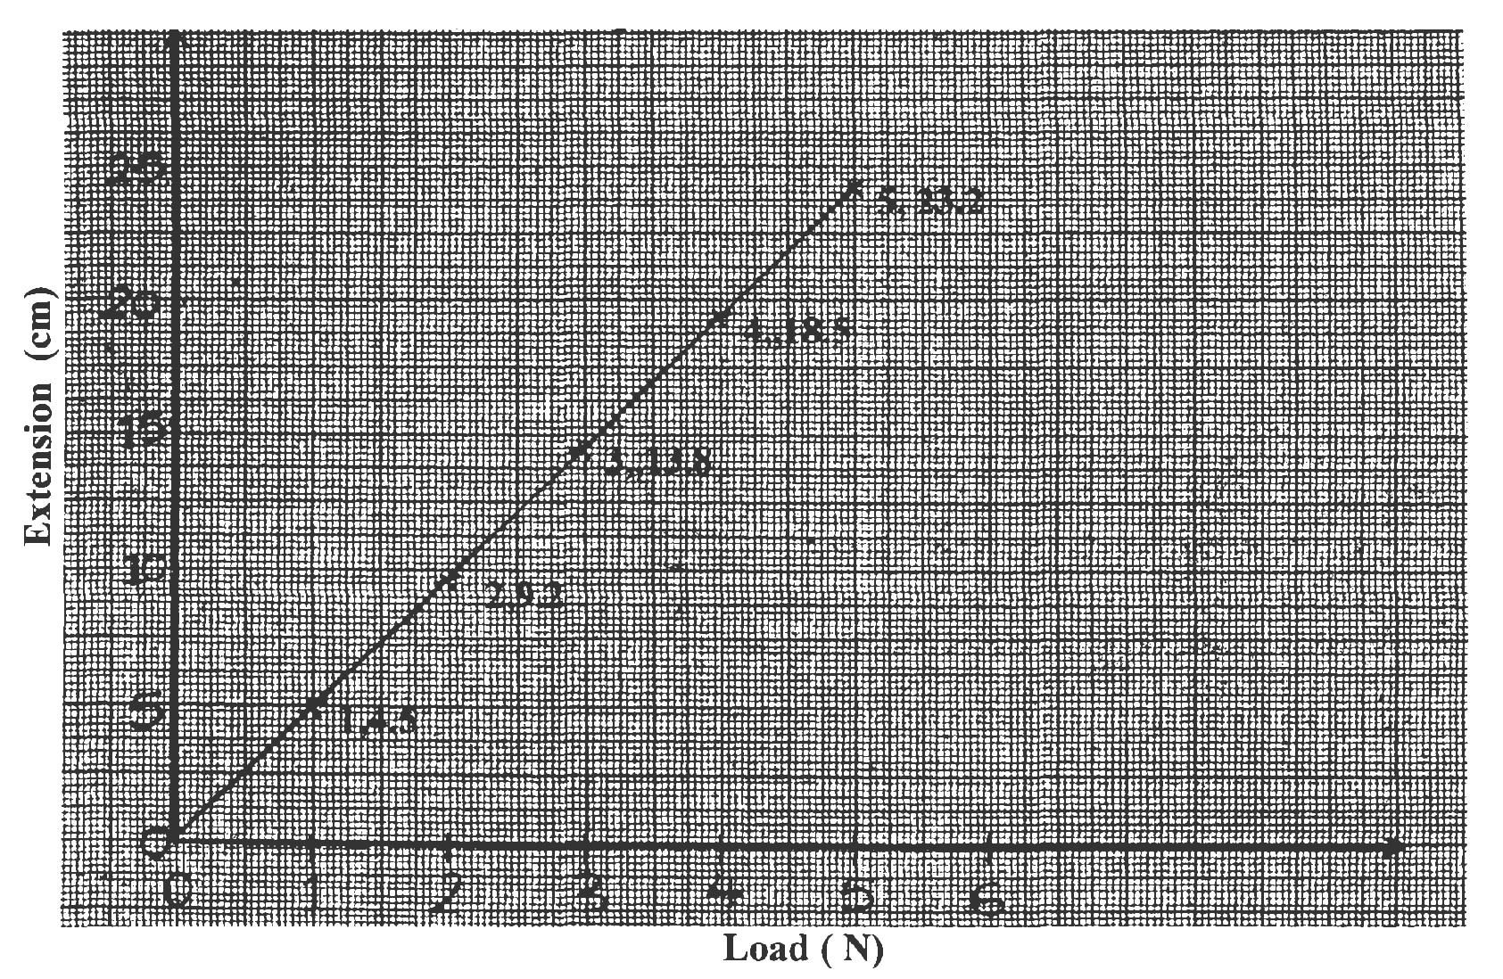
Determine from the graph, the proportionality constant of the spring. (3mks)

c) State two factors that affect the proportionality constant of a helical spring. (2mks)
………………………………………………………………………………………………………………………………………………………………………………………………………………………………………………………………………………………………………………………………………………………………………………………………………………………………………………………………………………………………………………………………………………………………………………………………
d) Two springs Q and R have proportionality constants 20Nm⁻¹ and 25Nm⁻¹ respectively. Q weighs 0.2 N while the weight of R is negligible. The two springs are arranged to support a load of 3.ON as shown in the diagram below.
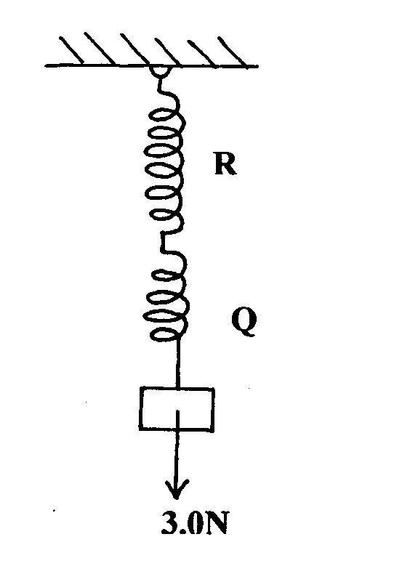
Determine the extension in
i) Q (2mks)
………………………………………………………………………………………………………………………………………………………………………………………………………………………………………………………………………………………………………………………………………………………………………………………………………………………………………………………………………………………………………………………………………………………………………………………………………………
ii) R (2mks)
………………………………………………………………………………………………………………………………………………………………………………………………………………………………………………………………………………………………………………………………………………………………………………………………………………………………………………………………………………………………………………………………………………………………………………………………………………

END

