NAME………………………………………………………. INDEX NO…………………/…….
SCHOOL……………………………………………………… DATE ………………………….…
CANDIDATE’S SIGNATURE………………………

232/3
PHYSICS
Paper 3
(PRACTICAL)
JUNE/JULY- 2012
Time: 2 ½ Hours

BUTERE DISTRICT JOINT EVALUATION - 2012
Kenya Certificate of Secondary Education (K C.S.E.)

INSTRUCTIONS TO CANDIDATES
1. Write your name and Index Number in the spaces provided above.
2. Sign and write the date of examination in the spaces provided above
3. Answer all the questions in the spaces provided in the question paper.
4. You are supposed to spend the first 15 minutes of the 2 ½ hours allowed for this paper reading the whole paper carefully before commencing your work.
5. Marks are given for a clear record of the observations actually made, their suitability, accuracy and the use made of them.
6. Candidates are advised to record their observations as soon as they are made.
7. Non-programmable silent electronic calculators and KNEC mathematical tables may be used.

QUESTION I
PART A | II | IV | V | VI  TOTAL
MAXIMUM SCORE | 1 | 1 | 1 | 2
CANDIDATES SCORE
TOTAL
PART B | II | III | IV | V
MAXIMUM SCORE | 5 | 5 | 3 | 2
CANDIDATES SCORE
QUESTION 2
TOTAL
PART C | a | g | h(i) | h(ii) | i
MAXIMUM SCORE | 2 | 6 | 5 | 3 | 4  GRAND TOTAL
CANDIDATES SCORE

This paper consists of 8 printed pages.
Candidates should check the question paper to ensure that all
pages are printed as indicated and no questions are missing
Question 1 (Part a) (13 marks)
You are provided with the following apparatus
• Clamp
• Stand
• Optical pin
• Copper Wire
• Protractor (your own)
• Two pieces of plasticine
• Stop watch
• Cork
a) Set up the apparatus as shown in the diagram below.
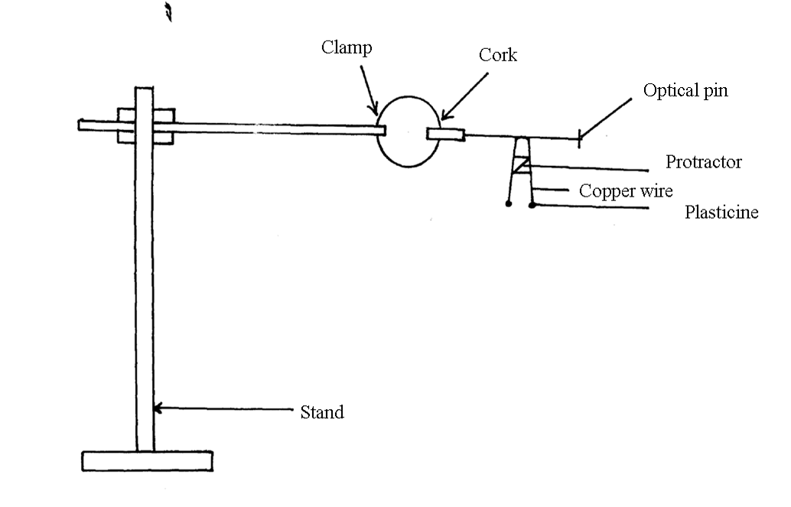
b) Bend the wire in the middle so as to make an angle of 50°. Attach the two small pieces of plasticine at both ends of the bent wire as shown in the diagram
c) Place the bent wire on the optical pin and give a small horizontal displacement. Take the time for 10 oscillations and record in the table below:

d) Repeat the procedure above for other values of θ and complete the table below (6mks)
Angle θ⁰ | Time t for 10 oscillations (sec) | Periodic Time T (sec) | Frequency f (HZ) | f²(Hz)² | Cos($θ$/2)
50
60
70
80
90
100

e) (i) On the graph paper provided, plot a graph of f² (y-axis) against Cos ($θ$/2) (4mks)

ii) Determine the gradient of the graph (1 mk)
………………………………………………………………………………………………………
………………………………………………………………………………………………………
iii) The equation for the oscillation of the wire is given by the formula
$f^{2}=\frac{1\text{.}5K}{4πL}\text{cos}\left(\frac{θ}{2}\right)$
Given that L= 0.15m
Use the gradient of the graph to determine the value of K (2mks) ………………………………………………………………………………………………………
………………………………………………………………………………………………………
………………………………………………………………………………………………………
………………………………………………………………………………………………………
………………………………………………………………………………………………………
………………………………………………………………………………………………………

Question 1 (part b) (7mks)
You are provided with the following apparatus:
• Prism
• 4 optical pins
• Plain paper
• Protractor
• Some plasticine
• Soft board
- Set up the apparatus as shown below.
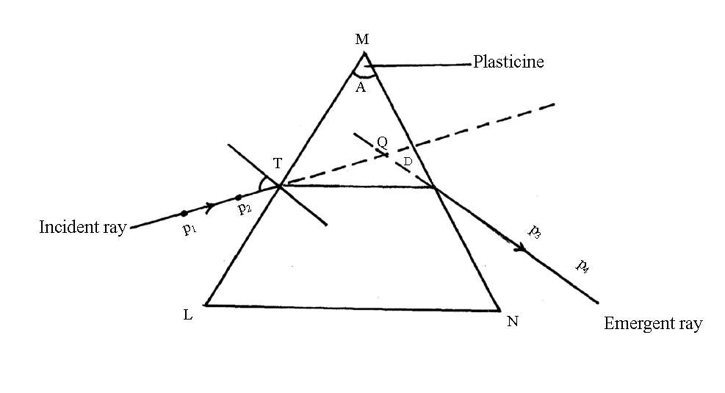
40º

II). Measure angle A of the prism using a protractor. (1mk)
………………………………………………………………………………………………………
………………………………………………………………………………………………………
………………………………………………………………………………………………………
Ill). Place the prism on a plain paper and trace its outline with a pencil. Attach some plasticine to the prism to indicate the prism angle, A.
Construct a normal at point T along LM. Draw an incident ray to strike the prism
at 40°.
Replace the prism and stick pins P₁ and P₂ to define the incident ray. View pins P₁
and P₂ from the opposite face (MN). Insert pins P₃ and P₄ so that they appear to be
in line with images of P₁ and P₂
Remove the prism and join P₃ and P₄ to give emergent ray.
Extrapolate the emergent ray into the prism so as to meet the extrapolated incident ray at Q.

IV). a) Measure angle D (2mks)
………………………………………………………………………………………………………
………………………………………………………………………………………………………
………………………………………………………………………………………………………
………………………………………………………………………………………………………
b) Calculate the value of (3mks)
$η=\frac{\text{cos}\left({\text{90}}^{0}−\frac{A+D}{2}\right)}{\text{Sin}\left(\frac{A}{2}\right)}$
………………………………………………………………………………………………………
………………………………………………………………………………………………………
………………………………………………………………………………………………………
………………………………………………………………………………………………………
………………………………………………………………………………………………………
………………………………………………………………………………………………………
c) What is the significance of $η$? (1mk)
………………………………………………………………………………………………………
………………………………………………………………………………………………………

Question 2 (20 marks)
You are provided with the following
• Two dry cells (size D)
• One bulb
• Voltmeter (0 — 3v or 0 -5v)
• Ammeter (0-2.5A)
• A mounted nicrome wire mounted on a millimeter scale
• Switch
• Seven connecting wire at least two with crocodile clips
• Micrometer screw gauge
Proceed as follows:
a) i) Set up the circuit as shown in figure below:
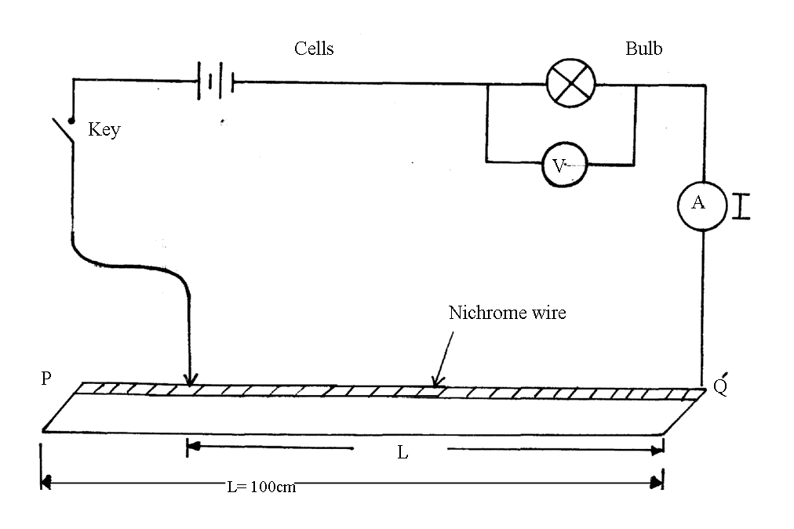

b)
ii) With the crocodile clip at P take the voltmeter reading and the ammeter reading.
Record V and I.
Repeat the readings for L= 80, 60, 40, 20 and 0cm respectively.
Complete the table below

Length(cm) | 100 | 80 | 60 | 40 | 20 | 0
Voltage, V(V)
Current I(A)

iii) What changes do you observe on the bulb as L decreases from P? (1mk)
………………………………………………………………………………………………………
………………………………………………………………………………………………………
iv) Plot a graph of the ammeter reading (y-axis) against voltmeter reading. (5mks)
(Provide a graph paper)

v) Determine the slope of your graph at V= I volt. (2mks)
………………………………………………………………………………………………………
………………………………………………………………………………………………………
………………………………………………………………………………………………………
………………………………………………………………………………………………………
………………………………………………………………………………………………………
………………………………………………………………………………………………………
vi) What physical quantity is represented by the slope of the graph at any given point (1mk)
………………………………………………………………………………………………………
………………………………………………………………………………………………………
………………………………………………………………………………………………………

c) i) Given the apparatus in a (i) above, draw a diagram of the circuit you would use to
determine the current through the resistance wire and the potential difference across. (1mk)
………………………………………………………………………………………………………
………………………………………………………………………………………………………
………………………………………………………………………………………………………

ii) Set up the circuit you have drawn. Record the ammeter reading I and the voltmeter
reading V. when L = 100cm. (2mks)
V =
………………………………………………………………………………………………………
………………………………………………………………………………………………………
………………………………………………………………………………………………………
I =
………………………………………………………………………………………………………
………………………………………………………………………………………………………
………………………………………………………………………………………………………

iii) Using a micrometer screw gauge, measure the diameter of the wire. (1 mk)
d=___________________ m
………………………………………………………………………………………………………
………………………………………………………………………………………………………
………………………………………………………………………………………………………
iv) Calculate the quantity:
=0.785 $\frac{\left(V\right)}{I}\frac{\left(d^{2}\right)}{L}$ and give its units, where L is one metre. (2mks)

END

