NAME……………………………………………………….. INDEX NO……………………........................

443/1 CANDIDATE’S SIGN………….….….….…..
AGRICULTURE
PAPER 1 DATE……….…………………………………

TIME: 2 HOURS

CENTRAL KENYA NATIONAL SCHOOLS JOINT EXAM - 2015

Kenya Certificate of Secondary Education
AGRICULTURE
PAPER 1
TIME: 2 HOURS

INSTRUCTIONS TO CANDIDATES:
• Write your name and index number in the spaces provided above.
• Sign and write the date of examination in the spaces provided above.
• This paper consists of THREE Sections A, B and C.
• Answer all questions in Section A and B and any Two in Section C.
• All answers must be written in the spaces provided.

FOR EXAMINER’S USE ONLY
Section | Question | Maximum  Score | Candidate’s  Score
A | 1 - 18 | 30
B | 19 – 23 | 20
C | 24 -26 | 40
Total Score |  | 90

Agriculture Paper 1 Turnover
SECTION A: (30 MARKS)

Answer all questions in this section in the spaces provided.

1. State two advantages of intensive farming system. (1mk)

_________________________________________________________________________________

_________________________________________________________________________________

_________________________________________________________________________________

2. Outline four effects of application of nitrogenous fertilizers on tomatoes. (2mks)

_________________________________________________________________________________

_________________________________________________________________________________

_________________________________________________________________________________

_________________________________________________________________________________

3. List four ways which are used to control stalk borers in maize. (2mks)

_________________________________________________________________________________

_________________________________________________________________________________

_________________________________________________________________________________

_________________________________________________________________________________

4. Give four factors that influence the quantity of water used in the farm. (2mks)

_________________________________________________________________________________

_________________________________________________________________________________

_________________________________________________________________________________

_________________________________________________________________________________

5. State four characteristics of trees and shrubs suitable for agroforestry. (2 marks)

_________________________________________________________________________________

_________________________________________________________________________________

_________________________________________________________________________________

_________________________________________________________________________________

Agriculture Paper 1 2
6. Name three examples of leguminous fodder crops. (1½mks)

_________________________________________________________________________________

_________________________________________________________________________________

_________________________________________________________________________________

7. Give four methods of layering in crop production. (2mks)

_________________________________________________________________________________

_________________________________________________________________________________

_________________________________________________________________________________

_________________________________________________________________________________

8. State four principles that govern the running of co-operatives in Kenya. (2mks)

_________________________________________________________________________________

_________________________________________________________________________________

_________________________________________________________________________________

_________________________________________________________________________________

9. Give four disadvantages of landlordism tenancy system of land tenure. (2mks)

_________________________________________________________________________________

_________________________________________________________________________________

_________________________________________________________________________________

_________________________________________________________________________________

10. List two types of labour record kept on the farm. (1mk)

_________________________________________________________________________________

_________________________________________________________________________________

_________________________________________________________________________________

_________________________________________________________________________________

11. Give reason as to why the following practices are carried out in preparation of planting
materials.
(i) Seed dressing. (½mk)

___________________________________________________________________________

Agriculture Paper 1 3
(ii) Seed innoculation. (½mk)

___________________________________________________________________________

- Chitting. (½mk)

__________________________________________________________________________

12. State four factors influencing supply of beans in a local market. (2mks)

_________________________________________________________________________________

_________________________________________________________________________________

_________________________________________________________________________________

_________________________________________________________________________________

13. State four ways in which biological agents influence soil formation. (2mks)

_________________________________________________________________________________

_________________________________________________________________________________

_________________________________________________________________________________

_________________________________________________________________________________

14. Beside providing water to the plants. State two other uses of flood water to rice field. (1mk)

_________________________________________________________________________________

_________________________________________________________________________________

15. Outline four reasons for pruning fruits crops. (2mks)

_________________________________________________________________________________

_________________________________________________________________________________

_________________________________________________________________________________

_________________________________________________________________________________

16. State four importance of breaking hard pan in land preparation. (2mks)

_________________________________________________________________________________

_________________________________________________________________________________

_________________________________________________________________________________

_________________________________________________________________________________

Agriculture Paper 1 4
17. How are the following conditions prevented in carrot production? (2mks)
(i) Forking.

____________________________________________________________________________

(ii) Greening of root tuber.

____________________________________________________________________________

SECTION B: (20 MARKS)

Answer all questions in this section in the spaces provided.

18. The illustration below shows a layout of a method of making compost manure. Study it correctly
and answer the questions that follow.

Field

(a) Identify the method above. (1mk)

___________________________________________________________________________

(b) Using letters X, Y and Z and arrows complete the diagram above. (4mks)

19. Observe the structures labelled L and answer the questions that follow.

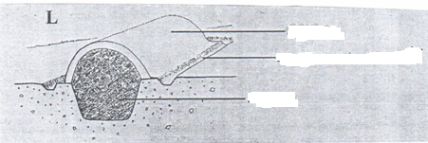
Soil layer
Channel
Silage

(a) Name the structure labelled L. (1mk)

___________________________________________________________________________

(b) State the importance of the channel around the structure L. (1mk)

___________________________________________________________________________

Agriculture Paper 1 5
(c) Outline two reasons for conserving forage. (2mks)

___________________________________________________________________________

___________________________________________________________________________

(d) Name two main silage losses that can occur during ensiling. (1mk)

___________________________________________________________________________

20. Below are diagrams of weed study them and answer the questions that follow.

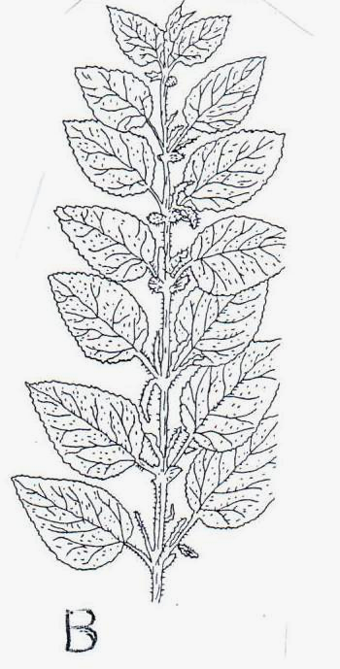

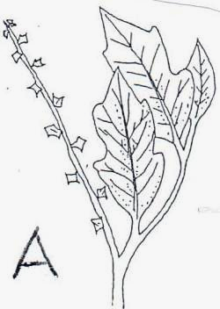

(a) Identify weed: (2mks)

A___________________________________________________________________________

B___________________________________________________________________________

(b) Explain why it’s difficult to control the above weeds. (1mk)

____________________________________________________________________________

____________________________________________________________________________

____________________________________________________________________________

(c) Mention two benefits of weed B to the farm. (2mks)

____________________________________________________________________________

____________________________________________________________________________

Agriculture Paper 1 6
21. The following transactions were extracted from Mr. Ouko’s financial books for the month
of February 2014.
1/2/14: Bought a mower Sh. 5,000
2/2/14: Bought animals feed Sh. 10,000
2/2/14: Sold 2 calves Sh. 4,000
19/2/14: Paid interest on loan Sh. 1,000
21/2/14: Sold eggs Sh. 2,000

Prepare a cash book for Mr. Ouko’s farm. (5mks)

SECTION C: (40 MARKS)

Answer any two questions in this section in the spaces provided.

22. (a) Describe five agricultural support services available to farmers. (10mks)

(b) Explain five structural methods of soil erosion control. (10mks)

23 (a) Describe ten management practices carried out on a nursery to ensure proper
seedling development. (10mks)

(b) Outline six benefits from practising minimum tillage. (6mks)

(c) State four precautinary measures that should be observed while harvesting
pyrethrum. (4mks)

24. (a) State five effects of wind while discourage crop production. (5mks)

(b) Explain cultural method to control crop diseases. . (8mks)

(c) What is a partial budget? (1mk)

Agriculture Paper 1 7
(d) Mr. Onyango has 4 hectares of arable land, 1.5 hectare of which is under
wheat, 0.5 hectare under maize, 0.3 hectare under fodder crops and the rest
is under either improved grass ley or natural grass. He wishes to know whether
replacing 0.3ha of maize with potatoes the following season would be worthwhile.
The fertilizer rate would have increased from 2 bags per hectare for maize to 2.5
bags per hectare for potatoes an extra 40 days of casual labour per hectare would
be necessary as a result of the change. Average yields of maize and potatoes are 56
and 90 bags per hectare respectively. The price are Ksh. 1200 per bag of maize and
Kshs. 300 per bag of potatoes. Seeds costs are Kshs. 1350 per 10 kg of maize and
Kshs. 200 per 50 kg of potatoes. DAP fertilizer costs Kshs. 1400 per 50 kg bag.
Labour is paid at Kshs. 150 per man day. He would require 10 bags of potatoes seed
and 1 bag of maize seed to cover 0.3 of a hectare. Draw up a partial budget and indicate
the effect of the change. (5mks)

(e) What advise would you give this farmer? (1mk)

________________________________________________________________________________________

________________________________________________________________________________________

________________________________________________________________________________________

________________________________________________________________________________________

________________________________________________________________________________________

________________________________________________________________________________________

________________________________________________________________________________________

________________________________________________________________________________________

________________________________________________________________________________________

________________________________________________________________________________________

________________________________________________________________________________________

________________________________________________________________________________________

________________________________________________________________________________________

________________________________________________________________________________________

________________________________________________________________________________________

________________________________________________________________________________________

________________________________________________________________________________________

________________________________________________________________________________________

________________________________________________________________________________________

________________________________________________________________________________________

________________________________________________________________________________________
Agriculture Paper 1 8
________________________________________________________________________________________

________________________________________________________________________________________

________________________________________________________________________________________

________________________________________________________________________________________

________________________________________________________________________________________

________________________________________________________________________________________

________________________________________________________________________________________

________________________________________________________________________________________

________________________________________________________________________________________

________________________________________________________________________________________

________________________________________________________________________________________

________________________________________________________________________________________

________________________________________________________________________________________

________________________________________________________________________________________

________________________________________________________________________________________

________________________________________________________________________________________

________________________________________________________________________________________

________________________________________________________________________________________

________________________________________________________________________________________

________________________________________________________________________________________

________________________________________________________________________________________

________________________________________________________________________________________

________________________________________________________________________________________

________________________________________________________________________________________

________________________________________________________________________________________

________________________________________________________________________________________

________________________________________________________________________________________

________________________________________________________________________________________

________________________________________________________________________________________
Agriculture Paper 1 9
________________________________________________________________________________________

________________________________________________________________________________________

________________________________________________________________________________________

________________________________________________________________________________________

________________________________________________________________________________________

________________________________________________________________________________________

________________________________________________________________________________________

________________________________________________________________________________________

________________________________________________________________________________________

________________________________________________________________________________________

________________________________________________________________________________________

________________________________________________________________________________________

________________________________________________________________________________________

________________________________________________________________________________________

________________________________________________________________________________________

________________________________________________________________________________________

________________________________________________________________________________________

________________________________________________________________________________________

________________________________________________________________________________________

________________________________________________________________________________________

________________________________________________________________________________________

________________________________________________________________________________________

________________________________________________________________________________________

________________________________________________________________________________________

________________________________________________________________________________________

________________________________________________________________________________________

________________________________________________________________________________________

________________________________________________________________________________________

________________________________________________________________________________________
Agriculture Paper 1 10

