NAME…………………………………………………………………………………..INDEX NO………………………………
443/2 CANDIDATES SIGN……………….
AGRICULTURE PAPER 2 DATE……………………………………
MARCH/APRIL 2015
2HOURS
MOKASA K.C.S.E. AGRICULTURE PAPER 2
INSTRUCTIONS TO CANDIDATES

[a]Write your name and index number in the spaces provided at the top of this page .
[b]Sign and write the date of the examination in the spaces provided above .
[c]This paper consists of three sections A ,B ,and C .
[d]Answer all the questions in sections A and B .Answer two questions in section C
[e]Answers should be written in the spaces provided on the question paper.
FOR EXAMINERS USE ONLY .
SECTION | QUESTIONS | MAX.SCORE | CANDIDATES SCORE
A | 1---24 | 30
B | 25—29 | 20
C | 30 ,31 ,32 | 20
 | 30 ,31 ,32 | 20
TOTAL SCORE |  | 90

SECTION A [30 MARKS]
Answer all the questions in this section in the spaces provided .

1.Name a breed of goats that has long hair .[0.5mks.]
…………………………………………………………………………………
2.Give three factors that should be considered when sitting a bee-hive in the farm[1.5marks]
……………………………………………………………………………………………………………………………………………………………………………………………………………………………………………………………………………………………………………………………………………………………………………………………
3.State four management practices that would ensure maximum harvest of fish in a fish pond [2marks]
………………………………………………………………………………………………………………………………………………………………………………………………………………………………………………………………………………………………………………………………………………………………………………………………………………………………………………………………………………………………………………………………
4.Give two reasons why walls of dairy sheds should be white –washed instead of painted with water or oil paint .[1mark]
……………………………………………………………………………………………………………………………………………………………………………………………………………………………………………………………..
5.What is the intermediate host for liver fluke .[0.5mks.]
…………………………………………………………………………………………
6.What is the duration of estrus cycle in a cow ? [0.5mks.]
……………………………………………………………………………………….
7.If a dairy cow was noticed to be showing first signs of heat at 6.00am.What time should she be inseminated ? [1mark] …………………………………………………………………………………………………………………………….
8Give four factors that determine the amount of water required by an animal .[2marks]
………………………………………………………………………………………………………………………………………………………………………………………………………………………………………………………………………………………………………………………………………………………………………………………………………………………………………………………………………………………………………………………………
9.Name three holding tools and equipment .[1.5marks]
………………………………………………………………………………………………………………………………………………………………………………………………………………………………………………………………
10.Give three functions of a combination squire . [1.5marks]
……………………………………………………………………………………………………………………………………………………………………………………………………………………………………………………………………………………………………………………………………………………………………………………………..
11.State three functions of the differential in a tractors power transmission.[1.5mks]
………………………………………………………………………………………………………………………………………………………………………………………………………………………………………………………………………………………………………………………………………………………………………………………………
12.State three factors that contribute to a high working efficiency of a disc harrow.[1.5marks]
………………………………………………………………………………………………………………………………………………………………………………………………………………………………………………………………………………………………………………………………………………………………………………………………

13.List three products obtained from dromedary camel.[1.5marks]
……………………………………………………………………………………………………………………………….
14.If the records showed that a rabbit doe was served on 27th September2014 what date did she give birth/kindle? [0.5marks]
……………………………………………………………………………………………………………………………
15.Give two signs that would show that a rabbit doe is about to parturate .[1mk.]
………………………………………………………………………………………………………………………………………………………………………………………………………………………………………………………………
16.Under what conditions would it be necessary to use a file to smoothen a piece of wood instead of using a smoothing plane ?[0.5marks]
……………………………………………………………………………………………………………………………………………………………………………………………………………………………………………………………..
17.What is the use of a plumb-bob ?[0.5marks]
……………………………………………………………………………………………………………………………….
18.State four characteristics of a corriedale sheep breed.[2marks]
………………………………………………………………………………………………………………………………………………………………………………………………………………………………………………………………………………………………………………………………………………………………………………………………………………………………………………………………………………………………………………………………
19.State any two disadvantages that may arise from inbreeding in livestock production .[1mark]
……………………………………………………………………………………………………………………………………………………………………………………………………………………………………………………………….

20.Name four cattle diseases caused by bacteria .[2marks]
………………………………………………………………………………………………………………………………………………………………………………………………………………………………………………………………………………………………………………………………………………………………………………………………
21.Name any two methods recommended for identifying goats .[1mark]
………………………………………………………………………………………………………………………………
22.State three field conditions under which a disc plough should be used instead of a mould board plough .[1.5marks]
………………………………………………………………………………………………………………………………………………………………………………………………………………………………………………………………………………………………………………………………………………………………………………………………
23.Give three symptoms of milk fever in dairy cattle .[1.5marks]
……………………………………………………………………………………………………………………………………………………………………………………………………………………………………………………………………………………………………………………………………………………………………………………………….
24.Give four reasons for steaming –up dairy animals.[2marks]
………………………………………………………………………………………………………………………………………………………………………………………………………………………………………………………………………………………………………………………………………………………………………………………………………………………………………………………………………………………………………………………………

SECTION B [20MARKS]
Answer all questions in this section in the spaces provided .
25.The drawing below shows the cross-section of a house under construction. Study it carefully and answer questions that follow .
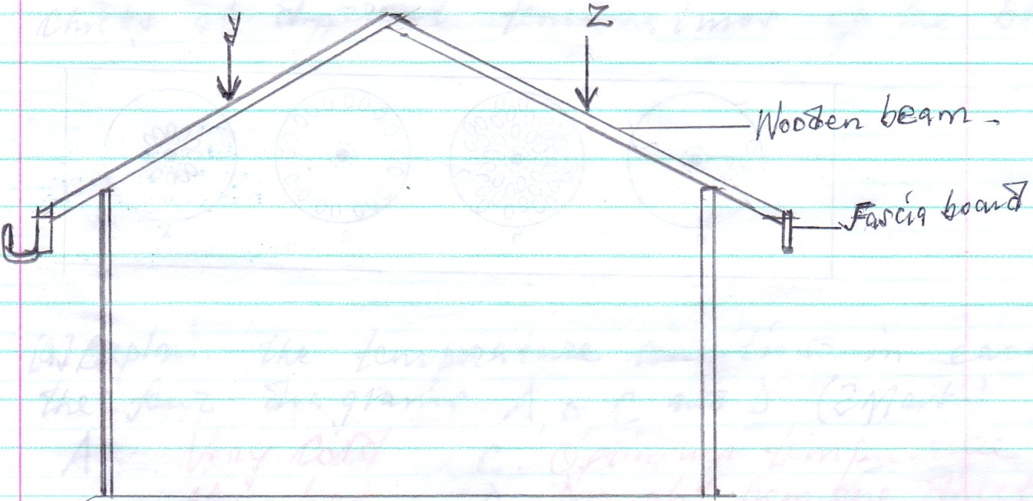
[a]Assuming that the wooden beams are strong enough to hold the roof load .What is the most likely thing to happen when the roof load exerted presses at point Y and Z .[1mark]
………………………………………………………………………………………………………………………………………………………………………………………………………………………………………………………………
[b]On the diagram provided draw and label two constructional features you would add to this structure in order to make it more efficient.[2marks]
…………………………………………………………………………………………………………………………….
[c]State two importance of the fascia board in the farm building.[2marks]
……………………………………………………………………………………………………………………………………………………………………………………………………………………………………………………………..
26.The following illustration show the behavior of chicks at different temperatures of the brooder.
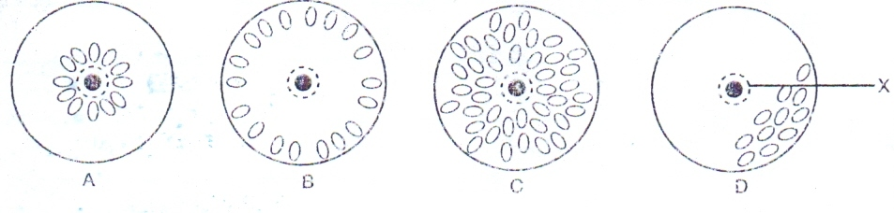
[a]Explain the temperature conditions in each of the four diagrams A ,B ,C ,and D.[2marks]
A…………………………………………………B…………………………………………………………………
C………………………………………………..D………………………………………………………………….
[b]Give one method of assessing temperature in the brooder.[1mark]
…………………………………………………………………………………………………………………………
[c]Name two other behavioral observations on chicks when temperature is very high in the brooder.[2marks]
……………………………………………………………………………………………………………………………………………………………………………………………………………………………………………………………………………………………………………………………………………………………………………………………..
27.The illustration below shows a pig far rowing pen .Study it and answer questions that follow.
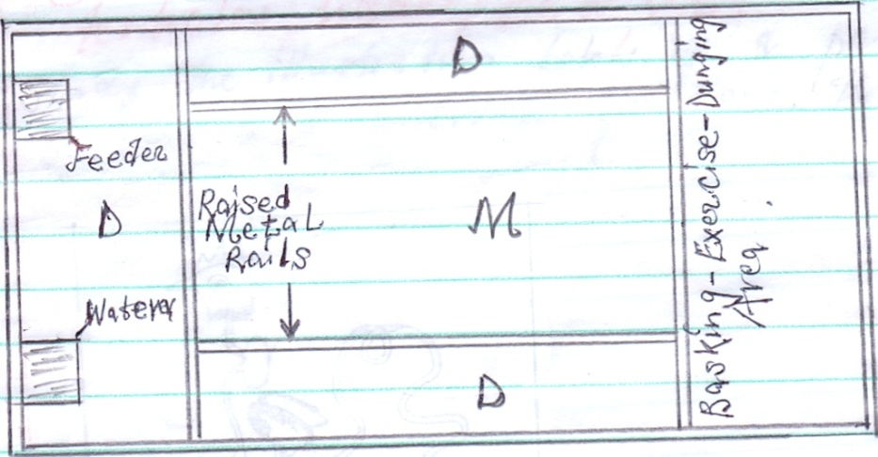
[a]What is the use of the raised metal rails.[1mark]
………………………………………………………………………………………………………………………
[b]Give two uses for the parts labeled D[2marks]
……………………………………………………………………………………………………………………………………………………………………………………………………………………………………………………………….
28.Below is an illustration representing a practice carried out in sheep. Study it and answer questions that follow.
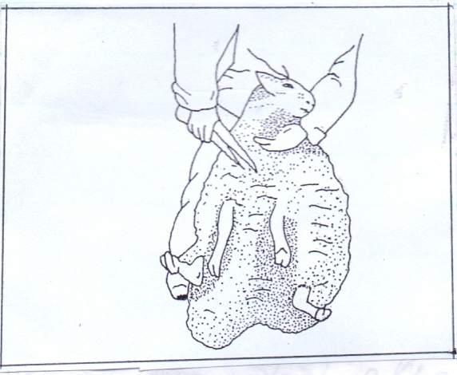
[a]Identify the practice illustrated above.[1mark]
……………………………………………………………………………………………………………………………..
[b]State three precautions taken when carrying out the above practice.[3marks]
……………………………………………………………………………………………………………………………………………………………………………………………………………………………………………………………………………………………………………………………………………………………………………………………………………………………………………………………………………………………………………………………….

29.Study the illustration below of a poultry digestive system and answer questions that follow.
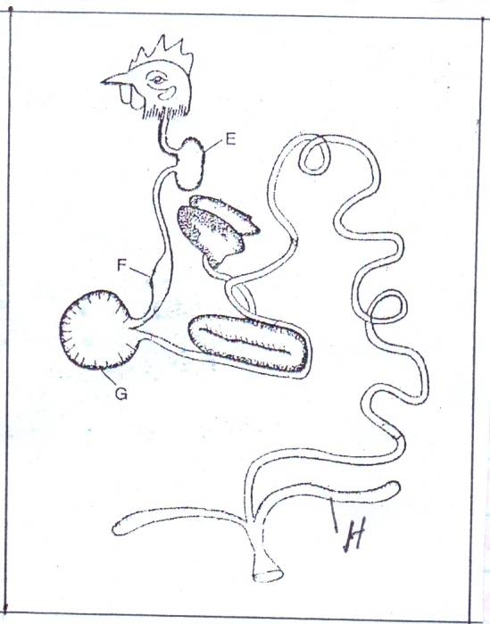
[a]Give two functions of part E.[2marks]
……………………………………………………………………………………………………………………………………………………………………………………………………………………………………………………………….
[b]State one function of part H.[1mark]
……………………………………………………………………………………………………………………………….

SECTION C [40MARKS]
Answer any two questions from this section in the spaces provided after each question.
30.[a]Describe ten factors that are considered during the selection of a breeding stock.[10marks]
……………………………………………………………………………………………………………………………………………………………………………………………………………………………………………………………………………………………………………………………………………………………………………………………………………………………………………………………………………………………………………………………………………………………………………………………………………………………………………………………………………………………………………………………………………………………………………………………………………………………………………………………………………………………………………………………………………………………………………………………………………………………………………………………………………………………………………………………………………………………………………………………………………………………………………………………………………………………………………………………………………………………………………………………………………………………………………………………………………………………………………………………………………………………………………………………….
[b]Describe five effects of parasites on livestock.[5marks]
………………………………………………………………………………………………………………………………………………………………………………………………………………………………………………………………………………………………………………………………………………………………………………………………………………………………………………………………………………………………………………………………………………………………………………………………………………………………………………………………………………………………………………………………………………………………………………………………………………………………………………………………………………………………………………………………………………………………………………………………………………………………………………………………

[c]Describe the mechanical control measures of ticks.[5marks]
……………………………………………………………………………………………………………………………………………………………………………………………………………………………………………………………………………………………………………………………………………………………………………………………………………………………………………………………………………………………………………………………………………………………………………………………………………………………………………………………………………………………………………………………………………………………………………………………………………………………………………………………………………………………………………………………….
31.[a]Outline five reasons why bees swarm away.[5marks]
………………………………………………………………………………………………………………………………………………………………………………………………………………………………………………………………………………………………………………………………………………………………………………………………………………………………………………………………………………………………………………………………………………………………………………………………………………………………………………………………………………………………………………………………………………………………………………………………
[b]Discuss the preparations and practices that should be carried out on a pregnant sow 10 days before she far rows.[5marks]
……………………………………………………………………………………………………………………………………………………………………………………………………………………………………………………………………………………………………………………………………………………………………………………………………………………………………………………………………………………………………………………………………………………………………………………………………………………………………………………………………………………………………………………………………………………………………………………………….
[c]Describe Gumboro disease under the following sub headings.
Causal organism [1mark]
……………………………………………………………………………………………………………………………..
Livestock attacked [1mark]
……………………………………………………………………………………………………………………………….
Symptoms of the disease [6marks]
………………………………………………………………………………………………………………………………………………………………………………………………………………………………………………………………………………………………………………………………………………………………………………………………………………………………………………………………………………………………………………………………………………………………………………………………………………………………………………………………………………………………………………………………………………………………………………………………………………………………………………………………………………………………………………………………
Control measures [2marks]
……………………………………………………………………………………………………………………………………………………………………………………………………………………………………………………………………………………………………………………………………………………………………………………………….
32.[a]Explain five advantages of animal draught power.[5marks]
………………………………………………………………………………………………………………………………………………………………………………………………………………………………………………………………………………………………………………………………………………………………………………………………………………………………………………………………………………………………………………………………………………………………………………………………………………………………………………………………………………………………………………………………………………………………………………………………
[b]Discuss the importance of lubrication system in a tractor.[4marks]
……………………………………………………………………………………………………………………………………………………………………………………………………………………………………………………………………………………………………………………………………………………………………………………………………………………………………………………………………………………………………………………………………………………………………………………………………………………………………………………………..

[c]Explain six factors considered when selecting construction materials for farm structures .[6marks]
………………………………………………………………………………………………………………………………………………………………………………………………………………………………………………………………………………………………………………………………………………………………………………………………………………………………………………………………………………………………………………………………………………………………………………………………………………………………………………………………………………………………………………………………………………………………………………………………………………………………………………………………………………………………………………………………
[d]Give five qualities of a good calf pen.[5marks]
………………………………………………………………………………………………………………………………………………………………………………………………………………………………………………………………………………………………………………………………………………………………………………………………………………………………………………………………………………………………………………………………………………………………………………………………………………………………………………………………………………………………………………………………………………………………………………………....................................................................................................................................................................................................................................................................................................................................................................................................................................................................................................................................................................................................................................................................................................................................................................................
……………....................................................................................................................................................................................................................................................................................................................................................................................................................................................................................................................................................................................................................................................................................................................................................................................
……………....................................................................................................................................................................................................................................................................................................................................................................................................................................................................................................................................................................................................................................................................................................................................................................................
……………....................................................................................................................................................................................................................................................................................................................................................................................................................................................................................................................................................................................................................................................................................................................................................................................
……………....................................................................................................................................................................................................................................................................................................................................................................................................................................................................................................................................................................................................................................................................................................................................................................................
……………....................................................................................................................................................................................................................................................................................................................................................................................................................................................................................................................................................................................................................................................................................................................................................................................
……………....................................................................................................................................................................................................................................................................................................................................................................................................................................................................................................................................................................................................................................................................................................................................................................................
……………....................................................................................................................................................................................................................................................................................................................................................................................................................................................................................................................................................................................................................................................................................................................................................................................
……………................................................................................................................................................................................................................................................................................................................................................................................................................................................................

