NAME……………………………………………………….. INDEX NO……………………........................

443/1 CANDIDATE’S SIGN………….….….….…..
AGRICULTURE
PAPER 1 DATE……….…………………………………
JULY/AUGUST, 2015
TIME: 2 HOURS

KAHURO /KIHARU DISTRICT JOINT EXAMINATION – 2015

Kenya Certificate of Secondary Education
AGRICULTURE
PAPER 1
TIME: 2 HOURS

INSTRUCTIONS TO CANDIDATES:
(a) Write your name and index number in the spaces provided above.
(b) Sign and write the date of examination in the spaces provided above.
(c) This paper consists of THREE Sections A, B and C.
(d) Answer ALL questions in Section A and B.
(e) In Section C, answer ANY Two questions.
(f) Candidates work must be legible.

FOR EXAMINER’S USE ONLY
Section | Question | Maximum  Score | Candidate’s  Score
A | 1 - 15 | 30
B | 16 – 19 | 20
C | 20 - 22 | 20
Total Score |  | 90

Agriculture Paper 1 Turnover
SECTION A: (30 MARKS)

Answer all questions in this section in the spaces provided.

1. State four reasons for practicing agro forestry in Kenya. (2 marks)

______________________________________________________________________

______________________________________________________________________

______________________________________________________________________

______________________________________________________________________

2. State four disadvantages of organic mulching. (2 marks)

______________________________________________________________________

______________________________________________________________________

______________________________________________________________________

______________________________________________________________________

3. (a) What is stooking as used in maize production? (1 mark)

________________________________________________________________

_________________________________________________________________

_________________________________________________________________

(b) State the importance of stooking. (1 mark)

_________________________________________________________________

_________________________________________________________________

_________________________________________________________________

4. Why is per capita income not a good measure of economic performance of a country? (1 mark)

______________________________________________________________________

______________________________________________________________________

______________________________________________________________________

Agriculture Paper 1 2 Kahuro/Kiharu
5. What is the use of a delivery note in farm accounts? (1 mark)

______________________________________________________________________

______________________________________________________________________

______________________________________________________________________

6. State four objectives of agricultural research. (2 marks)

______________________________________________________________________

______________________________________________________________________

______________________________________________________________________

______________________________________________________________________

7. Outline four factors considered when designing a crop rotation programme. (2 marks)

______________________________________________________________________

______________________________________________________________________

______________________________________________________________________

______________________________________________________________________

8. Outline six advantages of land consolidation. (3 marks)

______________________________________________________________________

______________________________________________________________________

______________________________________________________________________

______________________________________________________________________

______________________________________________________________________

______________________________________________________________________

Agriculture Paper 1 3 Kahuro/Kiharu
9. State four factors influencing soil erosion. (2 marks)

______________________________________________________________________

______________________________________________________________________

______________________________________________________________________

______________________________________________________________________

10. Outline four conditions that necessitate irrigation. (2 marks)

______________________________________________________________________

______________________________________________________________________

______________________________________________________________________

______________________________________________________________________

11. Name four variable inputs in a maize production enterprise. (2 marks)

______________________________________________________________________

______________________________________________________________________

______________________________________________________________________

______________________________________________________________________

12. State six factors that affect the quality of hay. (3 marks)

______________________________________________________________________

______________________________________________________________________

______________________________________________________________________

______________________________________________________________________

______________________________________________________________________

______________________________________________________________________

Agriculture Paper 1 4 Kahuro/Kiharu
13. Outline two reasons why a legume should be included when establishing forage crops. (1 mark)

______________________________________________________________________

______________________________________________________________________

______________________________________________________________________

______________________________________________________________________

14. State four advantages of tillage as a method of weed control. (2 marks)

______________________________________________________________________

______________________________________________________________________

______________________________________________________________________

______________________________________________________________________

15. Name three environmental factors affecting the effectiveness of herbicide. (3 marks)

______________________________________________________________________

______________________________________________________________________

______________________________________________________________________

______________________________________________________________________

SECTION B: (20 MARKS)

Answer all the questions in the spaces provided.

16. Below is an illustration of a soil structure. Study it carefully and answer the questions
beneath.
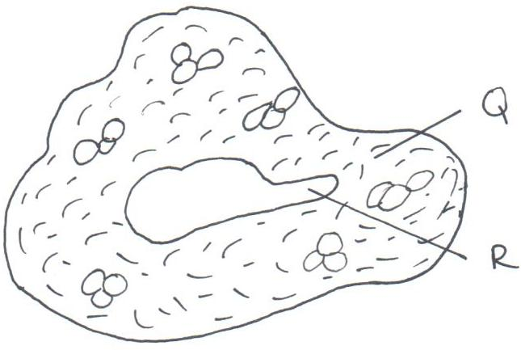

Agriculture Paper 1 5 Kahuro/Kiharu
(a) Identify the type of soil structure illustrated above. (½ mark)

_________________________________________________________________

(b) Name the parts labeled. (2 marks)

- Q ____________________________________________________________

- R ____________________________________________________________

(c) Name two areas where the structure is common within the soil profile. (2 marks)

_________________________________________________________________

_________________________________________________________________

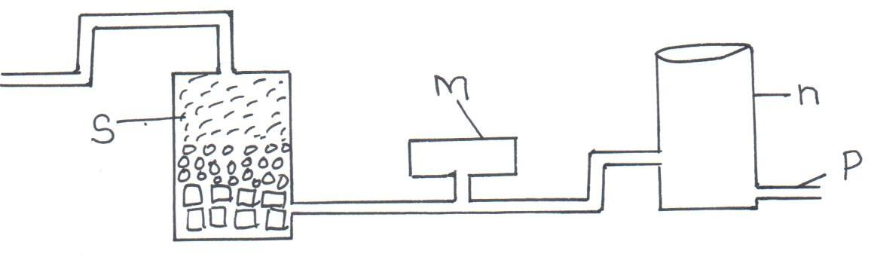
17. The illustration below represents the last stages of a water treatment system. Study it carefully and answer the questions beneath.

(a) Name the parts labelled. (1 mark)

M ______________________________________________________________

n _______________________________________________________________
(b) State one importance of: (2 marks)

P _______________________________________________________________

S _______________________________________________________________

(c) Briefly explain what happens to water as it passes through “M”. (2 marks)

_________________________________________________________________

_________________________________________________________________

________________________________________________________________

_________________________________________________________________

Agriculture Paper 1 6 Kahuro/Kiharu
18. Study the method of pruning illustration below and answer the questions that follow.
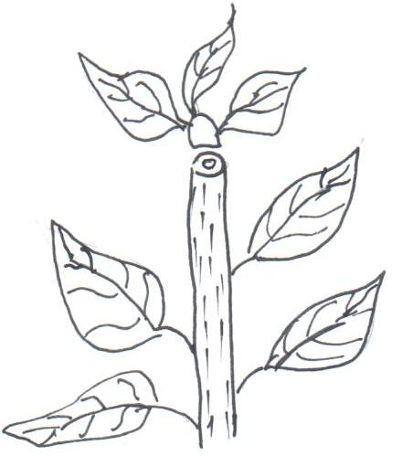

(a) Identify the method of pruning illustration above. (½ mark)

_________________________________________________________________

(b) Give a reason as to why the management practice is carried out. (1 mark)

_________________________________________________________________

_________________________________________________________________

_________________________________________________________________

(c) Name two crops onto which the practice is applicable. (2 marks)

_________________________________________________________________

_________________________________________________________________

(d) Name two other methods of pruning field crop. (2 marks)

_________________________________________________________________

_________________________________________________________________

19. (a) State four factors considered in choosing the planting time. (2 marks)

_________________________________________________________________

_________________________________________________________________

_________________________________________________________________

_________________________________________________________________

Agriculture Paper 1 7 Kahuro/Kiharu
(b) State two advantages of early planting. (2 marks)

_________________________________________________________________

_________________________________________________________________

_________________________________________________________________

_________________________________________________________________

(c) State one disadvantage of early planting. (1 mark)

_________________________________________________________________

_________________________________________________________________

_________________________________________________________________

SECTION C: (40 MARKS)

Answer any two questions in this section in the spaces provided after.

20. (a) Briefly describe the agricultural services available to the farmers. (10 marks)

(b) (i) What is farm Budgeting. (1 mark)
(ii) Name two types of farm Budget. (1 mark)

- A farmer intends to change his enterprise from livestock production to crop
production. The cost incurred is as follows.
The cost of livestock production includes.
- Cost of cow Kshs.15,000
- Fencing Kshs. 3,000
- Disease control Kshs. 1,000
- Milk man wager Kshs. 5,000
- Spraying costs Kshs. 500

The cost of crop production includes.
- Land preparation Kshs. 500
- Seeds Kshs. 600
- Planting Kshs. 800
- Fertilizers Kshs. 1,500
- Disease/pest control Kshs. 1,200
- Harvesting Kshs. 1,100

The revenue from milk sale is Ksh.25,000 and sale of calf Ksh.4,000 while
the revenue he gets from sale of crops is Ksh.23,000. Draw up a partial
budget and indicate whether the change is worthwhile or not. (8 marks)

Agriculture Paper 1 8 Kahuro/Kiharu
21. (a) Describe the various methods of drainage. (10 marks)
(b) State and explain five factors which influence pesticide efficiency. (10 marks)

22. Discuss the production of nappier grass under the following subheadings.
(i) Seedbed preparation. (4 marks)
(ii) Planting (5 marks)
(iii) Fertilizer application. (3 marks)
(iv) Weed control. (3 marks)
(v) Utilization. (5 marks)
___________________________________________________________________________

___________________________________________________________________________

___________________________________________________________________________

___________________________________________________________________________

___________________________________________________________________________

___________________________________________________________________________

___________________________________________________________________________

___________________________________________________________________________

___________________________________________________________________________

___________________________________________________________________________

___________________________________________________________________________

___________________________________________________________________________

___________________________________________________________________________

___________________________________________________________________________

___________________________________________________________________________

___________________________________________________________________________

___________________________________________________________________________

___________________________________________________________________________

___________________________________________________________________________

___________________________________________________________________________

Agriculture Paper 1 9 Kahuro/Kiharu
___________________________________________________________________________

___________________________________________________________________________

___________________________________________________________________________

___________________________________________________________________________

___________________________________________________________________________

___________________________________________________________________________

___________________________________________________________________________

___________________________________________________________________________

___________________________________________________________________________

___________________________________________________________________________

___________________________________________________________________________

___________________________________________________________________________

___________________________________________________________________________

___________________________________________________________________________

___________________________________________________________________________

___________________________________________________________________________

___________________________________________________________________________

___________________________________________________________________________

___________________________________________________________________________

___________________________________________________________________________

___________________________________________________________________________

___________________________________________________________________________

___________________________________________________________________________

___________________________________________________________________________

___________________________________________________________________________
Agriculture Paper 1 10 Kahuro/Kiharu

