NAME……………………………………………………….. INDEX NO……………………........................

443/2 CANDIDATE’S SIGN………….….….….…..
AGRICULTURE
PAPER 2 DATE……….…………………………………
JULY/AUGUST, 2015
TIME: 2 HOURS

KAHURO /KIHARU DISTRICT JOINT EXAMINATION – 2015

Kenya Certificate of Secondary Education
AGRICULTURE
PAPER 2
TIME: 2 HOURS

INSTRUCTIONS TO CANDIDATES:
(a) Write your name and index number in the spaces provided above.
(b) Sign and write the date of examination in the spaces provided above.
(c) This paper consists of THREE Sections A, B and C.
(d) Answer ALL questions in Section A and B.
(e) In Section C, answer ANY Two questions.
(f) Candidates work must be legible.

FOR EXAMINER’S USE ONLY
Section | Question | Maximum  Score | Candidate’s  Score
A | 1 - 16 | 30
B | 17 – 20 | 20
C | 21 - 23 | 20
Total Score |  | 90

Agriculture Paper 2 Turnover
SECTION A: (30 MARKS)

Answer all questions in this section in the spaces provided.

1. State four reasons that may discourage dairy farming in Kenya. (2 marks)

______________________________________________________________________

______________________________________________________________________

______________________________________________________________________

______________________________________________________________________

2. Outline four maintenance practices of a hack saw. (2 marks)

______________________________________________________________________

______________________________________________________________________

______________________________________________________________________

______________________________________________________________________

3. Name two methods used in disbudding. (1 mark)

______________________________________________________________________

______________________________________________________________________

4. Define line breeding. (1 mark)

______________________________________________________________________

______________________________________________________________________

______________________________________________________________________

5. Name four methods used in preserving fish. (2 marks)

______________________________________________________________________

______________________________________________________________________

______________________________________________________________________

______________________________________________________________________

Agriculture Paper 2 2 Kahuro/Kiharu
6. Name four sources of carbohydrates in livestock nutrition. (2 marks)

______________________________________________________________________

______________________________________________________________________

______________________________________________________________________

______________________________________________________________________

7. What is the effect of increasing the tractor speed on the cut slice when using a disc
plough? (1 mark)

______________________________________________________________________

______________________________________________________________________

______________________________________________________________________

8. Outline four routes through which disease Causing organisms get into the body of an
animal. (2 marks)

______________________________________________________________________

______________________________________________________________________

______________________________________________________________________

______________________________________________________________________

9. Outline three precautions a farmer should take to avoid infection by brucellosis. (3 marks)

______________________________________________________________________

______________________________________________________________________

______________________________________________________________________

______________________________________________________________________

10. Highlight three reasons for keeping feeding records. (3 marks)

______________________________________________________________________

______________________________________________________________________

______________________________________________________________________

______________________________________________________________________

Agriculture Paper 2 3 Kahuro/Kiharu
11. State four advantages of natural feeding in calf rearing. (2 marks)

______________________________________________________________________

______________________________________________________________________

______________________________________________________________________

______________________________________________________________________

12. Highlight four factors that affect maintenance requirements of an animal. (2 marks)

______________________________________________________________________

______________________________________________________________________

______________________________________________________________________

______________________________________________________________________

13. Name two developmental stages of a liver fluke. (1 mark)

______________________________________________________________________

______________________________________________________________________

14. State four reasons for feeding young calves on colostrum. (2 marks)

______________________________________________________________________

______________________________________________________________________

______________________________________________________________________

______________________________________________________________________

15. State four components of power transmission system. (2 marks)

______________________________________________________________________

______________________________________________________________________

______________________________________________________________________

______________________________________________________________________

Agriculture Paper 2 4 Kahuro/Kiharu
16. State four factors that stimulate milk let down in a lactating cow. (2 marks)

______________________________________________________________________

______________________________________________________________________

______________________________________________________________________

______________________________________________________________________

SECTION B: (20 MARKS)

Answer all the questions in the spaces provided.

17. Study the illustration of processing honey below and answer the question that follow.
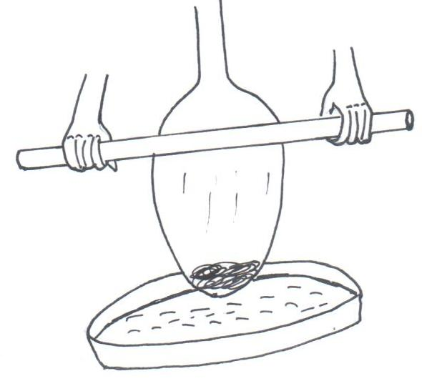

(a) Name the part labelled. (2 marks)

Q _______________________________________________________________

R _______________________________________________________________

(b) State the function of part labelled S. (1 mark)

_________________________________________________________________

_________________________________________________________________

(c) State four equipments used for harvesting honey. (2 marks)

_________________________________________________________________

_________________________________________________________________

_________________________________________________________________

_________________________________________________________________

Agriculture Paper 2 5 Kahuro/Kiharu
18. The diagram below represents a method of livestock nurture management practice. Study it carefully and answer the questions beneath/below.
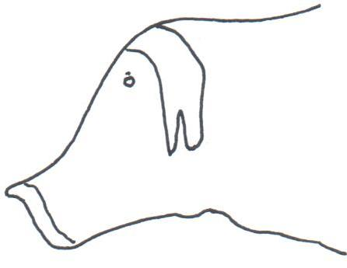

(a) Identify the management practice represented above. (1 mark)

_________________________________________________________________

(b) Name the farm tool used to carry out the management practice. (1 mark)

_________________________________________________________________

- State one major precautionary measure taken when carrying out the above management practice. (1 mark)

_________________________________________________________________

_________________________________________________________________

(d) Name four livestock animals which the management practice is carried out.
(1 mark)

_________________________________________________________________

_________________________________________________________________

_________________________________________________________________

_________________________________________________________________

19. Study the illustration below and answer the question beneath.
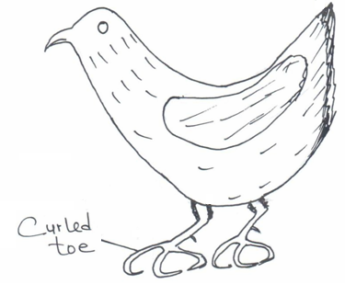

Agriculture Paper 2 6 Kahuro/Kiharu
(a) What causes curled toes? (1 mark)

_________________________________________________________________

_________________________________________________________________

(b) State two other deficiency symptoms besides curled toe paralysis. (2 marks)

_________________________________________________________________

_________________________________________________________________

_________________________________________________________________

_________________________________________________________________

(c) State four sources of vitamin B₂. (2 marks)

_________________________________________________________________

_________________________________________________________________

_________________________________________________________________

_________________________________________________________________

20. Animal power is a common means of transport in our country.
(a) Briefly explain the mechanism involved to enable them perform this practice. (3 marks)

_________________________________________________________________

_________________________________________________________________

_________________________________________________________________

_________________________________________________________________

(b) State two major factors which determine animals power efficiency. (2 marks)

_________________________________________________________________

_________________________________________________________________

_________________________________________________________________

_________________________________________________________________

Agriculture Paper 2 7 Kahuro/Kiharu
SECTION C: (40 MARKS)

Answer any two questions in this section in the spaces provided after.

21. (a) Explain the reasons for feeding livestock on a balanced ration. (6 marks)
(b) Describe the preparation and management of natural incubation. (9 marks)
(c) Describe the body conformation features of a beef cattle. (5 marks)

22. (a) What are the advantages of farm mechanization. (5 marks)
(b) State four maintenance practices of a tractor battery. (4 marks)
(c) Describe parts of a disc plough. (5 marks)
(d) State the disadvantages of animal drawn implements as compared
to tractor drawn implements. (6 marks)

23. (a) Outline three factors to consider when siting a calf pen. (3 marks)
(b) Name and describe the features of an ideal calf pen. (3 marks)
(c) What factors should a farmer consider when selecting materials for
constructing a dairy cattle shed. (10 marks)

________________________________________________________________________________________

________________________________________________________________________________________

________________________________________________________________________________________

________________________________________________________________________________________

________________________________________________________________________________________

________________________________________________________________________________________

________________________________________________________________________________________

________________________________________________________________________________________

________________________________________________________________________________________

________________________________________________________________________________________

________________________________________________________________________________________

________________________________________________________________________________________

________________________________________________________________________________________

________________________________________________________________________________________

________________________________________________________________________________________

________________________________________________________________________________________

________________________________________________________________________________________

________________________________________________________________________________________
Agriculture Paper 2 8 Kahuro/Kiharu
________________________________________________________________________________________

________________________________________________________________________________________

________________________________________________________________________________________

________________________________________________________________________________________

________________________________________________________________________________________

________________________________________________________________________________________

________________________________________________________________________________________

________________________________________________________________________________________

________________________________________________________________________________________

________________________________________________________________________________________

________________________________________________________________________________________

________________________________________________________________________________________

________________________________________________________________________________________

________________________________________________________________________________________

________________________________________________________________________________________

________________________________________________________________________________________

________________________________________________________________________________________

________________________________________________________________________________________

________________________________________________________________________________________

________________________________________________________________________________________

________________________________________________________________________________________

________________________________________________________________________________________

________________________________________________________________________________________

________________________________________________________________________________________

________________________________________________________________________________________

________________________________________________________________________________________

________________________________________________________________________________________

________________________________________________________________________________________

________________________________________________________________________________________
Agriculture Paper 2 9 Kahuro/Kiharu
________________________________________________________________________________________

________________________________________________________________________________________

________________________________________________________________________________________

________________________________________________________________________________________

________________________________________________________________________________________

________________________________________________________________________________________

________________________________________________________________________________________

________________________________________________________________________________________

________________________________________________________________________________________

________________________________________________________________________________________

________________________________________________________________________________________

________________________________________________________________________________________

________________________________________________________________________________________

________________________________________________________________________________________

________________________________________________________________________________________

________________________________________________________________________________________

________________________________________________________________________________________

________________________________________________________________________________________

________________________________________________________________________________________

________________________________________________________________________________________

________________________________________________________________________________________

________________________________________________________________________________________

________________________________________________________________________________________

________________________________________________________________________________________

________________________________________________________________________________________

________________________________________________________________________________________

________________________________________________________________________________________

________________________________________________________________________________________

________________________________________________________________________________________
Agriculture Paper 2 10 Kahuro/Kiharu

