NAME……………………………………………………….. INDEX NO……………………........................

443/2 CANDIDATE’S SIGN………….….….….…..
AGRICULTURE
PAPER 2 DATE……….…………………………………
TIME: 2 HOURS

CENTRAL KENYA NATIONAL SCHOOLS JOINT EXAM - 2015

Kenya Certificate of Secondary Education
AGRICULTURE
PAPER 2
TIME: 2 HOURS

INSTRUCTIONS TO CANDIDATES:
• Write your name and index number in the spaces provided above.
• Sign and write the date of examination in the spaces provided above.
• This paper consists of THREE Sections A, B and C.
• Answer all questions in Section A and B and any Two in Section C.
• All answers must be written in the spaces provided.

FOR EXAMINER’S USE ONLY
Section | Question | Maximum  Score | Candidate’s  Score
A | 1 -19 | 30
B | 20 – 23 | 20
C | 24 -26 | 40
Total Score |  | 90

Agriculture Paper 2 Turnover
SECTION A: (30 MARKS)

Answer all questions in this section in the spaces provided.

1. Differentiates between apiculture and aquaculture. (1mk)

_________________________________________________________________________________

_________________________________________________________________________________

_________________________________________________________________________________

_________________________________________________________________________________

2. State three ways of preventing predation in a fish pond. (1½mks)

_________________________________________________________________________________

_________________________________________________________________________________

_________________________________________________________________________________

3 Name one livestock disease that is transmitted by each of the following parasites.
(i) Brown ear tick. (½mks)
____________________________________________________________________________

(ii) Tse-tse fly. (½mks)

____________________________________________________________________________

4. Define the following terms as used in livestock production;
(i) Vaccination. (½mks)

__________________________________________________________________________

__________________________________________________________________________

(ii) Mortality rate. (½mks)

___________________________________________________________________________

___________________________________________________________________________

5. State the intermediate host for livefluke faciola (spp) (½mk)

_________________________________________________________________________________

_________________________________________________________________________________

6. State two roles of drones in a bee colony. (1mk)

_________________________________________________________________________________

_________________________________________________________________________________

Agriculture Paper 2 2
7. State four breeds of rabbit. (2mks)

_________________________________________________________________________________

_________________________________________________________________________________

_________________________________________________________________________________

_________________________________________________________________________________

8. State four important components of the power transmission system (2mks)

_________________________________________________________________________________

_________________________________________________________________________________

_________________________________________________________________________________

_________________________________________________________________________________

9. State four major routes of administering vaccines in a day old chicks. (2mks)

_________________________________________________________________________________

_________________________________________________________________________________

_________________________________________________________________________________

_________________________________________________________________________________

10. State four factors considered by farmers when sitting a beehive in the farm. (2mks)

_________________________________________________________________________________

_________________________________________________________________________________

_________________________________________________________________________________

_________________________________________________________________________________

11. Outline four reasons why calves should be fed on colostrum. (2mks)

_________________________________________________________________________________

_________________________________________________________________________________

_________________________________________________________________________________

_________________________________________________________________________________

12. State four characteristics of Bos taurus class of cattle. (2mks)

_________________________________________________________________________________

_________________________________________________________________________________

_________________________________________________________________________________

_________________________________________________________________________________

Agriculture Paper 2 3
13. State four importances of farm buildings. (2mks)

_________________________________________________________________________________

_________________________________________________________________________________

_________________________________________________________________________________

_________________________________________________________________________________

14. State two causes of bloat in ruminants. (1mk)

_________________________________________________________________________________

_________________________________________________________________________________

15. State four ways of controlling stress in a flock of layers. (2mks)

_________________________________________________________________________________

_________________________________________________________________________________

_________________________________________________________________________________

_________________________________________________________________________________

16. State four characteristics of roughage feedstuff. (2mks)

_________________________________________________________________________________

_________________________________________________________________________________

_________________________________________________________________________________

_________________________________________________________________________________

17. List four causes of livestock diseases. (2mks)

_________________________________________________________________________________

_________________________________________________________________________________

_________________________________________________________________________________

_________________________________________________________________________________

18. State two ways of improving traction in a tractor. (1mk)

_________________________________________________________________________________

_________________________________________________________________________________

19. Name the tools used to for;
(a) Carrying out open method of castration of livestock. (1mk)

__________________________________________________________________________

Agriculture Paper 2 4
(b) Cutting thick sheets of metal. (1mk)

__________________________________________________________________________

SECTION B: (20 MARKS)

Answer all questions in this section in the spaces provided.

20. Describe the procedure of manual milking in dairy cattle. (5mks)

_________________________________________________________________________________

_________________________________________________________________________________

_________________________________________________________________________________

_________________________________________________________________________________

_________________________________________________________________________________

_________________________________________________________________________________

_________________________________________________________________________________

_________________________________________________________________________________

_________________________________________________________________________________

_________________________________________________________________________________

_________________________________________________________________________________

_________________________________________________________________________________

21. The diagram below shows poultry digestive system. Use it to answer the questions that follows.
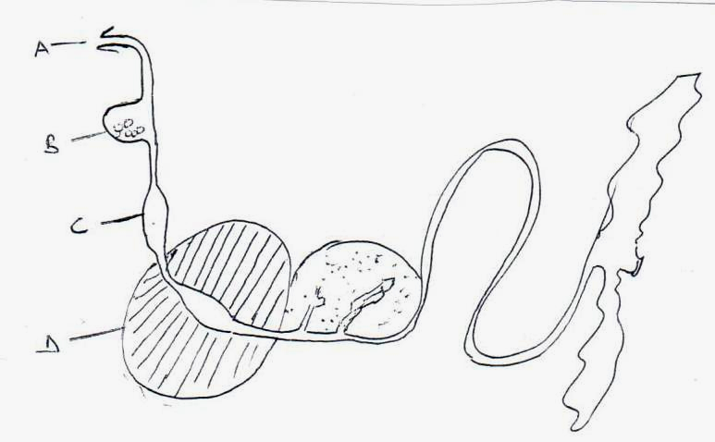

(a) State the function of part labelled B. (1mk)

____________________________________________________________________________

(b) Why is part C known as the true stomach? (1mk)

____________________________________________________________________________

Agriculture Paper 2 5
(c) State two advantages of part labelled D to its functions. (2mks)

____________________________________________________________________________

____________________________________________________________________________

____________________________________________________________________________

____________________________________________________________________________

(d) What management practice is carried out on part A? (1mk)

____________________________________________________________________________

22. The diagram below is of an illustration of a farm structure. Study it and answer the
questions that follow.
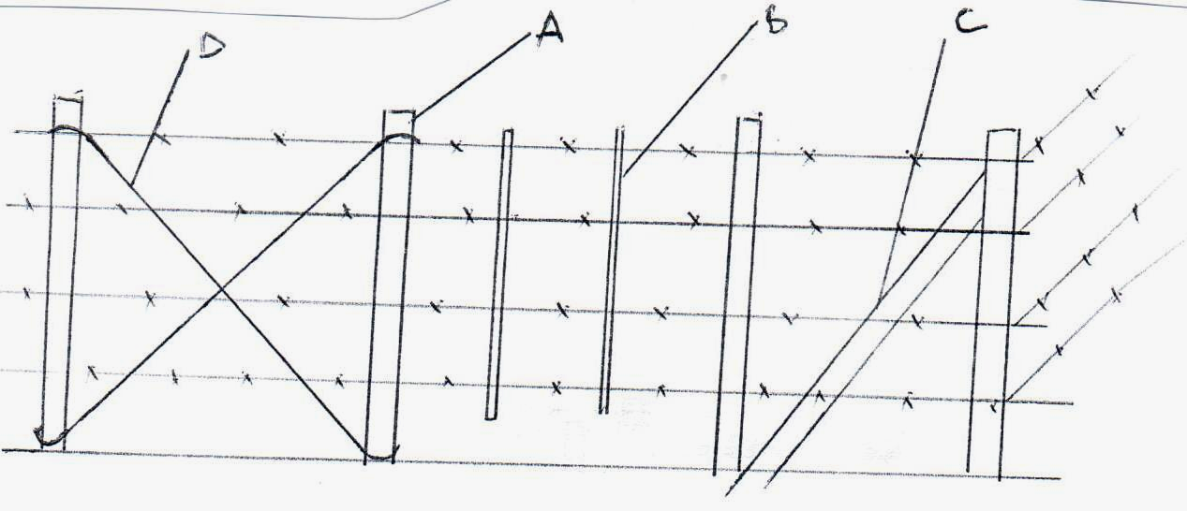

(a) State the type of the fence. (1mk)
___________________________________________________________________________

(b) Name the parts labeled: (1mk)

A___________________________________________________________________________

B___________________________________________________________________________

C___________________________________________________________________________

D___________________________________________________________________________

(c) State two reasons why the above fence is not recommended for sheep production. (2mks)

___________________________________________________________________________

____________________________________________________________________________

____________________________________________________________________________

___________________________________________________________________________

Agriculture Paper 2 6
23. Below are illustrations of farm tools. Study them and answer the question that follows:
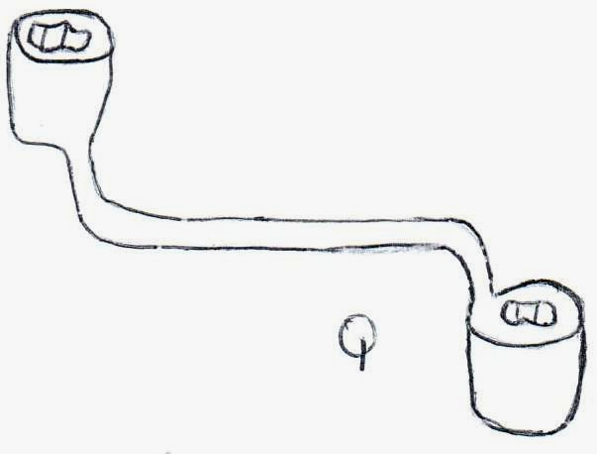

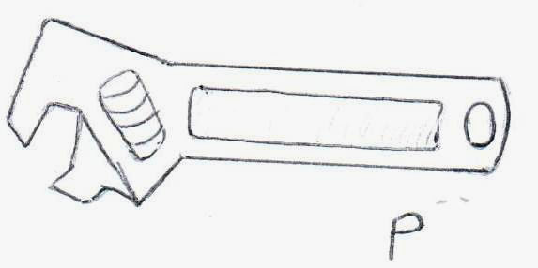

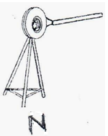

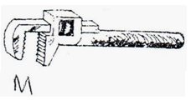

(a) Identify P and M. (1mk)

P___________________________________________________________________________

M__________________________________________________________________________

(b) State one advantage of P over Q. (1mk)

____________________________________________________________________________

____________________________________________________________________________

(c) State the function of tool labelled N and M. (2mks)

N__________________________________________________________________________

M__________________________________________________________________________

(d) Give two maintenance practices that can be carried out on tool P. (1mk)

____________________________________________________________________________

____________________________________________________________________________

____________________________________________________________________________

Agriculture Paper 2 7
SECTION C: (40 MARKS)

Answer any two questions in this section in the spaces provided.

24. (a) Discuss trypanosomiasis under the following subheading.
(i) Causal organisms. (1mk)
(ii) Animals attacked. (1mk)
(iii) Symptoms of attack. (6mks)
(iv) Methods of control. (2mks)

(b) State ten advantages of artificial insemination in dairy production. (10mks)

25 (a) State the advantages of battery cage system. (10mks)
(b) (i) List four examples of two host tick. (2mks)
(ii) Briefly discuss the life cycle of two host tick. (8mks)

26. (a) State ten tractor servicing done to a tractor. (10mks)

(b) Briefly discuss the management of a pig from birth up to weaning. (10mks)

________________________________________________________________________________________

________________________________________________________________________________________

________________________________________________________________________________________

________________________________________________________________________________________

________________________________________________________________________________________

________________________________________________________________________________________

________________________________________________________________________________________

________________________________________________________________________________________

________________________________________________________________________________________

________________________________________________________________________________________

________________________________________________________________________________________

________________________________________________________________________________________

________________________________________________________________________________________

________________________________________________________________________________________

________________________________________________________________________________________

________________________________________________________________________________________

________________________________________________________________________________________

________________________________________________________________________________________

________________________________________________________________________________________

Agriculture Paper 2 8
________________________________________________________________________________________

________________________________________________________________________________________

________________________________________________________________________________________

________________________________________________________________________________________

________________________________________________________________________________________

________________________________________________________________________________________

________________________________________________________________________________________

________________________________________________________________________________________

________________________________________________________________________________________

________________________________________________________________________________________

________________________________________________________________________________________

________________________________________________________________________________________

________________________________________________________________________________________

________________________________________________________________________________________

________________________________________________________________________________________

________________________________________________________________________________________

________________________________________________________________________________________

________________________________________________________________________________________

________________________________________________________________________________________

________________________________________________________________________________________

________________________________________________________________________________________

________________________________________________________________________________________

________________________________________________________________________________________

________________________________________________________________________________________

________________________________________________________________________________________

________________________________________________________________________________________

________________________________________________________________________________________

________________________________________________________________________________________

________________________________________________________________________________________
Agriculture Paper 2 9
________________________________________________________________________________________

________________________________________________________________________________________

________________________________________________________________________________________

________________________________________________________________________________________

________________________________________________________________________________________

________________________________________________________________________________________

________________________________________________________________________________________

________________________________________________________________________________________

________________________________________________________________________________________

________________________________________________________________________________________

________________________________________________________________________________________

________________________________________________________________________________________

________________________________________________________________________________________

________________________________________________________________________________________

________________________________________________________________________________________

________________________________________________________________________________________

________________________________________________________________________________________

________________________________________________________________________________________

________________________________________________________________________________________

________________________________________________________________________________________

________________________________________________________________________________________

________________________________________________________________________________________

________________________________________________________________________________________

________________________________________________________________________________________

________________________________________________________________________________________

________________________________________________________________________________________

________________________________________________________________________________________

________________________________________________________________________________________

________________________________________________________________________________________
Agriculture Paper 2 10

