NAME ____________________________________ INDEX NO. _______________

SCHOOL ____________________________________ SIGNATURE _______________ DATE _______________

**443/1**

**AGRICULTURE**

**PAPER 1**

JULY/AUGUST, 2015

**TIME: 2 HOURS**

443/1

AGRICULTURE

PAPER 1

TIME: 2 HOURS

**INSTRUCTIONS TO CANDIDATES**

* Write your name, school and index number in the spaces provided above.
* Sign and write the date of the examination in the spaces provided above.
* This paper consists of three sections: A, B and C.
* Answer **all** the questions in section **A** and **B** and **any two** questions from section **C.**
* All answers must be written in the spaces provided in this booklet.
* This paper consists of **12** printed pages.
* Candidates should check the question paper to ascertain that all pages are printed as indicated and that no questions are missing

For OFFICIAL use only

|  |  |  |  |
| --- | --- | --- | --- |
| SECTION | QUESTIONS | MAXIMUM SCORE | CANDIDATE’S SCORE |
| A | 1 − 16 | 30 |  |
| B | 17 − 20 | 20 |  |
| C | 21 | 20 |  |
| 22 | 20 |  |
| 23 | 20 |  |
|  | TOTAL SCORE | 90 |  |

**SECTION A** (30 MARKS)

***Answer ALL the questions in this section in the spaces provided.***

1. Give **two** ways in which agriculture offer employment. (2 marks)

______________________________________________________________________________________________________________________________________________________________________

2. Give **six** methods of managing agroforestry tree species after establishment in the farm. (3 marks)

__________________________________________________________________________________________________________________________________________________________________________________________________________________________________________________________________________________________________________________________________________________________________________________________________________________________________________________________________________________________________________________

3. Give **three** ways of utilizing Napier grass as a forage crop. (1½marks)

_________________________________________________________________________________________________________________________________________________________________________________________________________________________________________________________

4. Outline **four** edaphic factors which influence agriculture. (2 marks)

____________________________________________________________________________________________________________________________________________________________________________________________________________________________________________________________________________________________________________________________________________

5. List **four** characteristics of crops suitable for green manure production. (2 marks)

____________________________________________________________________________________________________________________________________________________________________________________________________________________________________________________________________________________________________________________________________________

6. Give **four** methods of acquiring land. (2 marks)

____________________________________________________________________________________________________________________________________________________________________________________________________________________________________________________________________________________________________________________________________________

7. Give **two** ways in which the problem of hardpans in the soil can be overcome. (1 mark)

____________________________________________________________________________________________________________________________________________________________________________________________________________________________________________________________________________________________________________________________________________

8. Give **three** reasons for treating water in the farm. (1½marks)

_________________________________________________________________________________________________________________________________________________________________________________________________________________________________________________________

9. Explain the meaning of the following terms as used in crop production:

i) Closed season (1 mark)

______________________________________________________________________________________________________________________________________________________________________

ii) Rogueing (1 mark)

______________________________________________________________________________________________________________________________________________________________________

iii) Earthing up (1 mark)

______________________________________________________________________________________________________________________________________________________________________

10. State **three** conditions under which opportunity cost does not exist or is equal to zero. (1½marks)

_________________________________________________________________________________________________________________________________________________________________________________________________________________________________________________________

11. List **three** functions of boron in crop development. (1½marks)

_________________________________________________________________________________________________________________________________________________________________________________________________________________________________________________________

12. Give **three** government policies that affect pricing of agricultural commodities in the market. (1½marks)

_________________________________________________________________________________________________________________________________________________________________________________________________________________________________________________________

13. List **four** areas suitable to discharge off storm from a cut-off drain. (2 marks)

____________________________________________________________________________________________________________________________________________________________________________________________________________________________________________________________________________________________________________________________________________

14. Give **four** ways of controlling weeds in maize field. (2 marks)

____________________________________________________________________________________________________________________________________________________________________________________________________________________________________________________________________________________________________________________________________________

15. State any **four** non-chemical methods of controlling storage pests in a maize granary . (2 marks)

____________________________________________________________________________________________________________________________________________________________________________________________________________________________________________________________________________________________________________________________________________

16. List **three** categories of capital used for farming. (1½marks)

_________________________________________________________________________________________________________________________________________________________________________________________________________________________________________________________

**SECTION B** (20 MARKS)

***Answer ALL the questions in this section in the spaces provided.***

17. The diagrams below show panicles of sorghum varieties. Study them and answer the questions that follow,

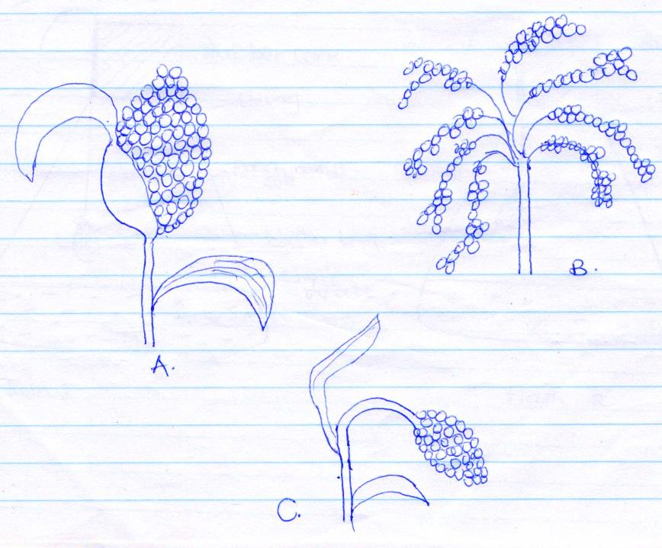 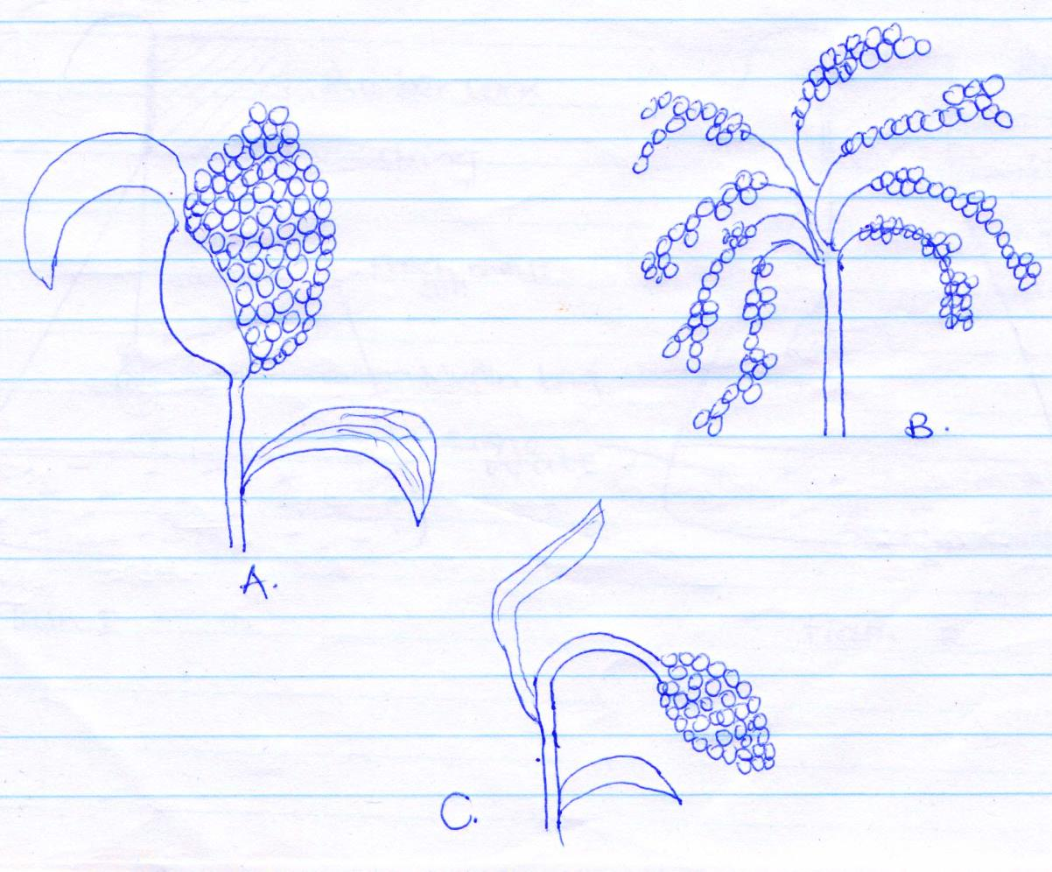

**A**

**C**

**B**

a) Identify the varieties A, B and C . (3 marks)

A ______________________________________________________________________________

B ______________________________________________________________________________

C ______________________________________________________________________________

b) What advantage does variety C have over variety A? (1 mark)

______________________________________________________________________________________________________________________________________________________________________

18. The diagrams below show an experiment that was carried out by form one students.

Study it carefully and answer the questions that follow.



a) What was the aim of the experiment? (1 mark)

______________________________________________________________________________________________________________________________________________________________________

b) What observation did the students make in the two flasks at the end of the experiment? (2 marks)

_________________________________________________________________________________________________________________________________________________________________________________________________________________________________________________________

c) Give reason for the observation made in flask I . (1 mark)

_________________________________________________________________________________________________________________________________________________________________________________________________________________________________________________________

d) Why did the students heat the garden soil in flask 2 strongly? (1 mark)

______________________________________________________________________________________________________________________________________________________________________

19. The diagram below shows a soil and water conservation structure.

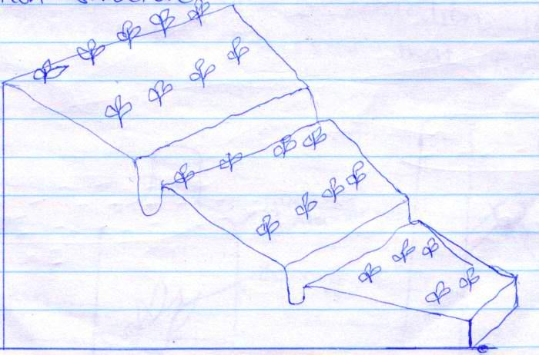

a) Identify the methods of soils and water conservation shown in the diagram. (1 mark)

______________________________________________________________________________________________________________________________________________________________________

b) State **three** practices that can be carried out on the above structure to make it stable. (3 marks)

_________________________________________________________________________________________________________________________________________________________________________________________________________________________________________________________

c) Outline the procedure of constructing a catchment basin as a micro-catchment. (3 marks)

______________________________________________________________________________________________________________________________________________________________________________________________________________________________________________________________________________________________________________________________________________________________________________________________________________________________________________________________________________________________________________________________________________________________________________________________________________________________________________________________________________________________________________________________________________________________________________________________________________________________________________________________

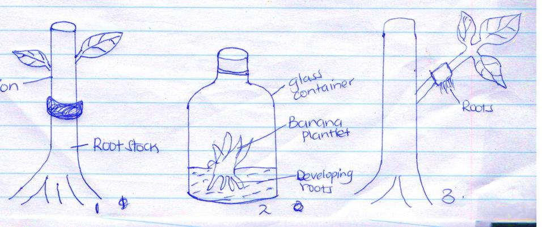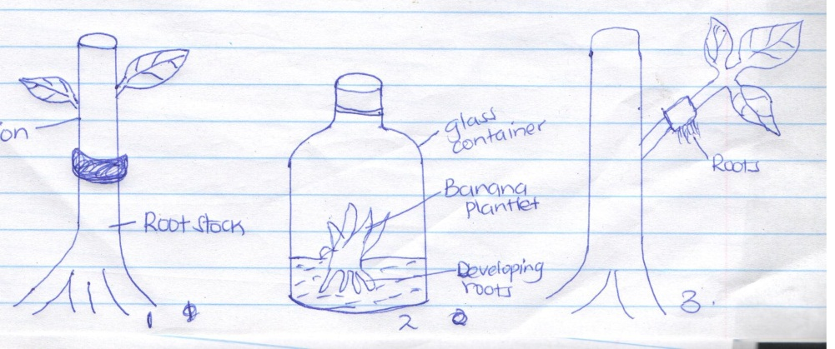20. Study the methods of crop propagation illustrated below and answer the questions that follow.



**Glass container**

**Scion**

**Banana plantlet**

**Roots**

**Root stock**

**Developing roots**

**1**

**3**

**2**

a) Identify the methods of crop propagation illustrated above (1½marks)

1 ______________________________________________________________________________

2 ______________________________________________________________________________

3 ______________________________________________________________________________

b) Give **one** condition under which method 1) above is carried out. (½ marks)

______________________________________________________________________________________________________________________________________________________________________

c) State **two** disadvantages of using stem cuttings for planting. (1 mark)

____________________________________________________________________________________________________________________________________________________________________________________________________________________________________________________________________________________________________________________________________________

**SECTION C** (40 MARKS)

***Answer any TWO questions from this section in the spaces provided.***

21. a) Prepare a balance sheet for Mr Ngesa’s farm from the following information extracted from

his farm records on 31-12-2013. (13 marks)

|  |  |
| --- | --- |
|  | Kshs |
| Cash at hand  Cash in bank  Bank overdraft from NBK  Debts payable to cooperative society  Debts receivable from KCC  Tax payable to KRA  Dairy cattle  Poultry comprising 100 layers  Beans in store  Millet in store  Inputs in store  Farm tools  Land  AFC Loan | 5,000  50,000  30,000  20,000  15,000  2,000  60,000  20,000  40,000  8,000  10,000  350,000  800,000  300,000 |

b) Explain the roles of a co-operative society to a dairy farmer. (7 marks)

22. Describe the field production of tomatoes under the following subheadings:

i) Ecological requirements (4 marks)

ii) Transplanting (4 marks)

iii) Field operations (6 marks)

iv) Disease control (4 marks)

v) Harvesting (2 marks)

23. a) Name **four** types of water pumps which can be used in a farm. (4 marks)

b) List **three** features of plastic pipes a farmer should consider before buying the pipes. (3 marks)

c) Describe the process involved in water treatment using a chemical treatment system

before pumping it to the farm. (13 marks)

____________________________________________________________________________________________________________________________________________________________________________________________________________________________________________________________________________________________________________________________________________________________________________________________________________________________________________________________________________________________________________________________________________________________________________________________________________________________________________________________________________________________________________________________________________________________________________________________________________________________________________________________________________________________________________________________________________________________________________________________________________________________________________________________________________________________________________________________________________________________________________________________________________________________________________________________________________________________________________________________________________________________________________________________________________________________________________________________________________________________________________________________________________________________________________________________________________________________________________________________________________________________________________________________________________________________________________________________________________________________________________________________________________________________________________________________________________________________________________________________________________________________________________________________________________________________________________________________________________________________________________________________________________________________________________________________________________________________________________________________________________________________________________________________________________________________________________________________________________________________________________________________________________________________________________________________________________________________________________________________________________________________________________________________________________________________________________________________________________________________________________________________________________________________________________________________________________________________________________________________________________________________________________________________________________________________________________________________________________________________________________________________________________________________________________________________________________________________________________________________________________________________________________________________________________________________________________________________________________________________________________________________________________________________________________________________________________________________________________________________________________________________________________________________________________________________________________________________________________________________________________________________________________________________________________________________________________________________________________________________________________________________________________________________________________________________________________________________________________________________________________________________________________________________________________________________________________________________________________________________________________________________________________________________________________________________________________________________________________________________________________________________________________________________________________________________________________________________________________________________________________________________________________________________________________________________________________________________________________________________________________________________________________________________________________________________________________________________________________________________________________________________________________________________________________________________________________________________________________________________________________________________________________________________________________________________________________________________________________________________________________________________________________________________________________________________________________________________________________________________________________________________________________________________________________________________________________________________________________________________________________________________________________________________________________________________________________________________________________________________________________________________________________________________________________________________________________________________________________________________________________________________________________________________________________________________________________________________________________________________________________________________________________________________________________________________________________________________________________________________________________________________________________________________________________________________________________________________________________________________________________________________________________________________________________________________________________________________________________________________________________________________________________________________________________________________________________________________________________________________________________________________________________________________________________________________________________________________________________________________________________________________________________________________________________________________________________________________________________________________________________________________________________________________________________________________________________________________________________________________________________________________________________________________________________________________________________________________________________________________________________________________________________________________________________________________________________________________________________________________________________________________________________________________________________________________________________________________________________________________________________________________________________________________________________________________________________________________________________________________________________________________________________________________________________________________________________________________________________________________________________________________________________________________________________________________________________________________________________________________________________________________________________________________________________________________________________________________________________________________________________________________________________________________________________________________________________________________________________________________________________________________________________________________________________________________________________________________________________________________________________________________________________________________________________________________________________________________________________________________________________________________________________________________________________________________________________________________________________________________________________________________________________________________________________________________________________________________________________________________________________________________________________________________________________________________________________________________________________________________________________________________________________________________________________________________________________________________________________________________________________________________________________________________________________________________________________________________________________________________________________________________________________________________________________________________________________________________________________________________________________________________________________________________________________________________________________________________________________________________________________________________________________________________________________________________________________________________________________________________________________________________________________________________________________________________________________________________________________________________________________________________________________________________________________________________________________________________________________________________________________________________________________________________________________________________________________________________________________________________________________________________________________________________________________________________________________________________________________________________________________________________________________________________________________________________________________________________________________________________________________________________________________________________________________________________________________________________________________________________________________________________________________________________________________________________________________________________________________________________________________________________________________________________________________________________________________________________________________________________________________________________________________________________________________________________________________________________________________________________________________________________________________________________________________________________________________________________________________________________________________________________________________________________________________________________________________________________________________________________________________________________________________________________________________________________________________________________________________________________________________________________________________________________________________________________________________________________________________________________________________________________________________________________________________________________________________________________________________________________________________________________________________________________________________________________________________________________________________________________________________________________________________________________________________________________________________________________________________________________________________________________________________________________________________________________________________________________________________________________________________________________________________________________________________________________________________________________________________________________________________________________________________________________________________