NAME: ………………………………………….........CLASS:……......ADM NO: ………......
SIGNATURE…………………………………………………DATE………………………….
231/2
BIOLOGY PAPER 2
(THEORY)
MAY 2015
TIME: 2 HOURS

TIGANIA SOUTH PRE-MOCKS 2015

INSTRUCTIONS TO CANDIDATES:-
- Write your name and adm number in the spaces provided above.
- This paper consists of two sections; A and B.
- Answer all the questions in Section A in the spaces provided.
- In section B, answer question 6 (compulsory) and either question 7 or 8 in the spaces provided after question 8.

For Examiner’s Use Only:

Section | Question | Maximum score | Candidates score
A | 1  2  3  4  5 | 8  8  8  8  8
B | 6  7 or  8 | 20  20  20
TOTAL SCORE |  | 80

This paper consists of 10 printed pages. Candidates should check to ascertain that all the pages are printed as indicated and that no questions are missing.

SECTION A (40 Marks)
Answer all questions in this section in the spaces provided.

1. In human beings, a downward pointed frontal hairline (“windows peak”) is a heritable trait. A person with windows peak always has at least one parent who has this trait; where as persons with frontal hairline may occur in families in which one or even both parents have windows peak. Using W and w to symbolize genes for this trait
(a) Determine the F1 generation if a homozygous windows peak male parent is married to a homozygous frontal hairlined female parent (4mks)

(b) State two causes of variations (1mk)
……………………………………………………………………………………………………………………………………………………………………………………………………………………………………
c) Name two sex linked genetic disorders affecting human females and males (2mks)
……………………………………………………………………………………………………………………………………………………………………………………………………………………………………
(d) What is genome
……………………………………………………………………………………………………….…………………………………………………………………………………………………

2. The diagram below shows an organism obtained from an aquatic ecosystem
(a) State the kingdom in which the organism belongs. (1mk)
………………………………………………………………………………………………

(b) Name the parts labeled (1mk)
B
………………………………………………………………………………………………

Y (1mk)
………………………………………………………………………………………………
(c) State the functions of the following parts
A (1mk)
………………………………………………………………………………………………………………………………………………………………………………………………

X (1mk)
……………………………………………………………………………………………………………………………………………………………………………………………
Z (1mk)
……………………………………………………………………………………………
(d)Explain briefly why the organism is described as eukaryotic (2mk)
………………………………………………………………………………………………………………………………………………………………………………………………………………

3a) The diagram below shows some of the features of a synovial joint. Study the diagram carefully and answer the questions that follow.

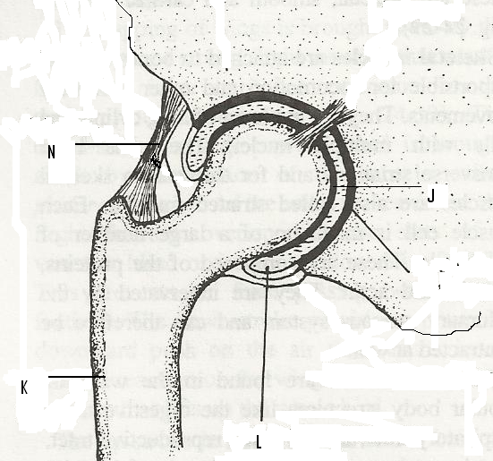
- Name the type of synovial joint. (1 mark)
………………………………………………………………………………………………
- Name the parts labeled J, and L (2 marks)
J ………………………………………………………………………………………...

L ………………………………………………………………………………………..
- State two roles of the part labeled L. (2 marks)
………………………………………………………………………………………………………………………………………………………………………………………………………………………………………………………………………………………………

- Suggest one advantage of this type of joint. (1 mark)
……………………………………………………………………………………………………………………………………………………………………………………………………
b) State how the following tissues are adapted to provide mechanical support in plants (2mks)
i) Parenchyma
……………………………………………………………………………………………
ii) Collenchyma
……………………………………………………………………………………………………

4. A student set up an experiment using soaked and dry seeds as shown below
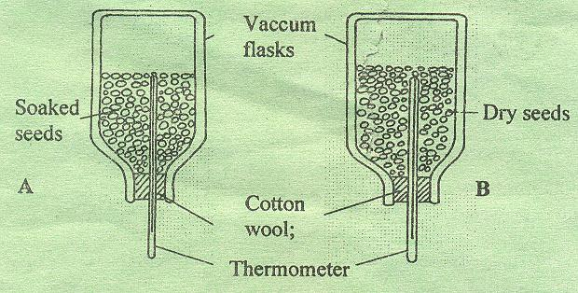

- State the objective of this experiment (1mk)
........................................................................................................................................................................................................................................................................................................................
- State the observations made in each of the flask after 24 hours (2mks)
………………………………………………………………………………………………………………………………………………………………………………………………………………………………………………………………………………………………………………………
- Account for the observation made in (b) above (2mks)
………………………………………………………………………………………………………………………………………………………………………………………………………………………………………………………………………………………………………………………………………………………………………………………………………………………………………………………………………………………………………………………………………
- Suggest why vacuum flasks were used in this experiment (1mk)
………………………………………………………………………………………………………………………………………………………………………………………………………………
- What alteration would you make in the set-up to make the results more reliable (1mk)
………………………………………………………………………………………………………………………………………………………………………………………………………………
- Why should the seeds be washed with antiseptic/10% formalin? (1mk)
……………………………………………………………………………………………………

5 a) Explain how the following meristematic tissues contribute to growth of higher plants
i) Vascular cambium (2mks)
………………………………………………………………………………………………………………………………………………………………………………………………………………………………………………………………………………………………………………………
ii) Cork Cambium (2mks)
………………………………………………………………………………………………………………………………………………………………………………………………………………………………………………………………………………………………………………………
b) The diagram below shows a life cycle of a cockroach

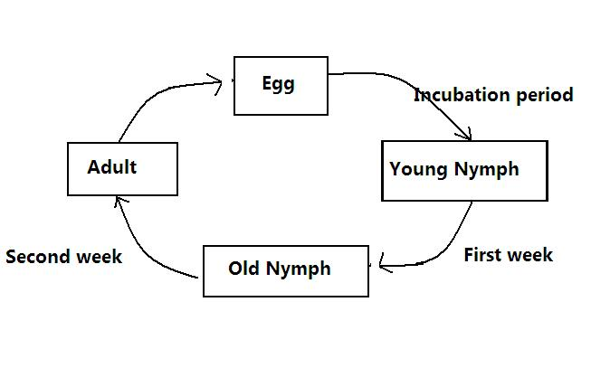
a) Name the hormone that would be at high concentration during.
- First week (1mk)
………………………………………………………………………………………………
(ii) Second week (1mk)
………………………………………………………………………………………………
b) Name the structure that produces hormone in a (ii) above (1mk)
……………………………………………………………………………………………………
c) Name the series of stages through which the nymph undergoes to reach adult stage (1mks)
……………………………………………………………………………………………………………………………………………………………………………………………………………...

SECTION B (40 Marks)
Answer question 6 (Compulsory) and either question 7 or 8 in the spaces provided.
6. The menstrual cycle is a sequence of events repeated monthly in the female production system. The table below shows the concentration of oestrogen and progesterone hormones and body temperatures of female against time.

Time in days | Oestrogen mg/100cm of blood | Progesterone mg/100cm³ of blood | Temperature in 0ºc
1 | 20 | 0 | 36.4
2 | 20.5 | 0 | 36.6
3 | 25 | 0 | 36.7
4 | 27.5 | 0 | 36.8
5 | 30 | 0 | 36.7
6 | 32.5 | 0 | 36.6
7 | 35 | 0 | 36.8
8 | 40 | 0 | 36.7
9 | 48 | 0 | 36.6
10 | 56 | 0 | 36.8
11 | 64 | 0 | 36.7
12 | 72 | 0 | 36.6
13 | 80 | 0 | 36.4
14 | 170 | 20 | 36.3
15 | 140 | 50 | 36.6
16 | 80 | 80 | 37.0
17 | 70 | 130 | 37.2
18 | 65 | 170 | 37.0
19 | 60 | 160 | 37.1
20 | 65 | 150 | 37.15
21 | 130 | 130 | 37.2
22 | 140 | 110 | 37.1
23 | 130 | 90 | 37.0
24 | 100 | 70 | 37.1
25 | 80 | 50 | 37.2
26 | 60 | 20 | 37.0
27 | 20 | 0 | 36.4

a). Using the same axis draw graphs of oestrogen and progesterone against time/days (8mks)

b) State the possible event taking place in the uterus during the first week? (1 mark)
……………………………………………………………………………………………………………………………………………………………………………………………………
c) State the events taking place in the ovary between day 1 and day 13. (2 marks)
………………………………………………………………………………………………………………………………………………………………………………………………………………………………………………………………………………………………………

d) Account for the sudden increase in the progesterone concentration between day 14 and day18.
(2 marks)
……………………………………………………………………………………………………………………………………………………………………………………………………………………………………………………………………………………………………………………
e) Account for the change in temperature between day 14 and 17. (1 mark)
………………………………………………………………………………………………………………………………………………………………………………………………………………
f) Account for the change of the curve of progesterone between day 19 and 27. (2marks)
……………………………………………………………………………………………………………………………………………………………………………………………………………………………………………………………………………………………………………………
- State the function of the following.
  - Ovary (1mark)
………………………………………………………………………………………………………………………………………………………………………………………………………………
  - Progesterone (1 mark)
………………………………………………………………………………………………………………………………………………………………………………………………………………
  - Oestrogen (1 mark)
………………………………………………………………………………………………………………………………………………………………………………………………………………

7 a) Describe how the following evidences support the theory of organic evolution: geographical distribution, fossil records and comparative anatomy (10mks)
b) Explain tropic responses in plants and their survival values (10mks)
8 a) Describe the structural adaptations of mammalian heart to its Functions (10mks)
b) Explain the role of osmosis in organisms (10mks)

