NAME: ............................................................................... INDEX NO.........................................
CLASS.............................................................................. STREAM..............................................
231/3
BIOLOGY
PAPER 3
(PRACTICAL)
MAY 2015
TIME: 1³/₄ HOURS

TIGANIA SOUTH PRE-MOCK – 2015
Kenya Certificate of Secondary Education (K.C.S.E)

INSTRUCTIONS TO CANDIDATES

1. Write your name and index number in the spaces provided.
2. You are required to spend the first 15 minutes of 1³/₄ hours allowed for this paper reading the whole paper carefully before commencing your work.
3. Answers must be written in the spaces provided in the question paper.
4. Additional pages should not be inserted candidates may be panelized for recording irrelevant information and for incorrect spellings especially of technical terms.

FOR EXAMINERS USE ONLY.

QUESTIONS | MAXIMUM SCORE | CANDIDATE’S SCORE
1 | 16
2 | 10
3 | 14
SCORE | 40
This paper consists of 7printed pages. Candidates should check the question paper to ensure that all pages are printed as indicated and that no questions are missing.
- You are provided with liquids labelled Q1 and Q2. Spare about 10ml of the liquids for part (a) of this question. Using a piece of thread, tie tightly one end of the visking (dialysis) tubing. Open the other end of the tubing and half fill it with liquid Q1. Tightly tie this end. Ensure there is no leakage in both ends. Immerse the tubing in a beaker containing liquid Q2. Leave the set up for at least 30 minutes.

- Using iodine and Benedict’s solution provided; test for the food substance in liquids Q1 and Q2. Record the procedure, observation and conclusion in the table below.
(6mks)

LIQUID | PROCEDURE | OBSERVATION | CONCLUSION
A
B

After at least 30 minutes remove the visking tubing from the beaker and wash the outside of the tubing thoroughly to remove traces of liquid Q2.

- Using the same reagents, test the food substance in liquid Q1 in the visking tubing.
Record your observations and conclusion in the table below. (2mks)

Liquid | Observation | Conclusion
Q1

- (i) Name the physiological process being demonstrated by this experiment. (1mk)
............................................................................................................................................................
- Name two parts of the human body where the process named in (c) (i) above takes place. (2mks)
............................................................................................................................................................................................................................................................................................................
- Account for the results obtained after carrying a second food test on liquid Q1. (2 mks)
................................................................................................................................................................................................................................................................................................................................................................................................................................................................................................................................................................................................................... .............................................................................................................................................................................................................................................................................................................................................................................................................................................................
- You are provided with diagrams of specimens taken from a mammal. Study them carefully and answer the questions that follow.
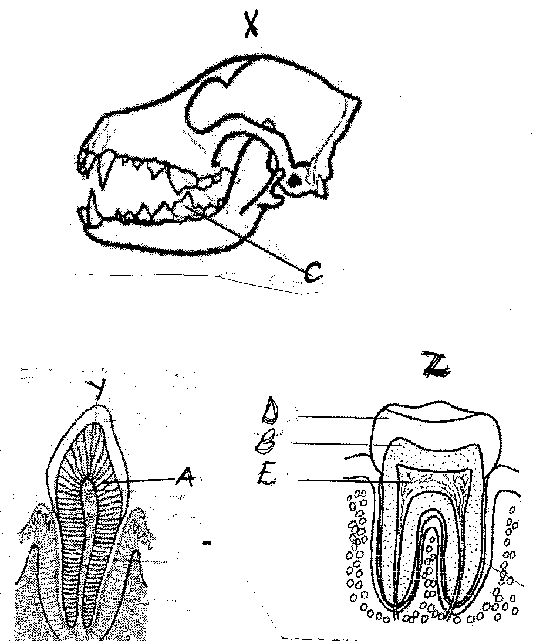

(a) Identify the diagrams labeled below. (3 marks)
X.......................................................................................................................
Y.......................................................................................................................
Z.......................................................................................................................

(b) State the diet of the animal from which diagram x was taken and give a reason for your answer. (1 marks)
(i) Diet................................................................................................................
(ii) Reason (2 marks)
………………………………………………………………………………………………………………………………………………………………………………………………………………………………………………………………………………………………………………………
(c) Name the parts labeled (3 marks)
A.........................................................................................................................................
B .............................................................................................................................
D.............................................................................................................................
(d) How are the following structures adapted to their functions (2 marks)
D
......................................................................................................................................................................................................................................................................................................................
C
..............................................................................................................................................
............................................................................................................................................
(e) State the function of the parts labeled. (2 marks)
...................................................................................................................................................................................................................................................................................................................................................................................................................................................................................

(f) State one structural difference between Y and Z (1 mark)
............................................................................................................................................................
- Examine the seedling below and use them to answer the question that follow.
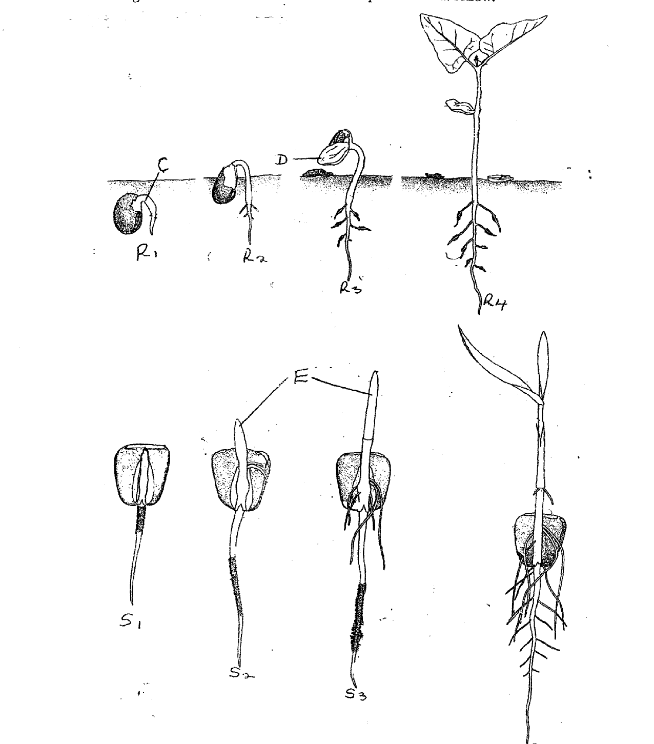
- Name the part labeled C,D, E and state their importance for the seedling.
C: ....................................................................................................................... (1mk)
Importance (1mk)
........................................................................................................................................................................................................................................................................................................................

D. ...................................................................................................................... (1mk)
Importance (1mks)
....................................................................................................................................................................................................................................................................................................................................................................................................................................................................................
(ii) E........................................................................................................................ (lmk)
Importance. (lmk)
.......................................................................................................................................................................................................................................................................................................................
(b) The R series of seedlings on the roots later in its life:
(i) What is the name of the swelling: (lmk)
..........................................................................................................................................................
(ii) Name the organisms that would be found in the swellings (1mk)
...........................................................................................................................................................
(iii) Explain the relationship that exists between the named organisms and the plant. (1mks)
........................................................................................................................................................................................................................................................................................................................(c) ( i) State the types of germination exhibited by R series of the seedlings. (1mk)
......................................................................................................................................................................................................................................................................................................................
(ii) Give a reason for your answer in (c) (i) above. (1mk)
........................................................................................................................................................................................................................................................................................................................
(d) State any two external factors necessary for germination. (2mks)

