NAME……………………………………………………….. INDEX NO……………………........................

231/1 CANDIDATE’S SIGN………….….….….…..
BIOLOGY
PAPER 1 DATE……….…………………………………
(THEORY)
TIME: 2 HOURS

CENTRAL KENYA NATIONAL SCHOOLS JOINT EXAM – 2015

Kenya Certificate of Secondary Education
BIOLOGY
PAPER 1
(THEORY)
TIME: 2 HOURS

INSTRUCTIONS TO CANDIDATES:

1. Write your Name, Index Number and School in the spaces provided above.
2. Sign and write the date of examination in the spaces provided above.
3. Answer all the questions in the spaces provided.
4. Answers must be written in the spaces provided in the question paper.
5. Additional pages must not be inserted.

FOR EXAMINER’S USE ONLY:
Question | Maximum  Score | Candidate’s  Score
1 – 25 | 80

Biology Paper 1 Turnover
1. (a) Name the branch of Biology that deals with the study of phyloygenetic relationship among
organisms. (1 mark)

___________________________________________________________________________

(b) Define each of the following terminologies.
(i) Microbiology. (1 mark)

_____________________________________________________________________

(ii) Anatomy. (1 mark)

______________________________________________________________________

2. Name the specific causative agent of the following diseases in man.
(a) Ascariasis. (1 mark)

____________________________________________________________________________

(b) Syphilis. (1 mark)

____________________________________________________________________________

3. The diagram below is of an organelle found in plant cells.
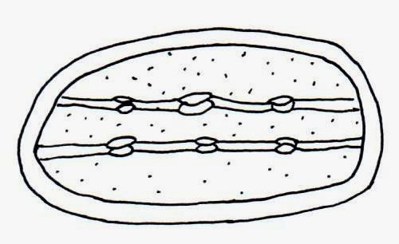

(a) Name the plant cell that has large number of the organelle above. (1 mark)

____________________________________________________________________________

(b) Name the cellular organelle that would be abundant in;
(a) Castor oil seeds. (1 mark)
_____________________________________________________________________

(b) Nectaries of the moon flower. (1 mark)

_____________________________________________________________________

4. (a) How do temperature affects the rate of active transport? (2 marks)

___________________________________________________________________________

___________________________________________________________________________

___________________________________________________________________________

___________________________________________________________________________

Biology Paper 1 2
(b) How do the following factor affect the rate of diffusion;
Diffusion gradient. (1 mark)

___________________________________________________________________________

___________________________________________________________________________

___________________________________________________________________________

5. State the importance of the following substances in nutrition;
(a) Roughage. (1 mark)

___________________________________________________________________________

___________________________________________________________________________

___________________________________________________________________________

(b) Water. (2 marks)

___________________________________________________________________________

___________________________________________________________________________

___________________________________________________________________________

(c) Name the substances stored in animal’s body which is similar to starch in plants. (1 mark)

___________________________________________________________________________

6. (a) Haemoglobin is enveloped by the plasma membrane of erythrocytes. Give two possible
reasons for phenomenon. (2 marks)

___________________________________________________________________________

___________________________________________________________________________

___________________________________________________________________________

(b) What is the function of the piliferous layer in rock? (1 mark)

____________________________________________________________________________

7. (a) Name two structures of gaseous exchange in aquatic plants. (2 marks)

___________________________________________________________________________

___________________________________________________________________________

(b) State two adaptive characteristics of respiratory surfaces common to the gills of a fish and
the trachea system of insects. (2 marks)

___________________________________________________________________________

___________________________________________________________________________

___________________________________________________________________________

Biology Paper 1 3
8. A certain substance has a molecular formula C57H110O6
(i) Write a balanced equation to represent its complete oxidation to carbon (IV) oxide and
water. (1 mark)

(ii) Calculate the respiratory quotient of the complete oxidation. (2 marks)

___________________________________________________________________________

___________________________________________________________________________

___________________________________________________________________________

___________________________________________________________________________

___________________________________________________________________________

(iii) From the RQ in (ii) above, what is the substance being metabolized. (1 mark)

____________________________________________________________________________

9. (a) State the main inorganic substance in the liver. (1 mark)

___________________________________________________________________________

(b) State three adaptations of desert animals to reduce loss of water. (3 marks)

___________________________________________________________________________

___________________________________________________________________________

___________________________________________________________________________

___________________________________________________________________________

___________________________________________________________________________

___________________________________________________________________________

10. A student collected an organism with;
- 2 body parts.
- 4 pairs of limb.
- No antennae.

(a) Identity the class the organism belong. (1 mark)

___________________________________________________________________________

Biology Paper 1 4
(b) State salient characteristics of kingdom monera. (2 marks)

___________________________________________________________________________

___________________________________________________________________________

___________________________________________________________________________

___________________________________________________________________________

11. Explain the reason why the carrying capacity of wild animals is higher than that of sheep
in any given piece of land. (3 marks)

_________________________________________________________________________________

_________________________________________________________________________________

_________________________________________________________________________________

_________________________________________________________________________________

12. The diagram below shows a pollen tube as it develops down the style.
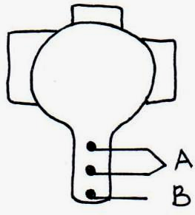

(a) Name the part labelled A and B. (2 marks)

A___________________________________________________________________________

B___________________________________________________________________________

(b) State the function of the part labelled A. (2 marks)

___________________________________________________________________________

___________________________________________________________________________

___________________________________________________________________________

___________________________________________________________________________

13. (a) Explain the importance of fertilisation taking place in the fallopian tubes and not in the
uterus in human females. (3 marks)

___________________________________________________________________________

___________________________________________________________________________

___________________________________________________________________________

___________________________________________________________________________

Biology Paper 1 5
14. (a) Name two tissues in plant stem are responsible for secondary growth. (2 marks)

___________________________________________________________________________

___________________________________________________________________________

(b) Define the term parthenogenesis. (1 mark)

___________________________________________________________________________

___________________________________________________________________________

___________________________________________________________________________

15. Define the following terms. (4 marks)
(i) Genetic engineering.

___________________________________________________________________________

___________________________________________________________________________

___________________________________________________________________________

(ii) Gene mapping.

___________________________________________________________________________

___________________________________________________________________________

___________________________________________________________________________

- Heterosis.

___________________________________________________________________________

___________________________________________________________________________

___________________________________________________________________________

- Gene sequencing.

__________________________________________________________________________

___________________________________________________________________________

___________________________________________________________________________

16. (a) What type of variation is exhibited by human beings having blood group A, B, AB or O.

________________________________________________________________ (1 mark)

(b) The paddles of whales and fins of fish adapt these two organisms to aquatic habitats;
Name the evolutionary process that may have given rise to such similar structures.

________________________________________________________________ (1 mark)

Biology Paper 1 6
(c) What name is given to such structures? (1 mark)

__________________________________________________________________________

17. The diagram below shows two adjacent synaptic knobs.

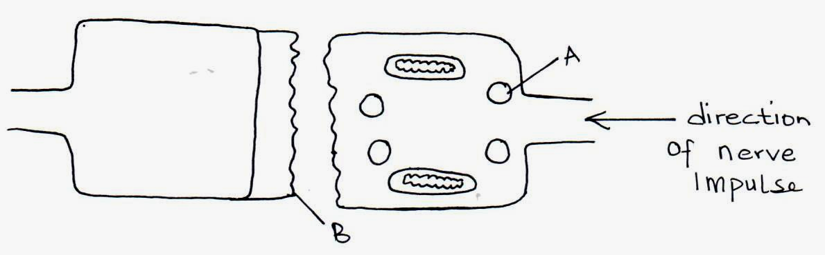

(a) Name the structures labelled A and B. (2 marks)

A___________________________________________________________________________

B___________________________________________________________________________

(b) Name the substance in the structure labelled A that facilitates impulse transmission. (1 mark)

___________________________________________________________________________

(c) State two features of nerves which increases the speed of nerve impulse transmission along
them. (2 marks)

__________________________________________________________________________

___________________________________________________________________________

18. (a) Give two structural differences between skeletal muscles and smooth muscles. (2 marks)

____________________________________________________________________________

____________________________________________________________________________

(b) Name one support tissue in plants that is;
(a) Thickened with lignin. (1 mark)

_____________________________________________________________________

(b) Thickened with cellulose and pectin. (1 mark)

_____________________________________________________________________

Biology Paper 1 7
19. The diagram below represents a mammalian bone.
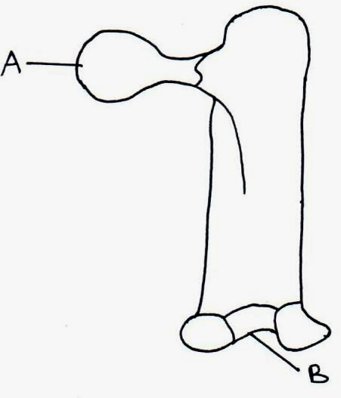

(a) Identify the bone. (1 mark)

___________________________________________________________________________

- Name the type of joint formed by the bone at its anterior end and the adjacent bone. (1 mark)

___________________________________________________________________________

20. (a) Differentiate between an enzyme and a hormone. (2 marks)

___________________________________________________________________________

___________________________________________________________________________

___________________________________________________________________________

___________________________________________________________________________

(b) Name the hormones involved in osmoregulation. (2 marks)

___________________________________________________________________________

21. The diagram below shows the mouth and the salivary glands.
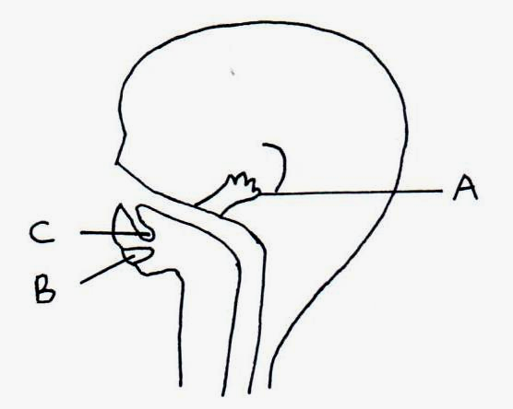

(a) Name the glands labelled A and B. (2 marks)

A___________________________________________________________________________

B___________________________________________________________________________

Biology Paper 1 8
(b) Give two digestive functions of saliva. (2 marks)

___________________________________________________________________________

___________________________________________________________________________

___________________________________________________________________________

___________________________________________________________________________

22. Below is a nucleic acid stand.
A
G
U
G
C
A
CC

(a) Name the nuclei acid. (1 mark)

___________________________________________________________________________

(b) Give a reason for your answer in (a) above. (1 mark)

___________________________________________________________________________

___________________________________________________________________________

___________________________________________________________________________

23. (a) Name the organism found in the root nodules of leguminous plant. (1 mark)

___________________________________________________________________________

(b) What is the role of the organism named above? (1 mark)

___________________________________________________________________________

24. (a) Name the process that occurs when carbon (IV) oxide combines with hydrogen atoms
from light stage. (1 mark)

___________________________________________________________________________

(b) What is the main product of dark stage of photosynthesis? (1 mark)

__________________________________________________________________________

___________________________________________________________________________

25. (a) State the function of the following. (2 marks)
(i) Tendon.

_____________________________________________________________________

_____________________________________________________________________

(ii) Ligament.

_____________________________________________________________________

_____________________________________________________________________

Biology Paper 1 9

