NAME……………………………………………………….. INDEX NO……………………............

231/1 CANDIDATE’S SIGN………….……
BIOLOGY
PAPER 1 DATE……….………………………...
(THEORY)
JULY/AUGUST, 2015
TIME: 2 HOURS

KAHURO /KIHARU DISTRICT JOINT EXAMINATION - 2015

Kenya Certificate of Secondary Education
BIOLOGY
PAPER 1
(THEORY)
TIME: 2 HOURS

INSTRUCTIONS TO CANDIDATES:

1. Write your Name, Index Number and School in the spaces provided above.
2. Sign and write the date of examination in the spaces provided above.
3. Answer all the questions in the spaces provided.
4. Answers must be written in the spaces provided in the question paper.
5. Additional pages must not be inserted.

FOR EXAMINER’S USE ONLY:
Question | Maximum  Score | Candidate’s  Score
1 – 30 | 80

Biology Paper 1 Turnover
1. Name the branch of Biology that deals with the study of
(i) Microscopic organisms. (1 mark)

_________________________________________________________________

(ii) Fungi. (1 mark)

_________________________________________________________________

2. (a) Name the kingdom into which the prokaryotes are placed. (1 mark)

_________________________________________________________________

(b) State two characteristics used to classify arthropods in classes. (2 marks)

_________________________________________________________________

_________________________________________________________________

_________________________________________________________________

- A certain plant had the following characteristics:
- Presence of roots, stem and leaves.
- Found with sori on the under surface.
- Life cycle in sporophyte and gametophyte generations.
- Sporophyte generation being dominant.
Name the division to which the plant belongs. (1 mark)

_________________________________________________________________

3. (a) Name two structures for gaseous exchange in aquatic plants. (2 marks)

_________________________________________________________________

_________________________________________________________________

(b) Explain why guards cells have thicker inner walls and thinner outer walls. (1 mark)

_________________________________________________________________

_________________________________________________________________

_________________________________________________________________

Biology Paper 1 2 Kahuro/Kiharu
4. (a) Distinguish between homozygote and heterozygote. (2 marks)

_________________________________________________________________

_________________________________________________________________

_________________________________________________________________

_________________________________________________________________

(b) State two causes of variations. (2 marks)

_________________________________________________________________

_________________________________________________________________

_________________________________________________________________

_________________________________________________________________

5. State the functions of the following cell organelles.
(i) Nucleolus. (1 mark)

_________________________________________________________________

_________________________________________________________________

(ii) Centriole. (1 mark)

_________________________________________________________________

_________________________________________________________________

6. Name the causative agent of the following diseases. (2 marks)
(i) Cholera.

_________________________________________________________________

(ii) Candidiasis.

_________________________________________________________________

7. Define each of the following terms.
(a) Speciation. (1 mark)

_________________________________________________________________

_________________________________________________________________

_________________________________________________________________

Biology Paper 1 3 Kahuro/Kiharu
(b) Natural selection. (2 marks)

_________________________________________________________________

_________________________________________________________________

_________________________________________________________________

(c) Divergent evolution. (1 mark)

_________________________________________________________________

_________________________________________________________________

_________________________________________________________________

8. (a) Study the diagram below and answer the questions that follow. (3 marks)
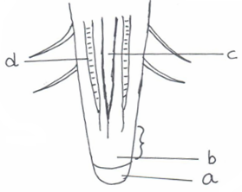

- Label parts:

a __________________________________________________________

b __________________________________________________________

c __________________________________________________________

(ii) State function of part labelled d. (1 mark)

____________________________________________________________

____________________________________________________________

____________________________________________________________

Biology Paper 1 4 Kahuro/Kiharu
9. State three distinguishing features of mammalian rib bone. (3 marks)

______________________________________________________________________

______________________________________________________________________

______________________________________________________________________

______________________________________________________________________

10. Give three factors that determine the amount of energy a human being require in a day.
(3 marks)

______________________________________________________________________

______________________________________________________________________

______________________________________________________________________

______________________________________________________________________

11. Name the antigens that determine human blood groups. (2 marks)

______________________________________________________________________

12. State the adaptation that enable red blood cell to move in blood capillaries. (1 mark)

______________________________________________________________________

______________________________________________________________________

______________________________________________________________________

13. (a) Give a reason why lumbar vertebrae have long and broad transverse processes. (1 mark)

_________________________________________________________________

_________________________________________________________________

_________________________________________________________________

(b) Which type of joint is found at articulation of pelvic girdle and femur? (1 mark)

_________________________________________________________________

Biology Paper 1 5 Kahuro/Kiharu
14. Why is oxygen important in the process of active transport, (1 mark)

______________________________________________________________________

______________________________________________________________________

______________________________________________________________________

15. Study the reaction below.
X
Hydrogen peroxide water and oxygen.
(a) Name enzyme X. (1 mark)

_________________________________________________________________

- Explain the importance of the above reaction in tissue of living organisms.
(2 marks)

_________________________________________________________________

_________________________________________________________________

_________________________________________________________________

_________________________________________________________________

16. Give a reason why staining is important when preparing specimen for observation by use of light microscope. (1 mark)

______________________________________________________________________

______________________________________________________________________

______________________________________________________________________

______________________________________________________________________

17. The diagram shows across section of mammalian skin.
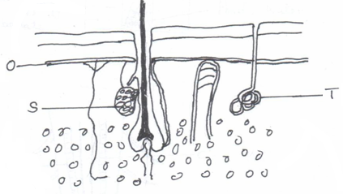

Biology Paper 1 6 Kahuro/Kiharu
- Name parts (2 marks)
  - T ____________________________________________________________

(ii) S __________________________________________________________

(b) State the function of part labelled S. (1 mark)

_________________________________________________________________

_________________________________________________________________

18. State two processes that occur during anaphase of mitosis. (2 marks)

______________________________________________________________________

______________________________________________________________________

______________________________________________________________________

______________________________________________________________________

19. What is the significance of meiosis? (2 marks)

______________________________________________________________________

______________________________________________________________________

______________________________________________________________________

20. State the site of production of progesterone. (1 mark)

______________________________________________________________________

______________________________________________________________________

______________________________________________________________________

21. An experiment was set up as shown below.
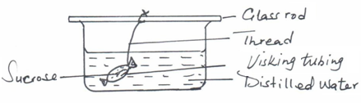

Biology Paper 1 7 Kahuro/Kiharu
The set up was left for 30 minutes.
(a) State the expected results. (2 marks)

_________________________________________________________________
_________________________________________________________________

_________________________________________________________________

_________________________________________________________________
(b) Explain the observation above. (2 marks)

_________________________________________________________________

_________________________________________________________________

_________________________________________________________________

_________________________________________________________________

22. How are leaves of submerged plants adapted for photosynthesis? (2 marks)

______________________________________________________________________

______________________________________________________________________

______________________________________________________________________

______________________________________________________________________

23. (a) The action of ptyalin stops at stomach explain. (1 mark)

_________________________________________________________________

_________________________________________________________________

_________________________________________________________________

(b) State two factor that denatures enzymes. (2 marks)

_________________________________________________________________

_________________________________________________________________

_________________________________________________________________

_________________________________________________________________

Biology Paper 1 8 Kahuro/Kiharu
(c) Name the features that increase the surface area of small intestine. (2 marks)

_________________________________________________________________

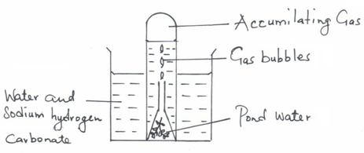
24. The apparatus below are used to investigate an aspect of photosynthesis.

(a) Name the aspect of photosynthesis being investigated. (1 mark)

_________________________________________________________________

(b) How can one verify the identity of the gas that accumulates in test tube?(1 mark)

_________________________________________________________________

_________________________________________________________________

_________________________________________________________________

(c) State the role of sodium hydrogen carbonate. (1 mark)

_________________________________________________________________

_________________________________________________________________

_________________________________________________________________

(d) What environmental factor are required in order to give positive results? (1 mark)

_________________________________________________________________

_________________________________________________________________

_________________________________________________________________

25. (a) Name two forms in which carbon (IV) oxide is transported in blood. (2 marks)

_________________________________________________________________

_________________________________________________________________

Biology Paper 1 9 Kahuro/Kiharu
(b) What is tissue fluid? (1 mark)

_________________________________________________________________

_________________________________________________________________

_________________________________________________________________

26. How are the mitochondria adapted to their function? (2 marks)

______________________________________________________________________

______________________________________________________________________

______________________________________________________________________

______________________________________________________________________

27. State three structural differences between arteries and veins. (3 marks)

______________________________________________________________________

______________________________________________________________________

______________________________________________________________________

______________________________________________________________________

28. Name the hormone secreted by:-
(i) Thyroid glands. (1 mark)

_________________________________________________________________

(ii) Adrenal glands. (1 mark)

_________________________________________________________________

29. State the functions of the following parts of the ear.
(a) Eustachian tube. (1 mark)

_________________________________________________________________

_________________________________________________________________

_________________________________________________________________

Biology Paper 1 10 Kahuro/Kiharu
(b) Cochlea. (1 mark)

_________________________________________________________________

_________________________________________________________________

_________________________________________________________________

(c) Ossicles. (1 mark)

_________________________________________________________________

_________________________________________________________________

_________________________________________________________________

(d) Semi circular canals. (1 mark)

_________________________________________________________________

_________________________________________________________________

_________________________________________________________________

30. Other than using quadrat method give two methods of estimating population of grass. (2 marks)

______________________________________________________________________

______________________________________________________________________

______________________________________________________________________

______________________________________________________________________

Biology Paper 1 11 Kahuro/Kiharu

