NAME……………………………………………………….. INDEX NO……………………........................

231/2 CANDIDATE’S SIGN………….….….….…..
BIOLOGY
PAPER 2 DATE……….…………………………………
(THEORY)
TIME: 2 HOURS

CENTRAL KENYA NATIONAL SCHOOLS JOINT EXAM - 2015

Kenya Certificate of Secondary Education
BIOLOGY
PAPER 2
(THEORY)
TIME: 2 HOURS

INSTRUCTIONS TO CANDIDATES:

(a) Write your Name, Index Number and School in the spaces provided above.
(b) Sign and write the date of examination in the spaces provided above.
(c) This paper consists of two Section; A and B.
(d) Answer all the questions in Section A in the spaces provided.
(e) In Section B answer question 6 (Compulsory) and either question 7 or 8 in the
spaces provided after question 8.

FOR EXAMINER’S USE ONLY:
Section | Question | Maximum  Score | Candidates  Score
A | 1 | 8
A | 2 | 8
A | 3 | 8
A | 4 | 8
A | 5 | 8
B | 6 | 20
B | 7 | 20
B | 8 | 20
Total Score |  | 80

Biology Paper 2 Turnover
SECTION A: (40 MARKS)

Answer all the questions in the spaces provided.

1. The figure below shows the effect of light intensity on the exchange of carbon (IV) oxide
between a green leaf and the air around it.
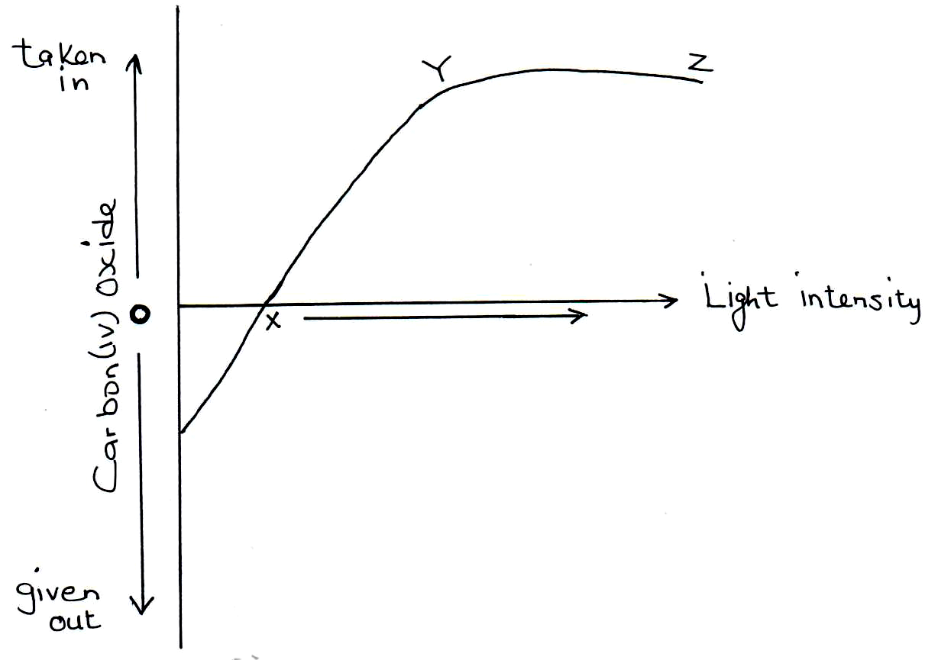

(a) Account for the effect of increasing light intensity on the rate of uptake of carbon (IV)
oxide. (4 marks)

___________________________________________________________________________

___________________________________________________________________________

___________________________________________________________________________

___________________________________________________________________________

(b) What is the name given to point X? (1 mark)

___________________________________________________________________________

(c) Explain why at point X, the carbon (IV) oxide taken in is equal to carbon (IV) given out
by the plant. (3 marks)

___________________________________________________________________________

___________________________________________________________________________

___________________________________________________________________________

___________________________________________________________________________

Biology Paper 2 2
2. (a) The diagram below shows the side view of a human brain.
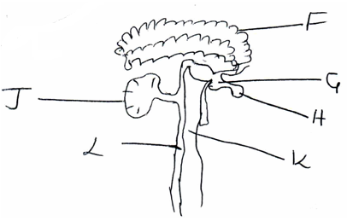

Which letter represent the part of the brain which; (2 marks)
- Control voluntary movements of the body.

_____________________________________________________________________

- Is more developed in birds and fish than in man.

_____________________________________________________________________

(b) The diagram below shows the arrangement of cones and rods in retina of the eye.
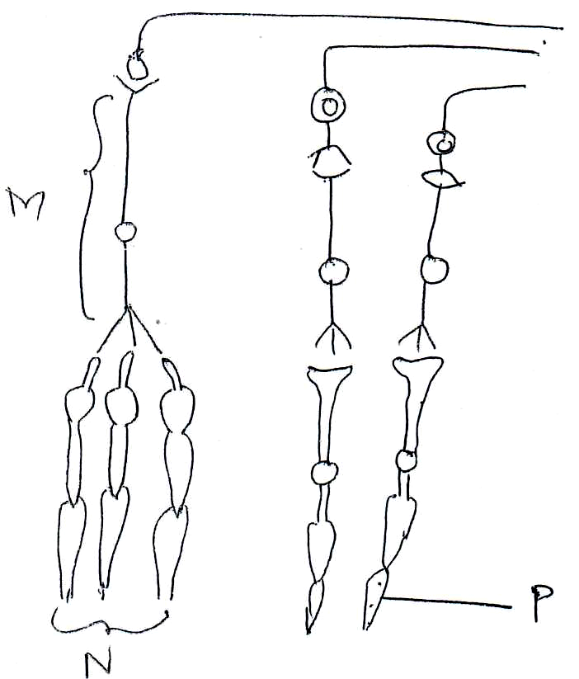

With reasons identify the following cells. (6 marks)

M__________________________________________________________________________

Reason(s) ___________________________________________________________________

___________________________________________________________________________

Biology Paper 2 3
N__________________________________________________________________________

Reason ____________________________________________________________________

___________________________________________________________________________

P___________________________________________________________________________

Reason ______________________________________________________________________

____________________________________________________________________________

3. A person met a leopard as he walked along a forest path. His adrenal gland secreted
adrenaline to prepare him to run away. What was the effect of adrenaline on his?
(a) Circulatory system. (5 marks)

____________________________________________________________________________

____________________________________________________________________________

____________________________________________________________________________

____________________________________________________________________________

____________________________________________________________________________

____________________________________________________________________________

(b) Respiratory system? (3 marks)

____________________________________________________________________________

____________________________________________________________________________

____________________________________________________________________________

____________________________________________________________________________

4. (a) Name the sex chromosome in humans that is considered to be ‘genetically empty’. (1 mark)

___________________________________________________________________________

(b) Colour blindness is a human disease inherited through a recessive gene carried on the X
chromosome. If the carrier female married a normal male. Work out the expected genotypes
of their children. Show all your working. (Let n stand for colour blindness allele) . (5 marks)

Biology Paper 2 4
(c) Work out the genotypic ratio of the off springs. (1 mark)

____________________________________________________________________________

(d) Work out the probability of the first child being a carrier female. (1 mark)

____________________________________________________________________________

____________________________________________________________________________

____________________________________________________________________________

____________________________________________________________________________

____________________________________________________________________________

5. During a biological practical lesson on estimation of the size of onion epidermal cells. Form one
student from Huduma Bora Academy placed a transparent ruler across the field of view, brought
the millimeter marks to focus and observed them as illustrated below. Give your answer in
micrometers.
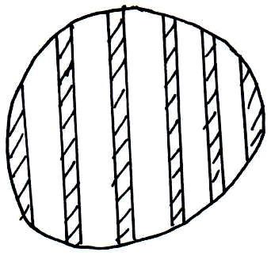

They then prepared a temporary slides of the onion epidermal cells and observed the
arrangement of cells as illustrated below:

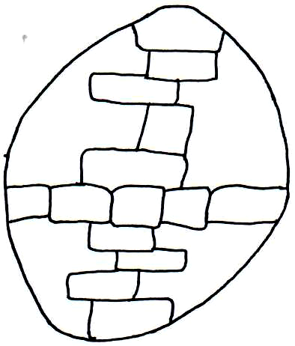

(a) Work out:
(i) Length of each cell. (2 marks)

_____________________________________________________________________

_____________________________________________________________________

_____________________________________________________________________

Biology Paper 2 5
(ii) The width of each cell. (2 marks)

_____________________________________________________________________

_____________________________________________________________________

_____________________________________________________________________

(b) State two limitations of using the above method of in estimating the size of cells. (2 marks)

___________________________________________________________________________

___________________________________________________________________________

___________________________________________________________________________

___________________________________________________________________________

(c) Give a reason why using the onion epidermis is more suitable than using a whole scale of
leaf of an onion bulb. (1 mark)

___________________________________________________________________________

___________________________________________________________________________

___________________________________________________________________________

(d) A part from iodine solution, identify a stain that was probably used by the students to make
observation clearer. (1 mark)

_________________________________________________________________________

___________________________________________________________________________

SECTION B: (40 MARKS)

Attempt question 6 (Compulsory) and either 7 or 8 in the spaces provided after question 8.

6. A group of students did an experiment to estimate the population of grasshoppers in a plot.
They swept the ground ten times with a net and recorded the number of grasshoppers in each
of the ten samples.
The table below shows the results obtained.

Sample number | No of grasshopper | Cumulative total
1 | 35 | 35
2 | 31 | 66
3 | 28 | 94
4 | 23 | 117
5 | 20
6 | 18
7 | 15
8 | 11
9 | 8
10 | 6

Biology Paper 2 6
(a) Complete the cumulative total column in the results table. (3 marks)

(b) (i) On the grid provided plot the number of grasshoppers collected per sample against
the cumulative total. (6 marks)

Biology Paper 2 7
(ii) From your graph estimate the population of grasshoppers in the plot.
______________________________________________________________________

(c) The number of grasshoppers in this study cannot be adequately determined by this method.
What would you consider to be the two main sources of error in this method?

____________________________________________________________________________

____________________________________________________________________________

(d) A fish farmer wanted to know the number of fish in his pond. He collected ten fish from the
pod and labelled each by tying a tag lag label on its fin, and returned the fish to the pond to
mix with other fish. When he later collected a sample of 50 fish from the same pond, he
found out that 4 of them had tag labels.
(i) From the information estimate the total number of fish in the pond. Show your working. (4 marks)

______________________________________________________________________

______________________________________________________________________

______________________________________________________________________

______________________________________________________________________

(ii) What assumption is made in this method of estimating size of population? (2 marks)

______________________________________________________________________

______________________________________________________________________

______________________________________________________________________

______________________________________________________________________

7. (a) Explain the economic importance of plant excretory products. (10 marks)

(b) Describe the adaptations of the lungs to their function. (10 marks)

8. (a) Describe the role of hormones in the human menstrual cycle. (15 marks)

(b) Explain how halophytes are adapted to their habitat. (5 marks)

________________________________________________________________________________________

________________________________________________________________________________________

________________________________________________________________________________________

________________________________________________________________________________________

________________________________________________________________________________________

________________________________________________________________________________________

________________________________________________________________________________________
Biology Paper 2 8
________________________________________________________________________________________

________________________________________________________________________________________

________________________________________________________________________________________

________________________________________________________________________________________

________________________________________________________________________________________

________________________________________________________________________________________

________________________________________________________________________________________

________________________________________________________________________________________

________________________________________________________________________________________

________________________________________________________________________________________

________________________________________________________________________________________

________________________________________________________________________________________

________________________________________________________________________________________

________________________________________________________________________________________

________________________________________________________________________________________

________________________________________________________________________________________

________________________________________________________________________________________

________________________________________________________________________________________

________________________________________________________________________________________

________________________________________________________________________________________

________________________________________________________________________________________

________________________________________________________________________________________

________________________________________________________________________________________

________________________________________________________________________________________

________________________________________________________________________________________

________________________________________________________________________________________

________________________________________________________________________________________

________________________________________________________________________________________

________________________________________________________________________________________
Biology Paper 2 9
________________________________________________________________________________________

________________________________________________________________________________________

________________________________________________________________________________________

________________________________________________________________________________________

________________________________________________________________________________________

________________________________________________________________________________________

________________________________________________________________________________________

________________________________________________________________________________________

________________________________________________________________________________________

________________________________________________________________________________________

________________________________________________________________________________________

________________________________________________________________________________________

________________________________________________________________________________________

________________________________________________________________________________________

________________________________________________________________________________________

________________________________________________________________________________________

________________________________________________________________________________________

________________________________________________________________________________________

________________________________________________________________________________________

________________________________________________________________________________________

________________________________________________________________________________________

________________________________________________________________________________________

________________________________________________________________________________________

________________________________________________________________________________________

________________________________________________________________________________________

________________________________________________________________________________________

________________________________________________________________________________________

________________________________________________________________________________________

________________________________________________________________________________________
Biology Paper 2 10

