NAME……………………………………………………….. INDEX NO……………………........................

231/3 CANDIDATE’S SIGN………….….….….…...
BIOLOGY
PAPER 3 DATE……….…………………………………
(PRACTICAL)
TIME: 1¾ HOURS

CENTRAL KENYA NATIONAL SCHOOLS JOINT EXAM – 2015

Kenya Certificate of Secondary Education
BIOLOGY
PAPER 3
(PRACTICAL)
TIME: 1¾ HOURS

INSTRUCTIONS TO CANDIDATES:
(a) Write your name and index number in the spaces provided above.
(b) Sign and write the date of examination in the spaces provided above.
(c) Answer all the questions in the spaces provided.
(d) You are required to spend the first 15 minutes of the 1¾ hours allowed for this paper
reading the whole paper carefully before commencing your work.
(e) Additional papers must not be inserted.
(f) This paper has three questions and pages.
(g) Candidates may be penalized for recording irrelevant information and for incorrect
spelling of technical terms.
(h) Candidates should answer all the questions in English.

FOR EXAMINER’S USE ONLY:
Question | Maximum  Score | Candidate’s  Score
1 | 16
2 | 12
3 | 12
Total Score | 40

Biology Paper 3 Turnover
1. You are provided with solution labelled L, a piece of visking tubing, some string, four
test tubes, a beaker a white tile and these reagents iodine solution and Benedict’s solution.

- Using the appropriate reagents, carry out food tests to identify the food substances
contained in L. Outline procedure used and record your observation and conclusions
in the table below. (6 marks)

Test | Procedure | Observation | Conclusion

Securely tie one end of the visking tubing with the string and place solution L into it
until it is about $34$full. Ensure that it is not leaking and tie up the other end securely.
Wash away all traces of solution L from the outside of the visking tubing. Place the
visking tubing in the beaker and submerge in distilled water. Note the time and allow
the set up to stand for at least 30 minutes. After 30 minutes take some of the water
from the beaker and carry out similar food tests on it.

Biology Paper 3 2
(b) Record your observation and conclusions in table below. (4mks)

Test | Procedure | Observation | Conclusion

(c) Account for the results obtained (a) and (b) (3 marks)

______________________________________________________________________

______________________________________________________________________

______________________________________________________________________

______________________________________________________________________

(d) What physiological process is demonstrated by this experiment? (1 mark)

_____________________________________________________________________

(e) (i) Name one part of the body where a similar process takes place. (1 mark)

________________________________________________________________

_________________________________________________________________

_________________________________________________________________

(ii) What is the process you have named in e(i) above called? (1 mark)

________________________________________________________________

Biology Paper 3 3
2. The diagram below K, L and M show seedlings that were grown under different conditions. Examine them and answer the questions that follow.
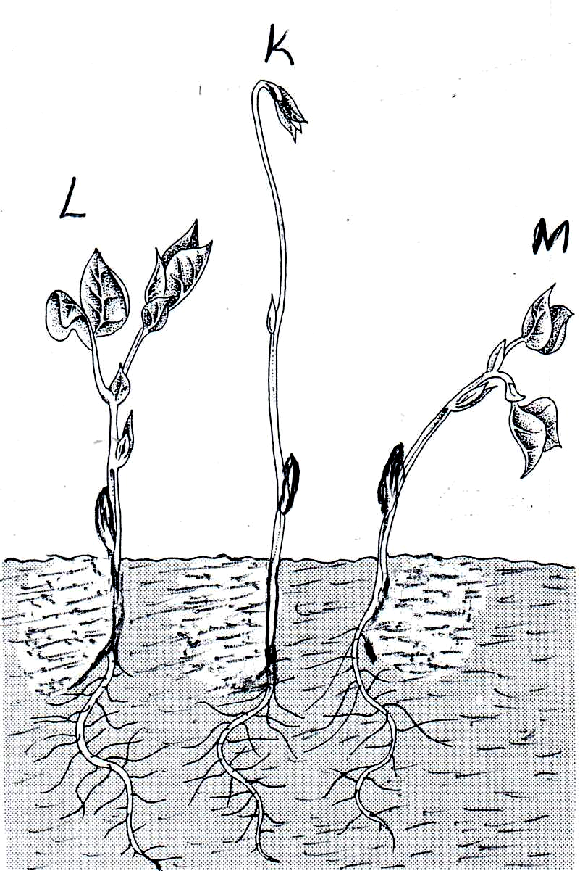

(a) Label any three parts of the seedling in diagram L. (3 marks)

______________________________________________________________________

______________________________________________________________________

______________________________________________________________________

(b) (i) Name the type of germination exhibited by the seedlings. (1 mark)

_________________________________________________________________

(ii) Give a reason for your answer in b(i) above. (1 mark)

_________________________________________________________________

_________________________________________________________________

_________________________________________________________________

Biology Paper 3 4
(c) State the conditions under which each seedling was grown. (2 marks)

K____________________________________________________________________

L_____________________________________________________________________

M____________________________________________________________________

(d) State two differences between seeding K and L. (2 marks)

K | L

(e) Name the phenomenon exhibited by seedling in K. (1 mark)

_____________________________________________________________________

(f) Name the response exhibited by seedling M. (1 mark)

_____________________________________________________________________

3. Below is a photograph of an adult human jaw with teeth. Study the diagram and answer the questions that follow.
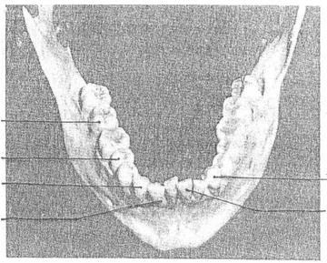
I
II
H
J
III
IV

(a) State the mode of nutrition in man. (1 mark)

______________________________________________________________________

(b) Name the type of teeth labeled I and III. (3 marks)

I_____________________________________________________________________

III____________________________________________________________________

Biology Paper 3 5
(c) Name the parts of teeth labeled H and J. (2 marks)

H_____________________________________________________________________

J_____________________________________________________________________

(d) Identify one distinguishing feature between teeth labeled II and IV. (1 mark)

______________________________________________________________________

______________________________________________________________________

______________________________________________________________________

(e) State one function of tooth IV. (1 mark)

______________________________________________________________________

(f) Write the dental formula from the jaw shown in the photograph. (2 marks)

(g) Explain why tooth I would be more prone to dental carries than tooth III. (2 marks)

______________________________________________________________________

______________________________________________________________________

______________________________________________________________________

______________________________________________________________________

Biology Paper 3 6

