NAME……………………………………………………….. INDEX NO……………………........................

233/1 CANDIDATE’S SIGN………….….….….…..
CHEMISTRY
PAPER 1 DATE……….…………………………………
(THEORY)
TIME: 2 HOURS

CENTRAL KENYA NATIONAL SCHOOLS JOINT EXAM - 2015

Kenya Certificate of Secondary Education
CHEMISTRY
PAPER 1
(THEORY)
TIME: 2 HOURS

INSTRUCTIONS TO CANDIDATES:
- Write your name and index number in the spaces provided above.
- Sign and write the date of examination in the spaces provided above.
(iii) Answer ALL the questions in the spaces provided.
(iv) Mathematical tables and silent electronic calculators may be used.
(v) All working must be clearly shown where necessary
(vi) Candidates should check the question paper to ascertain that all the pages
are printed as indicated and that no questions are missing

For Examiner’s Use Only
Questions | Maximum Score | Candidate’s Score
1 – 29 | 80

Chemistry Paper 1 Turnover
1. Three pure pigments were prepared and their spots placed on a filter paper as shown below. The
three pigments are A, B and C. A mixture F was also placed on the filter paper at the same time
with the pure pigments. The filter paper was then dipped in ethanol solvent and left for some half
an hour. The results were obtained as follows.

• •
•
• •

• • • •
A B C F

•

(i) Which of the three pure pigments is most sticky? Give a reason for your answer. (1mk)

____________________________________________________________________________

____________________________________________________________________________

(ii) Which pure pigment is not present in the mixture F? (1mk)

____________________________________________________________________________

(iii) Show on the diagram the baseline. (1mk)

2. Describe how a pure sample of lead (II) carbonate can be prepared in the laboratory starting with lead metal. (3mks)

__________________________________________________________________________________

__________________________________________________________________________________

__________________________________________________________________________________

__________________________________________________________________________________

3. The set up below was used to prepare nitric (V) acid in the laboratory.
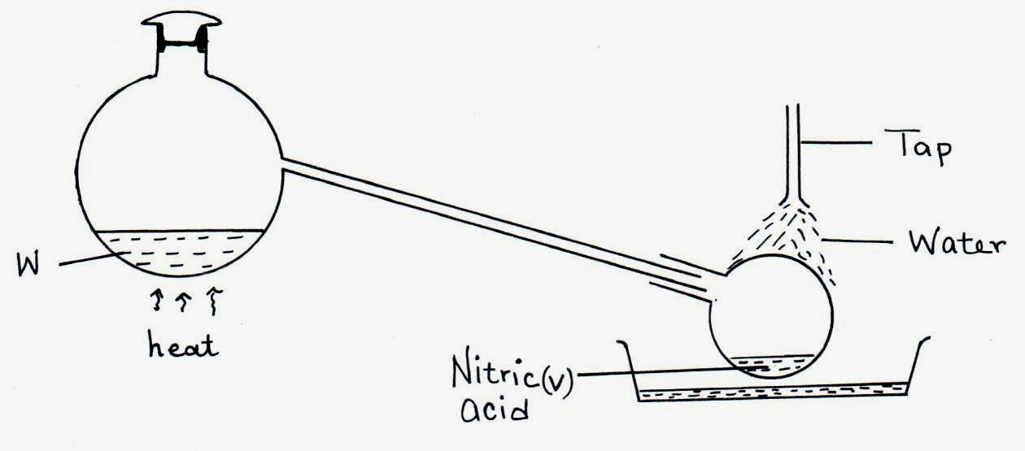

(a) Name the mixture W. (1mk)

____________________________________________________________________________

Chemistry Paper 1 2
(b) Write an equation for the reaction that takes place in flask A. (1mk)

(c) Explain why nitric (V) acid produced appears yellow. (1mk)

____________________________________________________________________________

____________________________________________________________________________

____________________________________________________________________________

4. A mixture contains ammonium chloride aluminium oxide and sodium chloride. Describe how each solid substance can be obtained from the mixture. (3mks)

__________________________________________________________________________________

__________________________________________________________________________________

__________________________________________________________________________________

__________________________________________________________________________________

5. State the difference between the following salts;
Deliquescent and hygroscopic salts. (2mks)

__________________________________________________________________________________

__________________________________________________________________________________

__________________________________________________________________________________

__________________________________________________________________________________

6. Below is a set-up of apparatus used to investigate the effect of electric current on molten lead (II) bromide.
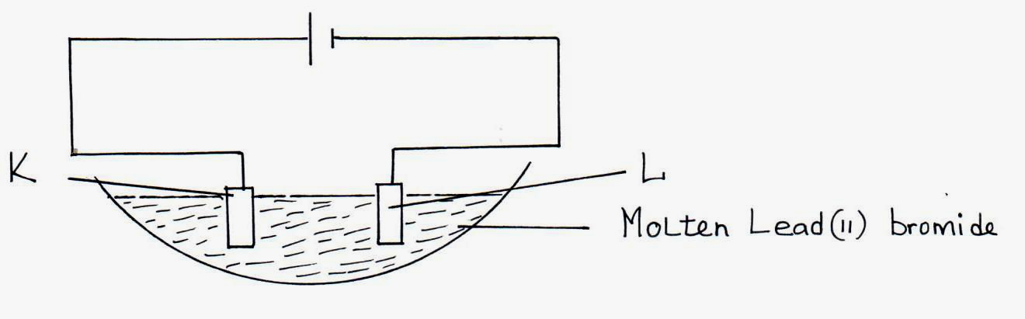

- Name electrode. (1mk)

K __________________________________________________________________________

L __________________________________________________________________________

(b) State the observation made at electrode K. (1mk)

____________________________________________________________________________
Chemistry Paper 1 3
(c) Write an equation for the reaction taking place at electrode L. (1mk)

7. (a) Name the two types of polymerization. (1mk)

____________________________________________________________________________

____________________________________________________________________________

- A sample of a polymer has the following structure.

H H H H H H
| | | | | |
⎯ C ⎯ C ⎯ C ⎯ C ⎯ C ⎯ C ⎯
| | | | | |
H Cl H Cl H Cl

The polymer is found to have a molecular mass of 5050g. Determine the number of monomers
in the polymer. (H = 1, Cl = 35.5, C = 12). (1mk)

8. Study the information given in the table below and answer the questions that follows.
Bond | Bond energy KJ/mol
C – H | 414
Cl – Cl | 244
C – Cl | 325
H - Cl | 431

- Calculate the enthalpy change for the reaction.
CH_{4(g)} + Cl_{2(g)} → CH₃ Cl_{(g)} + HCl_{(g)} (2mks)

(b) Sketch the energy level diagram. (1mk)

Chemistry Paper 1 4
9.
Solid H
Brown fumes +
Solid K
H₂SO_{4(aq)}
Solution B + H₂O₄
a gas that rekindles a glowing splint

White
ppt
1 drop of

NH_{3(aq)}
Colourless solution T
Excess NH_{3(aq)}

- Predict the cation and anion present, in solid H.

Cation _______________________________________________________ (½mk)

Anion ________________________________________________________ (½mk)

- Identify solid K, solution B and white-precipitate.

Solid K ____________________________________________________ (½mk)

Solution B ____________________________________________________ (½mk)

White precipitate _______________________________________________ (½mk)

(c) Write the formula of the complex ion present in solution T. (½mk)

10. When 15cm³ of a gaseous hydrocarbon P was burnt in 100cm³ of oxygen, the resulting gaseous mixture occupied 70cm³ at room temperature and pressure. When the gaseous mixture passed
through potassium hydroxide solution, it’s volume decreased to 25cm³.
(a) What volume of oxygen was used during the reaction? (1mk)

____________________________________________________________________________

(b) Determine the molecular formula of the hydrocarbon. (2mks)

Chemistry Paper 1 5
11. Sulphur (IV) oxide and nitrogen (IV) oxide reacts as shown below:

SO_{2(g)} + NO_{2(g)} → SO_{3(g)} + NO_{(g)}

- Using oxidation numbers of either sulphur or nitrogen show that this is a redox reaction.
(2mks)

____________________________________________________________________________

____________________________________________________________________________

____________________________________________________________________________

____________________________________________________________________________

(ii) Identify the reducing agent. (1mk)

____________________________________________________________________________

12. In an attempt to investigate the properties of halogens, a student bubbled chlorine gas through a solution of potassium bromide.
(a) State and explain what was observed. (1mk)

____________________________________________________________________________

____________________________________________________________________________

____________________________________________________________________________

(b) Write an ionic equation for the reaction. (1mk)

(c) Explain why iodine sublimes when heated to form a purple vapour. (1mk)

____________________________________________________________________________

____________________________________________________________________________

____________________________________________________________________________

13. The set-up below was used to investigate the products of burning methane gas. Study it and answer the questions that follow:
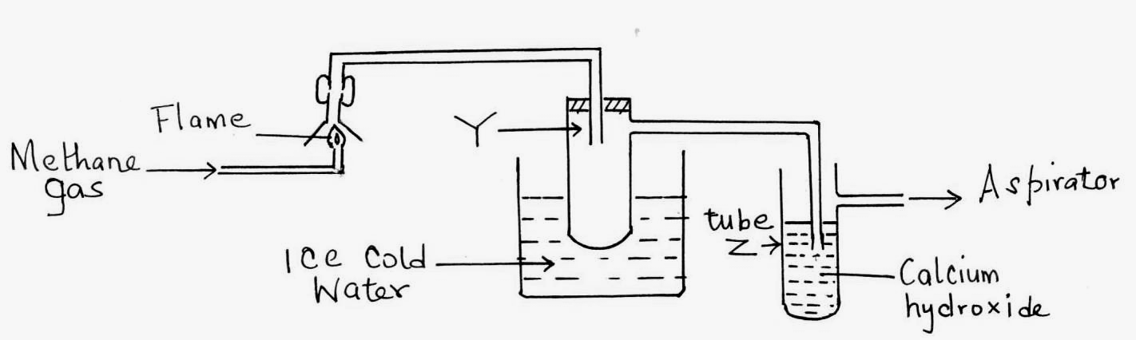

Chemistry Paper 1 6
(a) What product will be formed in the test tube Y? (1mk)

____________________________________________________________________________

(b) State and explain the observations made in tube Z. (2mks)

____________________________________________________________________________

____________________________________________________________________________

____________________________________________________________________________

____________________________________________________________________________

14. Below are P^{H} values of some solutions.
Solution | Z | Y | X | W
P^{H} | 6.5 | 13.5 | 2.2 | 7.2

- Which solution is likely to be

I Acidic rain. _______________________________________ (½mk)

II Potassium hydroxide _______________________________________ (½mk)

- A basic substance V reacted with both solutions Y and X. What is the nature of V. (1mk)

____________________________________________________________________________

(iii) Name two substances that show these characteristics in question (ii) above. (1mk)

____________________________________________________________________________

____________________________________________________________________________

15. In cold countries, salt is sprayed on the road to melt ice but in the long run it costs the motorists.
(a) How does the salt help in melting ice? (1mk)

____________________________________________________________________________

____________________________________________________________________________

____________________________________________________________________________

(b) How does the salt affect the motorists? (1mk)

____________________________________________________________________________

____________________________________________________________________________

____________________________________________________________________________

Chemistry Paper 1 7
16. The reaction below is in equilibrium.

Br_{2(aq)} + H₂O_{(l)} OBr${}_{\left(\text{aq}\right)}^{−}{}$ + Br${}_{\left(\text{aq}\right)}^{−}{}$ + $2H{}_{\left(\text{aq}\right)}^{+1}{}$

(a) State and explain the effect on the equilibrium when dilute hydrochloric acid is added. (1mk)

____________________________________________________________________________

____________________________________________________________________________

____________________________________________________________________________

____________________________________________________________________________

(b) What is the effect of increasing pressure in the reaction between hydrogen and chlorine?
Explain. (1mk)

H_{2(g)} + Cl_{2(g)} 2HCl_{(g)}

____________________________________________________________________________

____________________________________________________________________________

____________________________________________________________________________

17. (a) Define Graham’s law of diffusion. (1mk)

____________________________________________________________________________

____________________________________________________________________________

____________________________________________________________________________

- 20cm³ of an unknown gas Q takes 12.6 seconds to pass through small orifice, 10cm³ of
oxygen gas takes 11.2 seconds to diffuse through the same orifice under the same conditions
of temperatures and pressure. Calculate the molecular mass of unknown gas Q (O = 16).
(2mks)

18. The peaks below show the mass spectrum of element X.
9.1
8.1
82.8
24
25
26
Isotopic mass
Intensity
(% abundance)

Chemistry Paper 1 8
Calculate the relative atomic mass of X. (2mks)

19. Name the following compounds using the IUPAC rules.
(a) CH₃CH₂CHCH₂CH₂CH₃
|
CH₂CH₃ ______________________________________________ (1mk)

(b) CH₃CHCHCH₃ ___________________________________________ (1mk)

(c) Compounds A and B have the same molecular formula C₃H₆O₂. Compound A liberates
carbon (IV) oxide on addition of aqueous sodium carbonate while compound B does not compound B has a sweet smell. Draw the possible structures of:
(i) Compound A. (2mks)

______________________________________________________________________

(ii) Compound B.

20. (a) Study the equation below and use it to determine the type of water hardness being removed.
(1mk)
Mg(HCO₃)_{2(aq)} → MgCO_{3(S)} + H₂O_{(l)} + CO_{2(g)}

____________________________________________________________________________

(b) State one disadvantage of water hardness. (1mk)

____________________________________________________________________________

____________________________________________________________________________

21. (a) What is meant by the term half-life. (1mk)

____________________________________________________________________________

____________________________________________________________________________

____________________________________________________________________________

Chemistry Paper 1 9
- Study the diagram below and answer the questions that follow.
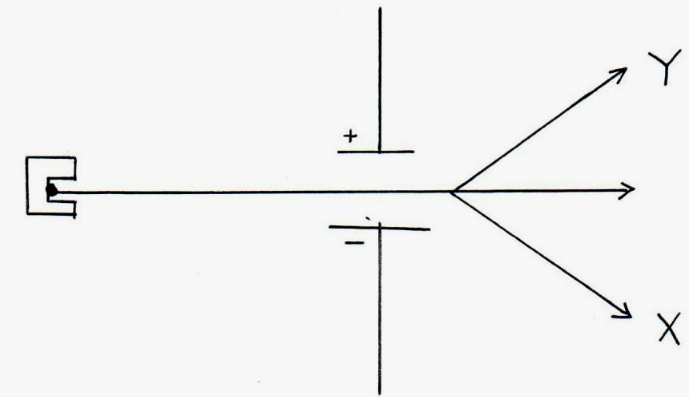

Identify particles X, Y. (1mk)

X _________________________________________________________________________

Y _________________________________________________________________________

(c) If 87.5% of a radioactive isotope decays in 66 years what is its half-life. (2mks)

____________________________________________________________________________

____________________________________________________________________________

____________________________________________________________________________

____________________________________________________________________________

22. A student reacted 0.2g zinc granules with 2M hydrochloric acid and volume of hydrogen gas produced was measured at various time intervals. A sketch graph of volume against time is as shown below.
Time (sec)
Volume of H₂(cm³)

(i) Explain why the graph is steepest at the beginning. (1mk)

____________________________________________________________________________

____________________________________________________________________________

____________________________________________________________________________

(ii) On the same axis above, draw a sketch graph of the reaction when 0.2g zinc powder was used instead of zinc granular. (1mk)

Chemistry Paper 1 10
(iii) State two other factors which affect the rate of the above reaction. (1mk)

____________________________________________________________________________

____________________________________________________________________________

____________________________________________________________________________

23. (a) Define the term enthalpy of combustion. (1mk)

____________________________________________________________________________

____________________________________________________________________________

____________________________________________________________________________

(b) In an experiment to determine heat of combustion of methanol CH₃OH, a student used a
set up like the one shown in the diagram below. Study the set up and the data below it
and answer the questions that follow.
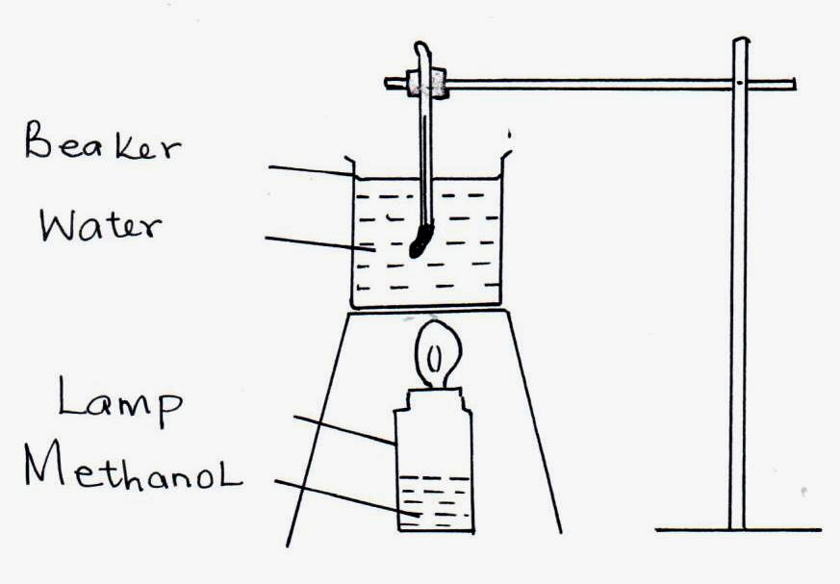

Volume of water = 500cm³
Final temperature of water = 27.0°C
Initial temperature of water = 20.0°C
Final mass of lamp + methanol = 22.11g
Initial mass of lamp + methanol = 22.98g
Density of water = 1.0g/cm³

Heat change = mass × temperature change × 4.2J/g/°C.
(i) Write an equation for the combustion of methanol. (1mk)

(ii) Calculate the:
- number of moles of methanol used in the experiment (C = 12, ) = 16, H = 1)
(½mk)

Chemistry Paper 1 11
(ii) heat change in this experiment. (½mk)

(iii) molar heat of combustion of methanol. (1mk)

24. 24cm³ of a solution of 0.1KOH were exactly neutralized by 30cm³ of a solution of sulphuric acid. Find the molarity of the acid.

25. The flow chart below shows processes involved in extraction of zinc metal. Use it to answer the questions that follow.
Zinc ore
Coke
Zn_{(S)}
Air
Roaster A
Roaster
SO2_{(g)}
Limestone
Slag
Impure

ZnO_{(S)}

(a) Name the main ore used in extraction of zinc. (1mk)

___________________________________________________________________________

(b) Write an equation for the reaction that takes place in a roaster A. (1mk)

(c) What is the function of limestone in roaster? (1mk)

___________________________________________________________________________

___________________________________________________________________________

___________________________________________________________________________

Chemistry Paper 1 12
26. The diagram below shows the Frash process used for extraction of sulphur use it to answer the questions that follow.
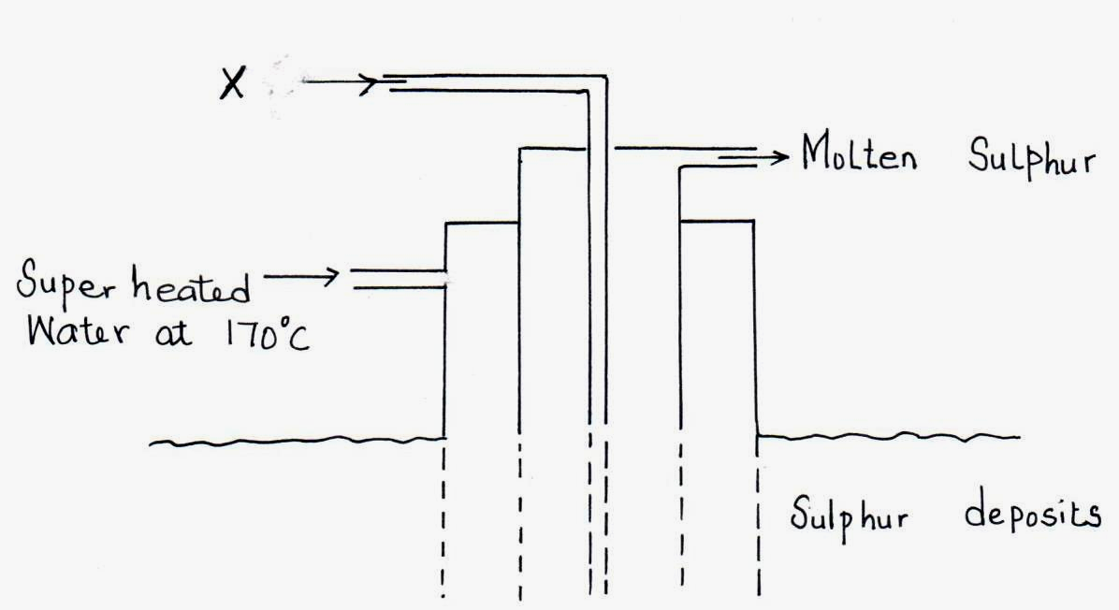

(i) Identify X. (1mk)

___________________________________________________________________________

(ii) Why is it necessary to use super heated water in this process? (1mk)

___________________________________________________________________________

(iii) State two physical properties of sulphur that makes it possible for it to be extracted by this method. (1mk)

___________________________________________________________________________

___________________________________________________________________________

___________________________________________________________________________

27. Use the information to answer the questions that follow.

C_{(S)} + O_{2(g)} → CO_{2(g)} ΔH₁ = -393 KJ/mol

H_{2(g)} + $\frac{1}{2}$O_{2(g)} → H₂O_{(l)} ΔH₂ = -286 KJ/mol

C₄H₁₀ + 6$\frac{1}{2}$O_{2(g)} → 4CO_{2(g)} + 5H₂O ΔH = -287.7 KJ/molˉ¹

(a) Define the term molar enthalpy of combustion of a compound. (1mk)

___________________________________________________________________________

___________________________________________________________________________

___________________________________________________________________________

Chemistry Paper 1 13
(b) Calculate the molar enthalpy of formation of butane C₄H₁₀ from its elements in their normal states at standard temperature and pressure. (2mks)

28. Concentrated sulphuric acid is slowly added to a mixture of freshly prepared solution of iron (II) sulphate and potassium nitrate as below.
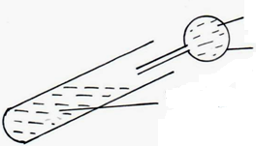
Concentrated sulphuric (VI) acid
Teat pipette
Mixture of iron (II) sulphate and potassium nitrate solution

(i) State the observation made. (1mk)

__________________________________________________________________________

(ii) Identify the complex salt formed. (1mk)

___________________________________________________________________________

___________________________________________________________________________

29. The table below gives some properties of three substances I, J and K. Study it and answer the questions that follow.

Substance | Mpt (°C) | Solubility in water | Electrical conductivity  Solid Molten
I | 1063 | Insoluble | Conduct Conduct
J | 113 | Insoluble | Doesn’t Doesn’t
K | 402 | Sparingly soluble | Doesn’t Conduct and  is decomposed

- Suggest the type of structure in

(i) I ______________________________________________________ (1mk)

(ii) K ______________________________________________________ (1mk)

- Explain why the molten K is decomposed by electric current but I is not decomposed.

___________________________________________________________________________

___________________________________________________________________________

___________________________________________________________________________

Chemistry Paper 1 14

