NAME……………………………………………………….. INDEX NO……………………........................

233/1 CANDIDATE’S SIGN………….….….….…..
CHEMISTRY
PAPER 1 DATE……….…………………………………
(THEORY)
JULY/AUGUST, 2015
TIME: 2 HOURS

KAHURO/KIHARU DISTRICT JOINT EXAMINATION - 2015

Kenya Certificate of Secondary Education
CHEMISTRY
PAPER 1
(THEORY)
TIME: 2 HOURS

INSTRUCTIONS TO CANDIDATES:
- Write your name and index number in the spaces provided above.
- Sign and write the date of examination in the spaces provided above.
- Answer ALL the questions in the spaces provided.
- Mathematical tables and silent electronic calculators may be used.
- All working must be clearly shown where necessary
- Candidates should check the question paper to ascertain that all the pages
are printed as indicated and that no questions are missing
- Candidates should answer the questions in English.

For Examiner’s Use Only
Questions | Maximum Score | Candidate’s Score
1 – 29 | 80

Chemistry Paper 1 Turnover
1. (a) The diagram below shows a non-luminous flame. Use it to answer the questions that
follow:
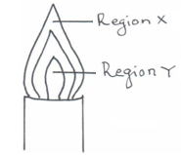

Two wooden splints were placed across regions X and Y respectively. Draw labelled diagrams to show the effects observed on the wooden splint placed across each region. (2 marks)
- Region X.

- Region Y.

- It is advisable to leave your flame in the luminous state when not in use. Give a reason why.
(1 mark)

__________________________________________________________________________

__________________________________________________________________________

__________________________________________________________________________

2. Explain the change in mass expected when each of the following substances is heated in an open crucible.
(a) Copper metal. (1 mark)

__________________________________________________________________________

__________________________________________________________________________

__________________________________________________________________________

(b) Copper (II) nitrate. (2 marks)

__________________________________________________________________________

__________________________________________________________________________

__________________________________________________________________________

3. The table below shows PH values of solutions A, B, C and D.
Solution | PH
A | 3.0
B | 13.0
C | 8.5
D | 7.0

Chemistry Paper 1 2 Kahuro/Kiharu
(a) Identify a solution which is
(i) Strongly acidic. _________________________________________ (½ mark)

(ii) Strongly basic _________________________________________ (½ mark)

(b) Which to solutions would react with lead (II) oxide? Explain. (2 marks)

____________________________________________________________________________

____________________________________________________________________________

____________________________________________________________________________

____________________________________________________________________________

4. In an experiment a certain volume of air was repeatedly passed between two syringes over heated zinc powder as shown below.
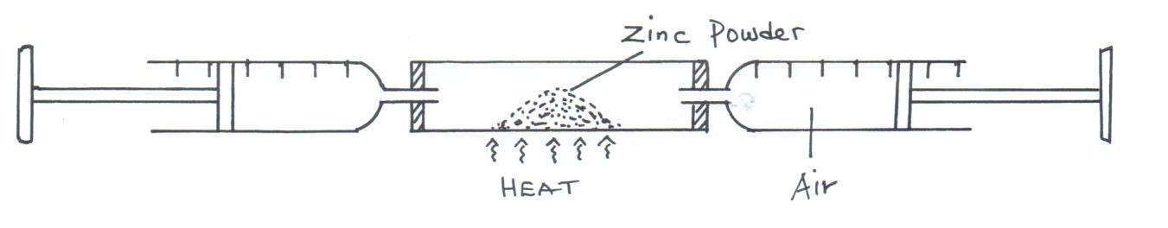

The same experiment was repeated using magnesium turnings instead of zinc powder. In which of
the two experiments was the overall change in volume greater? Explain. (3 marks)

__________________________________________________________________________________

__________________________________________________________________________________

__________________________________________________________________________________

__________________________________________________________________________________

5. The grid below is part of the periodic table. Study it and answer the questions that follow. The letters are not actual symbols of elements.

A |  |  | D | E |  |  | H | I
B | C |  | M |  | F | G |  | J

(a) What is the name given to the chemical family of element C? (1 mark)

______________________________________________________________________

(b) Would element B react with J? Explain. (1 mark)

____________________________________________________________________________

____________________________________________________________________________

____________________________________________________________________________

Chemistry Paper 1 3 Kahuro/Kiharu
(c) Compare the melting points of B and M. (1 mark)

____________________________________________________________________________

____________________________________________________________________________

____________________________________________________________________________

6. The atomic numbers of nitrogen, oxygen and sodium are 7, 8 and 11 respectively.
(a) Write the electron arrangements of their ions, N³⁻, O²⁻ and Na⁺. (1 mark)

(b) Arrange the 3 ions in increasing order of size. Give a reason for your answer. (2 marks)

____________________________________________________________________________

____________________________________________________________________________

____________________________________________________________________________

____________________________________________________________________________

7. The melting point of phosphorous (III) chloride is -91°C while that of magnesium chloride is +715°C. In terms of structure and bonding explain the difference. (3 marks)

__________________________________________________________________________________

__________________________________________________________________________________

__________________________________________________________________________________

__________________________________________________________________________________

__________________________________________________________________________________

8. The diagram below illustrates how lithium would react with steam. Study it then answer the
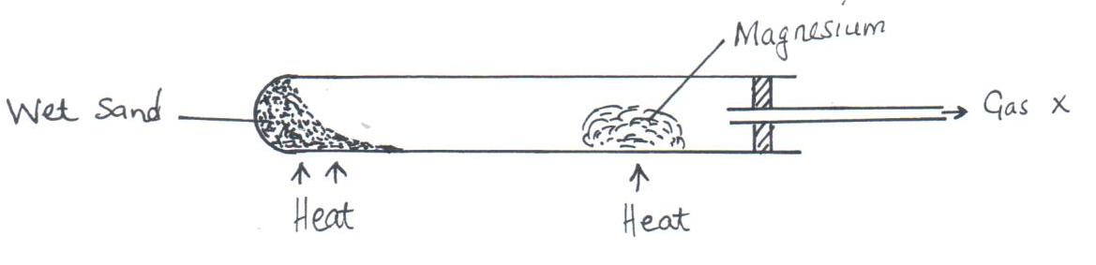
questions that follow.

(a) Write the equation for the reaction that takes place. (1 mark)

Chemistry Paper 1 4 Kahuro/Kiharu
(b) Explain why this experiment cannot be carried out with potassium in the same way
as shown. (1 mark)

____________________________________________________________________________

____________________________________________________________________________

____________________________________________________________________________

9. Explain why this experiment cannot be carried out with potassium in the same way as shown. (2 marks)

__________________________________________________________________________________

__________________________________________________________________________________

__________________________________________________________________________________

__________________________________________________________________________________

10. Calculate the volume of carbon (IV) oxide that would be produced if 15g of calcium carbonate reacted with 100cm³ of 2.0M hydrochloric acid (C = 12.0, O = 16.0, Ca = 40.0) molar gas volume = 24000cm³. (3 marks)

__________________________________________________________________________________

__________________________________________________________________________________

__________________________________________________________________________________

__________________________________________________________________________________

__________________________________________________________________________________

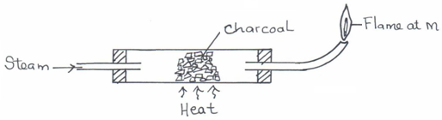
11. (a) Study the diagram below hence answer the questions that follow.

- Explain why it is necessary to have the flame at M. (1 mark)

______________________________________________________________________

______________________________________________________________________

______________________________________________________________________

(ii) Write down the equation for the reaction inside the apparatus. (1 mark)

Chemistry Paper 1 5 Kahuro/Kiharu
- Explain potassium hydroxide is not a suitable reagent for testing carbon (IV) oxide. (1 mark)

___________________________________________________________________________

___________________________________________________________________________

___________________________________________________________________________

12. The table below contains information regarding a species of helium.
Species | Number of electrons | Number of neutrons
$${}_{2}^{3}{}{\text{He}}^{2+}$$

Complete the table by indicating the numbers of electrons and neutrons. (2 marks)

13. (a) The diagram below represents a set-up of apparatus used to investigate the effect of electric
current on lead (II) bromide.
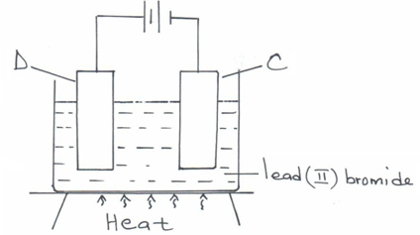

Describe what is observed at electrode C. (1 mark)

____________________________________________________________________________

____________________________________________________________________________

____________________________________________________________________________

(b) A current of 2.5A was passed through a cell containing N²⁺ ions for 25 minutes. The mass of the cathode increased by 0.36g. Determine the R.A.M of N. (F = 9.65 x 10⁴Cmolˉ¹). (2 marks)

____________________________________________________________________________

____________________________________________________________________________

____________________________________________________________________________

____________________________________________________________________________

14. When aluminium chloride is dissolved in water, the resulting solution has a PH of 3. Explain. (3 marks)

__________________________________________________________________________________

__________________________________________________________________________________

__________________________________________________________________________________

__________________________________________________________________________________

Chemistry Paper 1 6 Kahuro/Kiharu
15. Study the scheme below hence answer the questions that follow.

Solid Q + Ca(OH)₂
Ammonia
Solid P
Step I
Step II
Pass into aluminium sulphate then filter

(a) Identify solid Q.__________________________________________________ (1 mark)

(b) Write an ionic equation for the reaction in Step II. (1 mark)

(c) State the condition necessary for Step I. (1 mark)

____________________________________________________________________________

____________________________________________________________________________

____________________________________________________________________________

16. When sulphur is heated in a boiling tube in the absence of air, the yellow crystals melt into a golden yellow mobile liquid at 113°C. The liquid turns into a dark brown viscous mass at 180°C. At 400°C the brown liquid becomes less viscous and flows easily. Explain these observations. (3 marks)

_________________________________________________________________________________

_________________________________________________________________________________

_________________________________________________________________________________

_________________________________________________________________________________

17. Study the diagrams below.
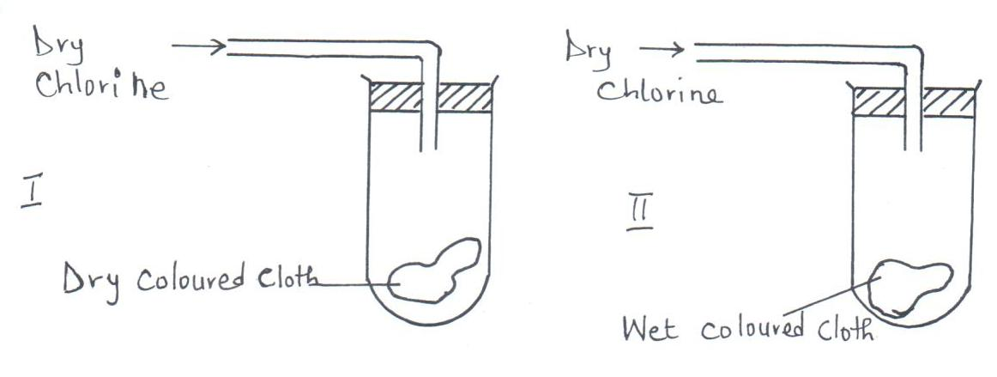

(a) State the observations made at

I _______________________________________________________________ (½ mark)

II __________________________________________________________ ____ (½ mark)

Chemistry Paper 1 7 Kahuro/Kiharu
(b) Write the equation to show the reactions at II if dry sulphur (IV) oxide was used in place of
dry chlorine. (2 marks)

18. In an experiment soap solution was used against 3 separate samples of water. Each sample was later boiled and soap added. Each water sample was 1000cm³. The results are tabulated below.

Volume of soap used to form lather | Sample
 | I | II | III
Before boiling (cm³) | 27 | 3 | 10.6
After boiling (cm³) | 27 | 3 | 3

(a) Which sample was likely to be soft water? Explain. (2 marks)

____________________________________________________________________________

____________________________________________________________________________

____________________________________________________________________________

____________________________________________________________________________

(b) State the cause of change in volume of soap used to form lather in sample III. (1 mark)

___________________________________________________________________________

___________________________________________________________________________

___________________________________________________________________________

19. Study the cycle below hence answer the questions that follow.
Fe_{(S)}
FeCl₂
Fe Cl₃
ΔH₂

ΔH₃

(a) What is ΔH₃? (1 mark)

___________________________________________________________________________

___________________________________________________________________________

___________________________________________________________________________

(b) Show the relationship connecting ΔH₁, ΔH₂ and ΔH₃ (1 mark)

___________________________________________________________________________

___________________________________________________________________________

___________________________________________________________________________

Chemistry Paper 1 8 Kahuro/Kiharu
20. When bromine gas reacts with aqueous sodium hydroxide an equilibrium is established as shown below.
Br_{2(aq)} + $2{\text{OH}}_{\left(\text{aq}\right)}^{−}$ ${\text{Br}}_{\left(\text{aq}\right)}^{−}$ + ${\text{OBr}}_{\left(\text{aq}\right)}^{−}$ + H₂O_{(l)}
(Brown) (Colourless)

What observation would be made if a few drops of dilute sulphuric (VI) were added to the
equilibrium mixture? Explain. (2 marks)

__________________________________________________________________________________

__________________________________________________________________________________

__________________________________________________________________________________

__________________________________________________________________________________

21. (a) Aqueous sodium sulphate was electrolysed using platinum. Name the products at each electrode. (1 mark)

I Cathode_______________________________________________________________

II Anode________________________________________________________________

(b) Explain why it is not advisable to use potassium chloride as salt bridge in the cell
shown below.
Pb_{(S)} / $\text{Pb}{}_{\left(\text{aq}\right)}^{2+}{}$ // $\text{Cu}{}_{\left(\text{aq}\right)}^{2+}{}$ / Cu_{(S)} E = +0.47V (1 mark)

____________________________________________________________________________

____________________________________________________________________________

____________________________________________________________________________

22. A compound has empirical formula C₃H₆O and relative formula mass of 116. Determine it’s molecular formula. (C = 12, H = 1, O = 16). (2 marks)

_________________________________________________________________________________

_________________________________________________________________________________

_________________________________________________________________________________

_________________________________________________________________________________

23. (a) State the law of combining volumes of gases. (1 mark)

___________________________________________________________________________

___________________________________________________________________________

___________________________________________________________________________

Chemistry Paper 1 9 Kahuro/Kiharu
(b) What volume of methane would remain if a burner containing 40cm³ of methane burns in 40cm³ of enclosed air (assuming that oxygen is 20% of air)? (2 marks)

____________________________________________________________________________

____________________________________________________________________________

____________________________________________________________________________

____________________________________________________________________________

24. The molecular formula of compound T is C₃H₈O. T reacts with acidified potassium manganate (VII) to form another compound U whose formula C₃H₆O₂. T also reacts with sodium metal to produce hydrogen gas and T is neutral to litmus.
(a) Suggest the homologous series to which T belongs. (1 mark)

____________________________________________________________________________

(b) Name the type of reaction leading to the formation of U in the reaction described above.
_________________________________________________________________ (1 mark)

(c) Write the structural formula of U. (1 mark)

25. Potassium has two isotopes ${}_{\text{19}}^{\text{39}}{}K$and radioactive${}_{\text{19}}^{\text{40}}{}K$.
(a) State how the two isotopes differ. (1 mark)

___________________________________________________________________________

___________________________________________________________________________

___________________________________________________________________________

(b) The half-life of ${}_{\text{19}}^{\text{40}}{}K$is 1.3 x 10⁹ years. Determine how long it would take for 4g of the
isotope to decay to 1g. (1 mark)

___________________________________________________________________________

___________________________________________________________________________

___________________________________________________________________________

(c) ${}_{\text{19}}^{\text{39}}{}K$undergoes beta decay to form an isotope of calcium. Write the equation for this decay. (1 mark)

Chemistry Paper 1 10 Kahuro/Kiharu
26. The diagram below represents a section of the hydrochloric acid manufacturing plant.
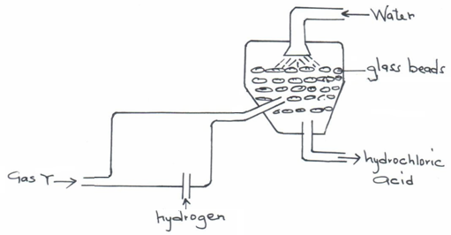

(a) Name Y.________________________________________________________ (1 mark)

(b) State the role played by glass beads. (1 mark)

____________________________________________________________________________

____________________________________________________________________________

____________________________________________________________________________

(c) Chlorine reacts with hydrogen sulphide gas according the equation shown below:
H₂S_{(g)} + Cl_{2(g)} → 2HCl_{(g)} + S_{(S)}
From the equation identify the oxidizing agent. (1 mark)

____________________________________________________________________________

27. The formulae below belong to 2 cleansing agents.
I RCOO⁻ K⁺

II R $\text{OSO}{}_{3}^{−}{}K^{+}$

(a) Which of the two cleaning agents would lather readily with hard water? (1 mark)

____________________________________________________________________________

(b) State one disadvantage of the continued use of cleansing agent II. (1 mark)

____________________________________________________________________________

____________________________________________________________________________

____________________________________________________________________________

Chemistry Paper 1 11 Kahuro/Kiharu
- Write the formula of the compound formed when cleansing agent I is used with water
containing Mg²⁺ ions. (1 mark)

______________________________________________________________________

28. Starting with solid lead (II) carbonate, briefly describe how a sample of lead (II) chloride can be prepared. (3 marks)

__________________________________________________________________________________

__________________________________________________________________________________

__________________________________________________________________________________

__________________________________________________________________________________

29. (a) State Boyle’s law. (1 mark)

____________________________________________________________________________

____________________________________________________________________________

____________________________________________________________________________

(b) 60cm³ of oxygen gas diffused through a porous hole in 50 seconds. How long will it take 80cm³ of sulphur (IV) oxide to diffuse through the same hole under the same conditions
(S = 32, O = 16). (2 marks)

____________________________________________________________________________

____________________________________________________________________________

____________________________________________________________________________

____________________________________________________________________________

____________________________________________________________________________

____________________________________________________________________________

Chemistry Paper 1 12 Kahuro/Kiharu

