NAME……………………………………………………….. INDEX NO……………………........................

233/2 CANDIDATE’S SIGN………….….….….…..
CHEMISTRY
PAPER 2 DATE……….…………………………………
(THEORY)
TIME: 2 HOURS

CENTRAL KENYA NATIONAL SCHOOLS JOINT EXAM - 2015

Kenya Certificate of Secondary Education
CHEMISTRY
PAPER 2
(THEORY)
TIME: 2 HOURS

INSTRUCTIONS TO CANDIDATES:
- Write your name and index number in the spaces provided above.
- Sign and write the date of examination in the spaces provided above.
(iii) Answer ALL the questions in the spaces provided.
(iv) Electronic calculators and Mathematical table may be used.
(v) All working must be clearly shown where necessary.

FOR EXAMINER’S USE ONLY:
Question | Maximum  Score | Candidate’s  Score
1 | 12
2 | 11
3 | 13
4 | 11
5 | 11
6 | 10
7 | 12
Total Score | 80

This paper consists of 12 printed pages.
Candidates should check to ascertain that all the pages are printed
as indicated and that no questions are missing.

Chemistry Paper 2 Turnover
1. Study the information in the table below and answer the questions that follow. The letters do not represent the symbols of the elements.

Element C | Atomic number | Melting point °C
L | 11 | 97.8
K | 12 | 650
M | 13 | 660
N | 14 | 1410
Q | 17 | -101
R | 19 | 63.7

- Write the electronic arrangement for the ions formed by elements M and Q.

M ____________________________________________________________ (½mk)

Q ____________________________________________________________ (½mk)

- Select an element which is:
(i) the most electronegative element. ____________________________ (1mk)

(ii) a poor conductor of electricity. ____________________________ (1mk)

(c) In which period of the periodic table does element Q belong? Explain. (1mk)

___________________________________________________________________________

___________________________________________________________________________

(d) Compare the re-activity of element R and L. Explain your answer. (2mks)

___________________________________________________________________________

___________________________________________________________________________

___________________________________________________________________________

___________________________________________________________________________

- Using dots (•) and crosses (X) to represent outmost electrons, show bonding in the compound formed by elements M and Q. (1mk)

Chemistry Paper 2 2
(f) Explain why the melting point of element M is higher than that of element L. (2mks)

___________________________________________________________________________

___________________________________________________________________________

___________________________________________________________________________

___________________________________________________________________________

(g) Write an equation for the reaction that would occur between K and water. (1mk)

- In terms of structure and bonding, explain why there is a large difference in the melting points of N and Q. (2mks)

___________________________________________________________________________

___________________________________________________________________________

___________________________________________________________________________

___________________________________________________________________________

2. I The scheme below show some reactions starting with ethanol.
CH₃ Cl
CH₄
D
A
CH₃ CH₂ OH
C
HCOOH

H⁺
KMnO₄

H⁺
Soda lime

heat
Step II
Step I
Na_{(S)}
B

Z
Br_{2(g)}

Conc. H₂SO₄ 170°C
CH₂ CH₂

n

(a) Name substances. (2mks)

A ____________________________________________________________________

B ____________________________________________________________________

C ____________________________________________________________________

D ____________________________________________________________________

Chemistry Paper 2 3
(b) Name the reagent and condition for the reaction in step I. (1mk)

______________________________________________________________________

(c) Write the chemical equation for the reaction between
(i) sodium metal and C. (1mk)

(ii) Bromine gas and compound B. (1mk)

(d) Name the process represented by step I. (1mk)

______________________________________________________________________
CH₂ – CH₂
n
(e) Given that the relative molecular mass of is 39200. Calculate the
value of n (C = 12, H = 1). (1mk)

______________________________________________________________________

______________________________________________________________________

______________________________________________________________________

II The structures below represents two cleansing agents.
R – C - O⁻ - Na⁺
O
R

In the table below, give one advantage and one disadvantage of using each one of them.

 | Advantage | Disadvantage
R – C - O⁻ - Na⁺
O

R |  |  | (2mks)

III Complete the table below by inserting the missing information in the spaces provided.

Name of polymer | Monomer | Use
 | Styrene
polyvinylchloride |  |  | (2mks)

Chemistry Paper 2 4
3. I Use standard electrode potentials for elements A, B, C, D and F given below to answer the
questions that follow.
E^{θ} (volts)
$A{}_{\left(\text{aq}\right) }^{2+}{} + 2e$ → A_{(S)} -2.90
$B{}_{\left(\text{aq}\right) }^{2+}{} + 2e$ → B_{(S)} -2.38
$C{}_{\left(\text{aq}\right) }^{+}{} + e$ → $\frac{1}{2}C$ 0.00
$D{}_{\left(\text{aq}\right) }^{2+}{} + 2e$ → D_{(S)} +0.34
$\frac{1}{2}F + e$ → $F{}_{\left(\text{aq}\right)}^{−}{}$ +2.87

(a) Identify the strongest oxidizing agent. Give reason for your answer. (1mk)

____________________________________________________________________

(b) Which two half-cells would produce the highest potential difference when combined?
(1mk)

(c) In the space provided, draw a labelled diagram of the electrochemical cell that would
be obtained when half-cells above is formed (b) above. Show the direction of flow of electrons. (3mks)

(d) Calculate E^{θ} value of the electrochemical cell constructed in (c) above. (2mks)

____________________________________________________________________

____________________________________________________________________

(e) Is it advisable to store solution of a nitrate of D in a container made of metal B. Explain. (2mks)

____________________________________________________________________

____________________________________________________________________

____________________________________________________________________

____________________________________________________________________

Chemistry Paper 2 5
II During the electrolysis of aqueous copper (II) sulphate using copper electrodes, a current of
0.2 amperes was passed through the cell for 5 hours.
(i) Write an ionic equation for the reaction that took place at the anode. (1mk)

(ii) Determine the change in mass of the anode which occurred as a result of the
electrolysis process. Cu = 63.5, 1 Faraday = 96,500 coulombs). (3mks)

_____________________________________________________________________

_____________________________________________________________________

_____________________________________________________________________

_____________________________________________________________________

_____________________________________________________________________

_____________________________________________________________________

4. I (a) Define allotropy. (1mk)

_____________________________________________________________________

_____________________________________________________________________

_____________________________________________________________________

(b) Name the two crystalline allotropes of carbon. (2mks)

____________________________________________________________________

_____________________________________________________________________

II Below is a simplified process for manufacture of sodium carbonate by Solvay process.
Brine
Ammonia
Step I
Ammoniated brine
NaHCO₃
NH₄Cl
Na₂CO₃
Step II
M
Step III

(a) Name substance M. ________________________________________ (1mk)

(b) Name the process taking place in Step II___________________________ (1mk)

(c) Write an equation for the reaction in Step III. (1mk)

Chemistry Paper 2 6
(d) What happens to ammonium chloride in the solvay process. (1mk)

______________________________________________________________________

______________________________________________________________________

______________________________________________________________________

(e) Name two substances that are recycled in the process. (2mks)

______________________________________________________________________

______________________________________________________________________

______________________________________________________________________

(f) State one use of sodium carbonate. (1mk)

______________________________________________________________________

______________________________________________________________________

______________________________________________________________________

(g) Name one other industry that can be located near the solvay plant. (1mk)

______________________________________________________________________

______________________________________________________________________

5. (a) Below is a simplified diagram of the Down’s cell used for the manufacture of sodium.
Study it and answer the questions that follow.
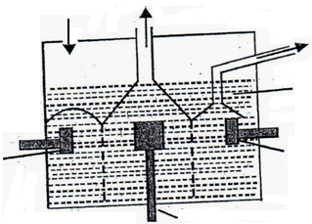
Chlorine
Anode
Sodium
Molten sodium chloride
Circular steel cathode
Hole through which NaCl is added
Circular steel
cathode

(i) The anode is made of graphite and not steel. Give a reason. (2mks)

______________________________________________________________________

______________________________________________________________________

______________________________________________________________________

______________________________________________________________________

Chemistry Paper 2 7
(ii) What precaution is taken to prevent chlorine and sodium from re-combining? (1mk)

______________________________________________________________________

______________________________________________________________________

_____________________________________________________________________

(iii) Write an ionic equation for the reaction in which chlorine gas is formed. (1mk)

- In the Down’s process a certain salt is added to lower the melting point of sodium chloride from about 800°C to about 600°C.
- Name the salt that is added. (1mk)

______________________________________________________________________

(ii) State why it is necessary to lower the temperature. (1mk)

______________________________________________________________________

______________________________________________________________________

______________________________________________________________________

(c) Explain why aqueous sodium chloride is not suitable as an electrolyte for the manufacture of sodium in the Down’s process. (2mks)

____________________________________________________________________________

____________________________________________________________________________

____________________________________________________________________________

____________________________________________________________________________

(d) Sodium metal reacts with air to form two oxides. Give the formulae of the two oxides. (2mks)

____________________________________________________________________________

____________________________________________________________________________

(e) State one use of sodium metal. (1mk)

____________________________________________________________________________

____________________________________________________________________________

6. (a) Define the term solubility. (1mk)

____________________________________________________________________________

____________________________________________________________________________

____________________________________________________________________________

Chemistry Paper 2 8
- The table below gives the solubilities of potassium nitrate at different temperature.

Temperature (°C) | 12 | 20 | 28 | 36 | 44 | 52
Solubility g/100g water | 22 | 31 | 42 | 55 | 70 | 90

(i) Plot a graph of solubility of potassium nitrate (vertical axis) against temperature. (3mks)

Chemistry Paper 2 9
(ii) Using the graph.
I determine the solubility of potassium nitrate at 25°C. (1mk)

_______________________________________________________________

II Determine the mass of potassium nitrate that remained undissolved given-that
100g of potassium nitrate were added to 100cm³ of water and warmed to 50°C.
(2mks)

________________________________________________________________

- Determine the molar concentration of potassium nitrate at 25°C. (Assume there is no change in density of water at this temperature). (K = 39.0; N = 14.0; O = 16.0). (3mks)

7. The diagram below shows the set-up used to prepare dry hydrogen gas in the laboratory. Study the diagram and answer the questions that follow:
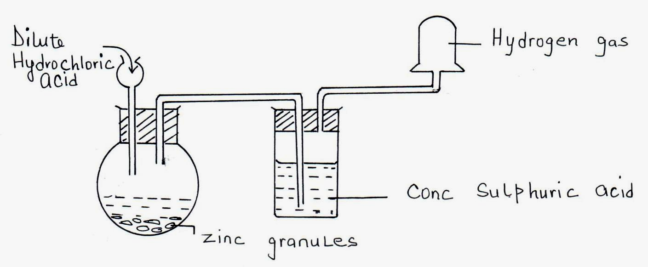

(a) (i) State one mistake in the set up. (1mk)

______________________________________________________________________

______________________________________________________________________

(ii) Which property of hydrogen gas enables it to be collected as shown in the diagram?
(1mk)

______________________________________________________________________

Chemistry Paper 2 10
(iii) (i) Write a chemical equation for the reaction between dilute sulphuric acid and
zinc to produce hydrogen gas. (1mk)

(ii) If 200cm³ of hydrogen gas was produced at R.T.P, calculate the mass of Zn used. (Zn = 65, MGV at R.T.P is 24dm³). (2mks)

- Hydrogen gas is passed over heated copper II oxide in a hard glass tube as shown below.

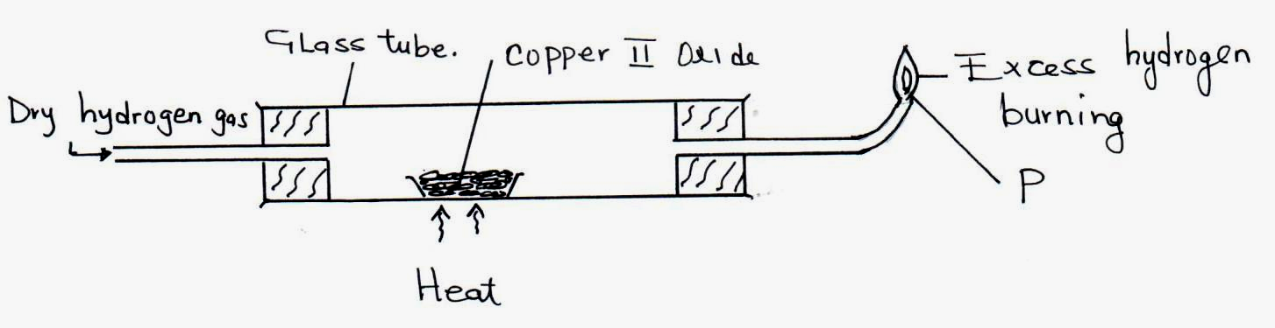

(i) Which precaution is taken before lighting the gas at point P.? (1mk)

_____________________________________________________________________

______________________________________________________________________

(ii) State the observation made at the end of the experiment in the glass tube. Explain.
(2mks)

______________________________________________________________________

______________________________________________________________________

______________________________________________________________________

______________________________________________________________________

Chemistry Paper 2 11
(iii) Excess hydrogen burns to form water. State one chemical test that can be carried out
to identify water. (1mk)

______________________________________________________________________

______________________________________________________________________

______________________________________________________________________

(iv) What would you expect to happen if magnesium oxide (MgO) is used instead of
copper (II) oxide? Explain. (1mk)

______________________________________________________________________

______________________________________________________________________

______________________________________________________________________

- State one industrial use of hydrogen. (1mk)

______________________________________________________________________

______________________________________________________________________

Chemistry Paper 2 12

