NAME……………………………………………………….. INDEX NO……………………..........

233/2 CANDIDATE’S SIGN…………...….
CHEMISTRY
PAPER 2 DATE…………………………………
(THEORY)
JULY/AUGUST, 2015
TIME: 2 HOURS

KAHURO/KIHARU DISTRICT JOINT EXAMINATION - 2015

Kenya Certificate of Secondary Education
CHEMISTRY
PAPER 2
(THEORY)
TIME: 2 HOURS

INSTRUCTIONS TO CANDIDATES:
- Write your name and index number in the spaces provided above.
- Sign and write the date of examination in the spaces provided above.
(iii) Answer ALL the questions in the spaces provided.
(iv) Mathematical tables and silent electronic calculators may be used.
(v) All working must be clearly shown where necessary.

FOR EXAMINER’S USE ONLY:
Question | Maximum  Score | Candidate’s  Score
1 | 12
2 | 12
3 | 14
4 | 10
5 | 10
6 | 11
7 | 11
Total Score | 80

This paper consists of 11 printed pages.
Candidates should check to ascertain that all the pages are printed
as indicated and that no questions are missing.

Chemistry Paper 2 Turnover
- Use the table below to answer the questions that follow. (The letters are not actual
symbols of the elements).
Element | Atomic number | M.P(°C)
A | 11 | 97.8
B | 13 | 660
C | 14 | 1410
D | 17 | -101
E | 19 | 63.7

- Write the electronic arrangement for the ions formed by the elements D and E.
(½ mark)

_________________________________________________________________
- Select and element which is:
(i) a poor conductor of electricity. (½ mark)

____________________________________________________________
(ii) the most reactive non-metal. (½ mark)

____________________________________________________________
(c) To which period of the periodic table does element E belongs? (½ mark)

_________________________________________________________________
(d) Element E losses its outermost electron more readily than A. Explain. (2 marks)

_________________________________________________________________

_________________________________________________________________
- Use dot (.) and crosses (X) to represent the valence electrons and show the bonding in the compound formed between element C and D. (2 marks)

_________________________________________________________________

_________________________________________________________________

_________________________________________________________________

_________________________________________________________________
(f) Explain why the melting point of element B is higher than that of element A.
(2 marks)

_________________________________________________________________

_________________________________________________________________
(g) Write an equation for the reaction that takes place between element A and water. (1 mark)

_________________________________________________________________

Chemistry Paper 2 2 Kahuro/Kiharu
- Describe how a solid mixture of the sulphate of element E and lead (II) sulphate can be separated into solid samples. (3 marks)

_________________________________________________________________

_________________________________________________________________

_________________________________________________________________

_________________________________________________________________

_________________________________________________________________

_________________________________________________________________

2. The scheme below shows several reactions starting with propanol. Study the scheme and answer the questions which follow.
Propane
Q
CH₂BrCHBrCH₃
S
CH₂BrCHBrCH₃
Gas R
CH₃CH₂COOCH₂CH₃
H⁺/K₂Cr₂O₇
Excess
Sodium

metal
Conc. H₂SO₄
Bromine

water

(a) Name gas R (½ mark)

________________________________________________________________
(b) Name and draw the structural formula of compound Q. (1 mark)

_________________________________________________________________

_________________________________________________________________

_________________________________________________________________
(c) What conditions and reagents are necessary to convert S to CH₃CH₂COOCH₂CH₃ (2 marks)

Reagents _________________________________________________________

Conditions ________________________________________________________

_________________________________________________________________

Chemistry P2 3 Kahuro/Kiharu
(d) Write an equation for the reaction that takes place when equal volumes of chlorine gas react with propane. (1 mark)

_________________________________________________________________
- The table below shows some properties of organic compounds U, V and W.
Use the information to answer the questions that follow.

 | W | V | U
Reaction with  liquid bromine | Decolourise  bromine very fast | No reaction | Decolourises bromine  liquid slowly
Combustion | Burns with yellow  smoky flame | Burns with a blue flame  leaving no residue | Burns with a yellow  sooty flame
Reaction with  conc. H₂SO₄ | No reaction | It is dehydrated to  form compound U | Reacts to form V
To which homologous series do the compounds belong? (3 marks)

U _______________________________________________________________

V _______________________________________________________________

W ______________________________________________________________
(f) CH₂ = CH – CH₃ when heated under high temperatures and pressures forms a solid with large molecular mass.
(i) Write the equation for the reaction which involves the formation of the
solid. (1 mark)

___________________________________________________________
(ii) Name the solid and give one use of the solid

Name _____________________________________________ (½ mark)

Use _______________________________________________ (1 mark)
(g) State two uses of cracking. (2 marks)

_________________________________________________________________

_________________________________________________________________

Chemistry Paper 2 4 Kahuro/Kiharu
3. (a) An aqueous solution of zinc sulphate is electrolysed using platinum electrodes
as shown in the set up below.
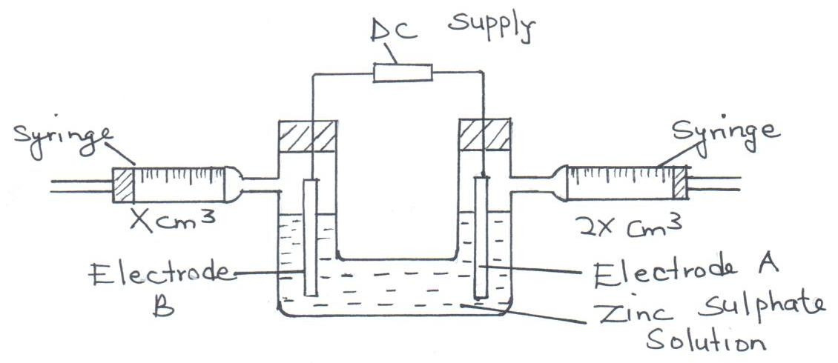

(i) Write a half equation for the reaction taking place at electrode A. (1 mark)

____________________________________________________________
(ii) Identify electrode B. (1 mark)

____________________________________________________________
(iii) Explain observation at electrode B if copper plate was used instead of
platinum electrode. (2 marks)

____________________________________________________________

____________________________________________________________
- 0.22g of metal Q is deposited by electrolysis when a current of 0.06A flows for 99 minutes (RAM of Q = 184, IF = 96500C)
(i) Find the number of moles of Q deposited. (1 mark)

____________________________________________________________

____________________________________________________________
(ii) Determine the value of n in the metallic ion Q^{n+}. (3 marks)

____________________________________________________________

____________________________________________________________

____________________________________________________________

____________________________________________________________

Chemistry Paper 2 5 Kahuro/Kiharu
- An iron spoon is to be electroplated with silver. Draw a labelled diagram to represent the set-up that could be used to carryout this process. (2 marks)

_________________________________________________________________

_________________________________________________________________

_________________________________________________________________

_________________________________________________________________

_________________________________________________________________
(d) The following are half-cell equations for some elements. The letters do not represent actual symbols. Use the information to answer the questions that follow.
Half cell E^{θ}, V
$M{}_{\left(\text{aq}\right)}^{2+}{} + 2\overline{e} → M$ +0.34
$L{}_{\left(\text{aq}\right)}^{2+}{} + 2\overline{e} → L$ +0.84
$K{}_{\left(\text{aq}\right)}^{2+}{} + 2\overline{e} → K$ -0.13
$J{}_{\left(\text{aq}\right)}^{2+}{} + 2\overline{e} → J$ -0.76
(i) Select the two half cells that would produce the highest emf of a cell.
(1 mark)

____________________________________________________________
(ii) Calculate the emf of the cell in d(i) above. (2 marks)

____________________________________________________________

____________________________________________________________
(iii) Give the cell diagram notation for the cell in d(ii) above. (1 mark)

____________________________________________________________

____________________________________________________________

4. (a) The results of an experiment to determine the solubility of solid Y in water at
40°C were as follows.
Mass of dish = 16.9g
Mass of dish + saturated salt at 40°C = 26.955g
Mass of dish + solid after evaporation to dryness = 17.96g
Determine solubility of solid Y using the data above. (3 marks)

_________________________________________________________________

_________________________________________________________________

_________________________________________________________________

Chemistry Paper 2 6 Kahuro/Kiharu
_________________________________________________________________

_________________________________________________________________

- The scheme below shows some reaction of salt. Study it and answer questions that follow.
Metal sulphide
Gas P
Solid X
Few drops of NH_{3(aq)}
Solution K
Solid Y
Deep blue solution
Excess NH_{3(aq)}
Burning

in air

(i) Write an equation for the reaction to show formation of gas P and solid X. (1 mark)

____________________________________________________________
(ii) Give the name and formula of the complex ion responsible for the deep blue colour in the solution. (2 marks)

____________________________________________________________

____________________________________________________________
- Study the equation below and answer the questions that follow.
$\text{NH}{}_{4}^{+}{}$ + H₂O_{(l)} NH_{3(aq)} + $HO{}_{\left(\text{aq}\right)}^{+}{}$
Identify the reactant that acts as an acid in the reverse process. Explain your
answer. (2 marks)
_________________________________________________________________

_________________________________________________________________
(d) (i) What is meant by hard water? (1 mark)

____________________________________________________________

____________________________________________________________
(ii) Using an ionic equation, explain how sodium carbonate removes permanent hardness of water. (1 mark)

____________________________________________________________

____________________________________________________________

Chemistry Paper 2 7 Kahuro/Kiharu
5. (a) In an experiment to determine the molar heat of displacement when magnesium
displaces copper 0.36g of magnesium powder were added to 25cm³ of 1M
copper (II) chloride solution, the temperature of solution increased by 43°C.
(Cu = 63.5, Mg = 24.0 specific heat capacity 4.2J/g/K).
(i) Other than increase in temperature, state and explain the other observation
made. (2 marks)

____________________________________________________________

____________________________________________________________

(ii) Determine the molar heat of displacement of copper. (3 marks)

____________________________________________________________

____________________________________________________________

____________________________________________________________

____________________________________________________________

____________________________________________________________
- Given the following reactions
2C_{(S)} + O_{2(g)} → 2CO_{(g)} ΔH = -220kJ
2CO_{(g)} + O_{2(g)} → 2CO_{(g)} ΔH = -566kJ
Using an energy cycle diagram, calculate the molar heat of formation of carbon (IV) oxide. (3 marks)

_________________________________________________________________

_________________________________________________________________

_________________________________________________________________

_________________________________________________________________

_________________________________________________________________

_________________________________________________________________

- Study the table of bond energies below.
Bond | Bond energy kJmolˉ¹
H – H | 435
Br – Br | 224
H - Br | 336

Chemistry Paper 2 8 Kahuro/Kiharu
Use the information to calculate the enthalpy of the reaction shown below.
(2 marks)
H_{2(g)} + Br_{2(g)} → Hbr_{(g)}

_________________________________________________________________

_________________________________________________________________

_________________________________________________________________

6. Study the reaction scheme below and answer the questions that follow.
Sulphur (IV) oxide
Hydrogen peroxide
Oxygen
Sodium peroxide
Sodium
Solution V
Substance U
Step 1
Step 2
Step 3
Step 5
+ Copper
Step 6
Step 4 + Water

(a) Identify the substances labeled U and V. (2 marks)

_________________________________________________________________

_________________________________________________________________
(b) Name the reagents necessary for the reactions in the following steps. (4 marks)

Step 1 ___________________________________________________________

Step 2 ___________________________________________________________

Step 3 ___________________________________________________________

Step 6 ___________________________________________________________
(c) Give the condition necessary for the reaction in Step 5 to take place. (1 mark)

________________________________________________________________
(d) Write equations for the reactions in the following steps. (2 marks)

Step 1 ____________________________________________________________

Step 6____________________________________________________________
(e) State and explain the observation made in Step 5. (2 marks)

_________________________________________________________________

_________________________________________________________________

Chemistry Paper 2 9 Kahuro/Kiharu
7. (a) Below is a graph that was obtained when different concentrations of hydrochloric
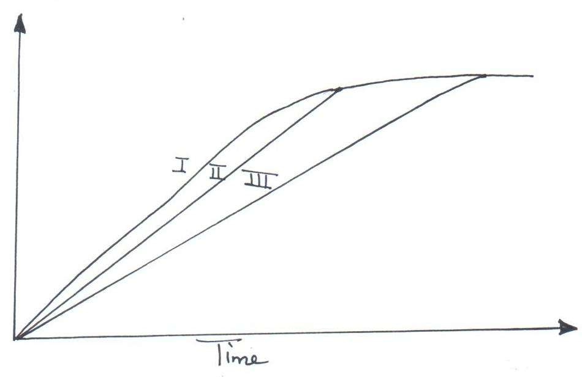
acid was reacted with equal amount of calcium carbonate.

The concentrations of hydrochloric acid were 0.8m, 0.5m and 0.1m. The calcium carbonate was in powder form. Match the graphs with concentrations.

Graph I _________________________________________________ (1 mark)

Graph II ________________________________________________ (1 mark)
- A state of equilibrium between dichromate (VI) and chromate ions is established as shown in the equation below.

Cr₂O_{7(aq)} + $2\text{OH}{}_{\left(\text{aq}\right)}^{−}{}$ $2{\text{CrO}}_{4}$+ H₂O_{(l)}
Orange Yellow

(i) What is meant by dynamic equilibrium? (1 mark)

____________________________________________________________
(ii) State and explain observation made when a few pellets of potassium hydroxide are added to the equilibrium mixture. (2 marks)

____________________________________________________________

____________________________________________________________

____________________________________________________________
- An experiment was done using magnesium ribbon and dilute hydrochloric acid of different concentrations. The time needed to produce 50cm³ of the gas for every experiment was recorded in the table below.

Conc. of HCl  in mol/litre | 2.0 | 1.75 | 1.50 | 1.25 | 1.00 | 0.75 | 0.50 | 0.25
Time in sec(s) | 8.8 | 10.0 | 11.7 | 13.5 | 17.5 | 22.7 | 35.5 | 70.0
$$\frac{I}{t} \text{sec}$$
(i) Complete the table above. (2 marks)

Chemistry Paper 2 10 Kahuro/Kiharu
(ii) Plot a graph of rate $\left(\frac{1}{\text{Time}}\right)$against concentration. (3 marks)

- Determine from your graph the concentration needed to produce 50cm³
of hydrogen gas, when time is 15 seconds. (1 mark)

Chemistry Paper 2 11 Kahuro/Kiharu

