451/2
COMPUTER STUDIES
PAPER 2 (PRACTICAL)
MAY 2015
2 ½ HOURS

TIGANIA SOUTH PRE-MOCKS 2015

Kenya Certificate of Secondary Education (K.C.S.E)

COMPUTER STUDIES
PAPER 451/2

INSTRUCTIONS TO CANDIDATES.
- Type your name and index number at the top right hand corner of each printout.
- Sign and write the date of the examination below the name and index number on each printout.
- Write your name and index number on the compact disks
- Write the name and version of the software used for each question attempted in the answersheet.
- Passwords should not be used while saving in the compact disks
- Answer all the questions
- All questions carry equal marks.
- All answers must be saved in your compact disks
- Make a printout of the answers on the answers sheets provided.
- Hand in all the printouts and the compact disks

QUESTION 1
(a) Using a DTP program, design the publication using the sample given in the next page as your reference and save it as Polite Notice. (29mks)

In your design take into account the following
The size of the publication should be A4, portrait orientation. (1mk)

(b) The page margins should be set all-round at 0.6” (inches) or 15.24mm – (Left, Right, Top and Bottom) (2mks)

(c) Format the header to 45pts font size; add a double outline border of 3pts. In weight (2mks)

(d) The text inside the star object should be reverse text, Bold and 20pts. (3mks)

(e) The numbered and bulleted lists should be formatted to 18pts with paragraph spacing of 1.5 pts. (1mk)

(f) Format the arrow lines pointing to the circle outlining the numbered and bulleted lists, and the circle to 2pts in weight with the text inside the circle formatted to 18pts. (2mks)

(g) The vertical text “Remember to abide ……” should be formatted to font size 20pts and underlined with thick dots. (1mk)

(h) (i) Format the line above the “All the Best …. “ text to 4.5pts in weight.
(ii) Format the text “All the Best …. “ to font size 22pts centered and interlaced. (2mks)

(i) Print the publication. (1mk)

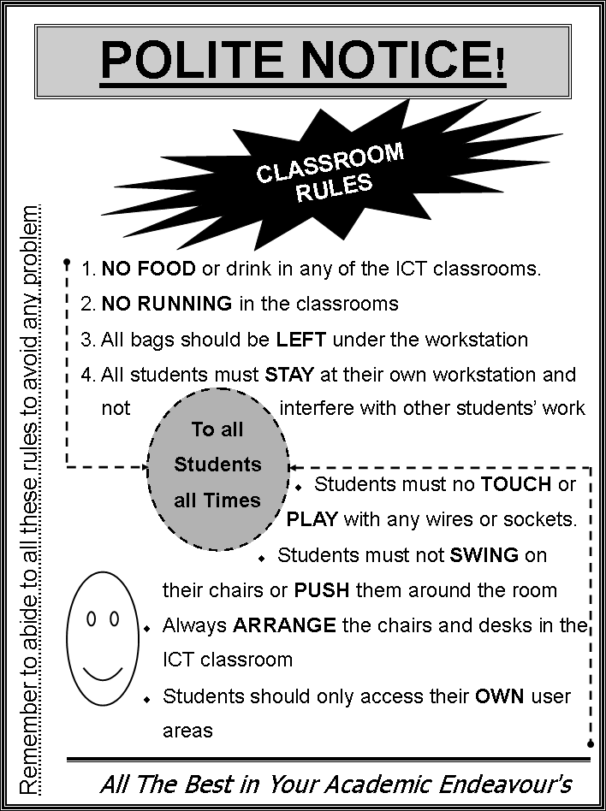
QUESTION 2
SaidiaKazi is non-governmental organizations giving manual jobs to unskilled labourers in rural areas to enable them have a way of earning a living. They issue them with tools in order for them to do the job assigned to them. They have asked you to computerize their stores to enhance their issuance of various tools.
The following files are held by the manual system.

Stores. Issues
Tool ID Tool ID
Tool description Quantity
Condition Number in Group
Issue date
Return date
Required
- Create a database named SaidiaKazi, and add two tables named Stores and Issues using the details given above. (11 mks)
- Add an appropriate primary key to the stores table and a foreign key into the issues tables during the design. (2 mks)
- The organization needs to keep track of the store tools issued to each of the group. Create a relationship between the two tables and reinforce referential integrity to enable them to do this. (5 mks)
- Create columnar forms for each of the tables above and save them as Storetoolentryform and Issuingtoolsform respectfully or create a form with a sub-form with the parent and the child forms having the suggested names. (10 mks)

- The following list of tools and tools issuing list was available as at 11th March 2015.
Stores table
Tool ID | Description | Condition
KK01 | Shovels | New
KK23 | Fork Jembe | Good
KK40 | Mattock | Fair
KK60 | Axes | Fair

Issue table
Tool ID | Group | Number of members | Quantity | Issue date | Return date
KK01 | 1 | 4 | 4 | 11/01/2015 | 28/01/2015
KK40 | 4 | 7 | 7 | 12/02/2015
KK60 | 8 | 3 | 3 | 14/01/2015
KK01 | 7 | 10 | 10 | 16/01/2015 | 17/02/2015

Use the appropriate form you have created to enter the records shown above. (8 mks)
- Add a validation rule and text that, validates data entry such that, the number of members in a given group should be more than one and less than ten (3 mks)
- (i) The management wishes to know the tools that have not been issued to any of the groups. Create a query that finds these tools, name it toolsnotissued. (3 mks)
(ii) You have been asked to produce a report of the tools that have not been returned to stores. Create a report named toolsout of these tools having the following fields Toolid, Description, Group, Quantity and IssueDate. (4 mks)
(h) Print (4 mks)
(i) The two tables
(ii) Query
(ii) Report

