NAME………………………………………………………INDEX NO………………………….
SCHOOL……………………………………………...…….CANDIDATE’SSIGNATURE………
DATE…………………………….

312 / 1
GEOGRAPHY
PAPER 1
MARCH / APRIL 2015
2 ¾ HOURS

KABONDO DIVISION JOINT EVALUATION TEST Kenya Certificate of Secondary Education

INTRODUCTION TO CANDIDATES
- This paper consist of Section A and B
- Answer All questions in section A .In section B answer question 6 and any other two questions from this section
- All answers must be written on the answer booklet provided
- Candidates should check to the question paper to ensure that all the pages are printed as indicated and that no questions are missing.

SECTION A (25 MARKKS)
Answer all the questions in this section

For examiner’s use only
Question | 1 | 2 | 3 | 4 | 5 | 6 | 7 | 8 | 9 | 10
Marks

This paper consists of 4 printed pages. Candidates should check the question paper to ensure that all pages are printed as indicated and no questions are missing.

SECTION A
Answer ALL the questions in this section
- Study the diagram below and then answer the following questions
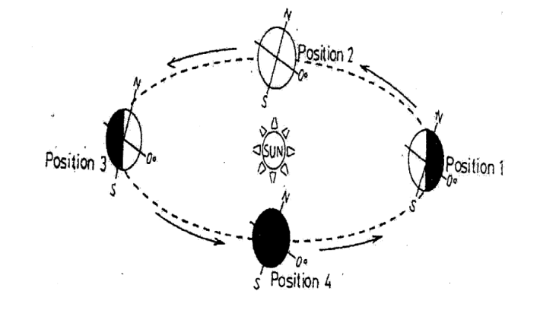

(a). How long (in days ) does it take the earth to move from position 2 to position 1 during a
leap year? (2mks)
(b). State three effects of the movement of the earth represented above (3mks)
- (a). Define the term microclimates (2mks)
(b). Identify three characteristics of convectioinal rainfall (3mks)
- Describe two process through which wind erode desert landscape (6mks)
- (a). What is natural vegetation? (2mks)
(b). State three characteristics of Mediterranean type of vegetation (3mks)
- (a). What is contact metamorphism? (2mks)
(b). Identify the resultant metamorphic rocks when the following rocks are metamorphosed.
(i). Granite (1mk)
(ii) Limestone (1mk)

SECTION B
- Use the map of Migwani(1:50,000)provided to answer the following questions
(a). i) What is the length of the dry weather road from grid square 9278 to the end in grid
square 0083.
Give your answer in kilometers (2mks)
(ii) Calculate the area enclosed by all weather road loose surface and the dry weather road
from grid square 9278 to 0083 in the Northwest part of the area covered by the map.
Give your answer in km² (3mks)
(b). (i) Give the appropriate height of Kyoom Hill. (2mks)
(ii). Describe the relief of the area covered by the map (4mks)
(c). Citing evidence from the map, Identify four social services offered in Migwani town
(4mks)

(d).( i) Enlarge the area enclosed by Eastings 08 and 11 and Northings 63 and 66 twice
(2mks)
(ii) On the enlarged map mark and name
-Water pipeline
-Dry weather roads
-Water tank

(e). Form four students from Mutitu Secondary School conducted a field study in Mutito
forest. Explain two problems that the students faced while conducting the study that
might have led to collection of unreliable data. (4mks)
- (a). (i). Differentiate between orogenesis and orogeny (2mks)
(ii). Name two Fold Mountains of the alpine orogeny (2mks)
(b). The following diagram represents a faulted landscape. Use it to answer
the following questions.
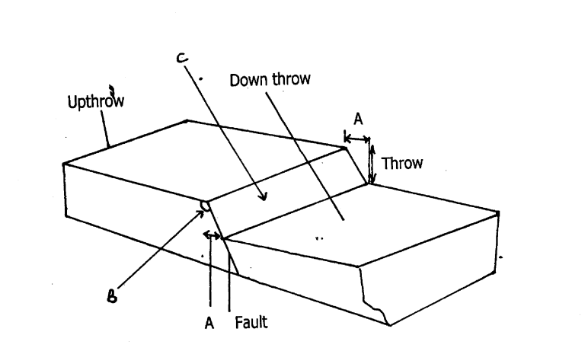

(i). Name the parts marked A,B and C (3mks)
(ii). Using well labeled diagrams ,Describe how a rift valley is formed through
anticlinal arching (7mks)
(c). State three effects of faulting on drainage (3mks)
(d). Explain the effects of Fold Mountains to human activities (8mks)
- (a) (i). Differentiate between weathering and mass wasting (2mks)
(ii). Identify three agents of weathering (3mks)
(b). Describe how the following processes of weathering occur
(i). Pressure release or unloading (4mks)
(ii). Carbonation (3mks)
(c). Explain the significance of weathering to human activities (8mks)

(d). Form four students from Danish Obara Secondary School conducted a field study on weathering around their school
(i). State three preparation they made before the field study (3mks)
(ii). Write down two hypotheses they formulated to guide the study (2mks)
- (a). Distinguish between catchment area and a drainage basin (2mks)
(b) . (i). Describe two processes through which a river transport its load (6mks)
(ii). State four factors which influence the ability of a river to transport its load(4mks)
(c). Using a well labeled diagram, explain how an ox-bow lake is formed (7mks)
(d). (i). What is the difference between drainage pattern and drainage system? (2mks)
(ii). State five importance of rivers to human activities (5mks)
- (a). (i). Differentiate between an aquifer and an aquifuge (2mks)
(ii). Name three sources of underground water (3mks)
(b). State four conditions necessary for the formation of artesian wells (4mks)
(c). (i). Name four surface features formed in areas dominated by limestone (3mks)

(ii). The diagram below represents underground features formed in a karsts landscape .Use it to answer the following questions

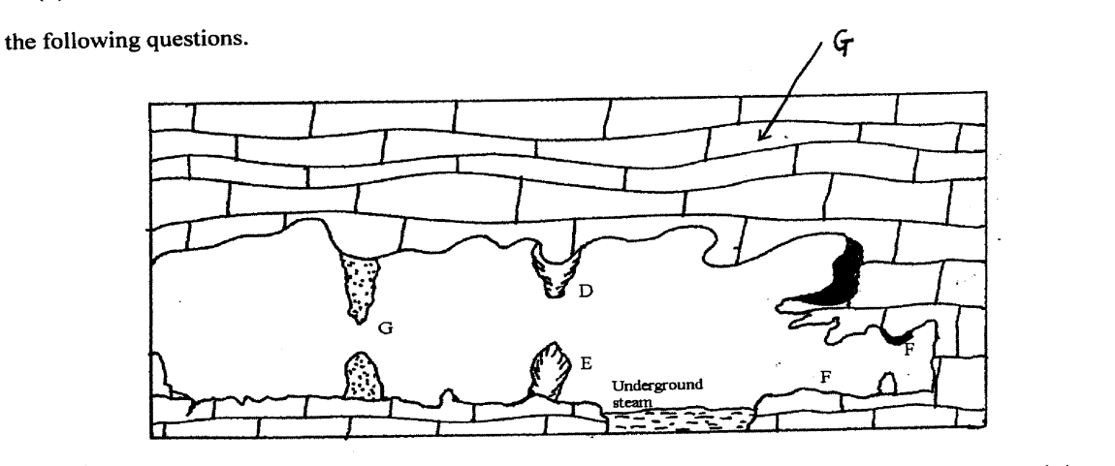

(i). Name the features marked D,E and G (3mks)
(ii). Describe how a limestone pillar is formed (3mks)
(d). Explain three effects of karst scenery to human activities (6mks)

