NAME………………………………………………………INDEX NO………………………….
SCHOOL……………………………………………...…….CANDIDATE’SSIGNATURE………
DATE…………………………….

312 / 2
GEOGRAPHY
PAPER 2
MARCH / APRIL 2015
2 ¾ HOURS

KABONDO DIVISION JOINT EVALUATION TEST Kenya Certificate of Secondary Education

INTRODUCTION TO CANDIDATES
- This paper consist of Section B and B
- Answer All questions in section A .In section B answer question 6 and any other two questions from this section
- All answers must be written on the answer booklet provided

SECTION A (25 MARKKS)
Answer all the questions in this section

For examiner’s use only
Question | 1 | 2 | 3 | 4 | 5 | 6 | 7 | 8 | 9 | 10
Marks

This paper consists of 4 printed pages. Candidates should check the question paper to ensure that all pages are printed as indicated and no questions are missing.

- (a). What is water pollution ? (2mks)
(b) state three sources of pollution along the East African Coastal waters (3mks)
- (a) Differentiate between biomass and biogas forms of energy (2mks)
(b). Give three reasons why the two sources in 2 (a) above should be developed (3mks)
- (a). Name two counties in Rift Valley where Dairy farming is practiced in Kenya (2mks)
(b) State four problems facing dairy farmers in Kenya (4mks)
- (a) State three physical factors that favor the growth of cocoa in Ghana
(3mks)
(b) Name two countries which imports cocoa from Ghana as a raw material(2mks)
- (a) Define international trade (1mk)
(b) Give three reasons why Kenya’s trade is mainly in raw form rather than finished products (3mks)
SECTION B (75 MARKS)
Answer questions 6 compulsory and any other two questions from this section
- The table below shows horticultural crops exported by Kenya in the year 2010 to European Union. Study it and answer the questions that follow
CROP | QUANTITY IN TONNES
Flowers | 42,500
Oranges | 28,700
Tomatoes | 21,600
Carrots | 15,400

(a) Draw a divided rectangle 15 cm long by 6 cm wide to represent horticultural crop production in Kenya in year 2010 using the data above (show your workings/calculations) (8mks)
(b). Calculate the range of the above data (1mk)
(c). Apart from divided rectangles, Name two other appropriate ways of representing the above data (2mks)
(d). Name two deciduous fruits exported by Kenya to European Union market(2mks)
(e) Explain two physical conditions favoring the development of horticultural industry in Naivasha (4mks)
(f). Explain how the Kenya Government is addressing problems facing horticultural farmers (8mks)
- (a). i). What is agro forestry? (1mk)
ii). Explain four reasons why agro forestry is being encouraged In Kenya(8mks)
(b). Give three examples of softwood trees found in Kenya (2mks)
(c). Explain four characteristics of softwood forests in Canada (8mks)
(d). State problems affecting forestry in Canada (5mks)
- (a) i) Define Age-structure (2mks)
ii). What was the population growth rate in Kenya in 1999,if the crude birth rate was 52 per 1,000 of the population and the crude death rate was 14 per 1,000 of population? (2mks)
iii). State three reasons why it is necessary to carry out population census (3mks)
(b). Account for the high population density in the Kenyan highlands (2mks)
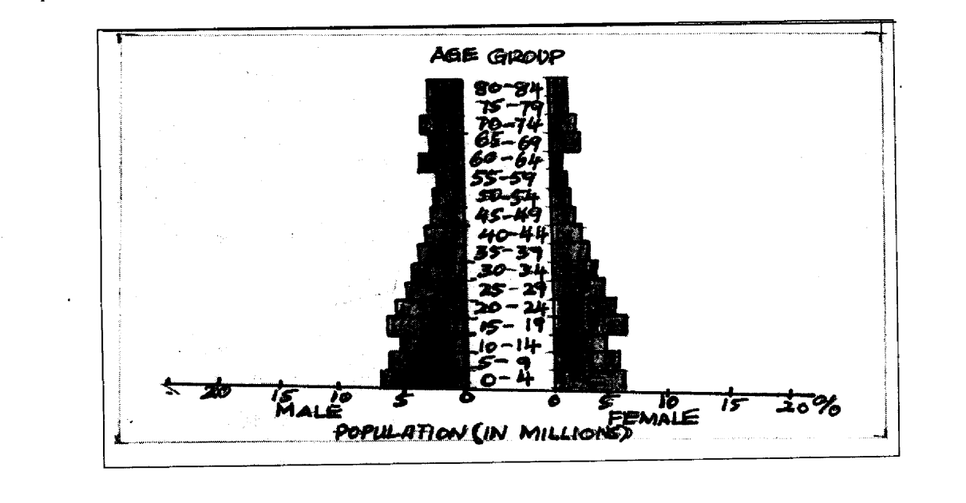
(c) The pyramid below represents the population structure of Country X.Use it to answer questions that follow.

- Describe the characteristics of the population represented by the pyramid (5mks)
- Other than migration,explain three factors influencing population growth and structure (6mks)
- State two positive effects of population growth and straucture (2mks)
- Give three problems that could arise from overpopulation (3mks)
- (a). Explain how the following factors influence mining (3mks)
i). Capital
ii)Value of mineral (3mks)
(b). Name four methods of underground mining (4mks)
(c ) Explain five factors which influence occurance of minerals. (10mks)
(d). Explain how gold is processed to its finest form (5mks)
- Study the map of the Great Lakes and the St.Lawrence Seaway below and answer the question that follow
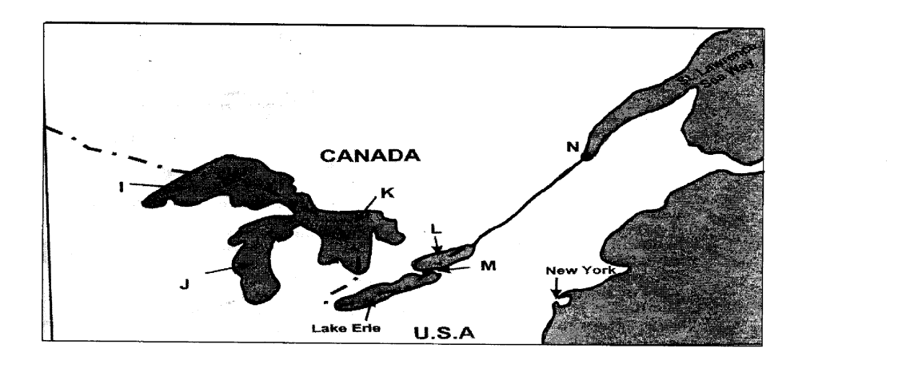

(a). Name
i). The port marked N (1mk)
ii) The waterfall marked M (1mk)
iii). The lake marked I,J,K and L (4mks)
(b). Explain five ways in which the great lakes and St.Lawrence Seaway has
contributed to the economy of U.S.A and Canada (10mks)
(c). i).State three recent developments that have taken place in Kenya to improve communication (3mks)
ii). Explain three problems facing telephone as a means of communication in Kenya (6mks)

