Name …………………………………………………… Index No. ……………………………

Candidate’s Sign ………………………………………. Date …………………………………

312/2
GEOGRAPHY
PAPER 2
MARCH/APRIL 2015
TIME:

MOKASA JOINT EVALUATION EXAMINATION
Kenya Certificate of Secondary Education (K.C.S.E)
312/2
GEOGRAPHY
Paper 2
March/April, 2015
Time:

INSTRUCTIONS TO CANDIDATES
- This paper has two sections A and B
- Answer ALL the questions in Section A. In Section B answer question 6 and any other TWO questions.

SECTION A:

Answer ALL the questions in this section.

1. a) State two ways in which minerals occur (2 marks)

b) Describe panning as a method of mining (3 marks)

2. a) Differentiate between a Forest and forestry (2 marks)

b) Give three characteristics of Tropical hard-wood forest (3 marks)

3. a) Name two main rivers which supply water to Mwea-Tebere irrigation scheme
(2 marks)

b) State three environmental problems faced by farmers in Mwea-Tebere irrigation scheme (3 marks)

4. a) Give two methods used to rehabilitate land in Kenya (2 marks)

b) State three benefits of Perkerra Irrigation scheme (3 marks)

5. a) What is a game sanctuary (2 marks)

b) State three reasons for encouraging domestic tourism in Kenya (3 marks)

SECTION B:

Answer question 6 and any other TWO questions from this section

6. Study the photograph below and use it to answer question (a)

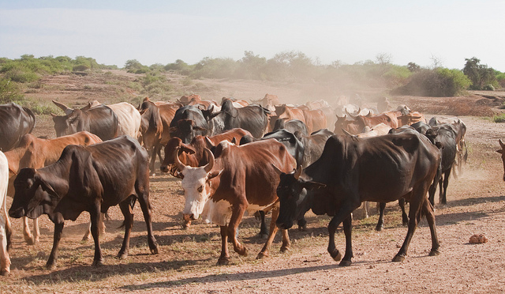

- (i) Name the type of photograph shown above (1 mark)

(ii) What time of the day was the photograph taken if the camera was held facing South?
(1 mark)

iii) Draw a rectangle measuring 16cm by 9cm to represent the area of the photograph. On it sketch and label the main features shown on the photograph (5 marks)

iv) Describe the landscape of the area represented by the photograph. (3 marks)

- (i) Identify two counties in the Rift Valley where ranching is practiced. (2 marks)

(ii) Name one exotic breed of beef cattle reared in Kenya (1 mark)

- State four physical factors which favour beef farming in Argentina (4 marks)

- Explain four benefits of beef farming to the economy of Argentina (8 marks)

7. a) Define agro-forestry (2 marks)

b) State three benefits of agro-forestry (3 marks)

c)i) Explain how the following factors have influenced distribution of natural forests in Kenya
- Aspect (2 marks)
- Soils (2 marks)

ii) Explain four ways of managing forests in Kenya (8 marks)

d) Compare softwood forestry in Kenya and Canada under the following sub-headings
- Transportation (2 marks)
- Harvesting (2 marks)
- Climate (2 marks)
- Distribution (2 marks)

8. a) What is mixed farming? (2 marks)

b) State three economic factors influencing agriculture (3 marks)

c)i) Give four physical factors influencing coffee growing in Kenya (4 marks)

ii) Describe coffee productions in Kenya from harvesting to marketing (8 marks)

iii) Give three differences between coffee farming in Kenya and Brazil (6 marks)

d) You intend to carry out a field study on coffee growing in a farm near your school. State two disadvantages of using secondary data during data collection (2 marks)

9. Use the map of North America below to answer questions (a) and (b)
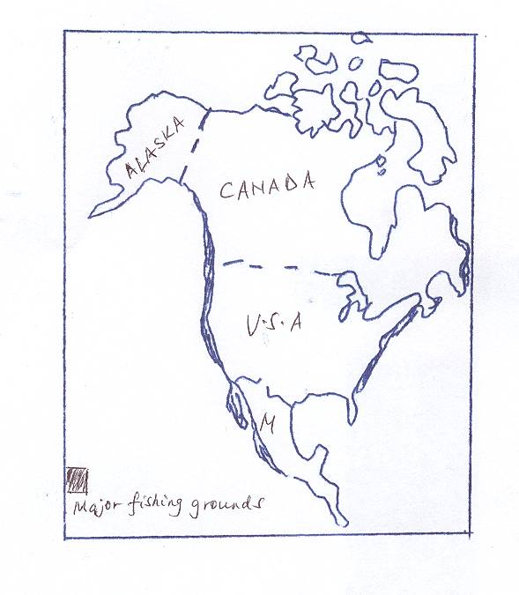
- Name
- The fishing ground shaded (1 mark)
- The ocean current marked (b) (1 mark)

- Explain four physical conditions necessary for fishing in the fishing ground shaded.
(8 marks)

- Describe trawling method of fishing (6 marks)

d)i) Explain three ways in which overfishing can be controlled in Lake Naivasha(6 marks)

ii) State three significance of fish farming (3 marks)

10. a)i) Apart from coal, name three other non-renewable sources of energy (3 marks)

ii) State four reasons why there has been a decline in the use of coal as a source of energy (4 marks)

iii) Give three advantages of using wind energy (3 marks)

b) Name two examples of agricultural non-food processing industries in Kenya(2 marks)

c) Below is a sketch map of the Ruhr Industrial Region. Use it to answer question (i)

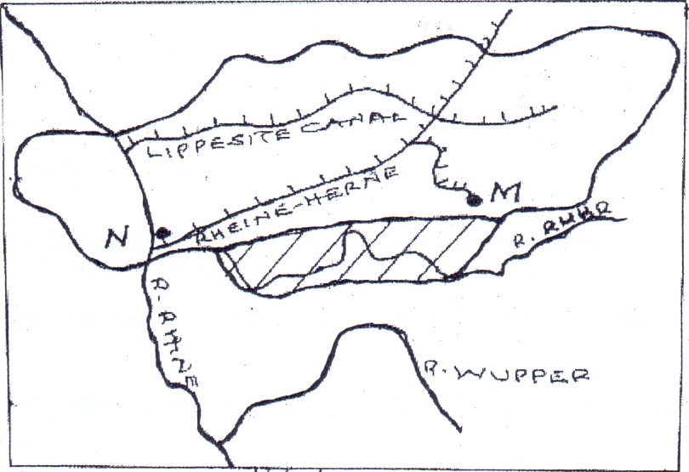

- Name:
- The canal market U (1 mark)
- The river marked V (1 mark)
- The town marked W (1 mark)

- Explain three factors which led to the growth of iron and steel industry in the Ruhr region of Germany (6 marks)

- Explain two environmental problems which have resulted from the development of car manufacturing industry in Japan (4 marks)

