312/1
GEOGRAPHY
PAPER 1
TIME: 2¾ HOURS

CENTRAL KENYA NATIONAL SCHOOLS

(CEKENAS) JOINT EXAMINATION - 2015

Kenya Certificate of Secondary Education
GEOGRAPHY
PAPER 1
TIME: 2¾ HOURS

INSTRUCTIONS TO CANDIDATES:
- This paper has two Sections A and B.
- Answer all the questions in Section A.
- Answer question 6 and any other two questions from Section B.
- All answers must be written in the answer booklet provided.
- Candidates should check the question paper to ascertain that all the papers
are printed as indicated and no questions are missing.
(f) Candidates should answer the questions in English.

Geography Paper 1 Turnover
SECTION A:

Answer all questions from this section.

1. (a) (i) What name is given to the shape of the earth? (1mk)

- Give the two dates in a year when the hours of darkness are equal
to the hours of light at the poles. (2mks)

(b) State two reasons why the interior of the earth is believed to be hot. (2mks)

2. (a) Give three examples of chemically formed sedimentary rocks. (3mks)

- Mention three changes that occur to sedimentary rocks when exposed
to great heat and pressure. (3mks)

3. (a) Give three reasons why it is important to study the plate tectonics theory. (3mks)

(b) Name two fold mountains formed during the alpine orogany (2mks)

4. (a) Differentiate between soil profile and soil catena. (2mks)

(b) Give three components of soil apart from humus. (3mks)

5. State four ways in which the earth’s crust is affected by earthquakes. (4mks)

SECTION B:

Answer question 6 and any other two questions from this section.

6. (a) (i) What kind of a map is the Karatina map sheet. (1mk)

- Measure the length of Road D451 from the junction grid reference
870472 to the LC grid reference 861522. Give your answer in
kilometers. (2mks)

(iii) Calculate the area of Mount Kenya forest to the East of Easting 02. (2mks)

(iv) Give the latitudinal and longitudinal location of the South West edge
of the map. (2mks)

- From the marginal information:
(i) Identify two districts covered in the map. (2mks)

(ii) Identify two man-made features in grid square 8454. (2mks)

Geography Paper 1 2
- Explain three factors that influence distribution of settlement in the area
covered by the map. (6mks)

- Citing evidence from the map.
  - Identify two agricultural activities carried out in the area covered by
the map apart from coffee farming. (2mks)

  - Explain three factors that favour coffee growing in the area covered
by the map. (6mks)

7. (a) (i) Name three types of faults. (3mks)

(ii) With the aid of clearly labelled diagrams, describe the formation
of the Rift Valley by compressional theory. (7mks)

(ii) State two ways in which faulting influences drainage. (2mks)

(b) Explain why most lakes in the Rift Valley have saline water. (6mks)

- Your class undertook a field study on lakes formed through faulting.
(i) Give two characteristic features of lakes you may have identified. (2mks)

(ii) State three uses of the lakes that you may have found. (3mks)

(iii) Give two benefits of studying lakes through field study. (2mks)

8. (a) With the aid of a well labelled diagram, illustrate the hydrological cycle. (5mks)

- Describe the following drainage patterns illustrate with clearly labelled
diagrams.
(i) Dendritic. (3mks)
(ii) Trellis. (3mks)

(c) (i) State three conditions necessary for data formation. (3mks)

(ii) Name the type of delta found on River:
- Tana (1mk)
- Omo (1mk)

(d) State five characteristics of a flood plain. (5mks)

(e) Describe the formation of an Ox-bow lake. (4mks)

Geography Paper 1 3
9. (a) What is micro-climate? (2mks)

- Use the map of Africa below to answer the questions that follow.
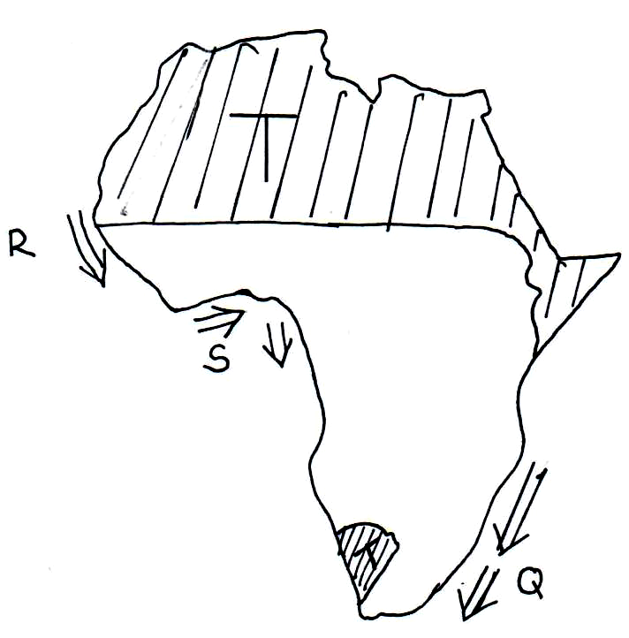

(i) Name the ocean currents marked R and S. (2mks)

(ii) Explain how the ocean current marked Q influence the climate
of the adjacent land. (4mks)

(c) Describe the characteristics of the climatic region marked T. (5mks)

(d) Apart from ocean currents, explain three factors that influence climate. (6mks)

(e) You are planning to carry out field study on the relationship between
climate and vegetation.
(i) State three objective of your filed study. (3mks)

(ii) Give three measures you would recommend to combat
desertification. (3mks)

10. (a) Name two ice capped mountains in Africa. (2mks)

- Describe the formation of the following features.
(i) Glacial trough. (3mks)

(ii) Pyramidal peak. (6mks)

(c) Explain three factors that influence glacial erosion. (6mks)

(d) Explain four ways in which Upland glaciated features are of significance to
human activities. (8mks)

Geography Paper 1 4

