312/2
GEOGRAPHY
PAPER 2
TIME: 2¾ HOURS

CENTRAL KENYA NATIONAL SCHOOLS

(CEKENAS) JOINT EXAMINATION - 2015

Kenya Certificate of Secondary Education
GEOGRAPHY
PAPER 2
TIME: 2¾ HOURS

INSTRUCTIONS TO CANDIDATES:
- This paper has two Sections A and B.
- Answer all the questions in Section A.
- Answer question 6 and any other two questions from Section B.
- All answers must be written in the answer booklet provided.
- Candidates should check the question paper to ascertain that all the papers
are printed as indicated and no questions are missing.
(f) Candidates should answer the questions in English.

Geography Paper 2 Turnover
SECTION A:

Answer all questions from this section.

1. (a) Give three processes which influence the occurrence of minerals. (3mks)

(b) Describe solution method of mining. (3mks)

2. (a) State three social factors that influence agriculture. (3mks)

(b) Give three reasons why flowers are grown in greenhouses. (3mks)

3. State four characteristics of Jua Kali Industries in Kenya. (4mks)

4. (a) Give two effects of drought on the energy and industrial sector in Kenya. (2mks)

- State three benefits of using geothermal energy over other forms of
energy. (3mks)

5. State four benefits that have resulted from reclamation of Yala Swamp. (4mks)

SECTION B:

Answer question 6 and any other two questions from this section.

6. The table below shows sugar production, imports, consumption and exports in
Kenya in 000 tonnes.

 | 1999 | 2000 | 2001 | 2002 | 2003
Production | 471 | 402 | 377 | 494 | 448
Imports | 58 | 118 | 249 | 130 | 182
Consumption | 609 | 631 | 645 | 680 | 692
Exports | - | 3 | 4 | 12 | 11

Source: Economic survey of Kenya, 2004.

(a) (i) Draw a comparative line graph to present the data of production
and consumption above. Use a scale of 1cm represents 100,000
tonnes. (6mks)

Geography Paper 2 2

Geography Paper 2 3
- Calculate the percentage increase in sugar imports between 2002
and 2003. (2mks)

(iii) Describe the trend of sugar production between 1999 and 2003. (3mks)

- Explain three reasons why Kenya imports sugar yet she is a producer
of sugar. (6mks)

- Describe the stages involved in commercial production of palm oil in
Nigeria from harvesting to the time it is ready for use. (8mks)

7. (a) (i) What is fish farming? (2mks)

(ii) Give four significance of fish farming in Kenya. (4mks)

(b) Explain four problems facing fishing industry in Kenya. (8mks)

- Explain how the following factors contribute to the development of
fishing industry in Japan.
(i) Ocean currents. (4mks)

(ii) Population. (2mks)

(d) (i) State three reasons why marine fisheries in Kenya are
underdeveloped. (3mks)

(ii) Give two examples of demersal fish. (2mks)

8. (a) (i) Name one canal in Africa. (1mk)

- Besides constructing canals, give three measures that can be
used to improve river transport in Africa. (3mks)

(b) Give four benefits of air links between Kenya and the rest of the world. (4mks)

(c) (i) Differentiate between bilateral and multilateral trade. (2mks)

(ii) List two invisible exports in Kenya. (2mks)

- Explain four factors that have discouraged trade between African
countries. (8mks)

(e) Identify five measures taken by the Kenya government to reduce
unfavourable balance of trade. (5mks)

9. (a) (i) What is a hinterland? (2mks)

(ii) Explain four factors that led to growth of Kisumu town. (8mks)

Geography Paper 2 4
- The diagram below shows the functional cones of an urban centre.

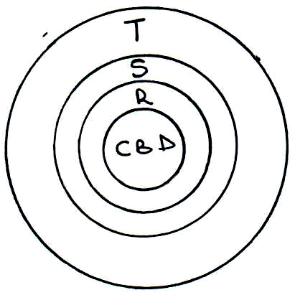

(i) Name the zones marked S and T. (2mks)

(ii) Give three reasons why slums are common in urban areas. (3mks)

(c) (i) Explain four produces facing urban centres in East Africa. (8mks)

(ii) Name a tourist resort in Kenya. (1mk)

10. (a) (i) What is pollution? (2mks)

(ii) Apart from land and air pollution, name two other types of
pollution. (2mks)
(iii) State three ways in which air is polluted. (3mks)

(b) (i) Explain three effects of land pollution on the environment. (6mks)

- State four ways in which land pollution can be controlled in
your school. (4mks)

(c) (i) Name two rivers in Kenya that cause large scale flooding. (2mks)

- Explain three causes of flooding in the Lake Victoria region
of Kenya. (6mks)

Geography Paper 2 5

