312/2
GEOGRAPHY
PAPER 2
JULY/AUGUST 2015
TIME: 2¾ HOURS

KAHURO/KIHARU DISTRICT JOINT EXAMINATION – 2015

Kenya Certificate of Secondary Education
GEOGRAPHY
PAPER 2
TIME: 2¾ HOURS

INSTRUCTIONS TO CANDIDATES:
- This paper has two Sections A and B.
- Answer all the questions in Section A.
- Answer question 6 and any other two questions from Section B.
- All answers must be written in the answer booklet provided.
- Candidates should check the question paper to ascertain that all the
papers are printed as indicated and no questions are missing.
(f) Candidates should answer the questions in English.

Geography Paper 2 Turnover
SECTION A:

Answer all questions from this section.

1. (a) State two advantages of using solar energy. (2 marks)
(b) Identify two non-renewable sources of energy used in Kenya. (2 marks)

2. (a) Apart from HIV and AIDS, give three other causes of mortality in
East Africa. (3 marks)
- State two ways in which the spread of HIV and AIDS in Kenya may
slow down economic development. (2 marks)

3. (a) Distinguish between land reclamation and land rehabilitation. (2 marks)
(b) State three methods that are used to control tsetse flies in Kenya. (3 marks)

4. (a) Name two main cattle breeds reared by nomadic pastoralists in Kenya. (2 marks)
(b) State three environmental conditions which favours beef farming in
Argentina. (3 marks)

5. (a) Name three forest reserves in Kenya. (3 marks)
(b) State three characteristics of equatorial rain forest. (3 marks)

SECTION B:

Answer question 6 and any other two questions from this section.

6. The table below shows the total number of horticultural crops exported from
Kenya in 2008 and 2009. Use it to answer question a(i) and a(ii) below.

Crop | Total number of horticultural crops
 | 2008 | 2009
Oranges | 942,000 | 965,000
Tomatoes | 120,000 | 154,000
French beans | 97,000 | 128,000
Passion fruits | 94,000 | 103,000
Onions | 19,000 | 24,000
Flowers | 29,000 | 41,000
Total | 1,301,000 | 1,415,000

(a) (i) Identify the crop which had the highest increase in the number of
export in Kenya between 2008 and 2009 and indicate the change. (2 marks)

(ii) Calculate the percentage increase of onions between 2008 and 2009. (3 marks)

- Draw a divided rectangle 15cm long and 5cm wide to represent the
horticultural export from Kenya in 2009. Show your calculations. (10 marks)

Geography Paper 2 2 Kahuro/Kiharu
(b) (i) Name three types of flowers grown in Kenya. (3 marks)

- Explain how the following factors influence horticultural farming
in the Netherlands.
  - Technology. (2 marks)
  - Marketing systems. (2 marks)

(c) State three reasons why horticultural crops are transported by air. (3 marks)

7. (a) (i) Name two mining methods used to mine diatomite in Kariandusi
in Kenya. (2 marks)

(ii) State three formations in which minerals occur. (3 marks)

(b) State four factors influencing exploitation of minerals in Kenya. (4 marks)

(c) Explain three negative effects of mining on the environment. (6 marks)

(d) The diagram below shows the occurrence of petroleum in the earth’s crust.
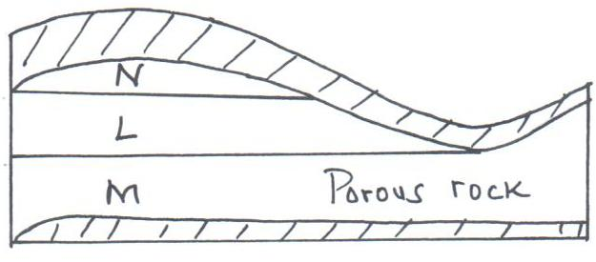

(i) Name the substances in the areas labelled L, M and N. (3 marks)

(ii) Give two by-products obtained when refining crude oil. (2 marks)

(e) State five significance of mining in Kenya. (5 marks)

8. (a) (i) Define the term tourism. (2 marks)
(ii) Name three natural habitats for wildlife. (3 marks)
(iii) Explain five problems facing wildlife conservation in Kenya. (10 marks)
(iv) State five significance of wildlife. (5 marks)

(b) (i) What is domestic tourism. (2 marks)
(ii) State three factors that hinder domestic tourism in Kenya. (3 marks)

Geography Paper 2 3 Kahuro/Kiharu
9. (a) Name two types of trade. (2 marks)

(b) Explain four problems facing trade in East Africa. (8 marks)

(c) State four benefits that Kenya derives from international trade. (4 marks)

(d) Identify three measures taken by the Kenya government to reduce
unfavourable balance of trade. (6 marks)

(e) You intended to carry out a field study on how trade is conducted in
the local open air market.
(i) Give three advantages of studying trade through field work. (3 marks)
(ii) State two methods the class may use to present their data. (2 marks)

10. (a) (i) Differentiate between transport and communication. (2 marks)
(ii) State two modern means of communication used in Kenya. (2 marks)
(iii) Give three advantages of railway transport over road transport. (3 marks)

(b) (i) Explain four ways in which road transport has been improved in
Kenya. (8 marks)

(ii) Give four reasons why motorcycle transport has become common
in most parts of Kenya. (4 marks)

(c) (i) Name two canals found along the St. Lawrence Seaway. (2 marks)
(ii) State four reasons why the St. Lawrence Seaway project was set up. (4 marks)

Geography Paper 2 4 Kahuro/Kiharu

