NAME ____________________________________ INDEX NO. _______________
SCHOOL ____________________________________ SIGNATURE _______________
DATE _______________

312/1
GEOGRAPHY

PAPER 1

July / August, 2015

TIME: 2¾ HOURS

312/1
GEOGRAPHY
PAPER 1
TIME: 2¾ HOURS

INSTRUCTIONS TO CANDIDATES
- This paper has two sections: A and B.
- Answer all the questions in section A.
- In Section B answer questions 6 and any other two questions.
- All answers must be written in the answer booklet provided.

This paper consists of 4 printed pages.
Candidates should check to ensure that all pages are printed as indicated and no questions are missing
SECTION A
Answer ALL the questions in this section.
- a) What is desertification? (2 marks)
b) State three negative effects of desertification. (3 marks)

- a) Give three reasons why it is necessary to study the plate tectonics theory. (3 marks)
b) Name two types of tectonic plate boundaries. (2 marks)

- i) Name two fold mountains outside Africa. (2 marks)
ii) Apart from fold mountains, name three features resulting from folding. (3 marks)

- a) State three natural causes of earthquakes. (3 marks)
b) Give two effects of earthquakes in built up areas. (2 marks)

- Give the processes involved in each of the following types of weathering:
- Physical weathering. (3 marks)
- Chemical weathering. (2 marks)

SECTION B
Answer question 6 and any other TWO questions from this section.
- Study the map of Migwani (1:50,000) sheet 151/1 provided and answer the following questions.
- i) Give the four grid figure reference for Usiani School. (1 mark)
ii) Give the adjoining sheet to the West and South East of the map sheet. (2 marks)
- i) Name two types of natural vegetation found in the area covered by the map. (2 marks)
ii) Measure the distance of the bound surface road from Thitani to Migwani shop. (2 marks)
- i) Name four human features in grid square 0964. (4 marks)
ii) Give the bearing of Thokoa shops 915835 from Kyome shops 943826. (2 marks)
- i) Citing evidence, state four services offered in the area covered by the map. (4 marks)
ii) Describe the distribution of the settlement to the East of Easting 07. (3 marks)
- Draw a rectangle 10cm long by 6cm wide to cover 0863, 0866, 1363 and 1366 and on it
indicate:
- Mutitu (NDOOA) Township
- Road to Zombe and Kitui
- Water pipeline
- Ikoo valley. (5 marks)
- a) i) What is faulting? (2 marks)
ii) Name five features formed as a result of faulting. (5 marks)
b) i) State three characteristics of Gregory rift valley. (3 marks)
ii) Explain four ways in which faulting influences the drainage. (8 marks)
c) Your class wants to carry out a field study on a section of the rift valley.
i) State two preparations they will make before the study. (2 marks)
ii) State two ways of data recording activities you would use during the study. (2 marks)
iii) State three follow up activities that your class will engage in after the study. (3 marks)

- a) Identify the drainage pattern shown in the diagrams below. (3 marks)

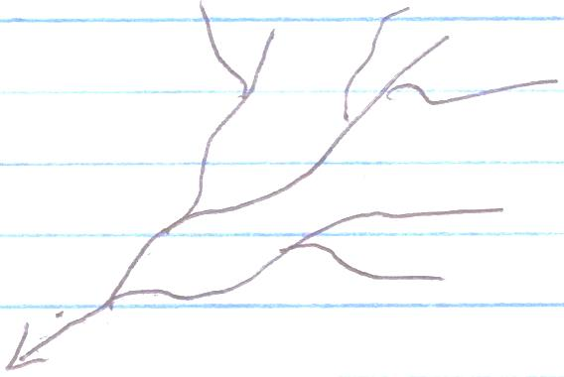

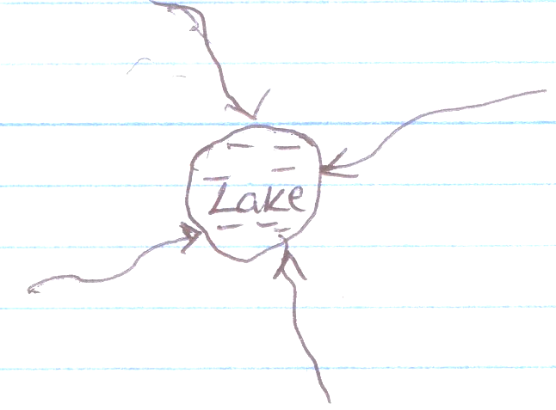
Lake

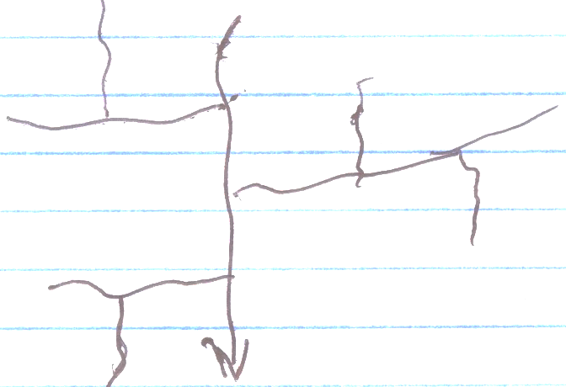
- Name two other drainage patterns. (2 marks)

b) i) What is a river capture? (2 marks)
ii) Explain how a river capture occurs. (7 marks)
c) i) State five characteristics of a flood plain. (5 marks)
ii) Apart from flood plains, name five other features formed by river deposition. (5 marks)

- The diagram below represents the structure of an artesian basin.
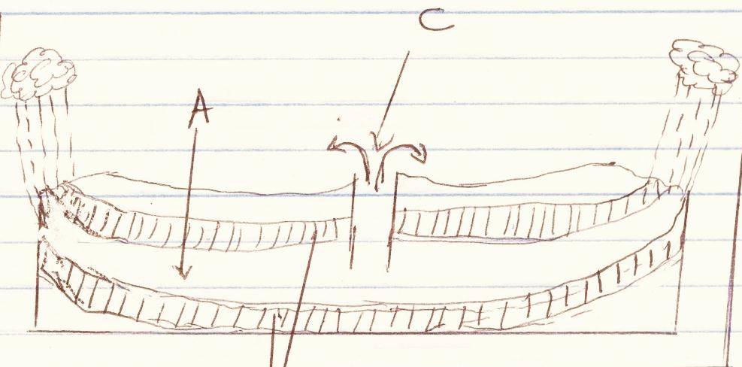
B
A
C

- i) Identify the parts marked A, B and C. (3 marks)
ii) State four conditions necessary for the formation of C above. (4 marks)
- i) Give the distinction between stalagmite and stalactite. (2 marks)
ii) Describe the formation of a limestone pillar. (6 marks)
- Form Four students intend to carry out a field study in a limestone area eroded by water:
- What preparations are they to make for the field study? (4 marks)
- Name three erosional features they are likely to observe during the field study. (3 marks)
- Give three problems they are likely to face in their field study. (3 marks)

- a) i) What is a rock? (2 marks)
ii) Explain the process of formation of mechanically formed sedimentary rocks. (6 marks)
iii) Give three types of mechanically formed sedimentary rocks. (3 marks)
b) Explain four ways in which rocks are significant to the economy of Kenya. (8 marks)
c) Students from your school carried out a field work on the type of rocks.
i) One of the rock samples they collected is coral. Give three uses of this type of rock. (3 marks)
ii) Give three methods of data collection they may have used during this study. (3 marks)
iii) State three problems they are likely to have encountered during this field study. (3 marks) `

