441/2

HOMESCIENCE (CLOTHING CONSTRUCTION)
PAPER 2
(PRACTICAL)
JULY/AUGUST 2015

TIME: 2½ HOURS

KAHURO/KIHARU DISTRICT JOINT EXAMINATION – 2015

Kenya Certificate of Secondary Education

HOMESCIENCE CLOTHING CONSTRUCTION
PAPER 2
(PRACTICAL)
TIME: 2½ HOURS

Home Science Paper 2 Turnover
A pattern of a child’s dress is provided. You are advised to study the sketches,
question paper and the layout carefully before you begin the test.

MATERIALS PROVIDED:

1. Pattern pieces.
A Dress front
B Dress front yoke
C Dress back
D Sleeve
E Front neck facing
F Back neck facing
G Collar

2. Plain light weight cotton fabric 62cm long by 90cm wide.

3. Sewing thread to match the fabric.

4. One large envelope.

THE TEST:

Using the materials provided, cut out and make up the LEFT HALF of the
child’s dress to show the following.

- The making of the double stitched seam at the shoulder.
- The joining of the yoke to front dress using a plain seam.
- Joining of the side with a French seam.
- Joining of the front and back facing and neatening of the free edge.
- Preparation of interfaced collar and attachment to neck edge using
the facing. Top stitch the collar.
(f) The joining of the underarm sleeve using a French seam.
(g) The joining of the sleeve seam without trimming or neatening of the
armhole seam allowance and distribution of gathers.
(h) The slip hemming of the front dress hem only.

At the end of the examination, firmly sew on to your work on a single layer
of fabric a label bearing your name and index number. Remove needles and
pins from your work. Then fold, put in envelope. Do not put scraps of fabric
in the envelope.

Home Science Paper 2 2 Kahuro/Kiharu

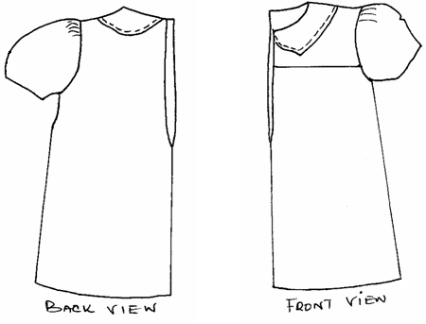

THE LAYOUT (NOT DRAWN TO SCALE)
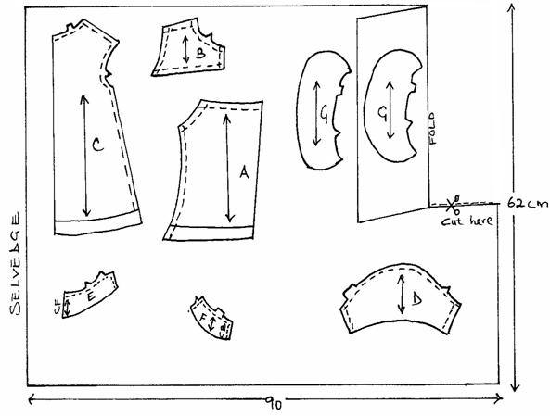

Home Science Paper 2 3 Kahuro/Kiharu

