NAME ____________________________________ INDEX NO. _______________
SCHOOL ____________________________________ SIGNATURE _______________
DATE _______________

441/2
HOME SCIENCE
Clothing Construction
Paper 2
Practical
July / August 2015
Time: 2½ Hours

441/2
HOME SCIENCE
Clothing Construction
Paper 2
Practical
Time: 2½ Hours

INSTRUCTIONS TO CANDIDATES
- This paper consists of three printed Pages.
- Candidates should check the question paper to ascertain that all the pages are printed as indicated and that no questions are missing.
They should also ensure that the pattern pieces match with sketches shown on question paper.

This paper consists of 3 printed pages.

Candidates should check to ensure that all pages are printed as indicated and no questions are missing.

A pattern of boy’s shirt is provided. You are advised to study the sketches, the question paper and the layout before you begin the test.

MATERIALS PROVIDED
1) A four pattern pieces for making the bodice of the shirt as follows:
A – Shirt bodice front with facing
B – Bodice back
C - Pocket
D - Collar
NB: Interfacing of the collar should be cut from the same fabric using the collar pattern.

2. Light weight plain cotton fabric 45cm long by 90cm wide.
3. Mercirized sewing cotton thread to match the fabric.
4. One large envelope.

THE TEST
Making use of the materials provided and the layout shown, cut out and make up the left half of the shirt to show the following:
- Making of the double stitched seam at the shoulder.
- Making of the side seam using an open seam.
- Neatening of the facing.
- The preparation and attachment of the interfaced collar.
- Attachment of collar
- Preparation and attachment of the patch collar.
- Management of the hem using hemming stitches (shirt front only)
- Making of a button hole by hand.

At the end of the examination, firmly sew on to your work, on a single fabric, a label bearing your name and index number. Remove the needle pins and unnecessary threads from your work. Then fold your work carefully and place it in the envelope provided.
Do not put scraps of materials in the envelope

LAYOUT NOT DRAWN TO SCALE

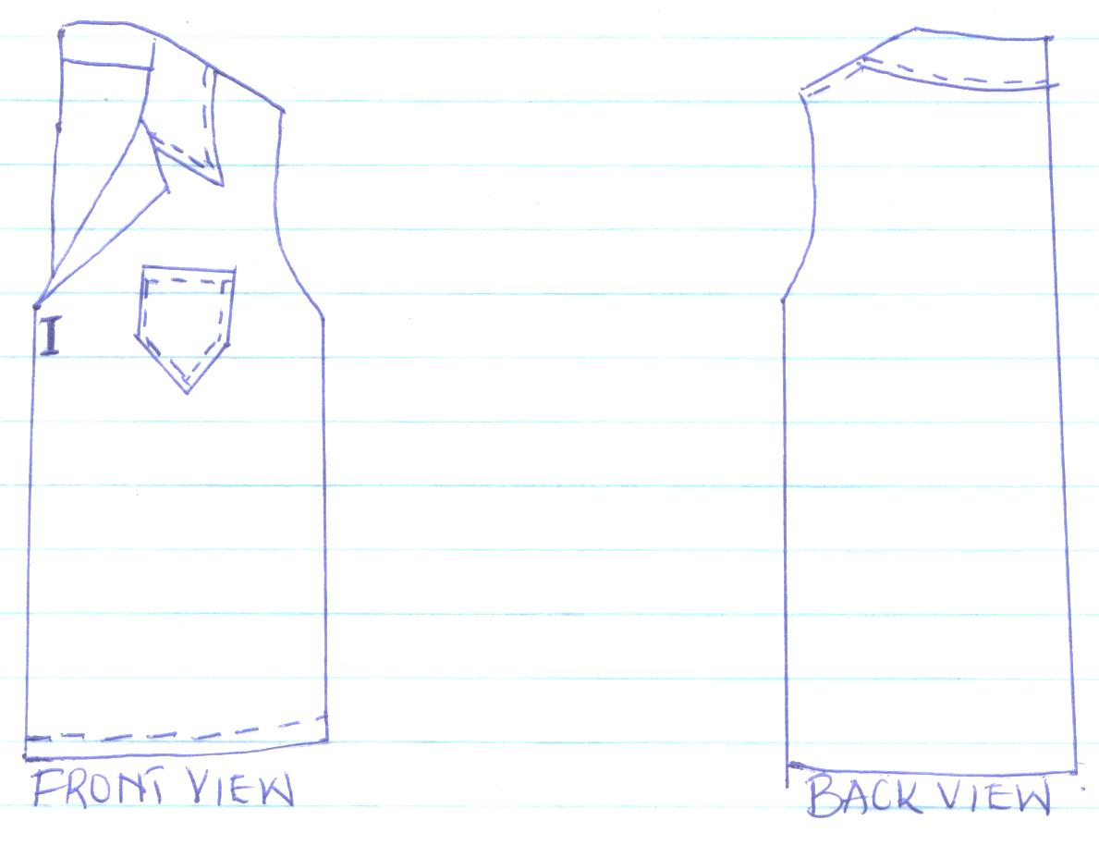
BACK VIEW
FRONT VIEW

