NAME:……………………………………………………… INDEX NO:…………………………
SCHOOL:………………………………………………….. DATE:……………………………….
SIGN:………………………………..

121/1
MATHEMATICS
Paper 1
JULY/AUGUST 2012
Time: 2 ½ HOURS

BORABU – MASABA DISTRICTS JOINT EVALUATION TEST– 2012
Kenya Certificate of Secondary Education (K.C.S.E)

INSTRUCTIONS TO CANDIDATES

- This paper has Two sections: A and B
- Answer all the question in section A.
- In section B answer question 6 and any other two questions
- All answer must be written in the answer booklet provided

FOR EXAMINERS USE ONLY
Section I
1 | 2 | 3 | 4 | 5 | 6 | 7 | 8 | 9 | 10 | 11 | 12 | 13 | 14 | 15 | 16

GRAND TOTAL
Section II
17 | 18 | 19 | 20 | 21 | 22 | 23 | 24 | TOTAL

This paper consists of 16 printed pages. Candidates should check the question paper to ensure that all pages are printed as indicated and that no questions are missing

SECTION I
1. Without using a calculate, evaluate
$\frac{\left(3\frac{1}{3}+1\frac{1}{9}\right)÷1\frac{1}{3}}{\left(4\frac{2}{9}−2\frac{5}{9}\right)x\frac{2}{3}}$ (3mks)

2. Given that $\frac{2x+3y}{3x+4y}=5,$find the ratio y:x (3mks)

3. A rectangle is thrice along as it is wide. It has its dimensions increased by 20%.Find percentage change in its area (4mks)

4. Square paring stones are used to cover an area measuring 16.5m by 12.75m.If the stones are all alike and only one whole ones are used ,find:
(i) The greatest size the stones used can be (2mks)

(i) The number of paring stones (2mks)

5. Solve the equation 120^{x-3}=15^{x-3} (3mks)

6. A salesman earns 3% commission for selling a chair and 4% commission for selling a table. A chair fetches sh 600 and a table goes for sh1500.One time, he sold 10 more chairs than tables and earned sh 7200 as commission. Find the number of chairs and tables sold (4mks)

7. Simplify : $\frac{9x−1}{3x+2x−1}$ (3mks)

8. The region R is the figure below is defined by the inequalities L1,L2 and L3.
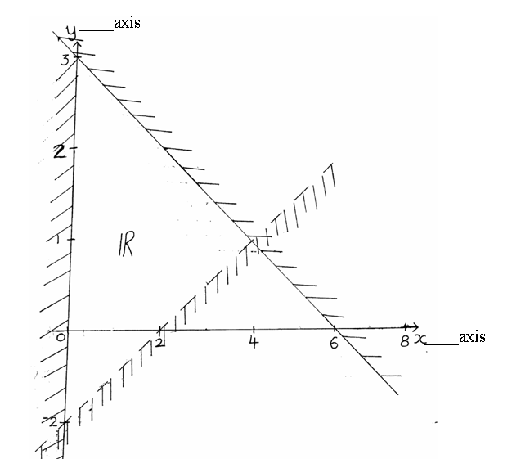

Find the three inequalities (3mks)

9. Peter paid sh 180 for a shirt after getting a discount of 10%.The shopkeeper made a profit of 20% on the sale of this shirt. What percentage profit would the shopkeeper have made if no discount was allowed? (3mks)

10. In the figure below,AD is parallel to GJ and GI is parallel to FD.Angle BAH=3⁰⁰ and angle BGF=63⁰.
Dia
By giving reasons
Find angle AFD. (3mks)
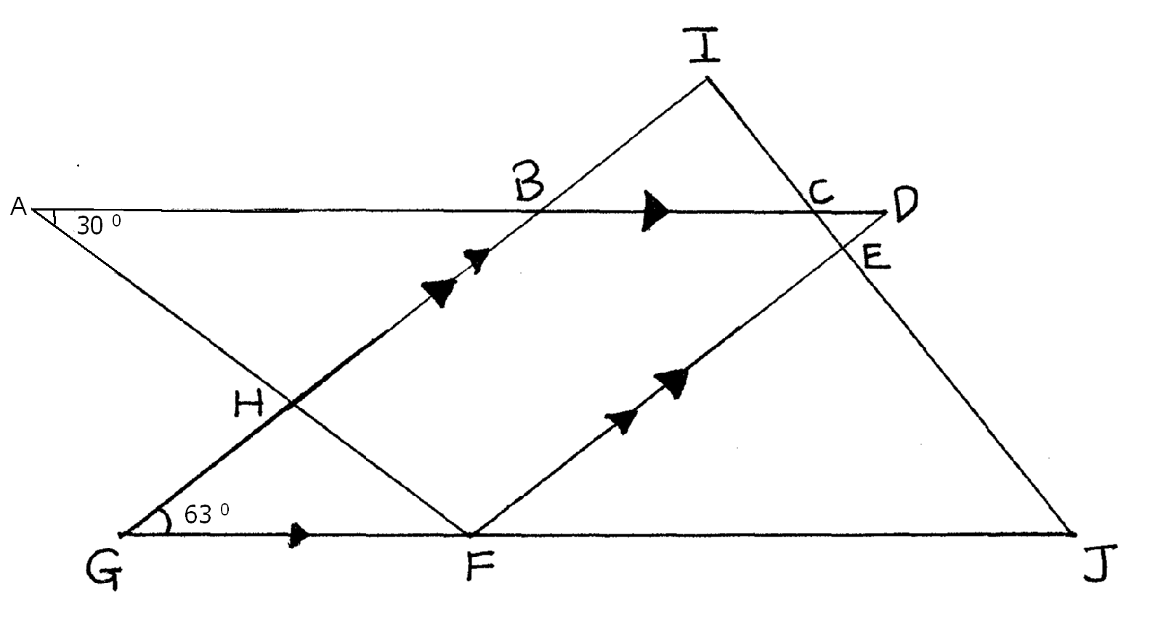

11. Without using mathematical tables or a calculator, evaluate
$\frac{0\text{.}\text{18}×4}{\sqrt{3\text{.}\text{24}×4}}$ (2mks)

- Determine the amplitude and the period for the graph of y=3sin ${\left(\frac{x}{3}−\text{120}\right)}^{0}$ (3mks)

13. Otieno,Karanja and Shiundu are three casual workers in a tea factory.Karanja earns twice as much as Otieno and Shiundu earns sh 70 more than Karanja.
If their total earning is sh1120,express the ratio of their earnings,Otieno:Karanja:Shiundu in its simplest form (3mks)

14. A map is drawn to a scale of 1:50,000 .Find the area in cm² on the map of a field with an actual area of 60,000m². (2mks)

15. A regular polygon has internal angle of 150⁰ and a side of length 10cm.
(a) Find the number of sides of the polygon (2mks)

(b) Find the perimeter of the polygon (2mks)

16. Two similar solids have surface areas of 48cm² and 108cm² respectively. Find the volume of the smaller solid if the bigger one has a volume of 162cm³. (3mks)

SECTION II
17. (a) Find the equation of a straight line passing through the points (3,2) and (-3,6) giving your
answer in the form $\frac{x}{a}+\frac{y}{b}$=1, where a and b are constants. (4mks)

(b) State the coordinates of point A and B, at which the line in (a) above crosses the x-axis and y-axis respectively (2mks)

(c) Using the information in (a) and (b) above, find the area of triangle AOB, where O is the origin (2mks)

(d) Find the acute angle the line in (a) above makes with the axis (2mks)

18. Triangle PQR has vertices at P(2,3),Q(1,2) and R(4,1), while triangle P¹Q¹R¹ has vertices at P¹(-2,3),Q¹(-1,2), R¹ (-4,1).
(a) (i) Draw triangle PQR and P¹Q¹R¹ on the grid provided below (2mks)

(ii) Describe fully a single transformation which maps triangle PQR onto triangle P¹Q¹R¹. (1mk)
(b) (i) On the same plane, draw triangle P¹¹Q¹¹R¹¹ the image of PQR, under reflector
on line y+x=0 (2mks)
(ii) Describe fully a single transformation which maps triangle P¹¹Q¹¹R¹¹ onto triangle P¹Q¹R¹. (1mk)
(c) Draw triangle P¹¹¹Q¹¹¹R¹¹¹such that it can be mapped onto triangle PQR by a positive quarter turnabout the origin (2mks)
(d) State all pairs of triangles that are oppositely congruent (2mks)

19. A bus and a Nissan left Nairobi for Eldoret a distance of 340 km at 7.00a.m.The bus traveled at 100km/h while the Nissan at 120km/h.After 30 minutes, the Nissan had a puncture which took 30 minutes to mend.
(a) Find how far from Nairobi did the Nissan catch up with the bus (5mks)

(b) At what time of the day did the Nissan catch up with the bus? (2mks)

(c) At what time did the bus reach Eldoret (3mks)

20. The figure below represents a quadrilateral piece of land PQRS divided into three triangular plots.The length QT and RS are 100m and 80m respectively.
Angle PQT=30⁰,angle PRT =45⁰ and angle PRS =100⁰.
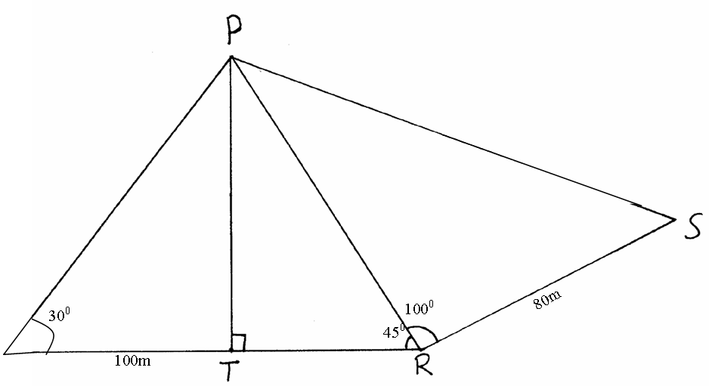
(a) Find to four significant figures
(i) the length of PT (2mks)

(ii) The length of PS (3mks)

(iii) the perimeter of the piece of land (2mks)

(b) The plots are to be fenced with five strands of barbed wire leaving an entrance of 2.8m wide to each plot. The type of marked wire to be used is sold in rolls of length of 480m.Calculate the number of rolls of marked wire that must be bought to complete the fencing of the plot. (3mks)

21. The figure below shows a circle centre O in which QOT is a diameter.
Angle QTP=46⁰ ,angle TQR=75⁰ and angle SRT =38⁰, PTU and RSU are straight lines.
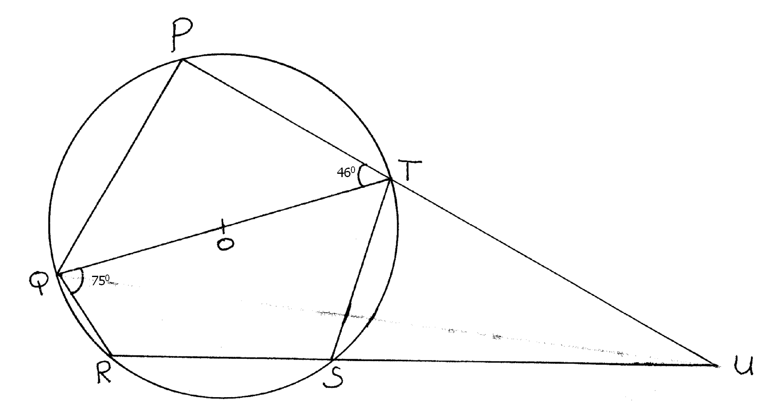

Determine the following, giving reasons in each case:
(a) angle RST (2mks)

(b) angle SUT (2mks)

(c) angle PST (2mks)

(d) obtuse angle ROT (2mks)

(e) angle SQT (2mks)

22. (a) Fill the table below of the function y=2x²+6x-5, for -4x3 (2mks)

x | -4 | -3 | -2 | -1 | 0 | 1 | 2 | 3
y

(b) (i) Draw the curve of y=2x²+6x-5, for -4x3. for -4 x3 on grid given (2mks)

(ii) On the same axes, draw line y=7x+1
(c) Determine the values of x at the points of intersection of the curve y=2x²+6x-5 and line y=7x+1 (1mk)

- Find the actual area of the region bounded by the curve y=2x²+6x-5 and line y=7x+1 (4mks)

23. The diagram below shows two cicles, centre A and B with intersect at points P and Q .
Angle PAQ =70⁰, angle PBQ =40⁰ and PA=AQ=8cm
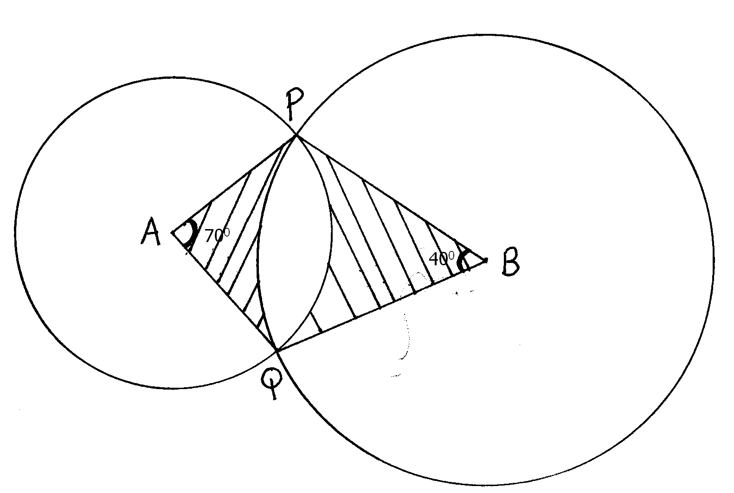
Use the diagram to calculate
(a) PQ to 2dec places (2mks)

(b) PB to 2 dec places (2mks)

(c) Area of minor segment circle center A (2mks)

(d) Area of shaded region (4mks)

24. The figure below shows triangle OPQ in which OS =$\frac{1}{3}$OP and OR =$\frac{1}{3}$OQ.T is a point on QS such that QT =$\frac{3}{4}$QS.
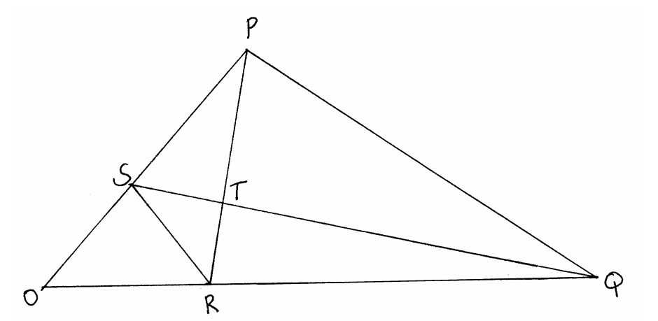
(a) Given that OP=p and OQ=q: express the following vectors in terms of p and q.

(i) SR (1mk)

(ii) QS (2mks)

(iii) PT (2mks)

(iv) TR (2mks)

(b) Hence or otherwise show that the points P,T and R are collinear. (3mks)

End

